2021 AASP School Psychologist of the Year
Matthew Turley, PhD, NCSP
Vail School District

“Dr. Matt Turley is, without a doubt, one of the best school psychologists I have had the honor of knowing and working with.” This quote comes directly from Michelle Wood, Director of Special Education in the Vail School District.
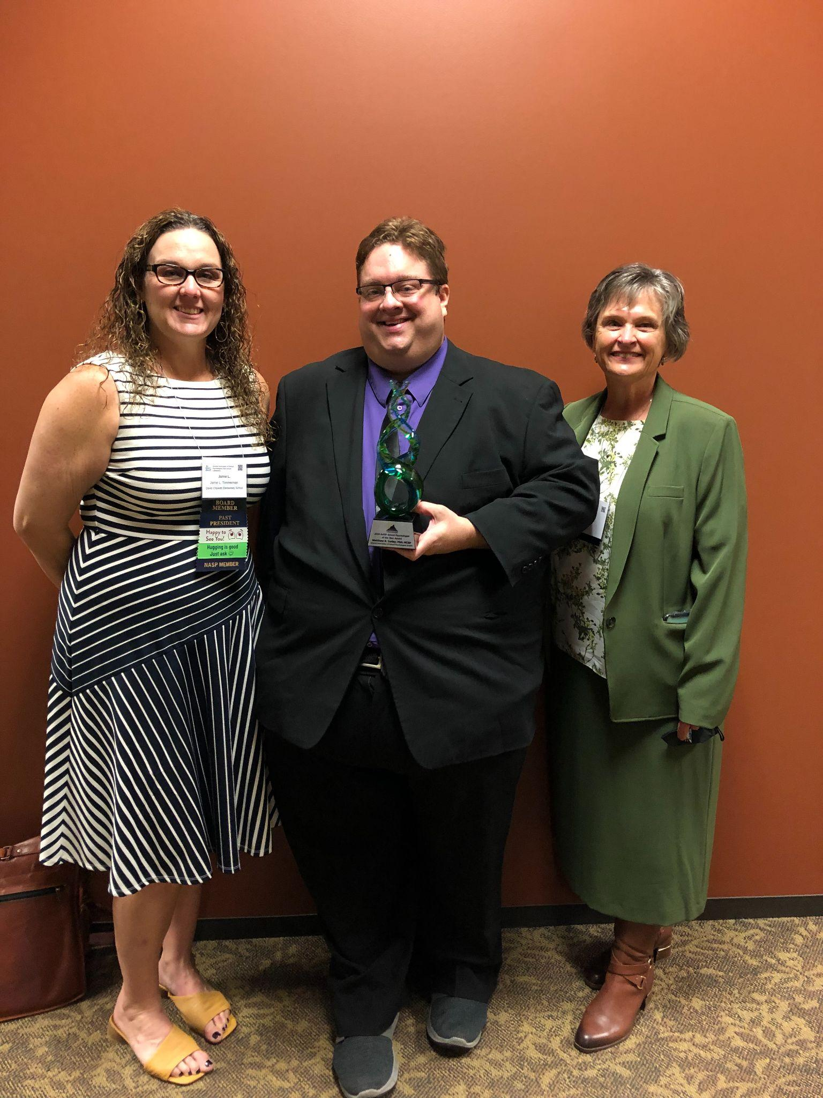
Dr. Turley works in the Vail School District who is lucky to have him! In the Vail School District, Dr. Turley has been a valued member of a variety of programs aimed at supporting students' educational and social-emotional needs and has taken on numerous leadership roles to better support the district and the families that we serve. Dr. Turley is always willing to support.
Dr. Turley currently leads and supports the district’s largest comprehensive high school with 2,000 students, almost double the norm. He was asked to move to the high school because of the skills he demonstrated at the other two middle schools where he'd served previously.
Dr. Turley isn't just focused on his caseload, rather, he supports and advocates for all students. He has a big picture mindset. As a creative problem solver and tremendous listener, he makes teams better working to enable them to work together for students with structures that move everyone forward.
Dr. Turley has blended right in at Cienega High School. He has built an incredible rapport with the staff who work to embrace his way of thinking about things. Some school psychologists get stuck in the box, but he works to expand that box and helps others to see things from very different viewpoints. And, perhaps most importantly, Dr. Turley has the ability to communicate effectively with all levels of people. He can very clearly walk through his thinking in a case making it clean and easy to follow for newer school psychologists. But his ability to explain complicated information to other staff and families is what allows him to move the needle forward for our students. He builds a team of people for every student... a team that can develop the same understanding and strategies to best serve each child we have!
Noteworthy is Dr. Turley's knowledge base and understanding of special education. He takes into consideration each child's unique ability and background and helps shape programs in which the student grows and is fully supported. When working with parents, he is thoughtful and constructive and effectively communicates data. He skillfully guides parents through a complicated process carefully presenting information so that parents understand and are not overwhelmed. He listens carefully to parents.

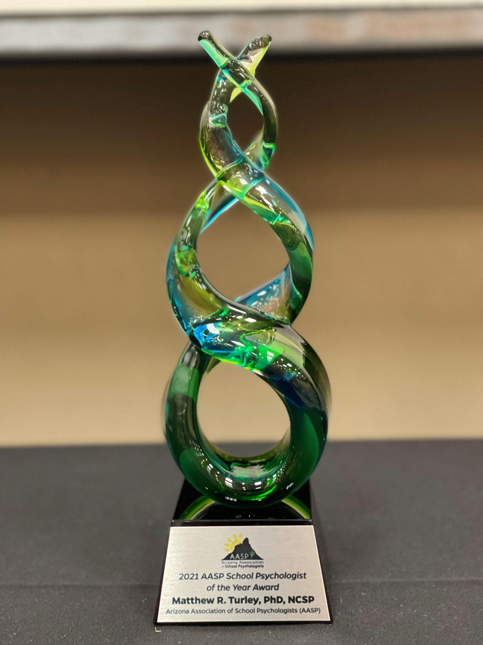
Last month, I was supporting a team through a meeting where the parent and the school staff did not agree on all points, but the final comment at the end of everything was to Dr. Turley–a genuine statement of gratitude to him for always fighting for and listening to their child. As I sat in that meeting, and saw that look of trust and thanks, I could not think of a better reflection of his impact on everyone that he works with.
Every decision Dr. Turley makes is based on data. He reviews all of the data collected on a student including benchmark testing data, attendance data, grades, STEEP data, state testing data, and more. He looks for patterns and trends, but beyond that, he works for consent from parents to dig for more data as needed. He scours through assessments in the behavioral realm as well. He is our expert in knowing which data is an indication of an area of concern that needs exploration and serves as a district wide mentor to all of our other school psychologists in this area.
Dr. Turley has cultivated amazing relationships with students, staff, parents, the district, and our community. He is that person, on and off of our campus, to whom teachers and district staff look to for support and guidance. Quite simply, when Dr. Turley talks, people listen. When other educators need help, he is their go-to person. Dr. Turley models what it is to be a consummate professional through all of his actions and interactions.
Dr. Turley can so easily mentor others because he is also intentional about building relationships. He works to get to know the staff on his campus as well as the parents with whom he works. People seek his expertise because his personality makes him so easily approachable. Further, his follow through is exceptional. Many of our other school psychologists call him to consult on a case as they value his expertise and friendly disposition as well. He also serves as the lead for our district-wide LINKS team, a program that focuses on high school students with autism. He collaborates with middle and high school teachers and staff to coordinate a team that implements functional structures to help students build independence before leaving high school.
Dr. Turley also serves as part of the team that responds at ANY site where there is a crisis. Unfortunately, he was called upon a few different times last year to assist schools (staff and students) with their response to suicide crises. Matt is always the first to volunteer to go. His heart is not just in the practice of psychology, but it is in the practice of serving children. He genuinely loves children and loves helping others. And those he touches with his skills know it!
Further, Dr. Turley works with our Ventana program, Vail's program to support students most in need of behavioral and mental health support. He ensures those students are continuing on with services outside the district and ensures that the partnerships with Vail remain strong. He has been Vail's go to for connecting families with resources across the community when needs extend beyond the school. In fact, he laid the groundwork for a new position added at the district level devoted to providing connections to external resources in the community for families in need. The need simply became bigger than one psychologist could do for Vail's 14,000+ students.
Another key strength of Dr. Turley's is his ability to implement school-wide practices, academic interventions, and instructional supports that promote learning. For example, he recently worked with a student with a 504 plan. He worked with staff to support the student's success. We usually have other groups for that task, but his expertise was essential. He also implemented school wide STEEP reading interventions bringing peer coaching to a middle school. Because of his relationships with kids, he was able to help them past the socially awkward component of peer coaching. The result was a group of struggling students who experienced tremendous academic growth in the area reading, preventing some of them from having to be placed in the special education system.
Dr. Turley is also a champion of equitable practices for diverse student populations. He fully embraces the research-based practice of full inclusion in the general education population used across the Vail School District. When students are segregated, they feel different. But, perhaps more importantly, the general education population benefits most from this practice as students learn from their first days in school to embrace diversity in all realms. However, when the needs of students aren't being met in that environment exclusively, Dr. Turley designs programs to meet those needs of each of our students.
Dr. Turley is such a valuable asset not just in terms of his personal connections, his ability to deeply assess needs based on data, and his ability to provide innovative support and practices, but also because of his depth of knowledge related to legal, ethical, and professional practices. He is the go-to when we need to ensure that all the I's are dotted and T's are crossed in regard to legal and ethical practices. They are followed precisely. He works to ensure we are making the right educational decision for EVERY student, not just students with disabilities or IEP's. When situations of crises happen, he becomes the expert liaison and resource regarding legal means of proceeding through difficult situations including manifestation hearings, etc. Teachers and staff come to him regularly to ensure they are following the letter of the law.

Dr. Turley has been a pivotal member in the Vail School District, and helped to provide district-wide professional development, support at four middle school and four high schools, train future members of the team, and this year took on the team lead role. Dr. Turley continues to build up the field at large and has regularly supervised practicum, externship, and internship students. Dr. Turley is an individual who leads his team by example. His expertise is called upon by administrators, teachers, and staff members.
All who work with Dr. Turley have absolute trust in his mission. He doesn't have to broadcast that mission anywhere; he simply “lives it.” Students, staff, parents, and the broader community can very easily see where his heart is as his actions display his true passion for ensuring success and high-quality opportunities for ALL with whom he engages. Vail found a gem, and Vail's community reaps the benefits of this fine human being.
Dr. Turley embodies all of the desired characteristics of a school psychologist. He is an individual of the highest character who possesses the qualifications of a master practitioner and whose competencies are regularly supported by both quantitative and qualitative data. Beyond the obvious skills that he processes, you will find him to be one of the most caring and authentic individuals that you will meet. Dr. Turley is always willing to step up and support staff and students in need. It is how he provides this support, and his genuine kindness, empathy, humor, and insight that truly sets him apart from many practitioners in our field. Dr. Turley is a trusted colleague, a valued consultant, an advocate for students and staff, a safe place for students in crisis, and a leader in data-based decision making and evidence-based practices. He exemplifies a true leader who leads by example, demonstrates great interpersonal skills, and has earned the respect from his colleagues. Most importantly, Dr. Turley truly cares about the students with whom he works.

