2021 AASP Administrator of the Year
Jennifer Benjamin
Principal of Palm Valley Elementary School, Litchfield Elementary School District

Principal Benjamin “exemplifies what every psychologist wants in a leader–passion, innovation, and a true belief in the notion of a ‘school family’ that is inclusive for all,” as quoted by Jennifer Elliott, School Psychologist.
To understand the true amazingness of this leader, you would have to walk with her for a full day. You would find Principal Benjamin out at student drop off, waving and smiling to all of her families and students. From there, you would see her individually talking to children who may be having a tough morning. Her true love for her children exudes from every ounce of her being and it is so clear that her children feel this! Talking to Principal Benjamin for a few short minutes [is all] most of her children need in order to understand they are exactly where they belong and they are so loved! From there, Principal Benjamin is out in classrooms where she is supporting her staff and students to ensure they have what they need to teach and learn and the highest levels possible. If they don't, you can be assured that Principal Benjamin will support them until they do! Principal Benjamin is an expert of meeting children where they are and supporting them every step of their journey! The children and parents at her school can rest assured that the services and support will always be top notch! Mrs. Benjamin is a champion for all children in the Litchfield Elementary School District but stands above the rest in advocating for students with disabilities.
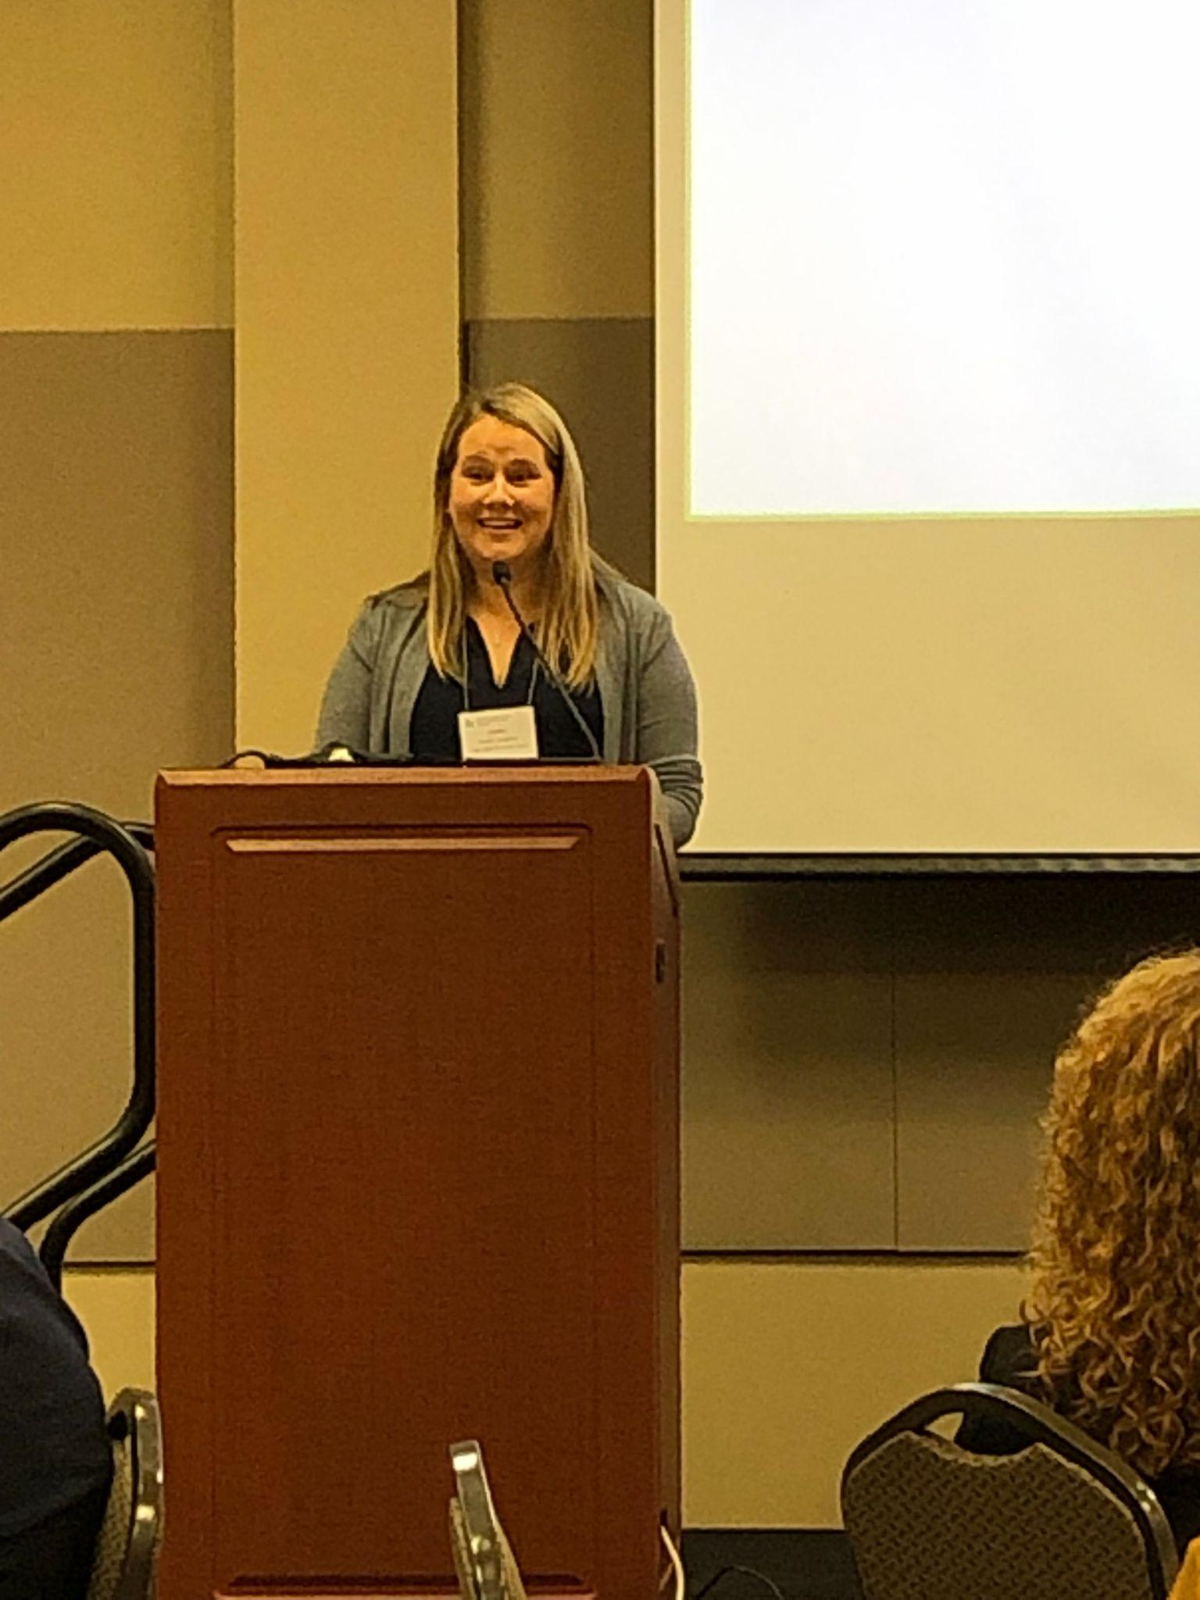
Being a previous special education teacher, she is equipped with so many skills, strategies and knowledge of special education law and procedures that she is a confident and true advocate for her children with special needs. She was a teacher in both general education and special education for several years and spent time teaching in both resource and self-contained settings. Mrs. Benjamin then moved from teaching to a special education instructional coach position where she was able to impact students district-wide for two years. Next, when the opportunity arose, she took the position as the Director of White Tanks Learning Center, our district Level D school. In the small community of White Tanks, Mrs. Benjamin perfected her ability to build a school family where students and staff felt safe and connected at school. There were days that were hard, but she completed four amazingly successful years there before moving into her current position as Principal at Palm Valley Elementary.
Principal Benjamin’s leadership skills are unparalleled. Her passion for education absolutely shows in her daily interactions. Her door is always open (literally and figuratively) for those who have a question, want to make a suggestion, or just talk. When we recognize a skill deficit in staff or students, she works with her team to determine the best way to build capacity so that they feel empowered to manage situations successfully. She works diligently to not only support academic growth, but social/emotional growth as well. She works with community members to get counseling services for students, takes meals to families when they have a tragedy or celebration, and encourages the community to support her staff in any way they are able. Principal Benjamin also sends weekly emails to staff and families to make sure that they are aware of what is happening on campus, and posts great things about the school almost daily on social media to encourage community interactions.
Mrs. Benjamin has been stellar for her entire career; however, in the role of principal is where she truly has outshined the rest in her leadership and advocacy for the special education community. The Palm Valley campus not only has anywhere from 35-50 (any given year) students in the resource programs but is also home to our four district SAILS (Social, Academic, Inclusion, and Life Skills) self-contained programs. In 2015, Principal Benjamin worked with the special education department and led the Inclusion Revolution Movement at Palm Valley. Yes, you heard that right… Inclusion Revolution Movement.
The Inclusion Revolution Movement initiative was two-fold:
- The first part focuses on intensive training for all staff on campus and an increase in effective inclusion for students from the SAILS classroom into the mainstream. Prior to that time, mainstreaming did take place, but it was not systematic in nature, the training for all staff had not been made available, and there had not been an emphasis necessarily on peer relationships.
- The second part of this initiative involved a peer tutoring program for students from general education to come into the SAILS classrooms and work with students. Peer tutors applied for the opportunity and were trained and prompted in order to model and support students in the SAILS classrooms by building friendships and by supporting academics, communication skills, social skills, and life skills. In turn, the students from general education gained skills in all of these areas in addition to empathy and compassion for others. What we teach and reinforce for others, we strengthen for ourselves and this became evident in the school data.
Inclusion Revolution and peer tutoring have continued through the years and have not phased out or lost fire over time but have in fact continued to grow stronger. The impact on the campus has been a stronger and more connected school family for all and measurable positive impacts throughout the school. Students from SAILS have continued to have increases in progress on IEP goals, positive peer relationships and social skills improvement, and increased communication skills and success in the mainstream classrooms. Students in general education have decreased overall in bullying behaviors, suspensions, and detentions, and have continued to see an increase in academic growth and the inclusion of others on the playground and in the community. The culture shift at Palm Valley since the start of the Inclusion Revolution has been both transforming and truly magical. We have watched friendships form that never would have been possible without the Inclusion Revolution. Students can also choose to forgo one special a week to be peer tutors in the SAILS classrooms. This is Mrs. Benjamin’s heart.
In addition to this initiative, Mrs. Benjamin knows every student in her program by name and could tell you something special about each student as well. She takes time to get to know them and works with the amazing teachers and paras to make sure they feel supported in the hard work they do with these very special students daily. Additionally, she works with her general education and resource teachers to make sure the students they share are getting all of the accommodations, modifications, and services they need for success. She is innovative and is always looking for new ways to reach our students with IEPs. Principal Benjamin attends most IEP meetings on her campus even though she has others designated as district representatives. Principal Benjamin is so knowledgeable in the area of special education and is happy to facilitate special education meetings in support of her teams.
Oftentimes, you see a school that's culture and social emotional learning program is stellar, but the rigor of the instruction needs work... NOT at Palm Valley! At Palm Valley you can see and feel it all! Children and staff are supported and challenged to be the very best versions of themselves, to learn at their highest level and to have fun along the way! All of these things are possible because of Principal Benjamin's huge heart and incredible leadership style!
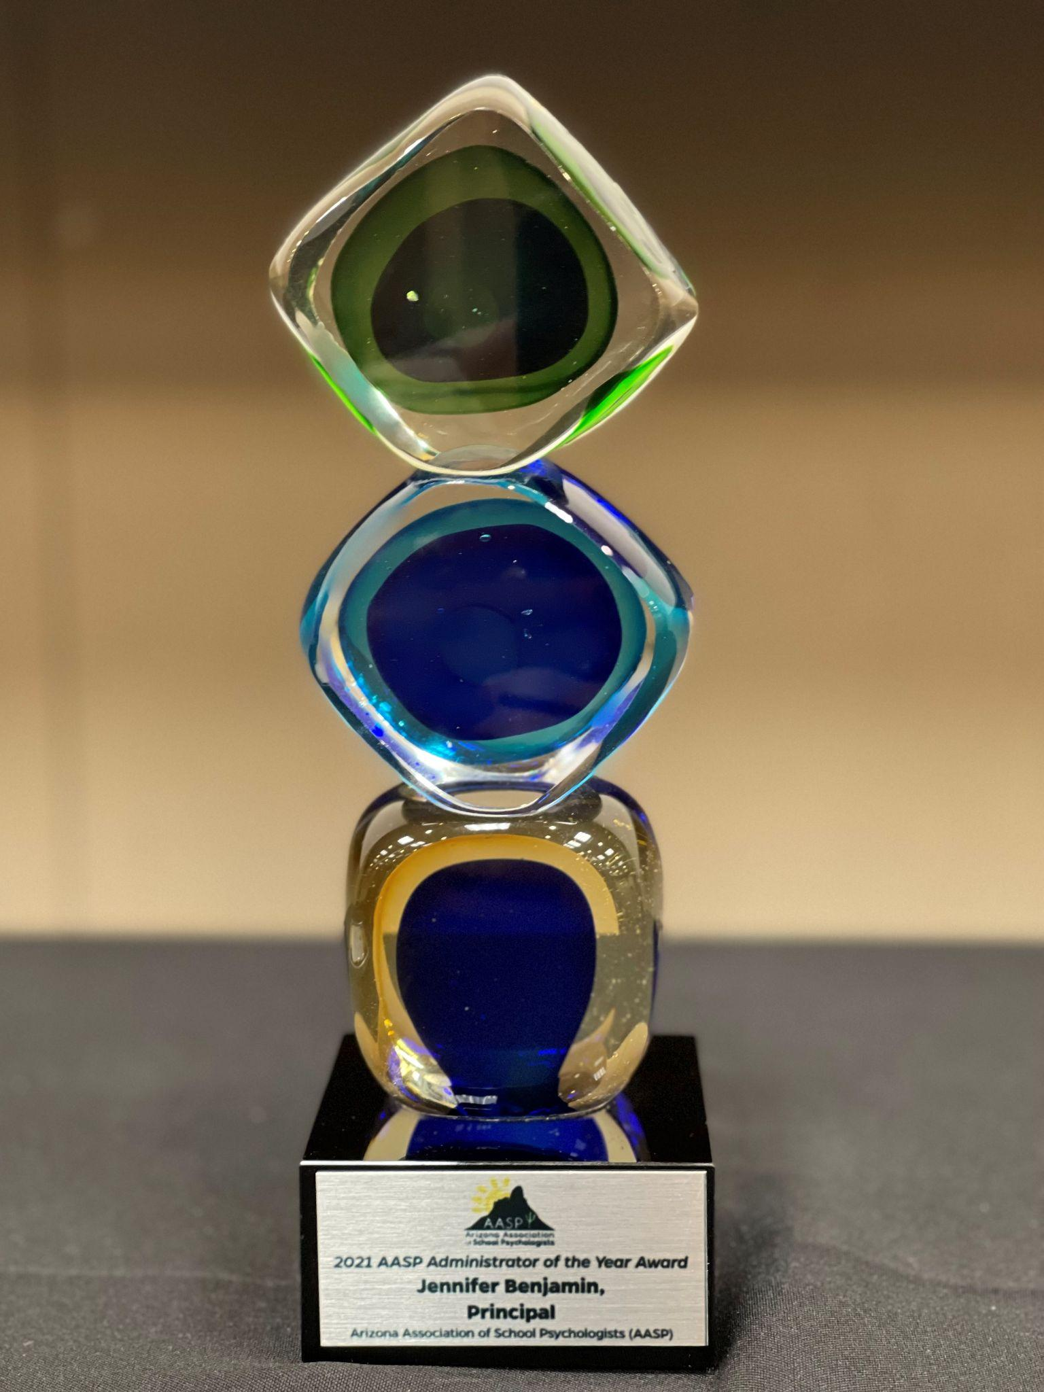
Palm Valley Elementary is consistently looked to in the district as a model school for innovative practices. Principal Benjamin not only wholeheartedly supports the use of the district’s SEL model of Conscious Discipline at her school, but she also requested to become a “trainer of trainers” so that she could help support her staff in this initiative. Unlike most schools in our district, Principal Benjamin advocated for an RTI approach that gives all students what they need, regardless of special education eligibility. This has allowed more students to receive a variety of interventions over the years prior to referral for evaluation because the interventionist and resource teacher pooled resources to provide services that most appropriately meet students’ needs regardless of eligibility. It also helped me to be able to promote a solution-focused system of intervention before referral for a variety of needs. In addition, Principal Benjamin is a mentor to other principals across the district to help them create programs on their campuses that benefit students.
Principal Benjamin truly is one of the absolute best administrators there could be. Principal Jennifer Benjamin goes above and beyond in all that she does each and every day for her staff, students, and families. She has created a family culture that can be felt by all as they step on the campus. Principal Benjamin encourages teachers to become leaders. She celebrates the strengths and gifts of teachers by allowing them to share their craft on professional development days. She is the first person the staff contacts when they have a celebration or to ask for wish wells. Principal Benjamin is visible, loved, and transparent. She communicates with staff regularly. She is in every classroom every day even if just to smile and wave.
Coffee with the Principal is another way Mrs. Benjamin communicates with all stakeholders. The school also has a Facebook page that Principal Benjamin updates almost daily with incredible learning happening around the school. She is not a principal you will find in her office very often because she is mingling with students in classrooms and the playground. She is taking pictures and videos to share with the staff and families and to highlight the incredible learning that happens in every nook and cranny of Palm Valley Elementary.
Principal Benjamin has an open-door policy. If you do find her in her office, she greets everyone with a smile and an invitation to come in to talk. She is an expert at difficult conversations. She knows when to listen or offer a helpful suggestion. She has very high expectations and is the first to celebrate any and all accomplishments. Just the other day, a teacher made a comment, “I can’t even begin to imagine what it would be like in her brain.” My answer, “It’s busy. It is busy finding new ways to make an incredible school even better and to make sure everyone on this campus is loved.”
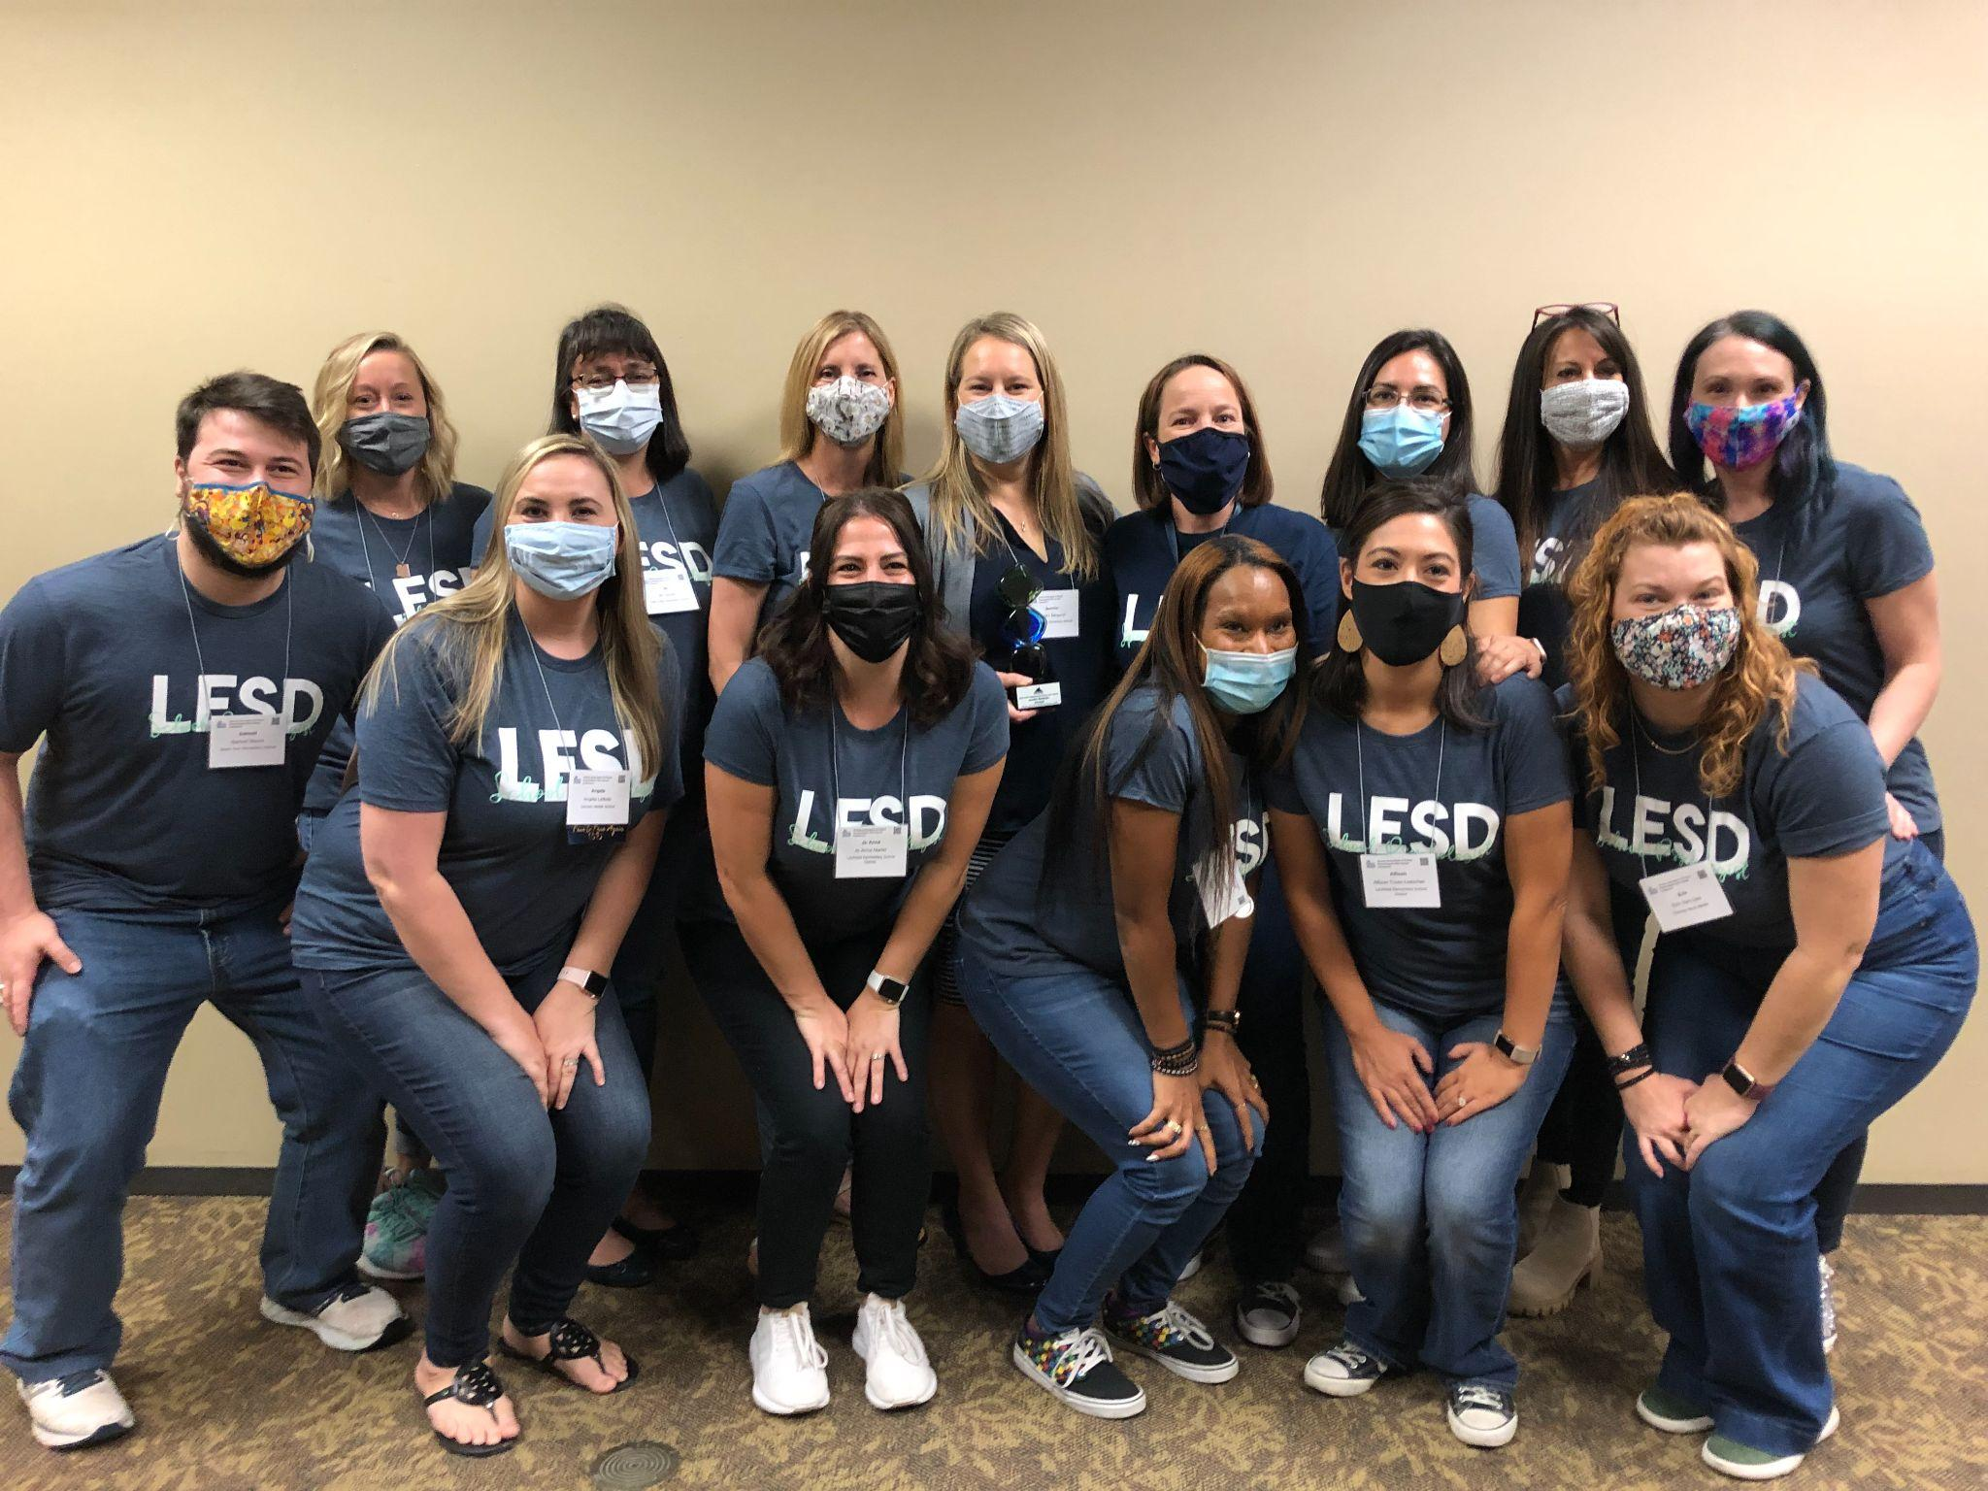
In addition to all of the responsibilities a building principal has, Principal Benjamin goes above and beyond in all that she does. She is admired and respected, adored and loved. Principal Benjamin has a gift. That gift is leading. Her staff are so very blessed to call her OUR leader.

