

A picture containing drawing

Description generated with very high confidenceTargeted Support and Improvement Guidance FY 21

Contents

Federal Targeted Support and Improvement (TSI) Schools…………………………………….…...3

Targeted Support and Improvement LEA Requirements……………………..……………….……..4

LEA Desktop Monitoring Protocol……………………………………………………………………....7

Required Evidence-based Systems…………………………………………………………..……..…8

………………………………………………………………..…….…10

Equity-based Multi-tiered Systems of Support Learning Series – Cohort 2!................................11

TSI Grant Opportunity…………………………………………………………………………..……….12

School Support and improvement Contact List………………………………………………….…...14

Appendices……………………………………………………………………………………………….15

Appendix A CNA, RCA, IAP Process Overview………………………………………………….…..16

Appendix B ADE Comprehensive Needs Assessment (CNA)…………………………………..….17

Appendix C Integrated Action Plan Worksheet Templates…………………………………….……39

Appendix D Evidence-based Practices, Strategies and “Interventions”……………………….…..45

Appendix E Evidence Based Summary Form…………………………………………………….…..49

Appendix F Targeted Support and Improvement LEA Programmatic Assurances…………….…50

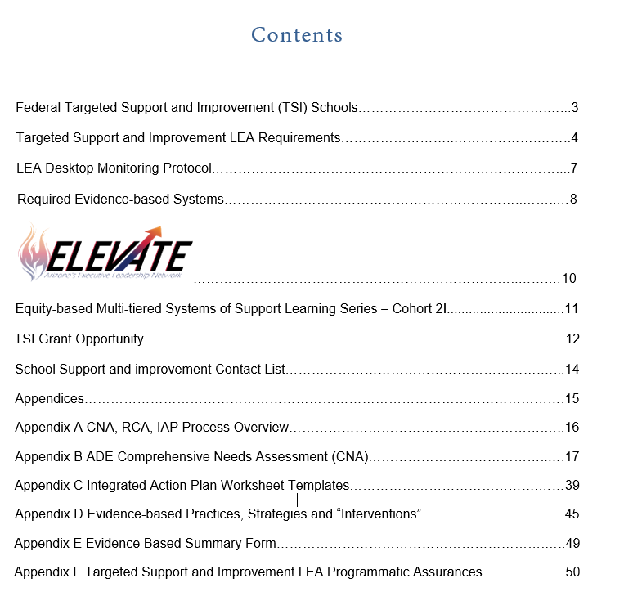



# Federal Targeted Support and Improvement (TSI) Schools

(first identified based on Spring 2018 AzMERIT) Any school with any subgroup of students, that on its own, would lead to identification as a Comprehensive Support and Improvement School will be identified as a Targeted Support and Improvement School.

Subgroups for accountability purposes are students from major racial and ethnic groups, students with disabilities, English learners and economically disadvantaged students

* The Targeted Support and Improvement N count is20
* Subgroup achievement in the bottom 5% of Title I schools

If a TSI school doesn’t meet exit criteria within four years, the result is identification as a Comprehensive Support and Improvement School.

### TSI Schools are identified every three years.

##### Exit Criteria

* A minimum of two years of consecutive increased subgroup achievement; and
* Implementation of school improvement goals, strategies and action steps relative to subgroup achievement in state required Integrated Action Plan; and
* Subgroup achievement above bottom 5% of Title l schools.

Per ESSA, **The LEA is responsible for the following:**

* Notifying each identified school
* Including specific goals, strategies and action steps in the LEA integrated action plan addressing trends and patterns across schools to increase subgroup achievement
* Supporting and monitoring TSI schools as they add specific goals, strategies and action steps addressing subgroup achievement to the school integrated action plan
* Supporting and monitoring implementation of strategies and action steps
* Progress monitoring of strategies and action steps
* Evaluating implementation and success of strategies and action step
* Overseeing grant expenditures and ensuring fiscal compliance

# Targeted Support and Improvement LEA Requirements

## LEA Requirements

1. **Complete School and LEA Contact Forms** on School Support and Improvement website for the LEA and TSI School/s at: [http:// www.azed.gov/improvement/](http://www.azed.gov/improvement/).

This is how we know who to contact.

1. **Complete Assurances** (appendix J)
   * Review, sign, upload in ALEAT

### Complete LEA Integrated Action Plan

* + Address trends and patterns across the identified schools
  + Include all required elements for selected principles (appendix D)
    - Primary need
    - Root cause
    - Need Statement
    - Desired outcome
    - Strategies (specific to subgroup achievement)
    - Action steps (implementing, monitoring and evaluating)
      * Use of evidence- based programs, practices and/or interventions (appendix E)
      * Tag action steps **TSI** (program tag) and/or

**FY20_TS** (funding tag)

* + - SMART goals - Subgroup goals to address low achievement
      * Leading and lagging indicators
* Process and impact goals as appropriate
* ELA and Math proficiency

1. **Maintain records and evidence** of TSI School oversight, support and monitoring
2. **Submit all requested SI documents** in a timely manner

##### The LEA is responsible for ensuring every TSI schools complete the following:

## Annual Comprehensive Needs Assessment (CNA) and Root Cause Analyses (RCA)

* + Title I schools upload in ALEAT
  + Non-Title I schools submit to LEA

*Note: Subgroup Key Indicators 1.2 A & D; 1.6, 1.7 A & B; 1.8 2.1; 2.4 A, B and I; 2.5 D*

*3.2 B; 3.5 C; 4.1; 4.4 B; 4.5; 5.1 B & C; 5.3 A*

## School Integrated Action Plan* (IAP)

addressing identified school unique primary needs and root causes from CNA relative to each identified low achieving subgroup (Title l schools submit in ALEAT and Non-Title l use School IAP Plan template and submit to LEA) (appendix D/appendix I)

Required elements for selected principles (appendix C):

* + Primary Need
  + Root Cause
  + Need Statement
  + Desired Outcome
  + Strategies (specific to subgroup achievement)
  + Action steps
    - Use of evidence-based programs, practices and/or interventions (appendix F)
      * Tag action steps **TSI** (program tag) and/or

**FY20_TS** (funding tag)

* + SMART goals - Subgroup goals to address low achievement
* Leading and lagging indicators
  + - Process and impact goals as appropriate
    - ELA and Math

## Implement, monitor and evaluate TSI School IAPs

*\*See guidance materials CNA to RCA to IAP* <http://www.azed.gov/improvement/>

# SMART Goals

## Subgroup achievement examples

Percent of (subgroup) scoring proficient will increase by % from % in 2018 to % in 2019.

or

The achievement gap between % of all students scoring proficient and the %

of (subgroup) students scoring proficient will be reduced by % from % in 2018 to in 2019.

### Leading indicator examples

(Subgroup) (Attendance Rate) will increase from % in 2017-2018 to %

in 2018-2019. or

(Subgroup) (Discipline Incidents) will be reduced by % from in 2017-18 to in 2018-19.

### CNA based examples

*(Process goal):* By (date) evidence-based reading intervention curriculum will be adopted as evidenced by written documents.

*(Process goal):* Implementation of reading intervention curriculum will begin (date).

*(Impact goal):* (Subgroup) reading proficiency will increase from 5% in 2018 to 18% in 2019 as measured by the district reading assessment.

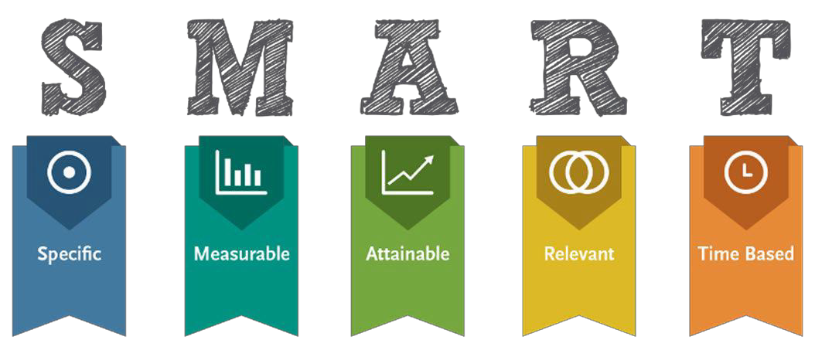

# LEA Desktop Monitoring Protocol

**School Support and Improvement Education Program Specialists will discuss, by phone, the following with the LEA designee:**

* + - 1. Describe communication and collaboration process between the LEA and each TSI school principal.
      2. Have all schools completed the CNA and Root Cause Analyses?
      3. Have all schools completed their Integrated Action Plan including the required elements in selected principles relative to identified subgroups?
         1. Primary needs
         2. Root Causes
         3. Need Statements
         4. Desired Outcomes
         5. SMART Goals
      4. What was your process to ensure that schools completed #1 and#2?
      5. Based on the LEA’s analysis of the TSI schools’ CNAs, what trends were identified across schools? What unique needs of specific schools were identified?
      6. LEA Integrated Action Plan
         1. What action steps in the LEA IAP address trends and unique school needs?

Implementation

Monitoring progress

Evaluation

Are action steps tagged TSI and/orFY19TS?

* + - * 1. What accountability measures does the LEA have in place for School IAP implementation ensuring increased student achievement for the identified subgroups?

How will you know implementation is taking place effectively?

How will you monitor and report progress?

* + - 1. Who is responsible for holding schools accountable?
      2. Discuss progress on the IAP strategies and action steps relevant to identified subgroups.
      3. If LEA has the grant, review grant expenditures and reimbursement requests and the progress with items in the grant.

# Required Evidence-based Systems

## Instructional Infrastructure

## A. Written Evidence and Standards Based Curriculum

**Standards** - What a student needs to know, understand, and be able to do by the end of each grade. Standards build across grade levels in a progression of increasing understanding and through a range of cognitive demand levels. Standards are adopted at the state level by the State Board of Education.

**Curriculum** - The resources used for teaching and learning the standards. Curricula are adopted at a local level by districts and schools. Curricula include scope and sequence of K-12 standards and/or learning objectives/targets aligned to the state standards. Comprehensive curricula are necessary to plan the pace of instruction, align standards and grade level expectations

horizontally and vertically, set district assessment and professional development calendars and guide teachers as they deliver instruction. (CNA Principle 4)

## Effective Instruction

## The methods and processes used by teachers in planning and providing rigorous, evidence-based instruction. Effective instructional practice includes strong standards-based instruction, data-based planning, differentiation and individualization, evidence-based pedagogical approaches and classroom management. Schools cultivate an environment of both high expectations and support for each and every students’ academic accomplishment. (CNA Principle 1, 2, 3 and 5)

### Professional Learning Communities

### Required, scheduled meetings organized around teaching and student learning, including data discussions, lesson planning and evidence-based pedagogy.

### Observation and Feedback

The purpose of short cycle observations and face to face feedback sessions is to coach teachers to improve student learning. Data from observations are the basis for actionable feedback to teachers including accountability for follow through on next steps and also to determine appropriate differentiated PD.

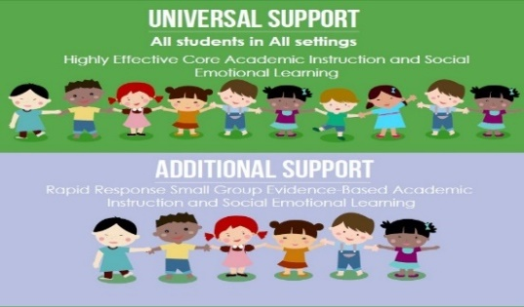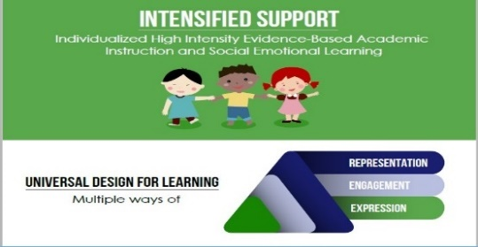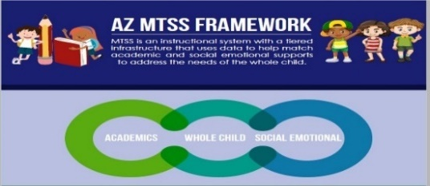

### Multi-tiered Systems of Support

Multi-Tiered System of Support (MTSS) is an instructional system with a tiered infrastructure that uses data to help match academic and social emotional supports to address the needs of the whole child.

### Universal Design for Learning

Implementation of Universal Design for Learning (UDL) is a framework to improve and optimize teaching and learning for all people based on scientific insights into how humans learn

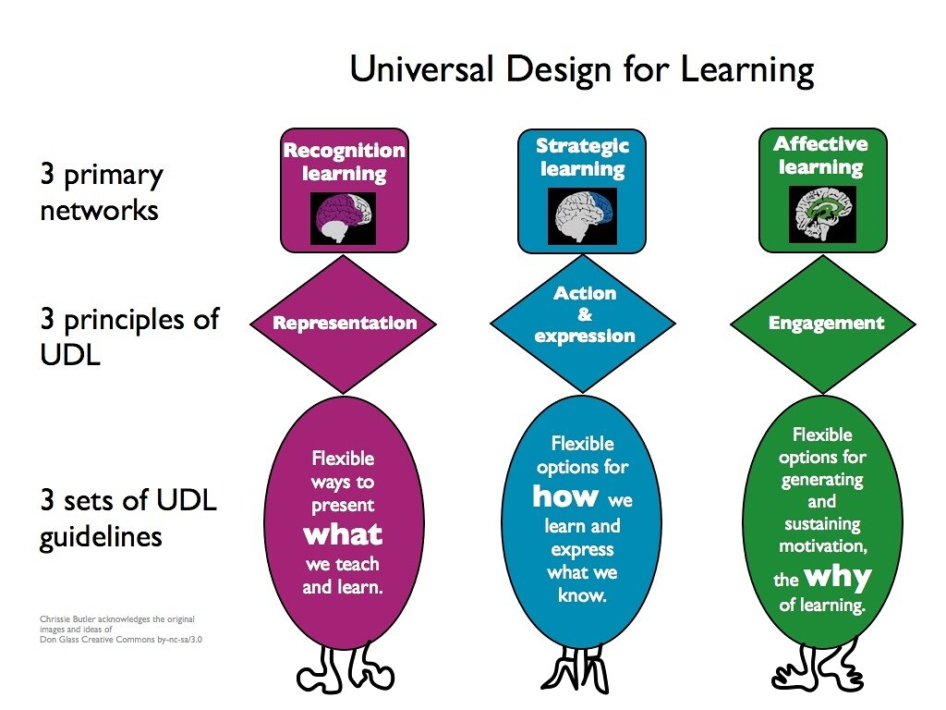

## Comprehensive, Balanced Assessment System

System includes screening and/or diagnostic assessments, formative assessment (student and teacher)

classroom summative assessments, schoolwide predictive interim or benchmark summative assessments,

and state mandated summative assessment (end of year); as well as a robust data management system to

ensure that the system provides accessible, up-to-date data reports to allow for deep analysis of student,

teacher, and school level data. (CNA Principle 2) [http://www.azed.gov/standards-practices/balanced-](http://www.azed.gov/standards-practices/balanced-assessment-resources/)

[assessment-](http://www.azed.gov/standards-practices/balanced-assessment-resources/) [resources](http://www.azed.gov/standards-practices/balanced-assessment-resources/)[/http://www.azed.gov/standards-practices/formativeassessrec/](http://www.azed.gov/standards-practices/formativeassessrec/)

## Culture intensely focused on equity, student learning, collaboration and safety

Organizational culture is a key element of school success.  A clearly expressed vision, mission and shared

values or commitments define purpose. These are widely communicated and understood and drive daily

decisions and actions. Staff, families and the community work together around common goals, engendering

a culture of trust, mutual respect, shared responsibility, and focused attention on student learning. Each

and every student is challenged and supported to aim higher, work harder, and achieve the highest expectations. Opportunity and access are ensured for all students, including those who have been historically marginalized.

(CNA Principal 1, 5 and 6)

## Talent Management

Talent management is a critical factor in developing successful organizations. It is an organization-wide, holistic system ensuring the right people are in the right positions to help achieve organizational goals. There is a need for organizations to develop 'talent pools' of great staff for the future direction and leadership of our schools. School Improvement requires competent and committed personnel at every level and in every position. Policies and procedures to identify, select, place, retain, and sustain these personnel, especially teachers and school-level leaders, are a precursor to school turnaround. Staffing of teachers and leaders for schools in improvement should be approached with equity in mind. A comprehensive system to support an environment of effective recruitment, on-going talent development and support, and retention is crucial. At all levels, educators must utilize and hone their instructional and transformational leadership to build capacity in those they supervise by continually balancing support and development with accountability. (CNA Principal 1, 2)

9

# is an evidence-based, executive leadership program developed and presented by the School Support and Improvement Unit of the Arizona Department of Education in collaboration with WestEd.

ELEVATE centers on equity-focused leadership and develops the knowledge, competencies and skills necessary for systemic change.

ELEVATE focuses on the culture of learning and high expectations for all, instructional infrastructure and talent management at the systems level

within LEAs and schools**.**

**Cohort 5** …Begins in November 2020. Grant funding is available for program and coaching costs. Contact Trish Geraghty at [trish.geraghty@azed.gov](mailto:trish.geraghty@azed.gov) for information or an application. Note: Only a few openings remaining.

Systemic Leadership Grant opens 3/1 and closes 5/30.

**Vision:** ELEVATE seeks to improve LEA and school systems in order to significantly increase and sustain quality outcomes for all Arizona Students.

**Mission:** ELEVATE develops and empowers LEA and school leaders to focus on improving teaching and learning that results in rapid and significant gains in student achievement.

**Theory of Action**

**If** we develop leaders’ skills and competencies to facilitate systemic change by creating and sustaining

* a high quality, cohesive instructional infrastructure
* a strong culture of learning and high expectations
* a strategic, evidence-based talent management system

**Then** student achievement significantly improves, and student subgroup achievement gaps are reduced.

10

# A close up of a sign Description generated with very high confidence

# Equity-based Multi-tiered Systems of Support Learning Series – Cohort 2!

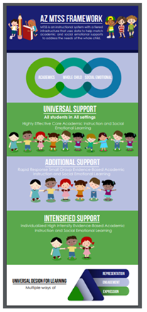

School Support and Improvement's second cohort of the Multi-tiered Systems of Support Learning Series begins this June.  This series focuses on helping schools and LEA's build a multi-tiered system of supports that are equity-based, proactive and preventative as well as culturally relevant and responsive.

**MTSS is** an instructional system with a tiered infrastructure that uses data to help match academic and social emotional supports to address the needs of the whole child.

**Equity in Education**: Where each and every student in a community is invited and welcomed into a system of teaching and learning that is fluid, responsive, dynamic, and alive, and that uses all available resources to meet student needs.

This learning series is a comprehensive, two-year experience for school and/or LEA teams. We are excited to share this opportunity to coordinate your existing systems and resources, strengthen your instructional infrastructure through a focus on student-centered practices, and ultimately help you build an evidence based MTSS framework that supports the whole child.

Watch the brief, pre-recorded webinar at the following link:

<https://www.azed.gov/mtss/>

For direct inquiries, contact Trish Geraghty at Trish.Geraghty@azed.gov or Stefaney Sotomayor at [Stefaney.sotomayor@azed.gov](mailto:Stefaney.sotomayor@azed.gov)

Grant funding available. MTSS Grant opens March 1 and closes May 30, 2020.

11

# TSI Grant Opportunity

**Eligibility:** LEAs with schools identified as Targeted Support and Improvement low achievement Schools. *For profit charter schools are NOT eligible*.

#### This is a competitive grant that funds integrated action plans aligned with the CNA and RCA. It requires a high- quality detailed application with all required elements and documents.

***LEAs out of fiscal and/or programmatic compliance will not be eligible.***

**The LEA maximum allocation is based on school enrollment. LEAs will be funded based on the Integrated Action Plan and allowable expenses aligned with that plan.**

|  |  |
| --- | --- |
| **School Size** | **Allocation** |
| **~100** | **$ 10,000** |
| **101-350** | **$ 12,500** |
| **351-600** | **$ 15,000** |
| **601-900** | **$ 20,000** |
| **>900** | **$ 25,000** |

Grant Application closes: May 30, 2020 (close of business) Complete all sections in GME

**Program Details**

* FFATA and GSA Verification
* Contact Information
* Program Narrative Questions
* Assurances
* Related Documents
  + Signature Page in required related documents (required)
  + Evidence Based Summary Form/s in required related documents (required)
  + Graphs, tables and charts necessary for a complete application (optional, as needed)

**Proposed Budget**

* Complete a *proposed* budget in GME. Be sure to include sufficient details in the narrative.
* Items must support improved achievement and identified root causes.
* Be sure that the requests for funds are allowable. Out of state travel and large expenditures for capital items are generally not allowed. Check with your specialist, if you have questions or need assistance building your budget.

12

* **Proposed expenditures must be specific. Amounts for general items will be disallowed.**

**Requirements**

* Completed **new** 2019-20 CNA uploaded in ALEAT
* Thorough root cause analyses (fishbones) uploaded in ALEAT
* Completed 2019-20 LEA and School IAP in ALEAT including SI required goals

**Allowable Expenditures**

All TSI School activities funded with Title I 1003 (a) School Improvement funds must be reasonable and necessary and directly related to the implementation of the LEA and School Integrated Action Plan relative to increasing subgroup achievement based on the needs and root causes identified in the schools’ Comprehensive Needs Assessment. **Proposed expenditures must be detailed and specific. Amounts for general items will be disallowed.**

* Data driven decision-making process
* Specific strategies and action steps based on root cause/s identified for increasing subgroup achievement
  + Leadership Development
  + Professional Learning activities and related travel costs
  + Specialized supplies directly related to supporting action steps
* Off contract pay for work (above and beyond duties necessary to job function); planning committees, researching evidence-based interventions, curricula, assessments
  + Board approved hourly rate paid, must be reasonable
  + Requires time and effort logs

This grant will NOT fund positions, performance incentive pay or stipends or capital outlay items; out of state travel is generally not allowed (speak with your Specialist for special circumstances; general office supplies are not allowed

Grant recipients are required to:

* + Receive EPS approval for revisions prior to implementing any change in spending or program
  + Submit revisions for any fiscal or programmatic change
  + In accordance with sound accounting practices, LEAs are required to request reimbursements monthly.
  + Keep necessary Time and Effort documentation
  + Submit Completion Reports on time

*Grantees failing to meet any single requirement of compliance are subject to possible funding forfeiture.*

*No pre-award costs will be allowed.*

Application and required related documents to be completed in GME. Application is in GME. Scoring rubric is in Document library and our webpage.

13

# School Support and Improvement Contact List



[Devon Isherwood,](mailto:Devon.Isherwood@azed.gov) Deputy Associate Superintendent [Trish Geraghty](mailto:trish.geraghty@azed.gov), Director

[Christina Pou](mailto:Christina.Pou@azed.gov), Director

[Peter Laing,](mailto:peter.laing@azed.gov) Director, Acceleration and Enrichment

[Gina Tignini](mailto:gina.tignini@azed.gov), Education Program Specialist, Phoenix [Jennifer Zorger](mailto:jennifer.zorger@azed.gov) Education Program Specialist, Phoenix

[Jessica Bartels](mailto:Jessica.bartels@azed.gov), Education Program Specialist, Phoenix [Stefaney Sotomayor](mailto:Stefaney.sotomayor@azed.gov), Education Program Specialist, Phoenix

[Sean Carney](mailto:Sean.carney@azed.gov) Education Program Specialist, Phoenix

[Frank Larby,](mailto:frank.larby@azed.gov) Education Program Specialist, South

Peggy Fontenot, Education Program Specialist, South

[Becca Moehring](mailto:becca.moehring@azed.gov), Education Program Specialist, Phoenix

[Danielle Skrip](mailto:danielle.skrip@azed.gov), Education Program Specialist, Phoenix

[Cindy Richards,](mailto:Cindy.Richards@azed.gov) Project Specialist

[Courtney Brown](mailto:courtney.brown@azed.gov), Project Specialist

ADE Email addresses: [first.last@azed.gov](mailto:first.last@azed.gov)

[schoolsupportandimprovementinbox@azed.gov](mailto:schoolsupportandimprovementinbox@azed.gov)

14



# Appendices

15

## Appendix A CNA, RCA, IAP Process Overview

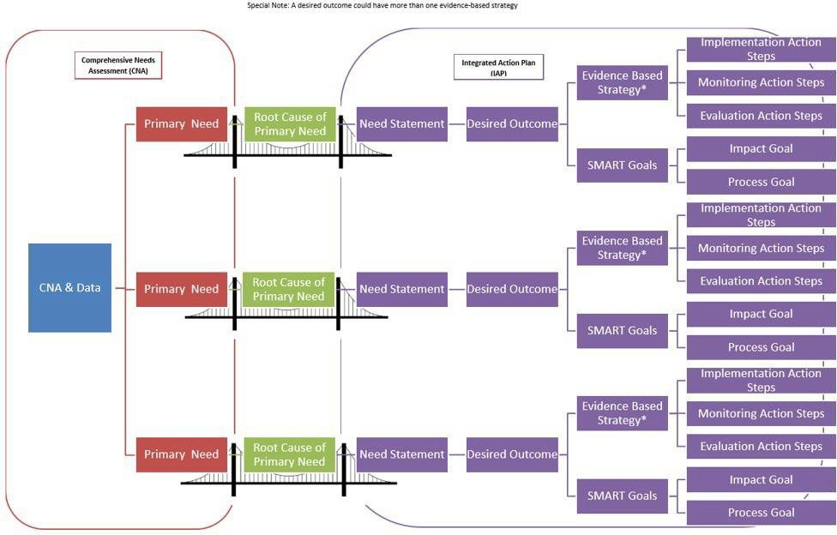

16

## 

## Appendix B ADE Comprehensive Needs Assessment (CNA)

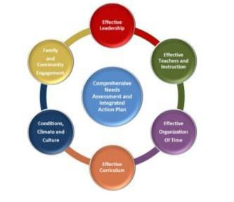The CNA is required by ADE. It is designed to inform need statements, desired outcomes, goals, strategies and action steps for the Title l, ll, lll, lV, and School Improvement programs.

The CNA will guide the process of evidence-based decision making in schools and LEAs to drive continuous improvement and significantly impact student achievement.

The CNA reflects the school’s current state.

Acknowledging that state honestly and transparently, based on evidence, allows a school to determine the best next steps to reach desired outcomes. It is not about a comparison among schools. It is about identifying strengths, needs and desired outcomes specific to individual schools. The CNA will allow the school to identify the greatest needs, root causes, and best solutions.

A limited number of well-defined desired outcomes and/or goals are a common feature of successful school and LEA improvement plans. These desired outcomes with goals, strategies and actions steps, help focus a school’s work by setting a target for student learning and achievement or systems, processes and programs that will impact achievement. By choosing strategies and action steps that leverage strengths and focus on connections and coherence, student learning and achievement increase. Carefully choose foundational small steps that lead to desired outcomes and systemic change over time.

The CNA is **not** a test; it is **not** an evaluation of good or bad. It **is** about knowing where you are as a school in relation to research-based exemplars of effective school systems to improve and be the best school possible in your context.

## Principles, Indicators and Elements

The Principles, Indicators and Elements describe an effective school system. Developed collaboratively by a team from ADE program areas and representatives from schools and LEAs, this self- reflection process required for continuous improvement is based on current educational research and evidence based best practice.

The Principles, Indicators and Elements describe criteria applicable to all schools, no matter their size, student population, philosophy or location. Schools use the Principles, Indicators and Elements to identify primary needs that when addressed and resolved result in increased student achievement and strengthened school systems leading to sustainable improvement.

Principle 1: Effective Leadership

Principle 2: Effective Teachers and Instruction

Principle 3: Effective Organization of Time

Principle 4: Effective Curriculum

Principle 5: Conditions, Climate and Culture

Principle 6: Family and Community Engagement

17

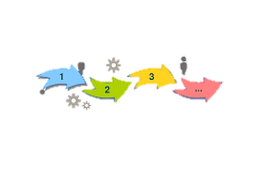

## Completing the Comprehensive Needs Assessment

* **Establish the Comprehensive Needs Assessment Leadership Team**: a [powerful,](http://www.forbes.com/sites/johnkotter/2011/05/24/building-the-team-you-need-to-drive-change/) [enthusiastic team](http://www.forbes.com/sites/johnkotter/2011/05/24/building-the-team-you-need-to-drive-change/) from across the organization and community is essential to transform an organization. Deciding who should take part in the process is crucial. Diversity and Inclusion is key. Building the momentum for change requires strong leadership and visible support from key people. Working as a team helps create momentum and build the sense of urgency in relation to the need for change.
* The CNA Leadership Team guides the larger CNA team of all staff members and stakeholders to complete the CNA process, gathering and analyzing data, discussing ratings, coming to consensus on individual elements. They plan and facilitate the process itself, including appropriate involvement and representation that will lead to sustainable systemic change.

**Overview of team tasks:**

* Establish group norms
* Develop completion timeline
* Establish roles and responsibilities
* Facilitate CNA Team; staff and stakeholder meetings
* **CNA Team:** The CNA team consists of people who are responsible for working collaboratively throughout the comprehensive needs assessment process.
* Ideal team members possess knowledge of programs with the capacity to plan and implement the comprehensive needs assessment, and the ability to ensure stakeholder involvement
* Include stakeholders representing all parts of the system, principal, other administrative staff, teachers, paraprofessionals, school office staff, parents, families, community members, and students
  + - Stakeholders are those individuals with valuable experiences and perspective who provide the team with important input, feedback, and guidance and represent all factions of the school community

## CNA Team Meetings

1. **The facilitator’s role** is to ensure that all CNA team members’ voices are heard and all possible theories from the group are considered before coming to an agreement of a specific CNA Element descriptor that matches the current state. Discuss the school vision and mission to ground the work.
2. **Use the rubrics in the resource document**. Using the rubrics allows CNA working teams to discuss each indicator, elements and evidence in detail and come to consensus on final rating. Before selecting the answer that reflects the current state within each element, data need to be collected, reviewed and analyzed. The data should act as information gathering and a confirmation of the selection. **The discussion is key.**
3. The CNA includes suggestions of **data or evidence** to be collected pertinent to the CNA Indicator and Element. These are suggestions of what data may be useful. While these suggestions are not required data points, we highly recommend you use multiple data sources.

18

1. **Guiding questions for gathering data**:
   * + What data do we currently collect that is relevant to the CNA Indicator and Element?
     + What additional data is needed or can contribute as evidence?
       - Curriculum design and implementation; Instruction methods, materials and resources; Teachers’ knowledge, skills and dispositions
       - Students’ knowledge, skills and dispositions; and
       - Infrastructure (i.e. Schedules, programming and resources).
     + Is data needed to show specific gains or losses or to better understand progression and/or effectiveness of a system or process?
     + Which data points do you feel are the most meaningful and useful?

#### Demographic data Guiding Questions

How do student outcomes differ by demographics and programs?

* + - What is the longitudinal progress of a specific cohort of students?
    - What are the characteristics of students who achieve proficiency and of those who do not?
    - Where are we making the most progress in closing achievement gaps?

1. **Leading Indicators are formative. They track progress along the way and guide course corrections as needed.** 
   * ***Dropout rate* Guiding Questions**
     + Are there significant differences in dropout rates among subgroups?
     + Are there any trends? Who? When?
     + Student attendance rate
     + Have there been changes in the attendance rate overtime?
     + Are there trends among subgroups or grade levels?
     + ***Discipline incidents Guiding Questions***
     + Have there been changes in the discipline incidents rate overtime?
     + Have there been changes in the types of discipline incidents overtime?
     + Are there trends among subgroups, grade levels or teachers?
     + ***Truancy***
     + Have there been changes in the truancy rate overtime?
     + Are there trends among subgroups or grade levels?
     + ***Teacher attendance rate***
     + Are there any overall trends?
     + Do the trends correlate with achievement data?
     + **Other Possible Leading Indicator Data**
   * Formative Assessments
   * Early Reading Proficiency
   * Enrollment in Pre-Algebra and Algebra
   * Over-Age/Under-Credited Students
   * Student Attendance and Suspensions
   * Special Education Enrollment
   * Student Engagement
   * Principal Quality
2. **Lagging/Achievement Indicators are summative—they are longer term outcomes that enable us to reflect on the impact of a strategy.**

* Percentage of students at or above each proficiency level on State assessments in reading/language arts and mathematics, by grade and by student subgroup

19

* **Possible Student Achievement Guiding Questions**
  + Are there trends among subgroups?
  + Are there trends among grade levels?
  + Are there teacher specific trends?
  + Are there trends relative to ELA or Mathematics?
  + ***Percentage of limited English proficient students who attain English language proficiency***
  + Are there trends among grade levels?
  + Are there teacher specific trends?
  + Have there been changes in the proficiency rates overtime?
  + **Graduation rate**
* What processes are in place to support practices that positively affect graduation outcomes? What gaps exist in outcomes among student subgroups?
* Have there been changes in the graduation rates over time? 4-year cohort? 5- year cohort? 6-year cohort?

1. Once the data is compiled for each indicator, the **team reviews** it all. This provides an opportunity for the team to share what they see in the data and to discuss what these findings mean for each CNA Element.
   * + 1. **Guiding questions for data review**:

* What patterns or trends can be found in the data?
* What are some positive areas that can be found in the data?
* What areas of need must be addressed based on the data?
* What can you infer from the data?
* What, if any, additional data is needed?

Remember, it is **THE PROCESS** to determine the current reality that has the **power**.

The **DISCUSSION** is what is important. The scores you agree on and the summaries of the scores guide identification of the greatest needs.

**GME Screen Shot**

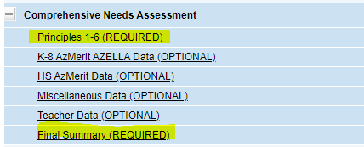

20

#### Identify 3 or 4 Primary Needs

Primary need is CNA principle, indicator or element PLUS data source.

Reread the trends and patterns summaries and possible primary needs from all 6 Principles. Analyze the data you have from a variety of resources. Use the information in these summaries to Identify three or four primary needs.

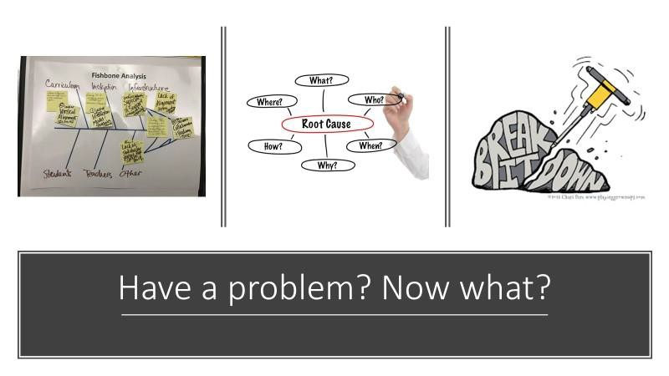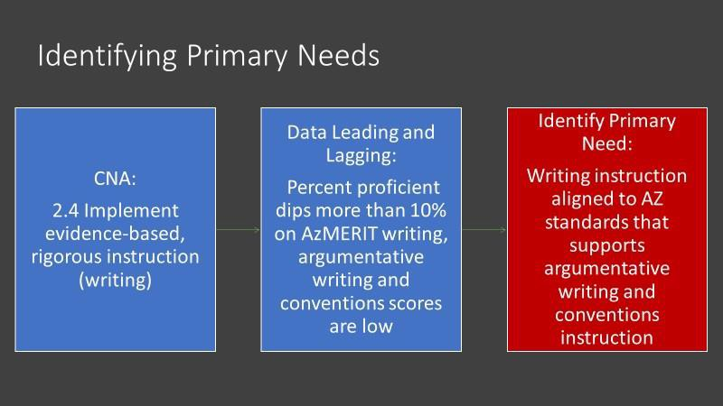

**Next step: Root Cause is critical to successful change**.

21

**Conduct a Thorough Root Cause Analysis**

for your top 3 or 4 primary needs, resulting in Needs Statements and Desired Outcomes. Root cause analyses take time! It is necessary for impactful change.

Root cause analysis is a structured team process. It allows the use of a strategic method to dig down into the primary need and determine causes and contributing factors. Often during the discussion of causes, different perspectives of the same situation are uncovered for an enhanced picture of the problem. At the end of the root cause analysis, the major cause is discovered and what needs to happen to remove the problem is determined. This is time to discuss causes, not solutions. The root cause is the **one** major contributing factor.

26

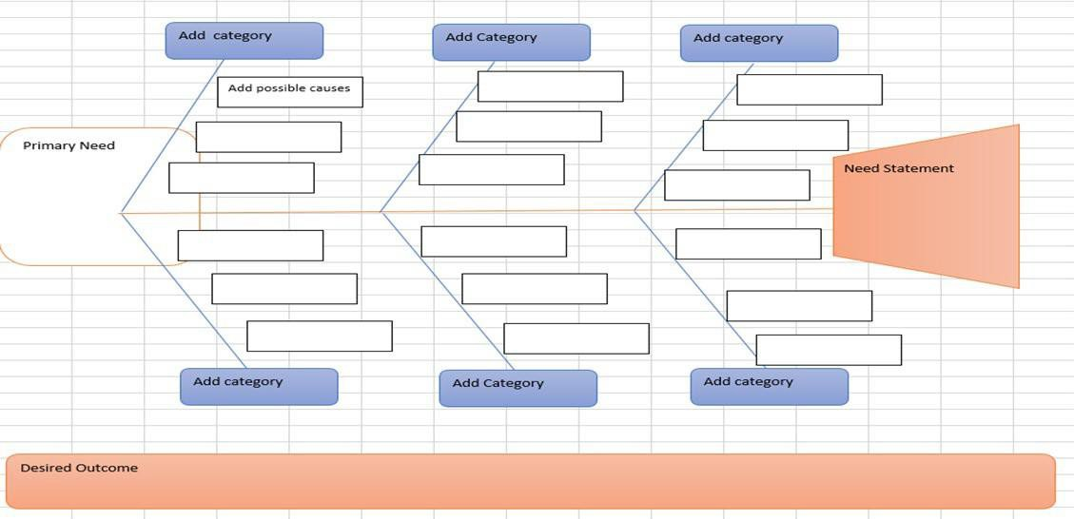

Fishbone Diagram

Root Cause:

22

#### Fishbone Diagram Process Directions: Choose ONE of the primary needs identified in the CNA to address first and write it in the head of the fishbone.

1. The team facilitator asks the team, “How do we know that problem exists? What are the teachers doing? What are the students doing? (see the root cause analysis questions for support with this)
2. The team recorder documents comments on the fishbone grouping items in like categories, for example: teachers, students, curriculum, assessment, etc.
3. After, all ideas are documented on the fishbone. Reread the ideas on the fishbone.
4. Highlight similar items.
5. Look at the highlighted items, what pattern or trend surfaced? That is your root cause.
6. Once the team agrees on the root cause, determine what needs to change to eliminate the root cause---what needs to change is the need statement. To verify you have gotten to the heart of the problem, ask the following:
   1. Is what in the fishbone tail, if it were corrected would the problem continue?
      1. If yes, you need to dig deeper and use the 5 whys.
      2. If no, you found the root cause
7. If you said the problem might continue, you need to dig deeper by asking the 5 whys…asking “Why?” until the root cause has been identified.
8. It often takes three to five whys, but it can take more than five. So, keep going until the team agrees on the root cause.

***Root Cause possible guiding questions:***

* + Would the problem have occurred if the cause had not been present? If no, then it is a root cause. If yes, then it is a contributing cause.
  + Will the problem reoccur as the result of the same cause if the cause is corrected or dissolved? If no, then it is a root cause. If yes, then it is a contributing cause.
  + Will correction or dissolution of the cause lead to similar events? If no, then it is a root cause? If yes, then it is a contributing cause.

***Important note: Focus on causes you can impact, not those out of the school’s control.***

Tips

* + Use the fishbone diagram tool to keep the team focused on the causes of the problem, rather than the symptoms or solutions.
  + Consider drawing your fish on a flip chart or large dry erase board.
  + Make sure to leave enough space between the major categories on the diagram so that you can add minor detailed causes later.
  + When brainstorming causes, consider having team members write each cause on sticky notes, going around the group asking each person for one cause. Continue going through the rounds, getting more causes, until all ideas are exhausted.
  + Encourage each person to participate in the brainstorming activity and to voice their own opinions.
  + Note that the “5 whys” method, below, is often used in conjunction with the fishbone.

**Example:** There are three main parts of the fish: head, body and tail.

In the head, you see the indicator that was identified in the CNA as a **primary need**: “2.4 Our teachers are not implementing evidence based rigorous and relevant instruction” as evidence from classroom observations, lesson plans and the % proficient on AZ Merit, combining the evidence and data was to determine that it was a primary need.

All the causes for teachers not implementing evidence based rigorous and relevant instruction were brainstormed. Target questions guide the work. After brain storming, all ideas were considered, and common trends and patterns identified; then key words or

23

phrases that are in common were highlighted. The **root cause** was identified as Teachers lack solid curriculum and training

* The **needs statement** is, “written evidence-based curriculum implemented with fidelity…”

The Needs statement is restated in a positive and becomes the **desired outcome.**

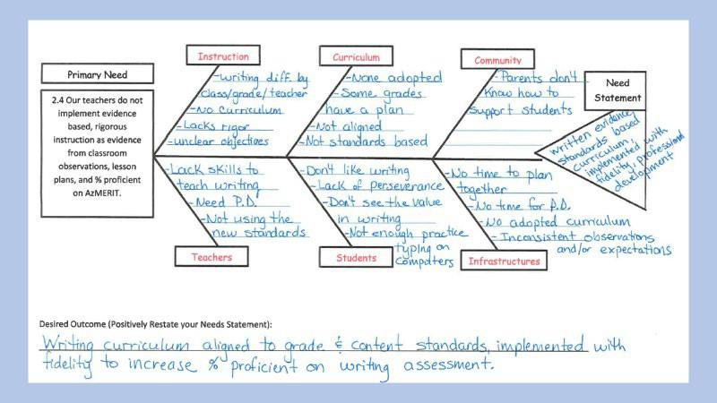

**Root Cause:** Teachers lack solid curriculum and training

**GME Screen Shot**

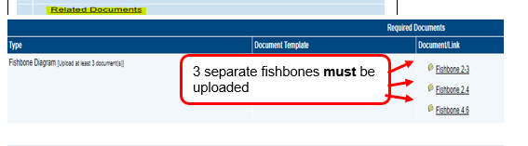

24

**The 5 Why Method**

The 5-Whys is a simple brainstorming tool that can help teams identify the root cause(s) of a problem. Once a general problem has been recognized, ask “why” questions to drill down to the root causes. Asking the “5- Whys” allows teams to move beyond obvious answers and reflect on less obvious explanations or causes.

Step-by-step instructions

* State the problem you have identified as a strategic problem to work on.
* Start asking “why” related to the problem. Like an inquisitive toddler, keep asking why in response to each suggested cause.
* Ask as many “whys” as you need in order to get insight at a level that can be addressed (asking five times is typical). You will know you have reached your final “why” because it does not make logical sense to ask why again.

The “5-Whys” is a strategy that is often used after an issue has been identified using another tool, such as a Fishbone Diagram or Process Mapping. Guard against using the “5-Why” questions on their own to avoid a narrow focus or bias.

This methodology is closely related to the Cause & Effect Fishbone diagram and can be used to complement the analysis necessary to complete a Cause & Effect diagram.

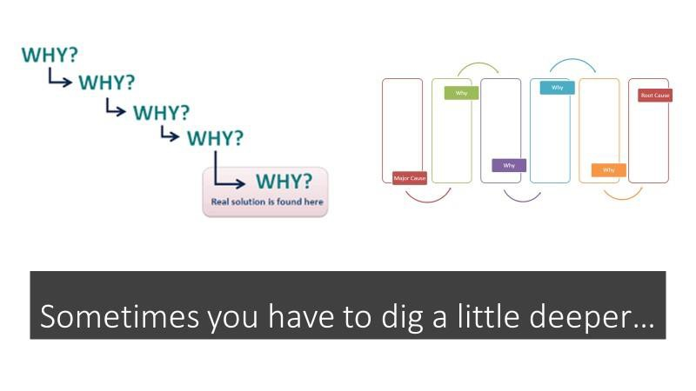

25

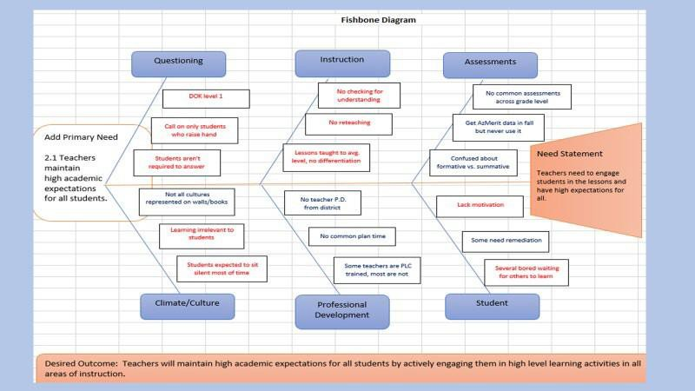

Root Cause:

After conducting the root cause analysis, the need statement is still too general…so digging deeper is necessary

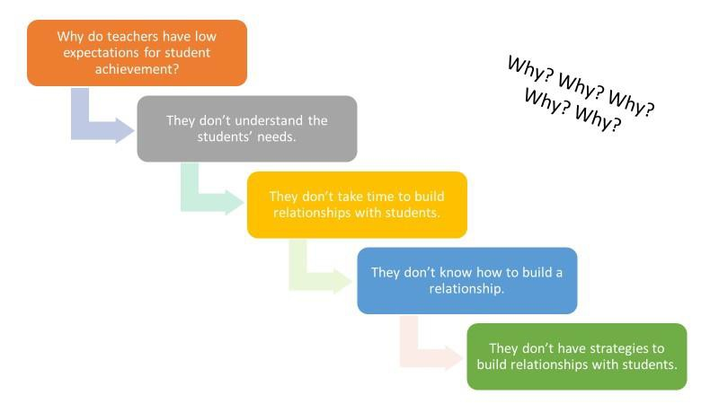

Root Cause

**Tips**

* Try to move on quickly from one question to the next, so that you have the full picture before you jump to any conclusions.
* Be used to complement the analysis necessary to complete a Cause & Effect diagram
* The "5" in 5 Whys is just a ["rule of thumb](https://www.mindtools.com/pages/article/newTMC_79.htm)." In some instances, you may need to go on and ask "why?" a few more times before you get to the root of the problem. In others, you may reach this point before you ask your fifth "why?" If you do, be careful that you've not stopped too soon. The important point is to stop asking "why?" when the useful response stop coming.
* As you work through your chain of questioning, you'll often find that someone has failed to take a necessary action. The great thing about 5 Whys is that it prompts you to go further than just assigning blame, and to ask why that happened. This often points to organizational issues or areas where processes need to be improved.

26

**Integrated Action Plan**

The **Integrated Action Plan (IAP)** is developed based on the School level Comprehensive Needs Assessment (CNA) and should be developed in concert with all applicable stakeholders, with opportunities for meaningful input and feedback from parents and community members, to ensure the plan is reflective of local context and needs.

The **school-level IAP (SIAP)** addresses three or four areas of need identified by the school’s CNA and satisfies the majority of the programmatic requirements of included state and federal grants received by the school in one comprehensive plan. This process serves to integrate and align plans required across grant programs to access state and federal grant resources and ensure a coherent, connected plan for continuous improvement. Current included programs are Title l, ll, lll, lV, MOWR and School Improvement.

The **LEA-level IAP (LIAP)** supports the system’s areas of focus as identified and informed by an LEA’s analysis of school CNAs and school IAPs. This provides the opportunity for the LEA to address and satisfy the majority of the programmatic requirements including state and federal grants received at the LEA level in one plan. School integrated Action Plan (SIAP) and the LEA integrated Action Plan (LIAP) are written annually.

**IAP Requirements:**

* Three or four Need Statements with correlated Desired Outcomes; SMART Goals, if required
* Evidence based Strategies
* Evidence based Action Steps (use appropriate tags are required, funding and program tags
  + Implementation Action Steps
  + Monitoring Action Steps
    - Measures
    - Success Criteria and Evidence
  + Evaluation Action Steps
    - Measures
    - Success Criteria and Evidence

Address only the applicable Principles (all 6 are **not** required) based on CNA, identified three or four Need Statements and Desired Outcomes and any that address additional program area requirements.

Targeted, intentional, focused actions result in real change. A “laundry list” of needs and desired outcomes will dilute focus, scatter efforts and will not result in real change.

27

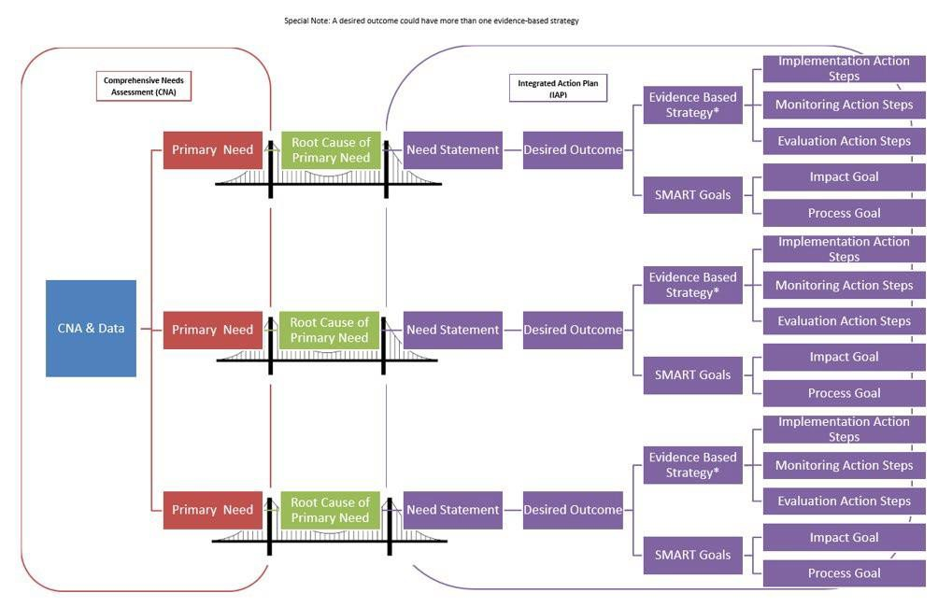

**Integrated Action Plan Diagram**

28

**School Integrated Action Plan (SIAP)**

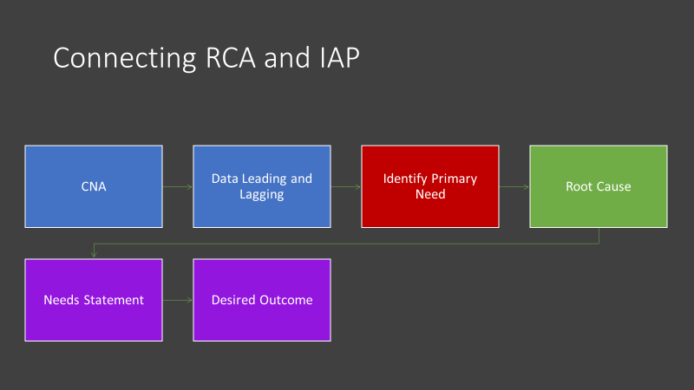

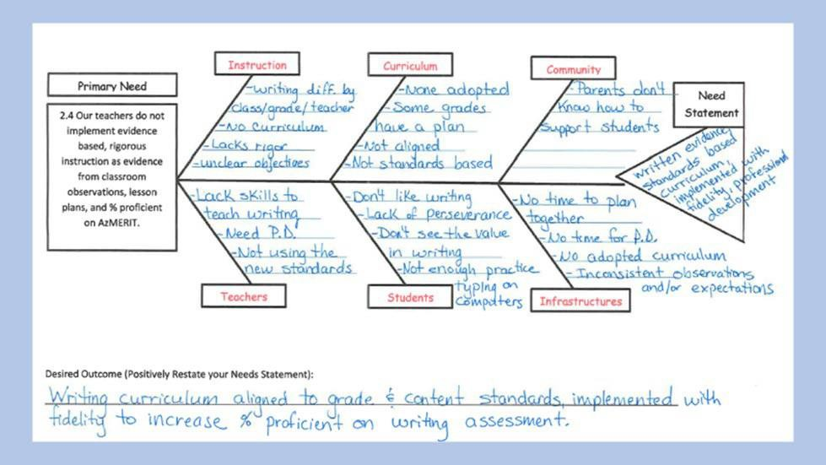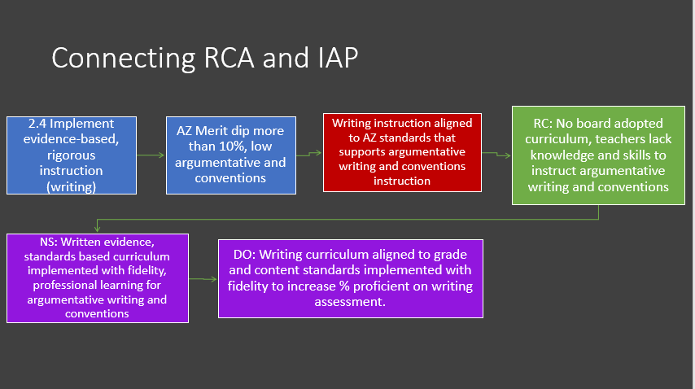

29

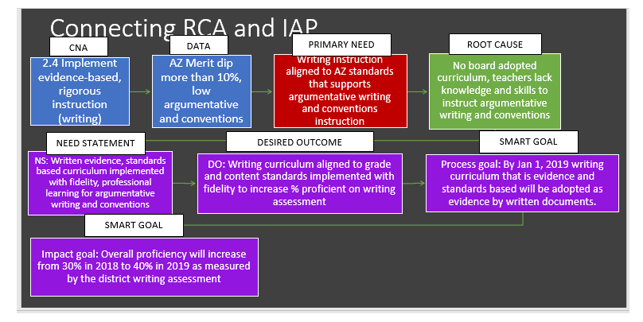

30

## School Integrated Action Plan (SIAP) Process:

* Identify school site writing team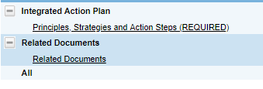
  + School leaders
  + All stakeholders
  + Establish group norms or agreements
* Establish timeline for writing the plan
* For each identified primary need, enter the need statement and desired outcome under the identified Principle
  + Add SMART goals as needed or required
* Starting with the identified specific desired outcomes, backward design the evidence-based improvement strategies and action steps
* Investigate evidence-based programs, strategies or interventions to address each desired outcome; resources available <http://www.azed.gov/improvement/>
  + Generate list of possibilities
  + Investigate possibilities
  + Select evidence-based strategies
* Add selected strategy under appropriate principle
* Develop action steps (using actionable verbs)
  + Implementation action steps
    - Develop clear and comprehensive actionable action steps including who is responsible and the timeline
    - Align resources, funding sources, people and time to action plan
  + Monitoring action steps
    - Determine measures to monitor implementation
      * Collect information to monitor the quality of supports being provided
    - Identify and track progress and performance
      * Consider what additional information is needed to determine if action steps are working
    - Assess the degree to which the implementation plan is being followed with fidelity
    - Is the intervention, strategy, system, or process accomplishing the intended goal/s?
    - Should it be continued, or adjustments made?
  + Evaluation action steps
    - Determine measure/s to evaluate success
    - Determine criteria and evidence of success
    - Use the evidence to determine whether the intervention should continue as is, be modified, or be discontinued
    - Were desired outcomes reached?
    - Were SMART goals met?
    - Ensure coherence and obvious relationships between all need statements, desired outcomes, SMART goals, strategies and action steps.

31

**Sample School Site IAP Worksheet**



**The following is a completed IAP Worksheet example with all required elements**

|  |  |  |
| --- | --- | --- |
|  | **Root Cause**:  Lack of rigor and utilization of data driven instruction by teachers due to lack of knowledge and time for collaboration; lack of administrator/coach feedback and support | |
| **Needs Statement:** (tail of fishbone)  A system of support is needed for teachers to learn and understand rigor and differentiation to ensure data driven, high quality, rigorous lesson development to meet the needs of all students. | |
| **Desired Outcome:** (Needs statement restated in a positive)  Teachers will create and implement rigorous, high quality, differentiated data driven lessons for all students resulting in improved student outcomes | |
| **SMART Goals** (If the primary need is fixed how will your % proficient be affected?)  **Process:** A system of support for teachers will be planned and put into place by November 2019.  **Impact:** Reading achievement for all students will increase by 15% moving from 18% proficient and highly proficient on 2018 AzMERIT to 33% proficient or highly proficient on 2019 AzMERIT. | |
| **Strategy #1:** | **Implementation Action Steps:** |
| Consistent walk through observations and feedback to provide instructional support, improve learning outcomes | * Administrators implement short cycle observation and feedback process * Instructional coaches observe classes on a frequently, scheduled basis * Instructional coaches report observation data/tracker to Principal and District Curriculum Director * Principal shares school wide observation data to improve instruction at staff meetings * Admin Team and Instructional Coaches meet regularly to review walk through data and plan supports as necessary * Admin Team and Instructional Coaches identify instructional focuses based on observation data * Targeted planning with the Instructional Coach and teachers building on short cycle observation/feedback loop |

32

|  |  |  |
| --- | --- | --- |
|  |  | **Monitor Implementation Action Steps**:   * Administrative walk through observation data * Observation data/tracker records * Monitor teacher lesson plans reflect rigor and use of data to drive instruction * Administrative calendars and feedback meeting notes * Coaches’ calendars and meeting notes * Staff meeting agendas * Administrative/coach meeting agendas |
|  | **Evaluation Action Steps:**   * Determine strategy impact by reviewing the following evidence:   + Last quarter lesson plan quality   + Last quarter PLC meeting minutes   + Coaching records   + Teacher evaluations   + Summative achievement data |
| Strategy #2: Develop a System of  Instructional Support to foster student-centered grade-level instruction, provide for time, adequate planning, collaboration and reflection**.** | **Implementation Action Steps:**   * PLC training for all teachers, coaches and administrators * Development of PD calendar with PLC process embedded * Department and Grade-level PLCs will be embedded into the PD calendar on a rotating basis focusing on student achievement; behavior and attendance * Administer end of year surveys for teachers and students-teachers will complete teacher inventory and students will complete student engagement survey * Support new and developing teachers with mentor support in the areas of data analysis, standards-based instructional planning and classroom management |
|  | **Monitor Implementation Action Steps**:   * PLC calendar and minutes * PD calendar * Coaches’ calendars and meeting notes * Staff meeting agendas * Administrative/coach meeting agendas |
|  |  | **Evaluation Action Steps:**   * Survey results * Determine strategy impact by reviewing the following evidence:   + Last quarter lesson plan quality   + Last quarter PLC meeting minutes   + Coaching records   + Teacher evaluations   + Summative achievement data |

33

## LEA Integrated Action Plan (LIAP)

The **LEA IAP** supports the implementation of the SIAP. The LEA IAP is based on:

* + A review of all School CNA results
  + Reflective questioning process and discussion
  + Identification of evidence-based strategies and action steps to support all school/s successful SIAP implementation.
  + Analyze Schools’ Comprehensive Needs Assessment (CNA) data for trends and patterns across schools.

**LEA Guiding Questions**

* + What patterns or trends are evident in student achievement data among the schools?
  + What patterns or trends are evident in student and teacher demographic data?
  + What patterns or trends are evident in the Leading Indicator data?
  + What patterns or trends are evident in the data regarding the 6 Principles?
  + What patterns or trends are evident in the primary needs selected by schools to be addressed in school IAPs?
  + What specific evidence-based strategies, actions and interventions can the LEA implement to support schools to successfully address identified primary needs and desired outcomes?
  + What systems, processes, procedures, operational flexibility can be put in place to support schools in implementation of School Integrated Action Plans?
  + How will these actions be monitored and evaluated? Are we doing what we said we would do? Are we doing it well? Is it impacting students learning and achievement? How do we know?

**Create an LEA integrated action plan with strategies and action steps** that align systems across the LEA to ensure successful school IAP implementation.

* + Three or four Need Statements with correlated Desired Outcomes and SMART Goals, if required based on school IAPs trends and necessary support
  + Evidence based Strategies
  + Evidence based Action Steps (use appropriate tags for required, funded and non- funded activities)
    - Implementation Action Steps
    - Monitoring Action Steps
      * Measures to be used
      * Success Criteria and Evidence
* Evaluation Action Steps
  + Measures to be used
  + Success Criteria and Evidence

34

**Sample LEA Integrated Action Plan Worksheet**

##### Completed LEA IAP with all required elements including schools with similar primary need Example #1

|  |  |  |
| --- | --- | --- |
| SAMPLE  Primary Need #1 | Primary Need: (head of fishbone)  Strong Math Instruction Aligned to Standards | |
| Schools that Display Primary Need:  Arizona Elementary School, Sunburst Elementary School | |
| Root Cause(s):  No adopted math curriculum | |
| Needs Statement(s): (tail of fishbone)  Need a written evidence and standards-based math curriculum implemented with fidelity and professionally learning for evidence-based math instruction (4.2, 4.3, 4.5, 2.2, 2.4, 2.6) | |
| Desired Outcome: (Needs statement restated in a positive)  Evidence and standards-based Math curriculum aligned to grade level and content standards, implemented with fidelity to increase math proficiency on state assessment. | |
| SMART Goals:  Impact (If the primary need is fixed how will your % proficient be affected?)  Math achievement for all students will increase by 15% moving from 0% proficient or highly proficient on 2018 AzMERIT to 15% proficient or highly proficient on 2019 AzMERIT.  Process: Research and select evidence and standards-based Math curriculum aligned to grade level and content standards by November 2019 as evidenced by written recommendation and documentation.  Process: Implementation of evidence and standards-based Math curriculum beginning August 2020 as evidenced by LEA implementation schedule and plan. | |
|  | Strategy: Support | Implementation Action Steps: |
| Research and Adoption of an evidence and standards-based math curriculum. | * Facilitate research of evidence-based programs for elementary school * Help facilitate the ordering of sample materials * Meet with Curriculum Adoption Committee * Support completing Curriculum Rubrics |

|  |  |  |  |  |
| --- | --- | --- | --- | --- |
|  |  |  | * Monitor Implementation Action Steps: * Adoption calendar * Participant roster * Meeting Schedules |  |
|  | * Evaluate Implementation Action Steps: * Adoption of an evidence and standards-based math curriculum by Board * Purchase of all adopted materials - evidence |

35

|  |  |  |  |  |
| --- | --- | --- | --- | --- |
|  |  | Strategy:  Support implementation of the selected evidence-based math instruction. | Implementation Action Steps:  Action Steps:   * Work with Site Principals to create a calendar to roll out implementation * Provide implementation support personnel as needed |  |
|  | Monitor Implementation Action Steps:   * Classroom walkthrough schedules, notes and next steps * Meeting agendas and minutes * Lesson Plans |
|  | Evaluate Implementation Action Steps:   * Evidence of curriculum implementation (with fidelity) * Evidence of site visits and classroom walkthrough and data-based actions taken as a result * Summative achievement data |
| Strategy: Support Consistent high- quality professional development and support for all teachers. | Implementation Action Steps:  Action Steps:   * Schedule PD sessions * Schedule and conduct meetings with site principals to review walkthrough observations and action plans * Attend site PDs to show support for the initiatives * Support sites with funds to conduct peer |
|  | Monitor Implementation Action Steps:   * PD calendar/schedule * Meeting agendas and minutes * PD sign ins * Coaches logs and notes * Peer observation calendar |
|  |  | Evaluate Implementation Action Steps:   * Completion of all PD * Evidence of classroom implementation * Summative achievement data |

36

**LEA IAP SAMPLE #2**

|  |  |  |
| --- | --- | --- |
|  | Schools that Display Primary Need:  Dream Big Middle School, Hope Middle School | |
| Root Cause(s): learning goals are not evident, content is not focused, pacing guides are inadequate | |
| Primary Need #2 | Need Statement: scope and sequence and pacing guides do not include learning goals and do not provide flexibility based on diverse learner needs with content learning progressions reflecting an appropriate scope and sequence with coherence | |
|  | Desired outcomes: Development of scope and sequence with pacing guides that are based on learning goals and provide flexibility based on diverse learner needs with content learning progressions reflecting an appropriate scope and sequence with coherence | |
|  | SMART Goal: (If the primary need is fixed how will your % proficient be affected?)  Math achievement for all students will increase by 15% moving from 0% proficient or highly proficient on 2018 AzMERIT to 15% proficient or highly proficient on 2018 AzMERIT.  Reading achievement for all students will increase by 10% moving from 5% proficient or highly proficient on 2018 AzMERIT to 15% proficient or highly proficient on 2018 AzMERIT. | |
| Strategy: Provide | Implementation Action Steps: |
| Training for Instructional Coaches in Backward Design | * District Leadership will plan PD on Backwards Design Principles * District Leadership will provide training to all instructional coaches and site leadership * District will provide ongoing PD quarterly to monitor Backwards Design Implementation * Create a District Template for Backwards Planning Units |
| Strategy: Teachers train in Backward Design | Implementation Action Steps:   * Create 2 district wide PD days on the calendar for training sites to complete initial training * Provide substitutes for teachers to participate in one full day of training each quarter to plan for instruction for each content area (Math and ELA). |
| Strategy:  Support sites with Backwards Design | Implementation Action Steps:   * Purchase Understanding by Design for each instructional coach and site principal * Purchase Understanding by Design Professional Development workbook for each instructional coach and site principal |

37

|  |  |  |
| --- | --- | --- |
|  | Strategy: Monitor Implementation*for all three strategies above | Action Steps:   * Instructional coaches will collect data on benchmarks/interims to determine unit effectiveness * Instructional coaches will monitor scope and sequence alignment for summer review based on unit plans |
|  |
| Strategy: Evaluate Implementation*for all three strategies above strategy. | Action Steps:   * Evidence: Use of learning goals in lesson plans resulting in increased student achievement on summative assessment |

#### NOTE:

#### When each strategy has separate monitoring and evaluating action steps, they are action steps included in each strategy.

#### When the monitoring and evaluation action steps are for multiple strategies addressing the same Need Statement, they are listed as a monitoring strategy with action steps and an evaluation strategy with action steps.

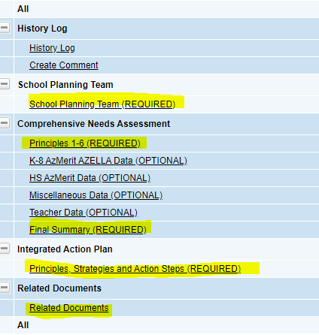**GME Screenshot-LIAP GME Screenshot SIAP**

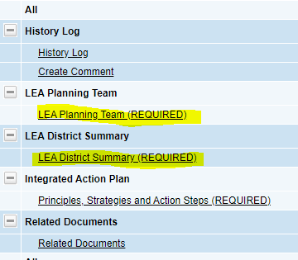

38

## 

## Appendix C Integrated Action Plan Worksheet Templates



***Plan Worksheet Option 1***

|  |  |  |
| --- | --- | --- |
| Primary Need 1 | Primary Need: (head of fishbone) | |
| Root Cause: | |
| Needs Statement: (tail of fishbone) | |
| Desired Outcome: (Needs statement restated in a positive) | |
| SMART Goal:  Process (if appropriate)  Impact (If the primary need is fixed how will your % proficient be affected?) | |
| Strategy: | Action Steps Implementation: |
| Monitoring: |
| Evaluating: |
| Strategy: | Action Steps Implementation: |
| Monitoring: |
| Evaluating: |

39

|  |  |  |
| --- | --- | --- |
| Primary Need 2 | Primary Need: (head of fishbone) | |
| Root Cause: | |
| Needs Statement: (tail of fishbone) | |
| Desired Outcome: (Needs statement restated in a positive) | |
| SMART Goal:  Process (if appropriate)  Impact (If the primary need is fixed how will your % proficient be affected?) | |
| Strategy: | Action Steps Implementation: |
| Monitoring: |
| Evaluating: |
| Strategy: | Action Steps Implementation: |
| Monitoring: |
| Evaluating: |

40

|  |  |  |
| --- | --- | --- |
|  | Strategy: | Action Steps Implementation:  Monitoring: Evaluating: |
| Primary Need 3 | Primary Need: (head of fishbone) | |
| Root Cause: | |
| Needs Statement: (tail of fishbone) | |
| Desired Outcome: (Needs statement restated in a positive) | |
| SMART Goal:  Process (if appropriate)  Impact (If the primary need is fixed how will your % proficient be affected?) | |
| Strategy: | Action Steps Implementation: |
| Monitoring: |
| Evaluating: |
| Strategy: | Action Steps Implementation: |
| Monitoring: |
| Evaluating: |

41

|  |  |  |  |  |  |  |
| --- | --- | --- | --- | --- | --- | --- |
| Put all this information in the principle summary box in ALEAT for your Target Principle | Primary Need: (head of fishbone) | | | | | |
| Root Cause: | | | | | |
| Needs Statement: (tail of fishbone) | | | | | |
| Desired Outcome: (Needs statement restated in a positive) | | | | | |
| SMART Goal:  Process (if appropriate)  Impact (If the primary need is fixed how will your % proficient be affected?) | | | | | |
| Strategy 1: Title: Narrative: | | Action Step Title | Action Step Narrative | Start-End Dates | Person Responsible | Data to Collect |
| Implementation: |  |  |  |  |
|  |  |  |  |  |
| Monitoring: |  |  |  |  |
| Evaluating: |  |  |  |  |

42

|  |  |  |  |  |  |  |
| --- | --- | --- | --- | --- | --- | --- |
| Put all this information in the principle summary box in ALEAT for your Target Principle | Primary Need: (head of fishbone) | | | | | |
| Root Cause: | | | | | |
| Needs Statement: (tail of fishbone) | | | | | |
| Desired Outcome: (Needs statement restated in a positive) | | | | | |
| SMART Goal:  Process (if appropriate)  Impact (If the primary need is fixed how will your % proficient be affected?) | | | | | |
| Strategy 2: Title: Narrative: | | Action Step Title | Action Step Narrative | Start-End Dates | Person Responsible | Data to Collect |
| Implementation: |  |  |  |  |
|  |  |  |  |  |
| Monitoring: |  |  |  |  |
| Evaluating: |  |  |  |  |

43

|  |  |  |  |  |  |  |
| --- | --- | --- | --- | --- | --- | --- |
| Put all this information in the principle summary box in ALEAT for your Target Principle | Primary Need: (head of fishbone) | | | | | |
| Root Cause: | | | | | |
| Needs Statement: (tail of fishbone) | | | | | |
| Desired Outcome: (Needs statement restated in a positive) | | | | | |
| SMART Goal:  Process (if appropriate)  Impact (If the primary need is fixed how will your % proficient be affected?) | | | | | |
| Strategy 3: Title: Narrative: | | Action Step Title | Action Step Narrative | Start-End Dates | Person Responsible | Data to Collect |
| Implementation: |  |  |  |  |
|  |  |  |  |  |
| Monitoring: |  |  |  |  |
| Evaluating: |  |  |  |  |

44

## Appendix D Evidence-based Practices, Strategies and “Interventions”

**Resources for Evidence-Based Strategies**

### NEW RESOURCE AVAILABLE HERE: [ESSA-Evidence Based Requirements and Resources](https://cms.azed.gov/home/GetDocumentFile?id=5c86bb871dcb250c085f15c3)

*Searchable data base of evidence-based programs, practices and interventions*

The Every Student Succeeds Act (ESSA) states that evidence-based “means an activity, strategy, or intervention that demonstrates a statistically significant effect on improving student outcomes or other relevant outcomes based on

**Strong** evidence from at least one well-designed and well-implemented experimental study; **Moderate** evidence from at least one well-designed and well-implemented quasi experimental study;

**Promising** evidence from at least one well-designed and well-implemented correlational study with statistical controls for selection bias;

or Demonstrates a rationale based on high-quality research findings or positive evaluation that such activity, strategy, or intervention is likely to improve student outcomes or other relevant outcomes; and (II) includes ongoing efforts to examine the effects of such activity, strategy, or intervention.

Integrated Action Plans are required to be evidence-based and may use any level of evidence indicated above. Funding for the 7% Title I set aside for school improvement must be used for interventions meeting only the top three tiers of evidence (strong, moderate, promising).

**Evidence for ESSA** Johns Hopkins University/Center for Data-Driven Reform in Education <http://www.evidenceforessa.org/>

This website provides information on programs and practices that meet each of the top three ESSA levels in a given subject and grade level (e.g., secondary math, elementary reading). It includes brief program descriptions, information on costs, availability, and other pragmatics, and links to program web sites. You can refine a search to look for programs that have been successful with particular populations (e.g., English learners, special education), communities (e.g., urban or rural), and other special interest areas. You can also search by program name, enabling you to find information about evidence for all programs, including those that have not yet been successfully evaluated. The website currently contains information on reading and math programs in grades K-12.

Additional topics will be added in the future, and the website will be continually updated to include new programs and to reflect new evaluations.

**What Works Clearinghouse**, developed by the Institute of Education Sciences (IES) (not categorized in ESSA evidence tiers; studies included here meet only most rigorous evidence criteria) <https://ies.ed.gov/ncee/WWC/>

45

**Learning Policy Institute**

[https://learningpolicyinstitute.org/product/evidence-based-](https://learningpolicyinstitute.org/product/evidence-based-interventions) [interventions](https://learningpolicyinstitute.org/product/evidence-based-interventions)

Achieving an equitable school system that leads to meaningful, relevant, and engaging learning opportunities for all children will require that states, districts, and schools undertake the different tasks—such as curriculum design, access to materials, and educator development—that will enable students to develop much richer learning supported by quality instruction. This resource examines the options available to states to redefine their accountability systems as they begin to implement the Every Student Succeeds Act (ESSA). It analyzes the research base and identifies the conditions under which they have shown to be effective. The four program areas identified in this resource are: high-quality professional development, class-size reduction, community schools and wraparound services, and High School redesign.

### Promising Practices Network on Children, Families and Communities

<http://www.promisingpractices.net/resources_highschoolgrad.asp>

This website began as a partnership between four state-level organizations to improve the well- being of children and families. The Promising Practices Network (PPN) funding has concluded, so the website has been archived and materials have not been updated since 2014.

The PPN site features summaries of evidence-based programs and practices that are proven to improve outcomes for children. All programs have been reviewed for quality and to ensure that they have evidence of positive effects.

Programs are assigned to one of three category levels: Proven, Promising, or Other Reviewed Programs. The Programs that Work section can be browsed in several ways: by outcome area by indicator

by topic

by evidence level alphabetically

PPN relied on publicly available information for reviewing a program’s effectiveness and was interested in programs as they were designed and evaluated. Programs were assigned a “Proven” or “Promising” rating, depending on whether they met the evidence criteria. The “Other Reviewed Programs” are ones which did not undergo a full review by PPN, but evidence of their effectiveness has been reviewed by one or more credible organizations that apply similar evidence criteria.

Evidence Criteria

* Types of Outcomes Affected Substantial Effect Size Statistical Significance Comparison Groups
* Sample Size
* Availability of Program Evaluation Documentation

46

**Best Evidence Encyclopedia,** developed by the Center for Data Driven Reform in Education at Johns Hopkins University (not categorized in ESSA evidence tiers) <http://www.bestevidence.org/>

The Best Evidence Encyclopedia (BEE) is a free web site created by the Johns Hopkins University School of Education's Center for Data-Driven Reform in Education (CDDRE) under funding from the Institute of Education Sciences, U.S. Department of Education. It is intended to give educators and researchers fair and useful information about the strength of the evidence supporting a variety of programs available for students in grades K-12. The BEE provides summaries of scientific reviews produced by many authors and organizations, as well as links to the full texts of each review. The summaries are written by CDDRE staff members and sent to review authors for confirmation. Program reviews include; Mathematics, Reading, Science Early Childhood and Comprehensive School Reform.

### National Center on Intensive Intervention at American Institutes for Research

<http://www.intensiveintervention.org/>

This website provides information on data-based individualization (DBI), a research-based process for individualizing and intensifying interventions through the systematic use of assessment data, validated interventions, and research- based adaptation strategies.

**Results First Clearinghouse Database**, developed by the Pew Charitable Trusts (not categorized in ESSA evidence tiers; evaluates interventions as rated by eight national databases) [http://www.pewtrusts.org/en/research-and-analysis/issue-](http://www.pewtrusts.org/en/research-and-analysis/issue-briefs/2014/09/results-first-clearinghouse-database) [briefs/2014/09/results- first-](http://www.pewtrusts.org/en/research-and-analysis/issue-briefs/2014/09/results-first-clearinghouse-database) [clearinghouse-database](http://www.pewtrusts.org/en/research-and-analysis/issue-briefs/2014/09/results-first-clearinghouse-database)

This website includes a downloadable excel spreadsheet of compiled interventions by: category, policy area, intervention type and rating. The intervention rating included is based on a compilation of data from eight different clearinghouses. A direct link to the intervention website is also included in the downloadable spreadsheet. This is a great starting place to find interventions, as well as a quick check to see if interventions being used are considered effective.

**Roadmap to Evidence Based Reform** for Low Graduation Rate High Schools, developed by the Every Student Graduates Center at Johns Hopkins University [http://new.every1graduates.org/everyone-graduates-center-roadmap-to-evidence-](http://new.every1graduates.org/everyone-graduates-center-roadmap-to-evidence-based-reform-for-low-graduation-rate-high-schools/) [based- reform-for-low-graduation-rate-high-schools/](http://new.every1graduates.org/everyone-graduates-center-roadmap-to-evidence-based-reform-for-low-graduation-rate-high-schools/) The Everyone Graduates Center provides a roadmap to evidence-based reform for low graduation high schools.

Resources include full reports, presentations, and teacher resources- all focused on addressing the dropout crisis.

**RAND report on school leadership interventions under ESSA** (categorized in ESSA evidence tiers) [http://www.wallacefoundation.org/knowledge-center/Documents/School](http://www.wallacefoundation.org/knowledge-center/Documents/School-Leadership-Interventions-ESSA-Evidence-Review.pdf)- [Leadership-](http://www.wallacefoundation.org/knowledge-center/Documents/School-Leadership-Interventions-ESSA-Evidence-Review.pdf) [Interventions-ESSA-Evidence-Review.pdf](http://www.wallacefoundation.org/knowledge-center/Documents/School-Leadership-Interventions-ESSA-Evidence-Review.pdf)

The Every Student Succeeds Act (ESSA) presents a renewed focus on school leadership and acknowledges the importance of school principals to school improvement and effective instruction. ESSA repeatedly calls for the use of evidence-based activities, strategies, and interventions and establishes a framework with tiers of evidence when considering their proven impact on student success. This represents a shift in thinking regarding the justification of funds

47

tied to Title funding, particularly as it relates to supporting school leadership. This report seeks

to resolve some of the ambiguity that may still exist as states, districts, and schools seek to determine if activities qualify as evidence-based and therefore allowable.

**Using Evidence to Create Next Generation High Schools**, developed by the U.S. Department of Education (not categorized in ESSA evidence tiers) [https://www2.ed.gov/rschstat/eval/high-school/using-evidence-](https://www2.ed.gov/rschstat/eval/high-school/using-evidence-create-next-gen-highschools.pdf) [create-next-gen-](https://www2.ed.gov/rschstat/eval/high-school/using-evidence-create-next-gen-highschools.pdf) [highschools.pdf](https://www2.ed.gov/rschstat/eval/high-school/using-evidence-create-next-gen-highschools.pdf)

Next Generation High Schools are schools that redesign the high school experience to make it more engaging and worthwhile for high school students. In order to create such Next Generation High Schools, schools, districts, and States should utilize evidence- based strategies to transform high schools in ways that engage students and help prepare them for college and career success. Evidence-based strategies encompass a variety of approaches.

This document highlights six general evidence-based strategies to improve America’s high schools for the next generation. Though many of the effective strategies may share common features, each has been identified by the research literature as a stand-alone intervention or model for improving students’ educational outcomes. Reviewed strategies for enhancing students’ high school and college outcomes include: 1) participation in rigorous curriculum; 2) small learning communities/small schools of choice; 3) career academies; 4) dual enrollment;

5) early college high schools; and 6) college and career counseling.

*Guidance can be found on the School Support and Improvement Webpage*

<http://www.azed.gov/improvement/>

## <http://www.azed.gov/improvement/evidence-based-practices/>

#### Searchable data base of evidence-based programs, practices and interventions

48

## Appendix E Evidence Based Summary Form



LEA Grade

LEA Community

* Preschool
* Elementary

☐Middle School

* Urban
* Rural
* Suburban

□ High School

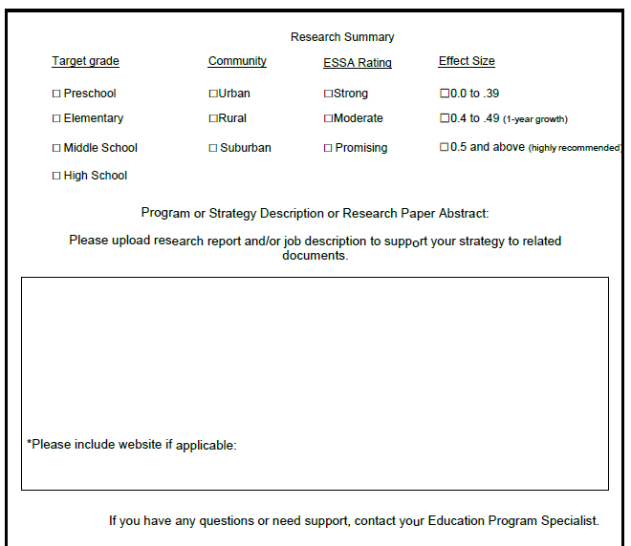

49

## Appendix F Targeted Support and Improvement LEA Programmatic Assurances

**The LEA assures for each TSI School**

☐ Complete and submit a School Comprehensive Needs Assessment (CNA) in ALEAT

☐ Complete and submit a thorough root cause analysis (RCA) for CNA identified primary needs and upload them into ALEAT

☐ Complete SIAP with all required elements in ALEAT

☐Each SIAP includes meaningful evidence-based interventions to improve student achievement

☐ Monitor and Update the SIAP quarterly by adding, deleting or retiring strategies and action steps

**The LEA assures**

☐ Complete analysis of TSI School CNAs and RCAs

☐The LIAP has all required elements in ALEAT

☐The LIAP includes meaningful evidence-based interventions to improve student achievement

□A system to monitor, update retire or add strategies and action steps to the LIAP in ALEAT at least quarterly

☐Systems, processes, procedures, including operational flexibility are in place to actively to support Targeted Support and Improvement Schools

☐Effective organization of time for weekly professional learning communities (PLCs)

☐A balanced assessment system including common interim/benchmark assessments administered at least three times a year.

☐ Use of an observation and feedback protocol implemented with fidelity

☐A LEA contact person who will oversee implementation activities, maintain contact with School Support and Improvement (SI) staff

☐I understand if the conditions herein are not adhered to or sufficient progress is not being made, a corrective action plan may be written and implemented LEA has written procedures to implement the requirement to minimize the time elapsing between receipt and expenditure of federal funds.

☐ LEA has written procedures for determining the allowability of costs

☐Submit quarterly reimbursement requests

☐The LEA has written methodology to distribute state and local funds to its schools without regard to schools’ Title l status.

☐I understand that at any time during the grant period, funds can be discontinued for lack of monthly reimbursement requests with evidence of use; misuse of funds or lack of evidence of IAP implementation on the part of the school and/or LEA.

☐I understand if the conditions herein are not adhered to or sufficient progress is not being made, a corrective action plan will be written and implemented

Signed this day by

(print name/title)

(LEA name) ensuring that the above is accurate and has or will occur.

50