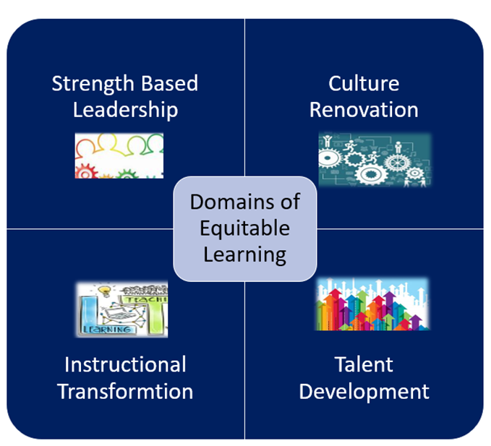
FY25 Comprehensive Support and Improvement Grants
Arizona Department of Education School Support and Improvement
FY25 Comprehensive Support and Improvement Grant- Low Achievement/Graduation (CSI LA/G)
Purpose

Our goal is to provide funding to enable the implementation of evidence-based strategies and action steps that are closely aligned with our mission to enhance student achievement and graduation rates.

The grant application will be reviewed for completeness and thoroughness. Please use the checklist provided in the application to ensure your application has all the necessary components.

Eligibility

Schools eligible for assistance under this grant are schools identified as CSI Low Achievement School and/or CSI Low Grad Rate.

Due date

Due May 31, 2024. Awards notifications will be sent the week of July 1, 2024.

Application Process

Please complete all sections in GME
- Program Details
  - Contact Information
  - Narrative questions
  - Assurances
  - FFATA/GSA Verification
  - General Education Provision Act (GEPA)
- Budget with narrative description of funded item(s) and costs
  - Funded strategies, practices and programs must meet the top three tiers of ESSA evidence.
  - Check with your specialist if you have questions or need assistance building your budget.
- Required Related Documents
  - Signature Page
- Application completion with all required documents and evidence in GME by May 31, 2024

Contact Information
Please be sure to include all the information in GME.

LEA/Charter Name | NCES ID# |  | CTDS# |  | Entity ID#
Board President | Email
Superintendent/Charter Holder | Email |  |  |  | Phone #
Federal Programs Director | Email |  |  |  | Phone #
Other- Title | Email |  |  |  | Phone #
School Name |  | NCES ID# |  | CTDS# | Entity ID#
Principal |  | Email |  |  | Phone #

Program Narrative Questions

Please collaborate with your team to write a detailed response to the following grant narrative questions. We are here to support you every step of the way.

- Tracking the Journey

Please list the goals that are being set for this project, the frequency in which the goals will be monitored and the data you will use to determine success in accomplishing your academic achievement and/or graduation rate goals.

Goal | With what frequency will the goals be monitored? | Data Used to Determine Success

- Turning Plans into Action:

Please describe how your grant funded item will support your goals.

Grant Funded Item |  | Desired Result

- Planting Seeds for the Future:
Please describe how successful implementation of grant funded goal(s) will continue when the grant funding ends.
Narrative response:

- LEA Support for Success (a TEAM Sport): This should be completed by the LEA

Please share the LEA's strategy for both supporting and ensuring the success of school’s grant funded strategies and action steps. Please be sure to include the concrete steps, individuals responsible, the expected timelines, and ways you plan to measure outcomes.

Narrative response:

Required Related Documents-Signature Page

Signatures below denote commitment to implementation, monitoring, and evaluation of strategies and action steps outlined in the IAP and the grant application.

Superintendent Name (print):

Superintendent Signature: Date

Charter Holder Name (print)

Charter Holder Signature: Date

Board President Name:

Board President Signature: Date

CSI LA/G Grant Allowable Expenditures

- Please remember to follow the ESSA evident practices to ensure funded items are allowable. We are here to help, so please work with your EPS
- Cost of approved program
- Related travel costs
- Cost of any required program, contracted service, coach, mentor, etc.
- Off contract pay above and beyond duties necessary to job function), planning committees, researching evidence-based interventions, curricula, assessments (aligned to CNA)
  - Board approved hourly rate paid, must be reasonable
  - Requires time and effort logs

As a friendly reminder, please be sure to follow your district’s fiscal policies/procedures. Additionally, please ensure that if awarded grant funding, the following best practices are highly encouraged:
  - Receive EPS approval for revisions prior to implementing any change in spending or program.
  - Submit timely, dated revisions for any fiscal or programmatic change.
  - In accordance with sound accounting practices, it is important for LEAs to request timely reimbursements.

CSI LA/G Grant Assurances
- Complete and submit School Comprehensive Needs Assessment (CNA) in GME.
- Develop LEA and School (for each school in improvement) Integrated Action Plan (L/SIAP), aligned to the CNA in GME.
- Funded strategies, practices and programs will meet the top three tiers of ESSA evidence.
- Ensure the use of high impact strategies to increase student achievement, such as, high quality professional learning communities (PLC), written evidence and standards-based curriculum, and balanced assessment systems.
- Ensure systems, processes, procedures, including operational flexibility are in place to actively support Comprehensive Support and Improvement Schools.
- Identify an LEA contact person who will oversee implementation activities, maintain contact with School Support and Improvement (SSI) staff, and accompany ADE FSI staff during site visits at the school upon request.
- Complete and submit EDFacts data when requested by ADE.
- LEA has written procedures and processes to:
  - minimize the time elapsing between receipt of funds and drawing down of funds
  - determine the allowability of costs
  - determine distribution of funds
  - draw down funds quarterly (at minimum)
- Ensure LEA and school leadership does their due diligence to follow all district and organizational guidelines regarding budget expenditures to ensure proper documentation is maintained.
- Ensure all budget expenditures are reasonable and necessary to support the identified needs of the school and address any programmatic needs. This includes but is not limited to benefits, out of state travel and consultant fees.
- Ensure any programs, practices or interventions that are grant funded meet the top 3 tiers of ESSA (strong, moderate, and promising)
- I understand that at any time during the grant period, funds can be frozen or forfeited with the misuse of funds; or lack of evidence of the IAP implementation on the part of the school and/or LEA.
- I understand if the conditions herein are not adhered to or sufficient progress is not being made, a corrective action plan may be written and implemented.

