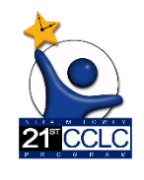
Nita M. Lowey 21st Century Community Learning Centers
(21st CCLC) Grant
FY 2025 Continuing Application- Word Version

Funding Disclaimer
The Grantee acknowledges and agrees that the Arizona Department of Education’s award and/or payment of funds under this agreement is contingent upon ADE receiving funds from Federal, State, or other funding sources to support the grant. Notwithstanding any other provisions of this agreement, in the event that ADE funding is reduced or rescinded by Federal, State, or other funding sources, ADE may immediately reduce the amount of funds awarded or terminate this agreement by written notice to the Grantee.
FFATA & GSA Verification
- The district/organization has submitted OR will be submitting the annual General Statement of Assurance. Yes or No

- The district/organization understands that if ADE is not updated with the organization's SAM.gov information, including CCR expiration, that funding for the organization can be placed on hold. Yes or No

- Please provide a short description of your project in one to two paragraphs:

General Education Provisions Act (GEPA)
GEPA – Section 427 Requirements
EQUITY FOR STUDENTS, EDUCATORS, AND OTHER PROGRAM BENEFICIARIES
Section 427 of the General Education Provisions Act (GEPA) (20 U.S.C. 1228a) applies to applicants for grant awards under this program.
To address this provision and receive funding, LEAs must provide responses to the following:
- Describe how your entity’s existing mission, policies, or commitments ensure equitable access to, and equitable participation in, the proposed project or activity. Applicants are not required to have mission statements or policies that align with equity in order to submit an application.

- Based on your proposed project or activity, what barriers may impede equitable access and participation of students, educators, or other beneficiaries? Applicants may identify any barriers that may impede equitable access and participation in the proposed project or activity, including, but not limited to barriers based on economic disadvantage, gender, race, ethnicity, color, national origin, disability, age, language, migrant status, rural status, homeless status or housing insecurity, pregnancy, parenting, or caregiving status, and sexual orientation.

- Based on the barriers identified, what steps will you take to address such barriers to equitable access and participation in the proposed project or activity?

- What is your timeline, including targeted milestones, for addressing these identified barriers?

Program Information / Instruction
Year 1 of the 21st CCLC Grant is competitive, and Years 2-5 are continuing based on maintaining substantial compliance and program eligibility requirements.
In the event that anticipated funding is decreased, a proportional decrease may be made to all awardees.
All funding is contingent upon receipt of federal funds.
The guidance for the continuing application is located in the Resource Library in the Grants Management System and on the 21st CCLC Required Reporting website located at http://www.azed.gov/21stcclc/required-reporting/. Review the guidance carefully before submitting the continuing application.
Complete a budget for each site within the funding application. Before submitting the 21st CCLC application, applicants MUST contact their Finance & Accounting Office for guidance on developing the budget and for information on the most current budget coding. In addition, 21st CCLC applicants MUST consult their Human Resources Office for guidance on Salary Placement Schedules and Hiring Procedures.
21st CCLC Continuing Important Dates and Deadlines for FY25
-- Project Start Date: July 1, 2024
-- Project End Date: June 30, 2025
-- ORIGINAL Application Submission Deadline: May 29, 2024
-- Revision Submission Deadline: June 1, 2025
-- Reimbursement Request Deadline: All Reimbursement Requests must be submitted and approved PRIOR to the project end date. (Please contact your Education Program Specialist for any programmatic stipulations surrounding the reimbursement period). Reimbursement Request deadlines will be set, as applicable, based on ADE/ADOA accounting requirements for the fiscal year and/or project end dates.
-- Completion Report Due Date: September 28, 2025
Questions regarding dates and deadlines, (with the exception of reimbursement request deadlines), should be directed to your assigned 21st CCLC Education Program Specialist or the 21st CCLC Inbox at 21stCCLCInbox@azed.gov.

Contact Information / District/Charter Holder Level
Contacts (District Level)
General Information and Contact Information: Contact at your organization who should receive all 21st CCLC updates from ADE and can forward information to the appropriate people within their organization.
1. Name:
2. Title:
3. Street Address:
4. Mailing Address:
5. City:
6. State:
7. Zip Code:
8. Phone Number:
9. Email Address:

Capital Outlay Worksheet
A Capital Outlay Worksheet is required when an organization enters items in any capital codes within the funding application’s Budget page. For Districts, the codes are 6731-6739. For Charters, the code is 0190. Contact the Grants Management Department for technical assistance.

Budget
Complete a budget for each site within the funding application. Before submitting the 21st CCLC application, applicants MUST contact their Finance & Accounting Office for guidance on developing the budget and for information on the most current budget coding. In addition, 21st CCLC applicants MUST consult their Human Resources Office for guidance on Salary Placement Schedules and Hiring Procedures.
The Arizona Auditor General website is https://www.azauditor.gov/ for USFR Chart of Accounts for School Districts and USFRCS for Charter Schools and other important fiscal resources.

Contact Information (School/Site Level)
Contacts (Site Level): General Information and Site Contact Information
- Site Name:
- Name of Site Principal:
- Site Street Address:
- Site Mailing Address:
- Site City:
- Site State:
- Site Zip Code:
- Site Phone Number:
- Site Email Address:
- Name(s) of Site Coordinator(s):

Program Narrative Questions
Program Plan
21st CCLC Data will be collected in each site’s Student Information System (SIS) and other required reports (Summary of Classes Report, Annual Performance Report, Site Evaluation Report, etc.).
The Continuing Application will collect information about the next fiscal year.
Enter budget information in the Budget section of the Continuing Application. Be sure to utilize your business office and internal auditors when developing the budget.
Enter any proposed changes to the 21st CCLC program in the Program Narrative Questions section of the Continuing Application.
- Describe any changes in the 21st CCLC program as identified in your original application or previous continuing applications for the upcoming year. All changes must be pre-approved by your assigned Education Program Specialist. If there are no changes then enter, “No changes for the upcoming year.”

Related Documents (School/Site Level)
The FY25 AFFIRMATION OF TIMELY/MEANINGFUL ONGOING CONSULTATION AND EQUITABLE SERVICES document should be uploaded in the Related Documents (District/Charter Holder Level) section of the continuing application.

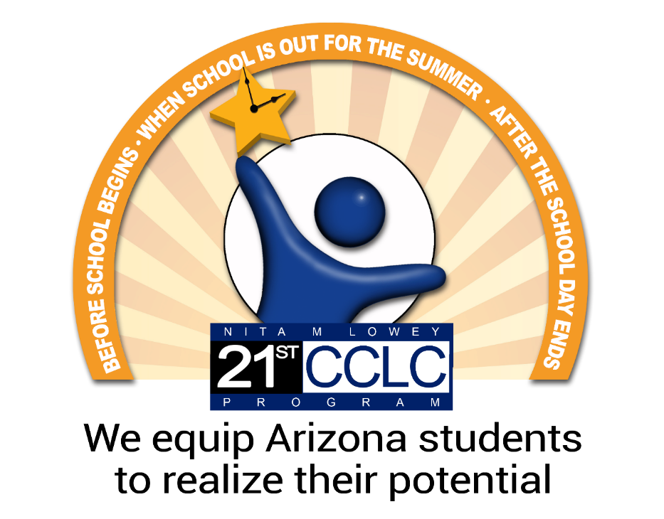
The Nita M. Lowey 21st Century Community Learning Centers (21st CCLC) Title IV-B Program is funded by a federal grant from the U.S. Department of Education and administered by the Arizona Department of Education. For more information visit: https://www.azed.gov/21stcclc/
The Arizona Department of Education is a service organization committed to raising academic outcomes and empowering parents.

