Completing the Success Gaps Rubric & Action Plan Activity:

Initial Submission

Success Gaps Rubric (SGR)

Step #1:
After assembling your SSIP Team with members consisting of a variety of perspectives in the learning community, begin by documenting your team members and by reviewing the guidance for the initial completion of the activity with fidelity. Beyond the directions, examples have been provided with screenshots and videos that can be used at the SSIP Team’s discretion.
- Examples:
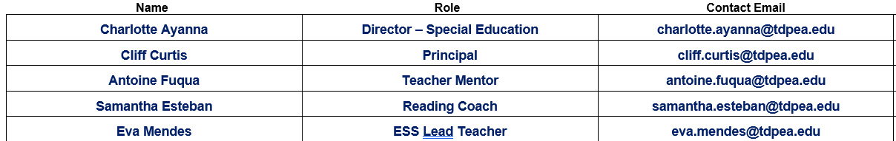

Step #2:
Read the Description of the first system Indicator. Then, one-at-a-time, discuss each strand of Evidence for Consideration. Discuss how each strand of evidence-based practices can be observed in your community, the extent to which the learning community currently implements each practice, and how you should document that strand in the Evidence section.
- Example:
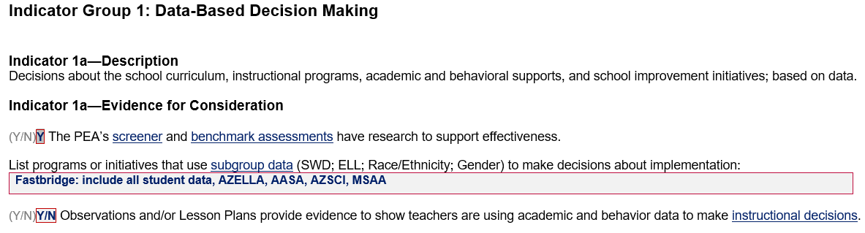
If any of the strands of evidence would benefit from clarification, and especially concerning fidelity if any strand fields were left blank, use the Notes section at the bottom of each indicator to refence that evidence strand for consideration.
- Example:

Step #3:
After the SSIP team has discussed each strand of Evidence for Consideration, review each level of implementation and decide as a team which level would most appropriately fit the current level of implementation in your learning community. Document your learning community’s current level in the first line of the submission periods.
- Example:
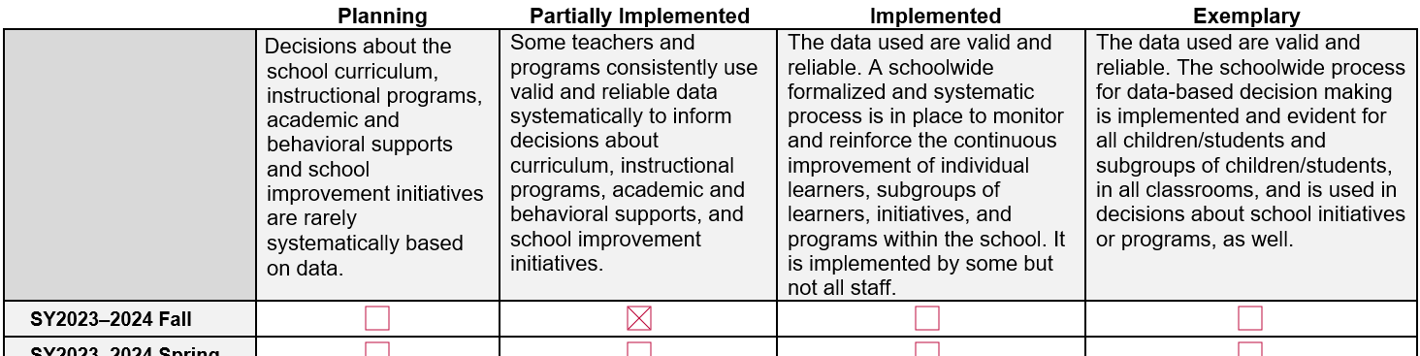

Step #4:
After the SSIP Team completes all 15 system indicators, talk about the systems that currently have the highest and lowest levels of implementation in the learning community. For the indicators with the lowest levels, make sure that the discussions include the evidence-based practices that support the level, the capacity for change, the connection to any current initiatives, and which may be targeted with an initiative toward a higher level of implementation.

The Action Plan (AP)
With your SSIP Team, transition to the documentation of initiative(s) on the AP.

Step #1
Begin by reviewing the guidance for initial completion of the activity with fidelity.
- Examples:

Step #2
For Action #1, target a system indicator from the SGR that has one of the lowest levels of implementation from the SGR (ref: SGR: Step #4). Including the language for level of implementation and document the current level and goal level from the SGR.
- Example:
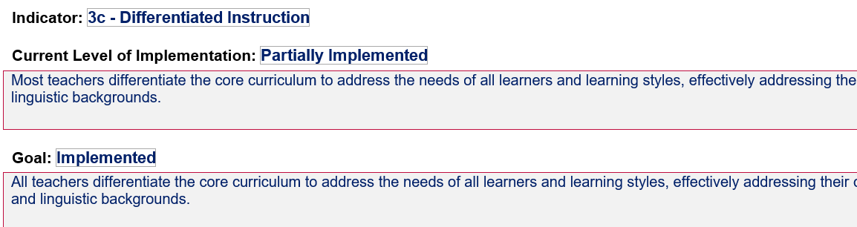
Step #3
While considering the evidence-based practices that support the system, people responsible, progress monitoring data collection, potential barriers, and necessary resources in mind, the team can discuss and document the initiatives steps and other considerations that will take the learning community from the current to goal level.
- Examples:
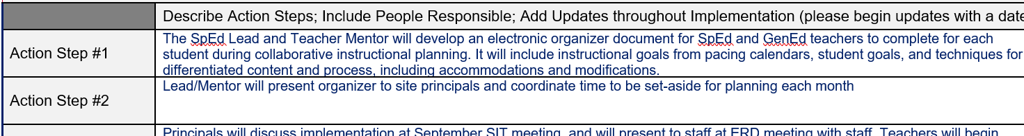
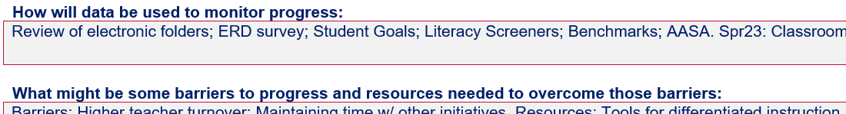

Step #4
As capacity and documentation allow, repeat Steps #1-3 for additional Action Plan initiatives.

