Practitioners of English Language Learning (PELL)
Intentional Practices for EL Funding

Federal Regulations: Notes:

Title III (program)

Title III Funds: Professional Development and Family Engagement

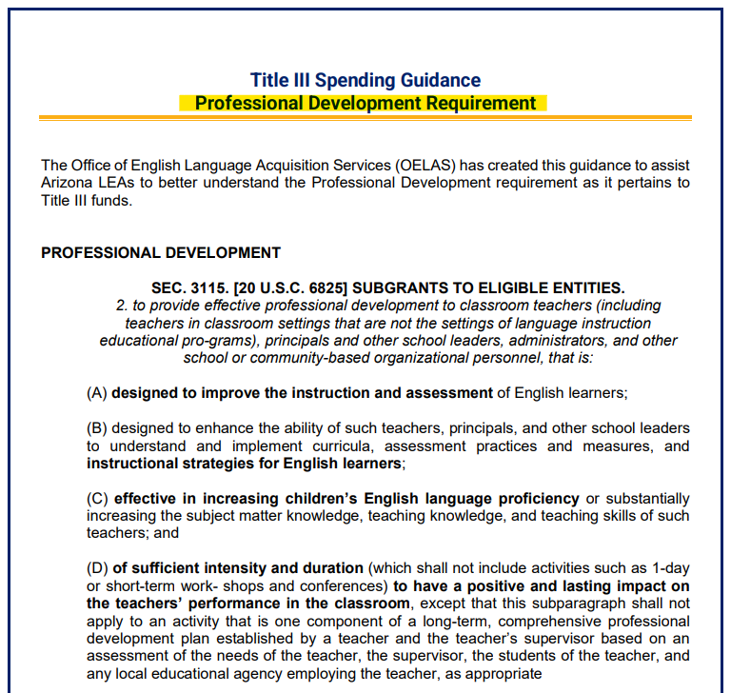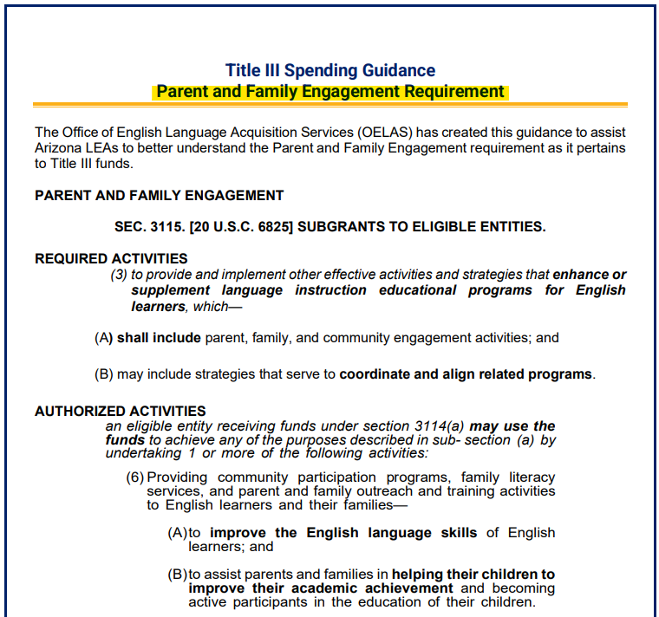

Compliance and Effectiveness Cycle: Notes:

Cycle Components:

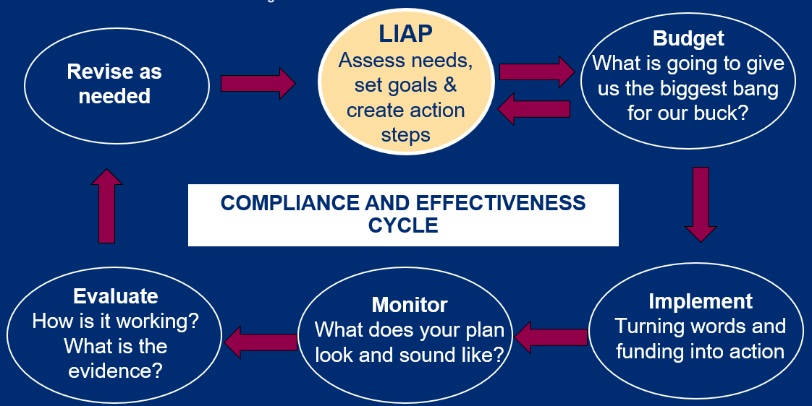

Planning and Funding:

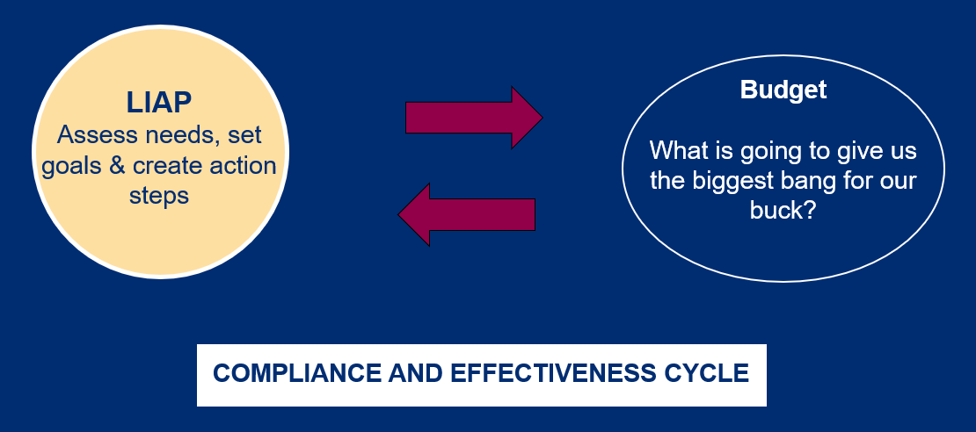

What is one goal or action step, specifically related to EL program and/or students, at your LEA? Is it funded by a Title III grant?

What data was used to create that goal/action step?

Planning Team:

Who is on the IAP team at your LEA?
Do administrators and educators of ELs give input when creating the EL Program?
Who could you ask if you aren’t currently aware?

Collaboration: Notes:

Professional Development:

- What has worked at your LEA?

- If your LEA has struggled to find meaningful PD that meets the needs of staff, what has been the biggest roadblock?

- What plan(s) does your LEA have for next year to address PD?

Family Engagement:

- What has worked at your LEA?
  - to increase attendance and/or active participation?
  - to create activities that enhance the language program while engaging families?
  - If your LEA has struggled with this component, what have been some of the roadblocks?

- What plan(s) does your LEA have for next year to address family engagement?

Collaboration contacts:

Use this space to note the name and contact information of participants you plan to collaborate with in the future.

