FY24 School Improvement

Contents
Contents
FY24 SI GRANTS 1
All grants Open in GME on March 1, 2023, and close May 30, 2023 1
Comprehensive Support and Improvement (CSI) Grant Low Achievement 1
CSI Low Graduation Rate Grant 9
Targeted Support and Improvement Schools (TSI/aTSI) 17
Systemic Leadership Development Grant 26
Appendices 31
Evidence-Based Improvement ESSA Guidance 32
ESSA-Evidence Based Requirements and Resources 39
SSI Grant Guidelines 40
Grant Revision Requirements 42
Tutoring Plan 45
School Support and Improvement Contact List 47

FY24 SI GRANTS

All grants Open in GME on March 1, 2023, and close May 30, 2023
- All are competitive and require detailed high-quality applications and direct, explicit alignment to CNA, RCA and IAP.
- Require newly (SY2023-24) completed CNA, root cause analyses, and aligned IAP and budget
- All funded strategies and action steps must be evidence-based and explicitly aligned directly to CNA-RCA-IAP. The goal is for the strategies and action steps to eliminate the root cause and therefore increase student achievement.

Application templates are for planning purposes. Complete all sections in GME to be considered for funding.

Comprehensive Support and Improvement (CSI) Grant Low Achievement

Eligible Applicants
CSI Low Achievement Schools identified SY2022-23

This is a competitive grant. A detailed application with all required elements and documents, including aligned CNA, RCA, IAP and budget is required to be considered for funding.
No LEA out of fiscal and/or programmatic compliance will be considered eligible.
.
Purpose: To provide CSI schools with funding to implement aligned evidence-based strategies and action steps in the School IAP.

Directions
- LEA and School teams collaborate to complete CNA, RCA and IAP and then write a strong, detailed application, provide all required documents, and check and sign assurances.
  - LEA’s assigned specialist is available for assistance.
  - Use the rubric when completing application narrative questions.
- Consultation with your assigned specialist is highly encouraged.
- Application completion with all required documents and evidence in GME by May 30, 2023 required. Additional inquiries from ADE will not be made. If all required documents are not in GME, the application will not be scored.
- The application will be scored using the rubric provided.
- Awards will be made based on the scored rubric. Seventy percent of points is required for funding. CNA, RCA and IAP aligned proposed budget are required for funding.
- LEAs will be notified of award or non-award by July 1.

Application

Complete all sections in GME
Program Details
  - FFATA and GSA Verification
  - Contact Information
  - Program Narrative Questions-thorough, detailed answers
  - Assurances
  - Related Documents
    - Signature Page in required related documents (required)
    - Evidence Based Summary Form/s in required related documents (required)
    - Graphs, tables, and charts necessary for a complete application (optional, as needed)
    - Quotes, Scopes of Work, Job Postings, Conference Brochures (if applicable)

Proposed Budget
Complete a proposed budget in GME. Be sure to include sufficient details in the narrative. See budget guidelines for examples.
- Items must support improved achievement by addressing identified root causes
- Items must be in IAP and aligned to CNA primary needs and the root cause identified.
- Be sure that the requests for funds are allowable
- LEA level positions are not allowed; out of state travel and large capital expenditures are generally not allowed
- All requested site level positions require position description and additional information in related documents
- Check with your specialist if you have questions or need assistance building your budget
- Funded strategies, practices and programs must meet top three tiers of ESSA evidence
Requirements
  - Completed 2023-24 CNA in GME
  - Thorough root cause analyses (RCA) (fishbone diagrams) on your top 3 primary needs in GME
  - Completed 2023-24 School IAP in GME, including process and impact goals
  - Tight alignment between CNA, RCA, IAP and program narrative questions and budget is required
  - Evidence of success in the Evaluation Tool is necessary for previously funded items.
  - If all required documents are not in GME, the application will not be scored

Contact Information (LEA complete once)

LEA/Charter Name | NCES ID# |  | CTDS# |  | Entity ID#
Board President | Email
Superintendent/Charter Holder | Email |  |  |  | Phone #
Federal Programs Director | Email |  |  |  | Phone #

Other- Title | Email |  | Phone #
School contact Information
School Name | NCES ID# | CTDS# | Entity ID#
Principal | Email |  | Phone #
School Name | NCES ID# | CTDS# | Entity ID#
Principal | Email |  | Phone #
Add additional school information, if needed

Required Related Documents Required Related Document
Evidence based summary form
Signature Page

Superintendent name Date

Signature

Charter Holder name Date

Signature

Board President Name Date

Signature

Narrative Questions
- Describe the CNA, RCA, IAP process in detail. What process did you use? Include data gathering process and the consensus process. Who was involved? What was the timeframe?
- List all SMART goals (process and impact) from the SY2022-23 (FY23) IAP with progress monitoring/evaluation data to demonstrate progress towards and/or achievement of your goals, what does the data tell you?
Goals | Progress Monitoring / Evaluation  Name Measures | *Here’s what…  Actual Data Sets | Met?  Yes or No | *So What? | *Now what?
*Data Analysis:
Here’s what…Factual data; What are the data the team needs to be analyzing? Simply recognize the data, categories, and student populations…
So what? Recognize trends from the data without yet making inferences or an action plan. What do you notice in the data?
Now what? Make conclusions and inferences about the data to structure a collective response, next steps
Source: Adapted from Wellman and Lipton (2004)

- What CSI strategies and action steps from the 2022-23 IAP were implemented successfully*? What is your evidence of success?
Strategy | Action Step | Evidence of success
* Data must have been provided in Evaluation Tool submitted previously.

- List any 2022-23 successful* strategies and action steps that will continue into 2023-24 that will be funded with the FY24 CSI LA grant. If no strategies from 2022-23 will continue to be funded with the FY24 grant, or if you did not have an FY23 CSI grant, write N/A.
- Strategy | - Action Step
*Data must have been provided in Evaluation Tool submitted previously.

- As a result of your new 2023-24 CNA, identify the principles/indicators, primary needs, root causes, need statements, desired outcome, impact goals and process goals.

Principle/ Indicator | Primary Need | Root Cause | Need statement | Desired Outcome | Impact Goal/s | Process Goal/s
Add rows as needed

6. What strategies and action steps aligned to the CNA and the identified root cause in the school 2023-24 IAP will be funded with the FY24 CSI LA grant? Include timelines and responsible staff. Be sure to upload Evidence Based Summary Form/s in required related documents. Any site level positions-need job description and details uploaded in related documents. LEA positions are not allowed.
Strategy with Action Step | Responsible Staff | Timeline

- Complete a proposed budget in GME. Be sure to include sufficient details in the narrative.
- Proposed budget is tightly aligned to the CNA, identified root cause and SIAP
- Proposed budget in GME is accurate; line items and codes are correct, math is correct
- Requests for funds are allowable. District level positions are not allowed. Out of state travel and large capital items are generally not allowed. Check with your specialist if you have a question or need assistance building your budget.
- Site level positions require job description and further details in related documents.
- Proposed expenditures have adequate narrative details. See appendix

LEA Narrative Questions
- Describe the LEA’s plan to support the schools as they implement their IAP. Include specific actions, person/s responsible, timelines and measures of success.
Strategy | Action Steps | Responsible Staff | Timeline | Measures of success

- Describe the LEA’s plan to hold school/s accountable as they implement their IAP, including monitoring and evaluating measures. Include actions, person/s responsible, and timelines.
Strategy/Action Steps | Monitoring Measures | Evaluation Measures | Responsible Staff | Timeline

- Describe the LEA’s fiscal monitoring plan (timely reimbursement requests, monitor necessary school actions, time and effort logs, requisitions, other fiscal records). Include action steps, person/s responsible, and timelines.
Action Steps | Responsible Staff | Timeline

Comprehensive Support and Improvement: Low Achievement Assurances
 Complete and submit School Comprehensive Needs Assessment (CNA) in GME.
 Complete thorough root cause analyses for CNA identified primary needs, submit fishbones in GME.
 Develop LEA and School (for each school in improvement) Integrated Action Plan (L/SIAP) as required, aligned to the CNA and root
cause analyses results in GME.
 The L/SIAP includes meaningful evidence-based interventions to improve student achievement; Evidence Based Summary Form in
GME.
 Monitor, review, update, delete, retire, or add strategies and action steps to the L/SIAP in GME at least quarterly.
 Ensure systems, processes, procedures, including operational flexibility are in place to actively to support Comprehensive Support
and Improvement Schools.
 Ensure effective organization of time for weekly professional learning communities (PLCs) during contract time.
 If no, add action steps to L/SIAP.
 Implement a balanced assessment system including common interim/benchmark assessments at least three times a year.
 If no, add action steps to L/SIAP.
 Implement written evidence and standards-based curriculum including materials.
 If no, add action steps to L/SIAP
 Observation and feedback protocol implemented with fidelity.
 If no, add action steps to L/SIAP.
 Submit Data Reflection Tool to assigned specialist, as required.
 Identify an LEA contact person who will oversee implementation activities, maintain contact with School Support and Improvement
(SSI) staff and accompany ADE SSI staff during site visits at the school upon request.
 Complete and submit EDFacts data when requested by ADE.
 If the LEA chooses an educational service provider (external provider) the LEA representative will provide ADE SSI with a copy of the process for selecting external providers, job description and evaluation of educational service provider services.
 Submit quarterly reimbursement requests (at a minimum).
 LEA has written procedures to implement the requirement to minimize the time elapsing between receipt and expenditure of federal funds.
 LEA has written procedures for determining the allowability of costs.
 LEA has a process ensuring equitable distribution of state funds to all schools regardless of other funding received.
 I understand that at any time during the grant period, funds can be frozen or forfeited with misuse of funds, or lack of evidence of
IAP implementation on the part of the school and/or LEA.
 I understand if the conditions herein are not adhered to or sufficient progress is not being made, a corrective action plan may be
written and implemented.

Allowable Expenditures
All Comprehensive Support and Improvement School activities funded with Title I 1003 (a) School Improvement funds must be reasonable and necessary and directly aligned to the implementation of the CNA, RCA, and LEA and School Integrated Action Plan. The grant budget must address the needs identified in the schools’ Comprehensive Needs Assessment and root cause analyses and advance the overall goal to increase the academic achievement in low performing schools.
  - Data driven decision-making process
  - Strategies and action steps aligned with the CNA and root cause analyses data
  - Leadership Development activities
  - Professional Learning activities (including conferences and related travel) aligned to needs
  - Educational Service Provider (external provider) services based on specific needs identified in CNA and root cause analyses (selection process, evidence of prior success, scope of work and evaluation measures required)
  - Supplies directly related to strategies and action steps (no general supplies)
  - Positions directly aligned with CNA identified needs and root causes, necessary for IAP implementation (discussion with specialist and job descriptions required)
  - Off contract pay for work (above and beyond duties necessary to job function), planning committees, researching evidence-based interventions, curricula, assessments (aligned to CNA and Root Causes)
    - Board approved hourly rate paid, must be reasonable
    - Requires time and effort logs
Generally, this grant will not fund large capital items or district level positions. Out of state travel may be approved only if absolutely necessary. This grant will NOT fund performance incentive pay or stipends.
Compliance
Grant recipients are required to:
  - Receive EPS approval for revisions prior to implementing any change in spending or program.
  - Submit timely, dated revisions for any fiscal or programmatic change.
  - In accordance with sound accounting practices, LEAs are required to request timely reimbursements.
  - Keep necessary Time and Effort documentation.
  - Submit Completion Reports on time.
  - Grantees failing to meet any single requirement of compliance are subject to corrective action.

CSI Low Graduation Rate Grant

Eligible Applicants
Schools identified in SY21-22 as Comprehensive Support and Improvement Schools for low graduation rate based on most current 5th year cohort data.
This is a competitive grant. A detailed, high-quality application with all required elements and documents is required to be considered for funding.

Grant awards will not be made to Local Education Agencies (LEAs) that are out of compliance with state or federal requirements, fiscal or programmatic.
Purpose
To provide funding to implement Integrated Action Plan evidence-based strategies and action steps to increase graduation rate aligned to CNA and RCA.
Directions
- LEA and School teams collaborate to write a strong, detailed application, provide all required documents, and check and sign assurances.
  - LEA’s assigned specialist is available for assistance.
  - Use the rubric when completing application narrative questions.
- Application completion with all required documents and evidence in GME by May 30, 2023, is required. Additional inquiries from ADE will not be made. If all required documents are not in GME, the application will not be scored.
- The application will be scored using the scoring rubric provided.
- Awards will be made based on the scored rubric. Seventy percent of points is required for funding. CNA, RCA and IAP aligned proposed budget are required for funding.
- LEAs will be notified of award or non-award by July 1.
Complete all sections in GME
Program Details
- FFATA and GSA Verification
- Contact Information
- Program Narrative Questions
- Assurances
- Related Documents
  - Signature Page in required related documents (required)
  - Evidence Based Summary Form/s in required related documents (required)
  - Graphs, tables, and charts necessary for a complete application (optional, as needed)
  - Quotes, Scopes of Work, Job Postings, Conference Brochures (if applicable)
Proposed Budget
Complete a proposed budget in GME. Be sure to include sufficient details in the narrative.
- Items must support improved grad rate and identified root causes.
- Be sure that the requests for funds are allowable. Out of state travel, district positions and large expenditures for capital items are generally not allowed. Check with your specialist if you have questions or need assistance building your budget.
Requirements
- Completed new 2023-24 CNA in GME
- Thorough root cause analyses (fishbone diagrams) on your top 3 primary needs and complete a Low Grad Rate Fishbone in GME
- Completed 2023-24 School IAP in GME, including SSI required goals
- Proposed budget aligned to Primary Needs, Root causes and SIAP
- If all required documents are not in GME, the application will not be scored.

Contact Information

LEA/Charter Name | NCES ID# | CTDS# | Entity ID#
Board President | Email
Superintendent/Charter Holder | Email |  | Phone #
Federal Programs Director | Email |  | Phone #
Other- Title | Email |  | Phone #

School Name | NCES ID# | CTDS# | Entity ID#
Principal | Email |  | Phone #
School Name | NCES ID# | CTDS# | Entity ID#
Principal | Email |  | Phone #
Add additional school information, if needed
In Required Related Documents
Evidence based form
Signature Page

Superintendent name

Signature Date

Charter Holder name

Signature Date

Board President Name

Signature Date

FY23 Graduation Rate Grant Application

Requirements:
Completed new 2022-23 CNA, including Root Cause Analyses relative to grad rate; new 2022-23 IAP with CSI grad rate goals, strategies and grad rate tagged action steps relative to increased grad rate; Evidence-Based Summary Forms (in required documents); signature page (in required documents); proposed detailed budget in GME.
School Narrative Questions

- List 5th year cohort graduation rates for the past three years.

- List all SMART goals (process and impact) related to achievement from the SY2022-23 (FY23) IAP with progress monitoring/evaluation data to demonstrate progress towards and/or achievement of your goals, what do the data tell you?

Goals | Progress Monitoring / Evaluation  Name Measures | *Here’s what…  Actual Data Sets | Met?  Yes or No | *So What? | *Now what?
*Data Analysis:
Here’s what…Factual data; What are the data the team needs to be analyzing? Simply recognize the data, categories, and student populations…
So what? Recognize trends from the data without yet making inferences or an action plan. What do you notice in the data?
Now what? Make conclusions and inferences about the data to structure a collective response, next steps
Source: Adapted from Wellman and Lipton (2004)

- What grad rate strategies and action steps from the 2022-23 IAP were implemented successfully? What is your evidence of success?
Strategy | Action Step | Evidence of success

- List any 2022-23 successful* strategies and action steps that will continue into 2023-24 that will be funded with the FY24 CSI LA grant. If no strategies from 2022-23 will continue to be funded with the FY24 grant, or if you did not have an FY23 CSI grant, write N/A.
Strategy | Action Step
*Data must have been provided in Evaluation Tool submitted previously.

- As a result of your new CNA, identify the principles, primary needs, root causes, need statements and desired outcomes, and impact and process goals.
Principle/ Indicator | Primary Need | Root Cause | Need statement | Desired Outcome | Impact Goal/s | Process Goal/s

- What new strategies and action steps have been added to the 2022-23 school IAP that will be funded with the FY24 Grad Rate grant? Remember to upload Evidence Based Summary Form/s in required related documents.
Strategy with Action Step | Responsible Staff | Timeline

- Complete a proposed budget in GME. Be sure to include sufficient details in the narrative.
- Proposed budget is tightly aligned to the CNA, identified root causes and SIAP
- Proposed budget in GME is accurate; line items and codes are correct, math is correct
- Requests for funds are allowable. District level positions are not allowed. Out of state travel and large capital items are generally not allowed. Check with your specialist if you have a question or need assistance building your budget
- Site level positions require job description and further details in related documents
- Proposed expenditures have adequate narrative details

LEA Narrative Questions
- Describe the LEA’s plan to support and hold school accountable as they implement their IAP. Include specific actions, person/s responsible, timelines and measures of success.
Strategy | Action Steps | Responsible Staff | Timeline | Measures of success

- Describe the LEA’s fiscal monitoring plan (timely reimbursement requests, monitor necessary school actions, time and effort logs, requisitions, other fiscal records). Include action seps, person/s responsible, and timelines.
Action Steps | Responsible Staff | Timeline

School Support and Improvement Assurances
- Complete and submit new School Comprehensive Needs Assessment (CNA) in GME.
- Complete thorough root cause analyses for CNA identified primary needs, submit fishbones in GME.
- Develop LEA and School Integrated Action Plan (L/SIAP) (for each school in improvement) as required based on the CNA and root cause analyses results in GME.
- The L/SIAP includes meaningful evidence-based interventions to improve student achievement, Evidence Based Summary Form submitted in GME.
- Monitor, update, delete, retire, or add strategies and action steps to the L/SIAP in GME at least quarterly.
- Ensure systems, processes, procedures, including operational flexibility are in place to actively support schools in improvement.
- Identify an LEA contact person who will oversee implementation activities, maintain contact with School Support and Improvement (SSI) staff, and accompany ADE SSI staff during site visits at the school upon request.
- Complete and submit EDFacts data when requested by ADE.
- If the LEA chooses an educational service provider (external provider) the LEA representative will provide ADE SSI with a copy of the process for selecting external providers, job description and evaluation of educational service provider services, if requested.
- Submit reimbursement requests in a timely manner (if applicable).
- LEA has written procedures to implement the requirement to minimize the time elapsing between receipt and expenditure of federal funds.
- LEA has written procedures for determining the allowability of costs.
- LEA has a process ensuring equitable distribution of state funds to all schools regardless of other funding received.
- Accurate and timely submission of all required documents including plan updates and data summaries.
- I understand that at any time during the grant period, funds can be frozen or forfeited for misuse of funds, lack of evidence of IAP implementation on the part of the school and/or LEA, or non-completion of requirements.
- I understand if the conditions herein are not adhered to or sufficient progress is not being made, a corrective action plan will be written and implemented.

Allowable Expenses
All Comprehensive Support and Improvement School activities funded with Title I 1003 (a) School Improvement funds must be reasonable and necessary and directly related to the implementation of the LEA and School Integrated Action Plan. It must address the needs identified in the schools’ Comprehensive Needs Assessment, aligned to the root causes, and advance the overall goal to increase graduation rate.
  - Data driven decision-making process
  - Strategies and action steps based on root cause/s identified for low graduation rate
    - Leadership Development
    - Professional Learning activities and related travel costs (out of state will be considered only if necessary)
    - Supplies directly related to action steps
  - Off contract pay for work (above and beyond duties necessary to job function); planning committees, researching evidence-based interventions, curricula, assessments
    - Board approved hourly rate paid, must be reasonable
    - Requires time and effort logs
This grant will NOT fund performance incentive pay or stipends, or capital outlay items.

Compliance
Grant recipients are required to:

- Receive EPS approval for revisions prior to implementing any change in spending or program.
- Submit revisions for any fiscal or programmatic change.
- In accordance with sound accounting practices, LEAs are required to request timely reimbursements.
- Keep necessary Time and Effort documentation.
- Submit Completion Reports on time.
- Grantees failing to meet any single requirement of compliance are subject to corrective action.

Additional/Targeted Support and Improvement Schools (TSI/aTSI)

Eligible Applicants
LEAs with schools identified as Targeted Support and Improvement Schools (TSI/aTSI) in SY 22-23.

This is a competitive grant. A detailed application with all required elements and documents is required to be considered for funding.
Grant awards will not be made to Local Education Agencies (LEAs) that are out of compliance with state or federal requirements, fiscal or programmatic.
Purpose:
To provide LEAs funding to support aTSI/TSI schools to implement L/SIAP, eliminate root causes of underachievement, and increase achievement of identified subgroups.

Directions
- LEA and School teams collaborate to conduct CNA, root cause analysis relative to identified subgroups, develop strategies and action steps relative to subgroups in the IAP, and to write a strong, detailed application, provide all required documents, and check and sign assurances.
  - LEA’s assigned specialist is available for assistance.
  - Use the rubric when completing application narrative questions.
- Application completion with all required documents and evidence in GME by 5/30/23 required. Additional inquiries from ADE will not be made. If all required documents are not in GME, the application will not be scored.
- The application will be scored using the scoring rubric provided.
- Awards will be made based on the scored application. Seventy percent of points and CNA, RCA and IAP aligned proposed budget are required for funding.
- LEAs will be notified of award or non-award by July 1.

Complete all sections in GME

Program Detail
  - FFATA and GSA Verification
  - Contact Information
  - Program Narrative Questions-detailed complete answers
  - Assurances
  - Related Documents
    - Signature Page in required related documents (required)
    - Evidence based summary form (required)
    - Graphs, tables and charts necessary for a complete application (optional, as needed)
    - Quotes, Scopes of Work, Job Postings, Conference Brochures (if applicable)

Proposed Budget
- Complete a detailed proposed budget in GME. Be sure to include sufficient details in the narrative. It must be directly aligned to the CNA summary page, RCA and IAP.
- Items must be evidence based and support improved outcomes for identified subgroups and the elimination of identified root causes.
- Be sure that the requests for funds are allowable. Out of state travel and large expenditures for capital items are generally not allowed.
- All positions require job descriptions and prior discussion with specialist as well as additional data and planning. District level positions are generally not allowed.
- Check with your specialist if you have questions or need assistance building your budget.

Requirements for application to be scored
- Completed 2023-24 CNA in GME
- Thorough root cause analyses (RCA) (fishbone diagrams) on top 3 primary needs with subgroups embedded in bones of fish or as a separate fishbone in GME
- Completed 2023-24 LEA with specific steps on how to support identified schools (tagged TSI) and School IAP (L/SIAP) in GME, including process and impact goals
- Completed application
- Required related documents
If all required documents are not in GME, the application will not be scored.
NOTE: Alignment between CNA, RCA and IAP and proposed budget is required. Grants with budgeted items that are not aligned to the CNA summary page, root causes, desired outcomes, and SIAP will NOT be funded.

Contact information

LEA/Charter Name | NCES ID# | CTDS# | Entity ID#
Board President | Email
Superintendent/Charter Holder | Email |  | Phone #
Federal Programs Director | Email |  | Phone #

Related Documents Evidence based form
Other- Title Required Related Documents LEA Signature Page - Signatures below denote commitment to implementation, monitoring and evaluation of strategies and action steps outlined in the IAP and the grant application.
Charter Holder Date

Signature

Board President Date

Signature

Superintendent Date

Signature

LEA Narrative Questions
- List all identified additioan;/Targeted Support and Improvement Schools, current enrollment, principal, and the identified subgroup/s (add lines as necessary).
School Name | School Enrollment | Principal | Identified Subgroup/s

- List all SMART goals (process and impact) related to identified subgroup achievement from the SY2022-23 (FY23) IAP with progress monitoring/evaluation data to demonstrate progress towards and/or achievement of your goals. What do the data tell you?

Goals | Progress Monitoring / Evaluation  Name Measures | *Here’s what…  Actual Data Sets | Met?  Yes or No | *So What? | *Now what?

*Data Analysis:
Here’s what…Factual data; What are the data the team needs to be analyzing? Simply recognize the data, categories, and student populations…
So what? Recognize trends from the data without yet making inferences or an action plan. What do you notice in the data?
Now what? Make conclusions and inferences about the data to structure a collective response and next steps
Source: Adapted from Wellman and Lipton (2004)

- List the SY2022-23 (FY23) TSI strategies and action steps that will continue to be funded in FY24 Included specific evidence of successful* implementation or progress on the identified strategies and action steps. (Add additional lines as necessary)
Indicate LEA or School name | Strategy | Action Step | *Evidence of success
* How do you know it made a difference in student outcomes? Data must have been provided in Evaluation Tool submitted previously. Write NA if you did not have previous TSI grant or if no FY23 funded strategies/actions will continue to be funded in FY24.

- As a result of analyzing the new FY24 CNAs of the school/s, list the trends across schools that will be addressed by grant funding.
List the specific schools that identified the same needs and root causes, with similar or the same desired outcomes and goals, that you will address as an LEA in the District Level Programs budget. Write NA if no trends are identified to be funded.

Trends across schools (funded by District Level Programs budget)

Trend #1 | School Names | CNA Principle | Primary Need | Root Cause/s | Need Statement | Desired Outcome | Process or impact SMART Goals

Trend #2 | School Names | CNA Principle | Primary Need | Root Cause/s | Need Statement | Desired Outcome | Process or impact SMART Goals

Add charts as needed

- List strategies and actions steps to be funded to address the LEA trends in question #4. Also provide how you will monitor and evaluate these actions. These strategies and action steps should be in the LEA IAP.
Trend | Strategy | Action Step | Monitoring measures | Evaluation Measures

- Based on the 2023-24 schools’ CNAs and leading and lagging indicator data analysis, what are the primary needs, root cause, desired outcomes, and goals relative to each identified subgroup’s low achievement unique to individual schools. NA if not funding unique needs.
School | Subgroup | Need | Root cause | Desired outcome | Process Goal | Impact goal

School | Subgroup | Need | Root cause | Desired outcome | Process Goal | Impact Goal

School | Subgroup | Need | Root cause | Desired outcome | Process Goal | Impact Goal

Add charts as needed

- List strategies and action steps to be funded to address unique school subgroup needs in question #6. Also provide how you will monitor and evaluate these actions. These strategies and action steps should be in the school’s IAP.
School | Subgroup/Need | Strategy | Action Step | Monitoring measures | Evaluation Measures

It is the LEA’s responsibility to support and monitor each school with low achieving subgroups, per ESSA statute.

Describe the LEA plan to communicate expectations and hold all identified TSI schools accountable for the implementation of the IAP’s TSI strategies, action steps and goals to increase achievement for identified subgroups.

- Communication Plan
Describe how the LEA will communicate current TSI status with each identified school, share data, and establish TSI expectations. Include what communication strategies the LEA will use, who is responsible, timeline/frequency of communication, monitoring and evaluating measures of success of communication strategies.
Communication Strategy | Responsible person/s | Timeline | Measures of success  (How will you know the communication strategies  are working)
Add lines as necessary

- Accountability Plan
Describe how the LEA will hold identified schools responsible for TSI action items, implementation of grant funded strategies, action steps and goals to raise achievement. Be specific on the methods the LEA will use, who is responsible, timeline and frequency as well as how the accountability methods will be monitored and evaluated for success.

Accountability Plan  Strategies/methods | Responsible person/s | Timeline | Measure of success  (How will you know the accountability strategies  are working)
Add lines as necessary

- Proposed budget with required detailed narrative in GME is directly and tightly aligned to the CNA, RCA, and IAP.
- Be sure that the requests for funds are allowable. Out of state travel and large capital items are generally not allowed. Check with your specialist if you have a question or need assistance building your budget.
- Proposed expenditures are reflected in the IAP and directly aligned to the CNA summary page and RCA.
- Proposed expenditures have adequate narrative details.
- Proposed expenditures are in correct function and object codes.
- Math is correct.

Budget
- Use this chart to determine maximum allocations based on total school enrollment.
School enrollment | Maximum Allocation
Up to 350 | $15,000
351-600 | $20,000
601-900 | $25,000
>900 | $30,000
- Allocation will be in District Level Programs only; you will not be creating dropdowns for each school.
        - Indicate specific school expenditures in the budget narrative (similar to the ESEA Consolidated Application, see example below).

Grant narrative example
Purchase Conscious Discipline Materials to support SEL needs of identified subgroups (Economically disadvantaged and students with disabilities) Total $3,931.00
LEA Leadership Team
5 Conscious Discipline Books $ 145.00
Sunshine School
1 E-Course site license $ 779.00
1 Premium Resources $ 70.00
42 Conscious Discipline Books $1,218.00
Total $2,067.00
Lizard School
1 E-Course site license $ 779.00
1 Premium Resources $ 70.00
30 Conscious Discipline Books $ 870.00
Total $ 1719.00

- Items must support improved subgroup achievement, be evidence-based, and aligned to CNA and identified root causes.
- Proposed expenditures must be specific. Amounts for general items will be disallowed and that funding forfeited.
- Be sure that the requests for funds are allowable. Out of state travel and large expenditures for capital items are generally not allowed. All positions require job description and additional data and planning. Check with your specialist if you have questions or need assistance building your budget.
- This grant will NOT fund performance incentive pay or stipends, large capital outlay items or general supplies. Prior approval of positions is required.

Compliance
Grant recipients are required to:
- Receive EPS approval for revisions prior to implementing any change in spending or program.
- Submit revisions for any fiscal or programmatic change.
- In accordance with sound accounting practices, LEAs are required to request reimbursements monthly.
- Keep necessary Time and Effort documentation.
- Submit Completion Reports on time.
- Grantees failing to meet any single requirement of compliance are subject to corrective action.
Targeted Support and Improvement LEA Programmatic Assurances
The LEA assures for each TSI School:
  - Complete and submit a School Comprehensive Needs Assessment (CNA) in GME.
  - Complete and submit a thorough root cause analysis (RCA) for CNA identified primary needs and identified subgroups and upload fishbones into GME.
  - Complete SIAP with all required sections in GME.
  - Each SIAP includes meaningful evidence-based interventions to address subgroups and improve student achievement.
  - Monitor and update the SIAP quarterly by evaluating data, adding, deleting, or retiring strategies and action steps.
  - Complete an analysis of TSI School CNAs and RCAs conducted by LEA leadership.
  - The LIAP includes strategies and action steps to address and support TSI schools’ trend needs and root causes for those needs.
  - The LIAP completes all required sections in GME.
  - The LIAP includes meaningful evidence-based interventions to address subgroups and improve student achievement.
  - Monitor, evaluate data, update, retire, or add strategies and action steps to the LIAP in GME at least quarterly.
  - Systems, processes, and procedures, including operational flexibility are in place to actively to support Targeted Support and Improvement Schools.
  - Effective organization of time for weekly professional learning communities (PLCs).
  - A balanced assessment system including common interim/benchmark assessments administered at least three times a year.
  - Implement written evidence and standards-based curriculum including materials.
  - Use of an observation and feedback protocol implemented with fidelity.
  - An LEA contact person who will oversee implementation activities, maintain contact with School Support and Improvement (SSI) staff
  - Written procedures to implement the requirement to minimize the time elapsing between receipt and expenditure of federal funds. (To be provided if requested)
  - Written procedures for determining the allowability of costs. (To be provided if requested)
  - Submit monthly reimbursement requests.
  - Written methodology to distribute state and local funds to its schools without regard to schools’ Title l status or funding. (To be provided if requested)
  - I understand that at any time during the grant period, funds can be frozen or forfeited with evidence of use; misuse of funds or lack of evidence of IAP implementation on the part of the school and/or LEA.
  - I understand if the conditions herein are not adhered to or sufficient progress is not being made, a corrective action plan will be written and implemented.

Systemic Leadership Development Grant

Eligible Applicants

LEAs with schools identified as Comprehensive Support and Improvement Schools (CSI), Additional Targeted Support and Improvement Schools and/or Targeted Support and Improvement Schools (TSI/ATSI).
Purpose
To provide funding to LEAs with CSI and/or aTSI/TSI Schools for participation in approved systemic leadership education or executive leadership programs and any required related costs.
An approved systemic leadership education or executive leadership program is defined as: Systemic leadership is the ability and preparedness to take accountability for the work of the organization and the impact it has on everyone – and thing – involved. Executive leadership is the ability of those who manage or direct employees in an organization to influence and guide these individuals.
An approved programs such as Arizona Executive Leadership Program: Elevate, University of Virginia’s NISL program, Beat the Odds, Instructional Empowerment are allowable.
Approved programs would have the following components:
  - Evidence Based 2-year program including systemic change and continuous improvement models
  - Multiple Convenings throughout the 2 year period
  - LEA and School Team Collaboration
  - Onsite Mentoring and Coaching

Application Process
Complete all sections in GME
- Program Details
- Contact Information
- Narrative questions
- Assurances
- Budget with detailed narrative
- Required Related Documents
- Signature Page
- Selected Leadership Program application/information
- Official program description or brochure including benefits, details program long-term and short-term goals, program elements, participant eligibility, participation dates, length of program, program research base
- Optional Related Documents

Contact Information

LEA/Charter Name | NCES ID# | CTDS# | Entity ID#
Board President | Email
Superintendent/Charter Holder | Email |  | Phone #
Federal Programs Director | Email |  | Phone #
Other- Title | Email |  | Phone #
School Name | NCES ID# | CTDS# | Entity ID#
Principal | Email |  | Phone #
Add school name and principal information for each school that will be participating

Program details
Special Note:
If in the first year, please answer question 1-7 and mark N/A for questions 8 and 9. If in the second year, please answer #1, 2, 6-9 only, and mark N/A on questions 3-5.

  - What Leadership Development Program does the LEA want to attend?
  - List schools that will participate
  - What are the short-term and long-term goals of the program? Add the brochure or other official program document/s in related documents. (NA if second year of attendance)
  - Why was this program selected? (NA if second year of attendance)
  - What is the length of the program? (NA if second year of attendance)
  - What is the registration cost?
  - Are there related costs other than registration?
  - List three critical learnings and actions taken as a result of program attendance. (N/A if first year of program)
  - List 2-3 goals you plan on achieving by your continued attendance to the program. (N/A if first year of program)

Related Documents
Evidence based form if not ELEVATE
Approval to Use 1003(a) Funds signed for ELEVATE
Signature Page - Signatures below denote commitment to implementation, monitoring and evaluation of strategies and action steps outlined in the IAP and the program requirements.
Charter Holder Date

Signature

Board President Date

Signature

Superintendent Date

Signature

Systemic Leadership Grants for ELEVATE

Approval to Use 1003(a) Funds
Required for ELEVATE

LEA approves the use of 1003(a) funds by the Arizona Department of Education to directly provide the ELEVATE, Executive Leadership Program, including all costs for convenings/conferences, including conference location, food, speakers, and all materials to improve student achievement, instruction, LEAs, and schools.

Superintendent Printed Name

Superintendent’s Signature

Date

Allowable cost
- Registration cost of approved program
- Related travel costs
- Substitute costs
- Cost of any required program coach or mentor
- Additional costs to support the implementation of program learning that is reasonable and necessary

Assurances
- Commitment to make the selected leadership program a top priority
- Adherence to all program requirements including:
- Completion of program’s planning requirements (i.e. 90-day plans)
- Participation of the LEA leadership Team including Superintendent sin the systemic program/process/plan implementation, monitoring and evaluation required by selected program
- Participation of the school leadership team in all ELEVATE convenings and systemic program/process/plan implementation, monitoring and evaluation required by selected program
- Top LEA leadership, including Superintendent and school leadership teams’ attendance and active, positive participation in every convening/training/meeting School leadership (principal and other appropriate personnel) regularly conduct short cycle observation and feedback classroom visits in addition to evaluation observation
- Effective organization of time for weekly structured professional learning communities (PLCs)
- LEA leadership, including Superintendent regularly conduct site visits to focus on and discuss successful planning and implementation of program plans (i.e. 90-day plans) and Integrated Action Plan, including necessary next steps and mid-course adjustments
- Planning for sustainability of systematic changes made as a result of the program
- Submission of timely reimbursement requests
- Submission of summary reports as requested by ADE

Appendices

Evidence-Based Improvement ESSA Guidance
ESSA Evidence Tiers ESSA (Section 8002) outlines four tiers of evidence. The table below includes ESSA’s definition for each of the four tiers, along with a practical interpretation of each tier.
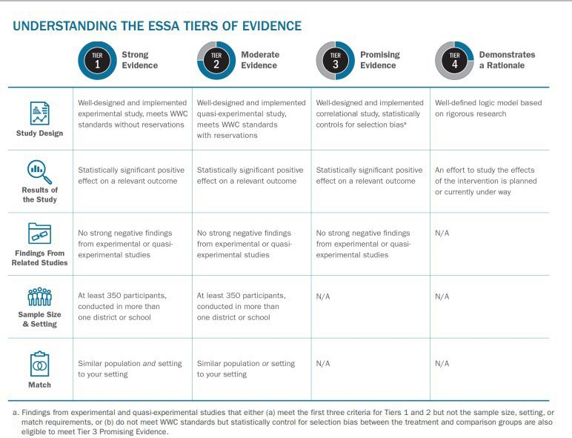

School Improvement Grants fund strategies and action steps using strategies, practices, programs, and interventionsi with strong, moderate, or promising evidence. “Demonstrating a Rationale” is not an allowable evidence base for schools in school improvement.

The table below includes ESSA’s definition for each of the four tiers, along with a practical interpretation of each tier.
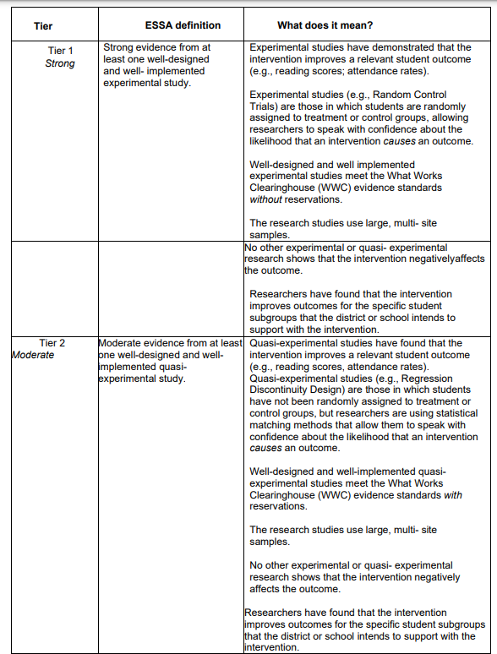

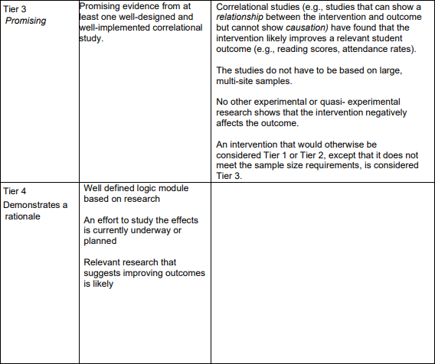
NOT ALLOWED FOR SCHOOL IMPROVEMENT

Evidenced-based improvement allows states and schools flexibility in choosing interventions however, it also brings more local responsibility. It becomes the combined responsibility of the state and the school to ensure that they align improvement efforts, at all tiers of instruction, to solid evidence.
LEA and school leadership teams can utilize multiple resources to determine whether a strategy, practice, program, or intervention meets the Strong, Moderate, or Promising ESSA evidence requirements based on rigorous studies from a reputable third-party evaluator.

RESOURCE AVAILABLE HERE: Evidence Based Practices

Additional Resources Available:

Searchable Databased on evidence-based practices, programs and interventions

Guidance on ESSA Levels of Evidence

Evidence Based Research Requirements (ESSA) Module

SSI Grant Guidelines
**LEAs must receive EPS approval for revisions prior to implementing any change in spending or program.
Below are examples of the level of detail required in the budget narrative. Please refer to the USFR or USFRCS for additional guidance on coding.
This document provides samples but is not an all-inclusive list of approvable formats, costs, etc.

6100 Salaries
Function Code 1000 (direct instructional contact with students)
Board adopted salary or hourly rate
Detail needed: # of staff x # of hours x hourly rate = total; FTE x salary = total
What is the pay for? (example: after school tutoring, substitutes)
Position example: reading interventionist
*Job description required for positions in related docs
*Tutoring plan required for tutoring programs
*Stipend amounts are not allowed – must break down hours x hourly rate

Function Code 2100, 2200, 2600, 2700 (staff)
Board adopted rates
Detail needed: # of staff x # of hours x hourly rate = total; FTE x salary = total
What is the pay for? (example: off contract committee work to research math curriculum)
Position example: data coach
*Job description required for positions in related docs
*Stipend amounts are not allowed – must break down hours x hourly rate

6200 Benefits
All Function Codes
Board adopted rates
Benefits are required for each position in 6100. Exceptions must be noted in your narrative. Provide the percentage used in your cost calculation for related benefits

6300 Purchased Professional Services
Function code 2100, 2200, 2600, 2700 (staff)
TBD based on provider services or conference fees
Educational Service Provider (external provider/consultant)
Detail needed: Who? What? When? For whom? *Must include date
How much? # of days x daily rate =
*Scope of work with deliverables required for external providers/consultants in related docs
Professional Learning Activities
Detail needed: Who? What? When? For whom? *Must include date
How much? # of days x daily rate =
Conference registration *Conference brochure or agenda requiredrelated docs
Detail needed: Conference name, location? length? Who is attending?
Registration cost x # of staff =
Function Code 2300, 2400, 2500, 2900 (administrators)
TBD based on provider services or conference fees
Leadership Development
Detail needed: Who? What? When? For whom? *Must include date
How much? # of days x daily rate =
*Scope of work with deliverables required for external providers/consultants in related docs

Professional Learning Activities
Detail needed: Who? What? When? For whom? *Must include date
How much? # of days x daily rate =
Conference registration *Conference brochure or agenda required in related docs
Detail needed: Conference name, location? length? Who is attending?
Registration cost x # of staff =

6500 Travel Costs
Function Code 2100, 2200, 2600, 2700 (staff)
TBD based on state per diem or board adopted rates
Travel expenses related to conferences attended by staff.
Detail needed: Conference name and date
Transportation cost (airfare, mileage, rideshare) x # of staff =
Hotel room cost x nights x # of staff =
Per Diem x # days x # of staff =
*Please check conference details. If breakfast and lunch are provided at the conference, per diem cannot be reimbursed for these meals.

Function Code 2300, 2400, 2500, 2900 (administrators)
TBD based on state per diem or board adopted rates
Travel expenses related to conferences attended by administrators.
Detail needed: Conference name and date
Transportation cost (airfare, mileage, rideshare) x # of administrators =
Hotel room cost x nights x # of administrators =
Per Diem x # days x # of administrators =
*Please check conference details. If breakfast and lunch are provided at the conference, per diem cannot be reimbursed for these meals.

6600 Supplies
Function Code 1000 (direct instructional contact with students)
Per quote(s)
Curricular materials, instructional kits, site licenses, etc. for student use
Detail needed: Who will use? What is the purpose?
Item name x # of items x cost =
*Miscellaneous office supplies and student rewards not allowed.
*Quotes are needed for all items in related doc

Function Code 2100, 2200, 2600, 2700 (staff)
Per quote(s)
Supplies for staff, professional learning books, etc.
Detail needed: Who will use? What is the purpose?
Item name x # of items x cost =
*Miscellaneous office supplies not allowed
*Quotes are needed for all items in related docs

6910 Indirect Costs
Function Code 0000
As approved

SSI Grant recipients are required to:
- Receive EPS approval for revisions prior to implementing any change in spending or program.
- Submit revisions for any fiscal or programmatic change.
- In accordance with sound accounting practices, LEAs are required to request reimbursements monthly.
- Keep necessary Time and Effort documentation.
- Submit Completion Reports on time.

*Grantees failing to meet any single requirement of compliance are subject to possible funding forfeiture or having funds placed on hold.

Grant Revision Requirements
-A remaining balance of zero is necessary.
*Do not delete any of the original narrative (unless you no longer have any funds allocated in that line) – add to/below the original narrative.
-Note the revision # and date of revision (i.e. Revision #1, Oct. 5, 2021)

-Use a different color font for each new revision or highlight the new revision.

-Be detailed in your narrative to indicate if an expenditure increased, decreased, or was added/new.

-Double check the math. The total in the narrative must match the line item total.

-Upload any revised quotes, scopes of work, evidence-based summary forms, etc.

-Revise your IAP to match the revision in GME. Add/remove any funding tags if needed.

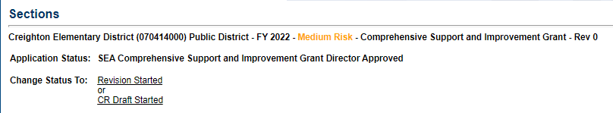
Starting a revision: Under Sections: Choose Revision Started and then click Confirm.
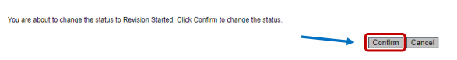

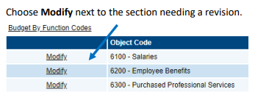

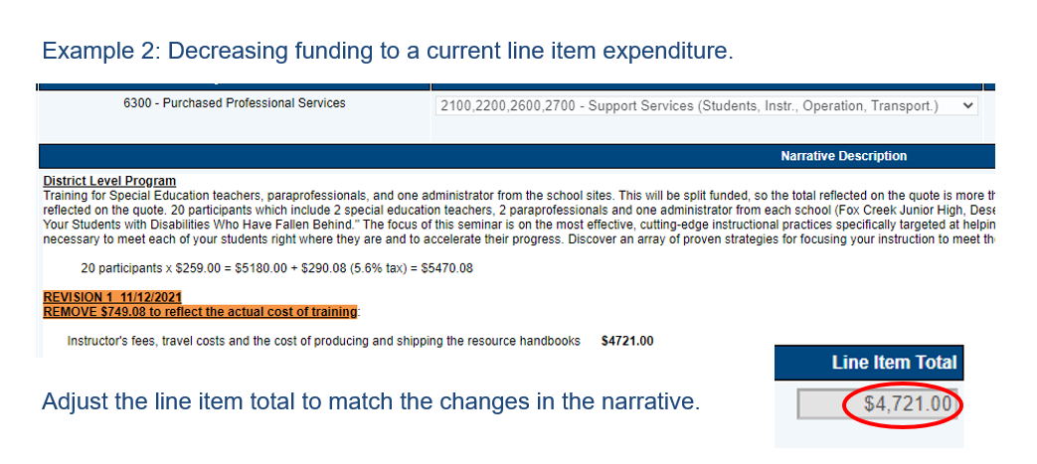
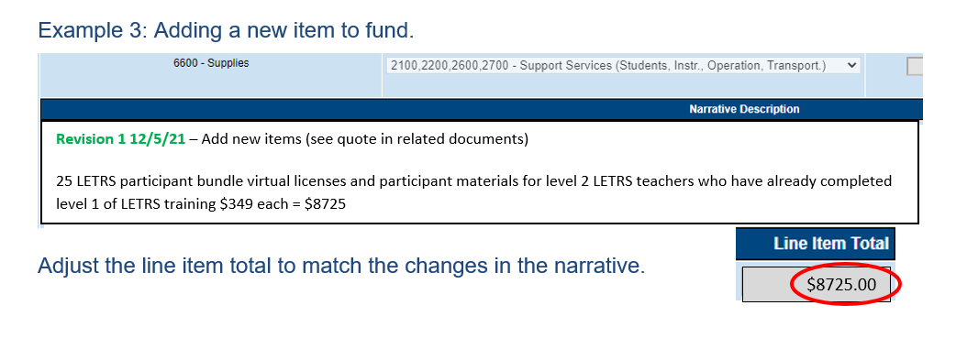
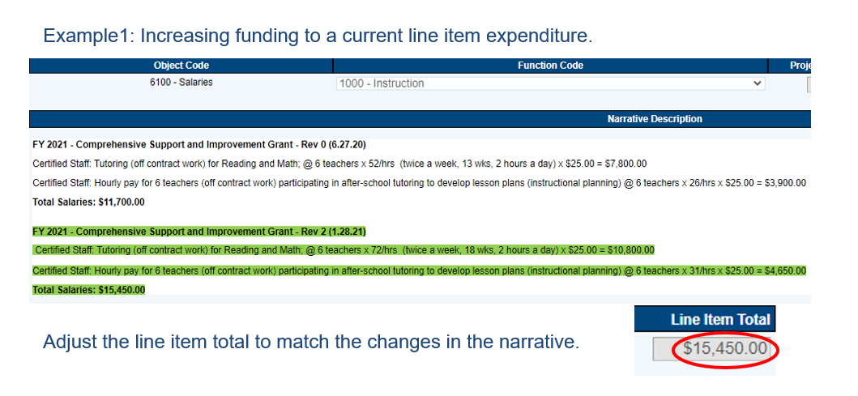
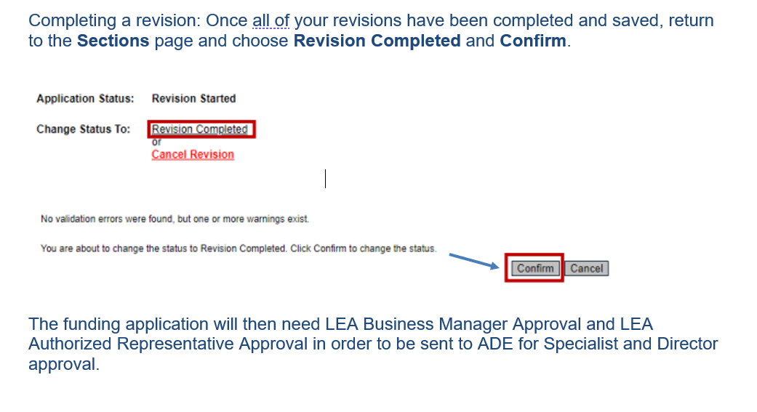
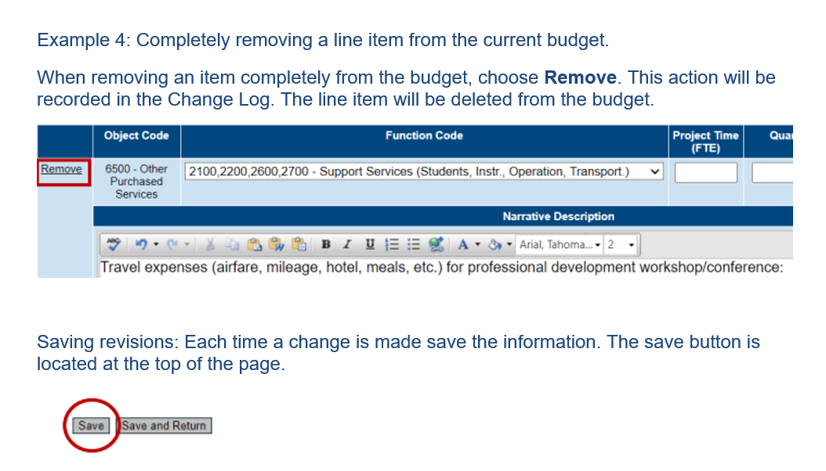

Tutoring Plan
For use of School Improvement Grant Funds (CSI, aTSI/TSI,)

When using any school improvement funds for a tutoring program, an explicit plan must be provided to ensure that the instruction is targeted, evidence-based and different than instruction provided during the school day. Tutoring time may not be used as a study hall, work completion opportunity or homework room.

LEA:

School:

Circle Grant: CSI TSI

Tutoring Purpose: content area/s and expected outcomes

Targeted Students Populations:

Tutoring Dates:
Tutoring Session Times:

Staffing: Who is teaching the tutoring groups (positions, not names; every effort should be made to assign highly effective teachers; required to be effective teachers)?

Student Identification for Participation: How will students be identified; indicate data to be used, including instruments/assessments?

Program Content: What evidence-based material are being used?

Program and Pedagogy: How is the tutoring different from core instruction?
Student Progress Monitoring: What data will be used to measure progress in the program? (include monitoring instruments/assessments and intervals/timelines)

Program Monitoring: How will the tutoring program be monitored? (include who will oversee the project)

Program Evaluation: How will the tutoring program be evaluated?
Accessibility: How will equitable accessibility be ensured for all eligible (identified subgroup) students; will transportation be provided?

TSI **If providing tutoring to students with disabilities, the following assurances apply: The school/LEA assures that:
- FAPE services are provided during the school day.
- Tutoring services are above and beyond what is stated in the IEP.
- Tutoring services will be accessible to all eligible students in the target population Initialing the boxes and the signature below assures to the conditions described.

Signature (superintendent or designee)

Print Name and Title

Date

School Support and Improvement Contact List

School Support and Improvement
(602) 364-2269
SchoolImprovementInbox@azed.gov

Devon Isherwood, Deputy Associate Superintendent  (602) 364-0379  Devon.Isherwood@azed.gov | Christina Aldrich,  Director  (602) 364-2202  Christina.Aldrich@azed.gov | Russel Potter,  Data Specialist  (602) 542-3281  Russel.Potter@azed.gov

Education Program Specialists
Amanda Wilber  Amanda.Wilber@azed.gov  602-542-3069 | Becca Moehring  Becca.Moehring@azed.gov  602-542-3058
Cindy Robinson  Cindy.Robinson@azed.gov  602-364-4115 | Kelly Curtin  Kelly.Curtin@azed.gov  602-542-3370
Andrew Ward  Andrew.Ward@azed.gov  602-364-4992 | Sarah Barnes  Sarah.Barnes@azed.gov  520-770-3062
Lucedes McBroom  Lucedes.McBroom@azed.gov  520-770-3790 | Michael Hansen  Michael.Hansen@azed.gov  602-542-0836
Serena Lobo  Serena.Lobo@azed.gov  602-542-3123 | Tony Cuevas  Tony.Cuevas@azed.gov  928-637-1899
Chelle Kemper  Chelle.Kemper@azed.gov  602-364-1980 | Ken Rausch  Ken.Rausch@azed.gov  602-364-4992

