FY24 Comprehensive Support and Improvement-Low Achievement Grant Arizona Department of Education School Support and Improvement
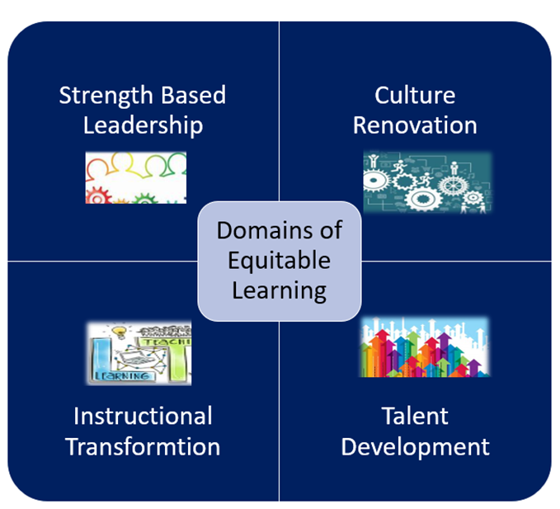
Grant application will open in GME on March 1, 2023 ,and closes on May 30, 2023.
The purpose of this document is as a planning resource ONLY.
All information is required to be entered in GME

Comprehensive Support and Improvement Low Achievement (CSI LA) Grant FY23
Purpose:
To provide CSI schools with funding to implement aligned evidence-based strategies and action steps in the School IAP.

Eligible Applicants
CSI Low Achievement Schools
This is a competitive grant.
A detailed application with all required elements and documents is required to be considered for funding.

No LEA out of fiscal and/or programmatic compliance will be considered eligible.
Directions
1. LEA and School teams collaborate to write a strong, detailed application, provide all required documents, and check and sign assurances.
a. LEA’s assigned specialist is available for assistance.
b. Use the rubric when completing application narrative questions.
2. Application completion with all required documents and evidence in GME by March 1 required. Additional inquiries from ADE will not be made. If all required documents are not in GME, the application will not be scored.
3. The application will be scored using the scoring rubric provided.
4. Awards will be made based on the scored rubric. Seventy percent of points is required for funding.
5. LEAs will be notified of award or non-award by July 1.
Complete all sections in GME
Program Details
- FFATA and GSA Verification
- Contact Information
- Program Narrative Questions-thorough, detailed answers
- Assurances
- Related Documents
  - Signature Page in required related documents (required)
  - Evidence Based Summary Form/s in required related documents (required)
  - Graphs, tables and charts necessary for a complete application (optional, as needed)
Proposed Budget
Complete a proposed budget in GME. Be sure to include sufficient details in the narrative.
- Items must support improved achievement by addressing identified root causes.
- Items must be in IAP and aligned to CNA and RCA
- Be sure that the requests for funds are allowable. LEA level positions are not allowed; out of state travel and large capital expenditures are generally not allowed.
- All requested site level positions require position description and additional information in related documents
- Check with your specialist if you have questions or need assistance building your budget.
- Funded strategies, practices and programs must meet top three tiers of ESSA evidence.
Requirements for application to be scored
- Completed 2023-24 CNA in GME
- Thorough root cause analyses (RCA) (fishbone diagrams) in GME
- Completed 2023-24 LEA and School IAP in GME, including process and impact goals

NOTE: Alignment between CNA, RCA and IAP and proposed budget is required. Grants with budgeted items that are not aligned to root causes, desired outcomes and SIAP will NOT be funded.

LEA Contact Information
LEA/Charter Name | NCES ID# | CTDS# | Entity ID#
Board President | Email
Superintendent/Charter Holder | Email |  | Phone #
Federal Programs Director | Email |  | Phone #
Other- Title | Email |  | Phone #
School Contact Information
School Name | NCES ID# | CTDS# | Entity ID#
Principal | Email |  | Phone #
School Name | NCES ID# | CTDS# | Entity ID#
Required Related Documents Signature Page - Signatures below denote commitment to implementation, monitoring and evaluation of strategies and action steps outlined in the IAP and the grant application.
Superintendent name Date

Signature

Charter Holder name Date

Signature

Board President Name Date

Signature

Required Related Document-Evidence based summary form
Comprehensive Needs Assessment (CNA), root cause analyses (RCA) and Integrated Action Plan (IAP)development process

Narrative Questions
- Describe the CNA, RCA, IAP process in detail. What process did you use? Include data gathering process and the consensus process. Who was involved? What was the timeframe?
- List all SMART goals (process and impact) related to identified subgroup achievement from the SY2022-23 (FY23) IAP with progress monitoring/evaluation data to demonstrate progress towards and/or achievement of your goals, what do the data tell you?
Goals | Progress Monitoring / Evaluation  Name Measures | *Here’s what…  Actual Data Sets | Met?  Yes or No | *So What? | *Now what?
*Data Analysis:
Here’s what…Factual data; What are the data the team needs to be analyzing? Simply recognize the data, categories, and student populations…
So what? Recognize trends from the data without yet making inferences or an action plan. What do you notice in the data?
Now what? Make conclusions and inferences about the data to structure a collective response, next steps
Source: Adapted from Wellman and Lipton (2004)

- What CSI strategies and action steps from the 2022-23 IAP were implemented successfully*? What is your evidence of success?
Strategy | Action Step | Evidence of success
* Data must have been provided in Evaluation Tool submitted previously.

- List any 2022-23 successful* strategies and action steps that will continue into 2023-24 that will be funded with the FY24 CSI LA grant. If no strategies from 2022-23 will continue to be funded with the FY24 grant, or if you did not have an FY23 CSI grant, write N/A.
- Strategy | - Action Step
*Data must have been provided in Evaluation Tool submitted previously.

- As a result of your new 2023-24 CNA, identify the principles/indicators, primary needs, root causes, need statements, desired outcome, impact goals and process goals.

Principle/ Indicator | Primary Need | Root Cause | Need statement | Desired Outcome | Impact Goal/s | Process Goal/s

6. What strategies and action steps aligned to CNA and the identified root cause in the school 2023-24 IAP will be funded with the FY24 CSI LA grant? Include timelines and responsible staff. Be sure to upload Evidence Based Summary Form/s in required related documents. Any site level positions-need job description and details uploaded in related documents.
Strategy with Action Step | Responsible Staff | Timeline
- Complete a proposed budget in GME. Be sure to include sufficient details in the narrative.
- Proposed budget is tightly aligned to the CNA, identified root cause and SIAP
- Proposed budget in GME is accurate; line items and codes are correct, math is correct
- Requests for funds are allowable. District level positions are not allowed. Out of state travel and large capital items are generally not allowed. Check with your specialist if you have a question or need assistance building your budget
- Site level positions require job description and further details in related documents
- Proposed expenditures have adequate narrative details.

LEA Narrative Questions
- Describe the LEA’s plan to support the schools as they implement their IAP. Include specific actions, person/s responsible, timelines and measures of success.
Strategy | Action Steps | Responsible Staff | Timeline | Measures of success

- Describe the LEA’s plan to hold school/s accountable as they implement their IAP, including monitoring and evaluating measures. Include actions, person/s responsible, and timelines.
Strategy/Action Steps | Monitoring Measures | Evaluation Measures | Responsible Staff | Timeline

- Describe the LEA’s fiscal monitoring plan; timely reimbursement requests, monitor necessary school actions) time and effort logs, requisitions, other fiscal records) . Include action seps, person/s responsible, and timelines.
Action Steps | Responsible Staff | Timeline

Comprehensive Support and Improvement: Low Achievement Assurances
- Complete and submit School Comprehensive Needs Assessment (CNA) in GME.
- Complete thorough root cause analyses for CNA identified primary needs, submit fishbones in GME.
- Develop LEA and School (for each school in improvement) Integrated Action Plan (L/SIAP) as required, aligned to the CNA and root cause analyses results in GME.
- The L/SIAP includes meaningful evidence-based interventions to improve student achievement; Evidence Based Summary Form in GME.
- Monitor, review, update, delete, retire or add strategies and action steps to the L/SIAP in GME at least quarterly.
- Ensure systems, processes, procedures, including operational flexibility are in place to actively to support Comprehensive Support and Improvement Schools.
- Ensure effective organization of time for weekly professional learning communities (PLCs) during contract time.
- If no, add action steps to L/SIAP.
- Implement a balanced assessment system including common interim/benchmark assessments at least three times a year.
- If no, add action steps to L/SIAP.
- Implement written evidence and standards-based curriculum including materials.
- If no, add action steps to L/SIAP
- Observation and feedback protocol implemented with fidelity
- If no, add action steps to L/SIAP.
- Submit quarterly interim/benchmark assessment data reports and reflective analysis to assigned specialist.
- Identify an LEA contact person who will oversee implementation activities, maintain contact with School Support and Improvement (SSI) staff, and accompany ADE SSI staff during site visits at the school upon request.
- Complete and submit EDFacts data when requested by ADE.
- If the LEA chooses an educational service provider (external provider) the LEA representative will provide ADE SSI with a copy of the process for selecting external providers, job description and evaluation of educational service provider services.
- Submit quarterly reimbursement requests (at a minimum).
- LEA has written procedures to implement the requirement to minimize the time elapsing between receipt and expenditure of federal funds.
- LEA has written procedures for determining the allowability of costs.
- LEA has a process ensuring equitable distribution of state funds to all schools regardless of other funding received.
- I understand that at any time during the grant period, funds can be frozen or forfeited with misuse of funds; or lack of evidence of IAP implementation on the part of the school and/or LEA.
- I understand if the conditions herein are not adhered to or sufficient progress is not being made, a corrective action plan may be written and implemented.

