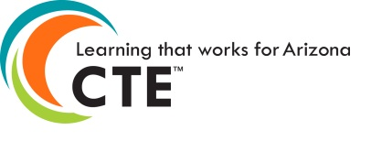
CTE Administrators Meeting
November 3, 2022
8:00am – 11:30am
Sign-in begins at 8:00am
Meeting starts promptly at 8:30am

Prescott Resort - 1500 E State Rte. 69, Prescott AZ 86301

AGENDA
Welcome – Clarkdale/Cottonwood Rooms

Introduction and ADE Updates: Strategic Plan
Presidential Scholars
Allocation Update

Grants and Comprehensive Local Needs Assessment (CLNA)

Accountability

Updates: ACTEAZ

Program Monitoring, Local Occupational Programs, Regional In Demand List

Updates: AZ CTE Curriculum Connection

Break

Updates: Premier Program Series, Project Change

School Counselors

Standards and Assessment Update, TSA Meetings, Website

CTSO

Update: ACOVA

Reminders and Closing
Next CTE Administrators Meeting will be
February 2, 2023 – Prescott Resort, Prescott AZ – 8:00am to 11:30am

ACOVA Conference & CTE Administrators Meeting - Room Rates - $99 single/$119 double

