FY23 School Improvement Sustainability Grant Progress Monitoring Tool
Directions: Use the form below to document progress on the use of your FY23 School Improvement Sustainability Grant. Additional guidance to support you in completing this task can be found on the ADE SSI Professional Learning website.
Submissions are due on: October 31,2022, January 31, 2023, and April 30, 2023, to your Education Program Specialist.
LEA: _________________________________ Form Completed By: ________________________________
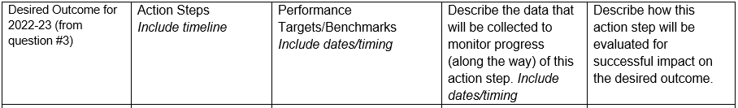
*Refer to your responses to program narrative question #4 in your FY23 Sustainability Grant application in GME to support the completion of this document.

------------------------------------------------------------------------------------------------------------------------------------------------------------------------------------------------------------------------------------------------------------------------
Fall Reporting Period
List your Desired Outcome(s) for 2022-23 (from question #3 in the grant application) | What action steps related to achieving the desired outcome(s) have taken place this reporting period? | What progress have you made towards your performance targets/benchmarks during this reporting period? | What data did you collect in relation to monitoring progress on this desired outcome during this reporting period? | Based on the data collected, what impact has been made in achieving the desired outcome?  What barriers are you experiencing?  What adjustments need to be made to the IAP or grant?
Add additional rows if needed.

Winter Reporting Period
List your Desired Outcome(s) for 2022-23 (from question #3 in the grant application) | What action steps related to achieving the desired outcome(s) have taken place this reporting period? | What progress have you made towards your performance targets/benchmarks during this reporting period? | What data did you collect in relation to monitoring progress on this desired outcome during this reporting period? | Based on the data collected, what impact has been made in achieving the desired outcome?  What barriers are you experiencing?  What adjustments need to be made to the IAP or grant?
Add additional rows if needed.

Spring Reporting Period
List your Desired Outcome(s) for 2022-23 (from question #3 in the grant application) | What action steps related to achieving the desired outcome(s) have taken place this reporting period? | What progress have you made towards your performance targets/benchmarks during this reporting period? | What data did you collect in relation to monitoring progress on this desired outcome during this reporting period? | Based on all the data collected throughout the school year, did you achieve the desired outcome?  If not, why not? What barriers did you experience?  How will you overcome these barriers in the next school year? What adjustments need to be made to the new IAP or grant to achieve this desired outcome?
Add additional rows if needed.

