SSI Grant Guidelines
**LEAs must receive EPS approval for revisions prior to implementing any change in spending or program.

Below are examples of the level of detail required in the budget narrative. Please refer to the USFR or USFRCS for additional guidance on coding.
This document provides samples but is not an all-inclusive list of approvable formats, costs, etc.

6100 Salaries
Function Code 1000 (direct instructional contact with students)
Board adopted salary or hourly rate
Detail needed: # of staff x # of hours x hourly rate = total; FTE x salary = total
What is the pay for? (example: after school tutoring, substitutes)
Position example: reading interventionist
*Job description required for positions
*Tutoring plan required for tutoring programs
*Stipend amounts are not allowed – must break down hours x hourly rate

Function Code 2100, 2200, 2600, 2700 (staff)
Board adopted rates
Detail needed: # of staff x # of hours x hourly rate = total; FTE x salary = total
What is the pay for? (example: off contract committee work to research math curriculum)
Position example: data coach
*Job description required for positions
*Stipend amounts are not allowed – must break down hours x hourly rate

6200 Benefits
All Function Codes
Board adopted rates
Benefits are required for each position in 6100. Exceptions must be noted in your narrative. Provide the percentage used in your cost calculation for related benefits

6300 Purchased Professional Services
Function code 2100, 2200, 2600, 2700 (staff)
TBD based on provider services or conference fees
Educational Service Provider (external provider/consultant)
Detail needed: Who? What? When? For whom? *Must include date
How much? # of days x daily rate =
*Scope of work with deliverables required for external providers/consultants
Professional Learning Activities
Detail needed: Who? What? When? For whom? *Must include date
How much? # of days x daily rate =
Conference registration *Conference brochure or agenda required
Detail needed: Conference name, location? length? Who is attending?
Registration cost x # of staff =
Function Code 2300, 2400, 2500, 2900 (administrators)
TBD based on provider services or conference fees
Leadership Development
Detail needed: Who? What? When? For whom? *Must include date
How much? # of days x daily rate =
*Scope of work with deliverables required for external providers/consultants

Professional Learning Activities
Detail needed: Who? What? When? For whom? *Must include date
How much? # of days x daily rate =
Conference registration *Conference brochure or agenda required
Detail needed: Conference name, location? length? Who is attending?
Registration cost x # of staff =

6500 Travel Costs
Function Code 2100, 2200, 2600, 2700 (staff)
TBD based on state per diem or board adopted rates
Travel expenses related to conferences attended by staff.
Detail needed: Conference name and date
Transportation cost (airfare, mileage, rideshare) x # of staff =
Hotel room cost x nights x # of staff =
Per Diem x # days x # of staff =
*Please check conference details. If breakfast and lunch are provided at the conference, per diem cannot be reimbursed for these meals.

Function Code 2300, 2400, 2500, 2900 (administrators)
TBD based on state per diem or board adopted rates
Travel expenses related to conferences attended by administrators.
Detail needed: Conference name and date
Transportation cost (airfare, mileage, rideshare) x # of administrators =
Hotel room cost x nights x # of administrators =
Per Diem x # days x # of administrators =
*Please check conference details. If breakfast and lunch are provided at the conference, per diem cannot be reimbursed for these meals.

6600 Supplies
Function Code 1000 (direct instructional contact with students)
Per quote(s)
Curricular materials, instructional kits, site licenses, etc. for student use
Detail needed: Who will use? What is the purpose?
Item name x # of items x cost =
*Miscellaneous office supplies and student rewards not allowed.
*Quotes are needed for all items.

Function Code 2100, 2200, 2600, 2700 (staff)
Per quote(s)
Supplies for staff, professional learning books, etc.
Detail needed: Who will use? What is the purpose?
Item name x # of items x cost =
*Miscellaneous office supplies not allowed
*Quotes are needed for all items.

6910 Indirect Costs
Function Code 0000
As approved

SSI Grant recipients are required to:
- Receive EPS approval for revisions prior to implementing any change in spending or program.
- Submit revisions for any fiscal or programmatic change.
- In accordance with sound accounting practices, LEAs are required to request reimbursements monthly.
- Keep necessary Time and Effort documentation.
- Submit Completion Reports on time.

*Grantees failing to meet any single requirement of compliance are subject to possible funding forfeiture or having funds placed on hold.
Grant Revision Requirements
-A remaining balance of zero is necessary.
*Do not delete any of the original narrative – add to/below the original narrative.
-Note the revision # and date of revision (i.e. Revision #1, Oct. 5, 2021)

-Use a different color font for each new revision or highlight the new revision.

-Be detailed in your narrative to indicate if an expenditure increased, decreased, or was added.

-Double check your math. The total in the narrative must match the line item total.

-Upload any revised quotes, scopes of work, evidence-based summary forms, etc.

-Revise your IAP to match the revision in GME. Add/remove any funding tags if needed.

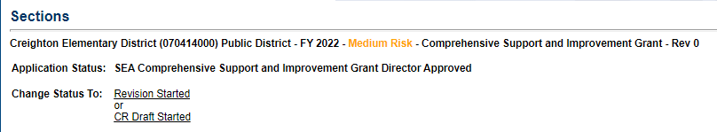
Starting a revision: Under Sections: Choose Revision Started and then click Confirm.
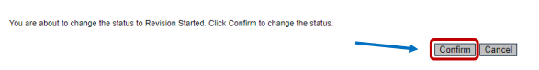

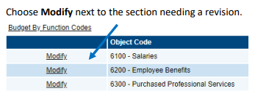

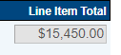
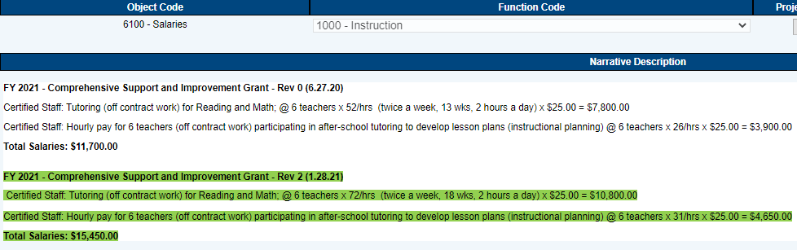
Example1: Increasing funding to a current line item expenditure.

Adjust the line item total to match the changes in the narrative.

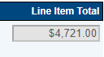
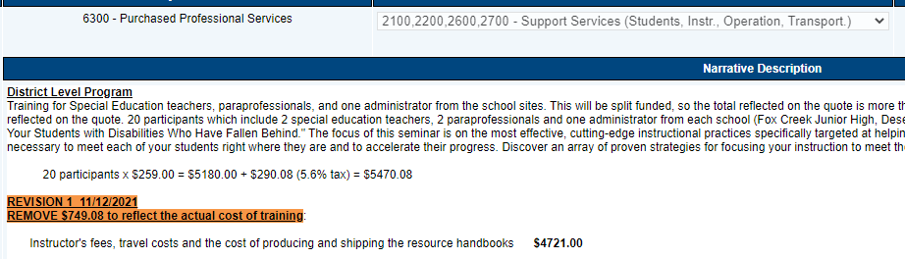
Example 2: Decreasing funding to a current line item expenditure.

Adjust the line item total to match the changes in the narrative.

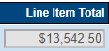
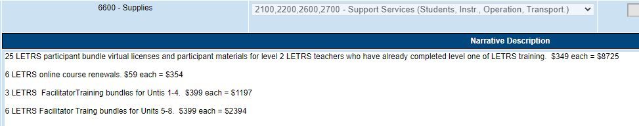
Example 3: Adding a new item to fund.
Revision 1 12/5/21 – Add new items (see quote in related documents)
25 LETRS participant bundle virtual licenses and participant materials for level 2 LETRS teachers who have already completed level 1 of LETRS training $349 each = $8725

Adjust the line item total to match the changes in the narrative.
$8725.00

Example 4: Completely removing a line item from the current budget.
When removing an item completely from the budget, choose Remove. This action will be recorded in the Change Log. The line item will be deleted from the budget.
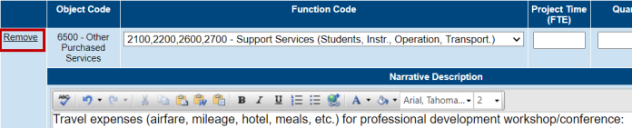

Saving revisions: Each time a change is made save the information. The save button is located at the top of the page.
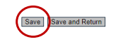
Completing a revision: Once all of your revisions have been completed and saved, return to the Sections page and choose Revision Completed and Confirm.
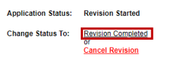

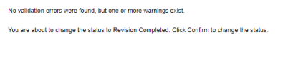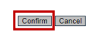
The funding application will then need LEA Business Manager Approval and LEA Authorized Representative Approval in order to be sent to ADE for Specialist and Director approval.

