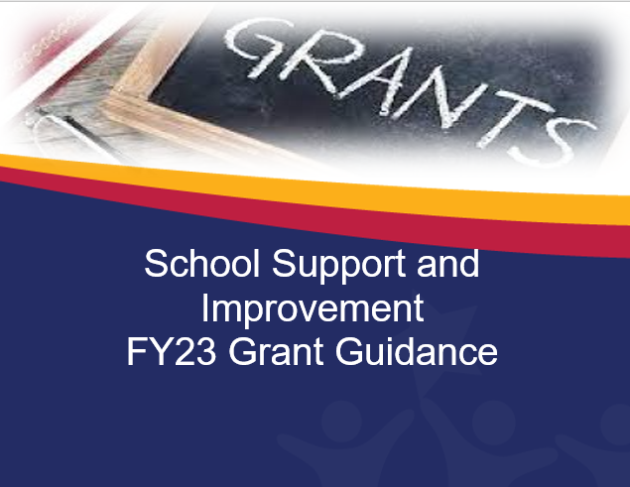

Contents
Contents
FY23 SI GRANTS 1
Comprehensive Support and Improvement (CSI) Grant 1
CSI Low Graduation Rate Grant – Opens March 1, 2022 9
Targeted Support and Improvement Schools (TSI/ATSI) 15
Systemic Leadership Development Grant – opens March 1, 2022 25
Systemic Leadership Grants for ELEVATE 28
Appendices 36
Evidence-Based Improvement ESSA Guidance 37
SSI Grant Guidelines 40
Grant Revision Requirements 42
Tutoring Plan 45
School Support and Improvement Contact List 47

FY23 SI GRANTS

FY23 CSI Grad Rate, Systemic Leadership Development and SSI Sustainability Grants Open in GME on March 1, 2022 and close May 30, 2022
- All are competitive and require detailed high-quality applications
- Require newly (2022-23) completed CNA, root cause analyses and aligned IAP
- All funded strategies and action steps must be evidence-based and aligned directly to CNA-RCA-IAP.
FY 23 Comprehensive Support and Improvement and Targeted Support and Improvement Grants Open in August, once new identification takes place.

Applications for planning purposes. Complete all sections in GME

Comprehensive Support and Improvement (CSI) Grant

This grant will open in August for LEAs with newly identified Comprehensive Support and Improvement schools.
Eligible Applicants

Newly identified CSI Low Achievement Schools

This is a competitive grant. A detailed application with all required elements and documents is required to be considered for funding.
No LEA out of fiscal and/or programmatic compliance will be considered eligible.
.
Purpose: To provide CSI schools with funding to implement aligned evidence-based strategies and action steps in the School IAP.
DIRECTIONS
- LEA and School teams collaborate to write a strong, detailed application, provide all required documents, and check and sign assurances.
  - LEA’s assigned specialist is available for assistance.
  - Use the rubric when completing application narrative questions.
- Application completion with all required documents and evidence in GME by Sept. 23, 2022 required. Additional inquiries from ADE will not be made. If all required documents are not in GME, the application will not be scored.
- The application will be scored using the scoring rubric provided.
- Awards will be made based on the scored rubric. Seventy percent of points is required for funding.
- LEAs will be notified of award or non-award by Oct. 1.

Complete all sections in GME
Program Details
  - FFATA and GSA Verification
  - Contact Information
  - Program Narrative Questions-thorough, detailed answers
  - Assurances
  - Related Documents
    - Signature Page in required related documents (required)
    - Evidence Based Summary Form/s in required related documents (required)
    - Graphs, tables and charts necessary for a complete application (optional, as needed)

Proposed Budget
Complete a proposed budget in GME. Be sure to include sufficient details in the narrative.
  - Items must support improved achievement by addressing identified root causes.
  - Items must be in IAP and aligned to CNA and RCA.
  - Be sure that the requests for funds are allowable. Out of state travel and large expenditures for capital items are generally not allowed. Check with your specialist if you have questions or need assistance building your budget.
  - Funded strategies, practices and programs must meet top three tiers of ESSA evidence.

Requirements
  - Completed 2022-23 CNA in GME
  - Thorough root cause analyses (RCA) (fishbone diagrams) in GME
  - Completed 2022-23 LEA and School IAP in GME, including SSI required goals
  - Alignment between CNA, RCA an IAP is required.

Contact Information (LEA complete once)

LEA/Charter Name | NCES ID# | CTDS# | Entity ID#
Board President | Email
Superintendent/Charter Holder | Email |  | Phone #
Federal Programs Director | Email |  | Phone #

Other- Title | Email |  | Phone #
School Name | NCES ID# | CTDS# | Entity ID#
Principal | Email |  | Phone #
School Name | NCES ID# | CTDS# | Entity ID#
Principal | Email |  | Phone #
Add additional school information, if needed
Required Related Documents Signature Page - Signatures below denote commitment to implementation, monitoring and evaluation of strategies and action steps outlined in the IAP and the grant application.

Superintendent name Date

Signature

Charter Holder name Date

Signature

Board President Name Date

Signature

Narrative Questions

School (answer separately for each school)
- Vision:
Mission:
Shared/ Core Values/Beliefs:
Latest revision date:
Note if these are not available or have not been updated recently, it is a required action plan to develop them (no loss of points).

Comprehensive Needs Assessment (CNA), root cause analyses (RCA), and Integrated Action Plan (IAP)development process

- Describe the CNA, RCA, IAP development process in detail. What process did you use, include data gathering process, the consensus process? Who was involved? What was the timeframe?

- As a result of your new 2022-23 CNA, identify the principles/indicators, primary needs, root causes, need statements and desired outcomes.

Principle | Primary Need | Root Cause | Need statement | Desired Outcome

- List both process and impact SMART goals from your IAP.

Principle | Strategy and/or action steps | Process Goal | Impact Goal

- What strategies and action steps in the school 2022-23 IAP will be funded with the FY23 CSI grant? Include timelines and responsible staff. Be sure to upload Evidence Based Summary Form/s in required related documents.

Strategy | Action Steps | Responsible Staff | Timeline

- Think five years in the future…describe your school, what it looks like, feels like, sounds like…

- Complete a proposed budget in GME. Be sure to include sufficient details in the narrative. Proposed budget with required detailed narrative in GME is accurate; line items and codes are correct, math is correct. CSI funding tags are accurate in IAP.
  - Be sure that the requests for funds are allowable. Out of state travel and large capital items are generally not allowed. Check with your specialist if you have a question or need assistance building your budget.
  - Proposed Expenditures are reflected in the IAP and aligned to the CNA and RCA.
  - Proposed expenditures have adequate narrative details.
  - Proposed expenditures are in correct function and object codes.
  - Math is correct.

LEA Support (COMPLETE ONCE)
- Describe the LEA’s plan to support the schools as they implement their IAP. Include actions, person/s responsible, timelines and measures of success.
Actions | Responsible Staff | Timeline | Measures of success

- Describe the LEA’s plan to hold school/s accountable as they implement their IAP, including monitoring and evaluating measures. Include actions, person/s responsible, and timelines.
Complete narrative description and chart
Actions | Monitoring Measures | Evaluation Measures | Responsible Staff | Timeline

- Describe the LEA’s plan to fiscally monitor school/s receiving CSI funds. Include actions, person/s responsible, and timelines.
Action Steps | Responsible Staff | Timeline

Comprehensive Support and Improvement: Low Achievement Assurances
 Complete and submit School Comprehensive Needs Assessment (CNA) in GME.
 Complete thorough root cause analyses for CNA identified primary needs, submit fishbones in GME.
 Develop LEA and School (for each school in improvement) Integrated Action Plan (L/SIAP) as required, aligned to the CNA and root
cause analyses results in GME.
 The L/SIAP includes meaningful evidence-based interventions to improve student achievement; Evidence Based Summary Form in
GME.
 Monitor, review, update, delete, retire or add strategies and action steps to the L/SIAP in GME at least quarterly.
 Ensure systems, processes, procedures, including operational flexibility are in place to actively to support Comprehensive Support
and Improvement Schools.
 Ensure effective organization of time for weekly professional learning communities (PLCs) during contract time.
 If no, add action steps to L/SIAP.
 Implement a balanced assessment system including common interim/benchmark assessments at least three times a year.
 If no, add action steps to L/SIAP.
 Implement written evidence and standards-based curriculum including materials.
 If no, add action steps to L/SIAP
 Observation and feedback protocol implemented with fidelity
 If no, add action steps to L/SIAP.
 Submit quarterly interim/benchmark assessment data reports and reflective analysis to assigned specialist.
 Identify an LEA contact person who will oversee implementation activities, maintain contact with School Support and Improvement
(SSI) staff, and accompany ADE SSI staff during site visits at the school upon request.
 Complete and submit EDFacts data when requested by ADE.
 If the LEA chooses an educational service provider (external provider) the LEA representative will provide ADE SSI with a copy of the process for selecting external providers, job description and evaluation of educational service provider services.
 Submit quarterly reimbursement requests (at a minimum).
 LEA has written procedures to implement the requirement to minimize the time elapsing between receipt and expenditure of federal funds.
 LEA has written procedures for determining the allowability of costs.
 LEA has a process ensuring equitable distribution of state funds to all schools regardless of other funding received.
 I understand that at any time during the grant period, funds can be frozen or forfeited with misuse of funds; or lack of evidence of IAP
implementation on the part of the school and/or LEA.
 I understand if the conditions herein are not adhered to or sufficient progress is not being made, a corrective action plan may be
written and implemented.

Comprehensive Support and Improvement Grant Allowable Expenditures

All Comprehensive Support and Improvement School activities funded with Title I 1003 (a) School Improvement funds must be reasonable and necessary and directly aligned to the implementation of the LEA and School Integrated Action Plan. The grant budget must address the needs identified in the schools’ Comprehensive Needs Assessment and root cause analyses and advance the overall goal to increase the academic achievement in low performing schools.
  - Data driven decision-making process
  - Strategies and action steps aligned with the CNA and root cause analyses data
  - Leadership Development activities
  - Professional Learning activities (including conferences and related travel) aligned to needs
  - Educational Service Provider (external provider) services based on specific needs identified in CNA and root cause analyses (selection process, evidence of prior success, scope of work and evaluation measures required)
  - Supplies directly related to strategies and action steps (no general supplies)
  - Positions directly aligned with CNA identified needs and root causes, necessary for IAP implementation (job descriptions required)
  - Off contract pay for work (above and beyond duties necessary to job function); planning committees, researching evidence-based interventions, curricula, assessments (aligned to CNA and Root Causes)
    - Board approved hourly rate paid, must be reasonable
    - Requires time and effort logs
Generally, this grant will not fund large capital items. Out of state travel may be approved only if absolutely necessary. This grant will NOT fund performance incentive pay or stipends.

Criteria for Compliance

Grant recipients are required to:
  - Receive EPS approval for revisions prior to implementing any change in spending or program.
- Submit timely, dated revisions for any fiscal or programmatic change.
- In accordance with sound accounting practices, LEAs are required to request timely reimbursements.
- Keep necessary Time and Effort documentation.
- Submit Completion Reports on time.

Grantees failing to meet any single requirement of compliance are subject to corrective action.

CSI Low Graduation Rate Grant – Opens March 1, 2022
Eligible Applicants

Schools identified in SY21-22 as Comprehensive Support and Improvement Schools for low graduation rate based on most current 5th year cohort data.
This is a competitive grant. A detailed, high quality application with all required elements and documents is required to be considered for funding.

Grant awards will not be made to Local Education Agencies (LEAs) that are out of compliance with state or federal requirements, fiscal or programmatic.
Purpose
To provide funding to implement Integrated Action Plan evidence-based strategies and action steps to increase graduation rate.
Directions
- LEA and School teams collaborate to write a strong, detailed application, provide all required documents, and check and sign assurances.
  - LEA’s assigned specialist is available for assistance.
  - Use the rubric when completing application narrative questions.
- Application completion with all required documents and evidence in GME by May 30, 2022, is required. Additional inquiries from ADE will not be made. If all required documents are not in GME, the application will not be scored.
- The application will be scored using the scoring rubric provided.
- Awards will be made based on the scored rubric. Seventy percent of points is required for funding.
- LEAs will be notified of award or non-award week of July 1, 2022.

Complete all sections in GME Program Details
- FFATA and GSA Verification
- Contact Information
- Program Narrative Questions
- Assurances
- Related Documents
  - Signature Page in required related documents (required)
  - Evidence Based Summary Form/s in required related documents (required)
  - Graphs, tables, and charts necessary for a complete application (optional, as needed)

Proposed Budget
Complete a proposed budget in GME. Be sure to include sufficient details in the narrative.
- Items must support improved achievement and identified root causes.
- Be sure that the requests for funds are allowable. Out of state travel and large expenditures for capital items are generally not allowed. Check with your specialist if you have questions or need assistance building your budget.

Requirements
- Completed new 2022-23 CNA in GME
- Thorough root cause analyses (fishbone diagrams) in GME
- Completed 2022-23 LEA and School IAP in GME, including SSI required goals
Contact Information

LEA/Charter Name | NCES ID# | CTDS# | Entity ID#
Board President | Email
Superintendent/Charter Holder | Email |  | Phone #
Federal Programs Director | Email |  | Phone #
Other- Title | Email |  | Phone #
School Name | NCES ID# | CTDS# | Entity ID#
Principal | Email |  | Phone #
School Name | NCES ID# | CTDS# | Entity ID#
Principal | Email |  | Phone #
Add additional school information, if needed

In Required Related Documents Signature Page - Signatures below denote commitment to implementation, monitoring and evaluation of strategies, and action steps outlined in the IAP and the grant application.

Superintendent name

Signature Date

Charter Holder name

Signature Date

Board President Name

Signature Date

FY23 Graduation Rate Grant Application

Requirements:
Completed new 2022-23 CNA, including Root Cause Analyses relative to grad rate; new 2022-23 IAP with CSI grad rate goals, strategies and grad rate tagged action steps relative to increased grad rate; Evidence-Based Summary Forms (in required documents); signature page (in required documents); proposed detailed budget in GME.

Narrative Questions:
- List 5th year cohort graduation rates for the past three years.

- List all SMART goals (process and impact) from the 2021-22 IAP with progress monitoring/evaluation data to demonstrate progress towards and/or achievement of your goals.
Goals | Progress monitoring / Evaluation data

- What grad rate strategies and action steps from the 2021-22 IAP were implemented successfully? What is your evidence of success?
Action Step | Evidence of success

- List any 2021-22 successful strategies and action steps that will continue into 2022-23 that will be funded with the FY23 Grad Rate grant. If no strategies from 2021-22 will continue to be funded with the FY23 grant, or if you did not have an FY22 Grad Rate grant, write N/A.

- As a result of your new CNA, identify the principles, primary needs, root causes, need statements and desired outcomes.

Principle | Primary Need | Root Cause | Need Statement | Desired Outcome

- What new strategies and action steps have been added to the 2022-23 school IAP that will be funded with the FY23 Grad Rate grant? Remember to upload Evidence Based Summary Form/s in required related documents.

- What is your graduation rate SMART goal?

- List other IAP goals relative to increasing grad rate (process and impact).

- How will the LEA support and monitor this grant? Be specific.

- Proposed budget with required detailed narrative in GME is accurate; line items and codes are correct, math is correct.

School Support and Improvement Assurances
- Complete and submit new School Comprehensive Needs Assessment (CNA) in GME.
- Complete thorough root cause analyses for CNA identified primary needs, submit fishbones in GME.
- Develop LEA and School (for each school in improvement) Integrated Action Plan (L/SIAP) as required based on the CNA and root cause analyses results in GME.
- The L/SIAP includes meaningful evidence-based interventions to improve student achievement, Evidence Based Summary Form submitted in GME.
- Monitor, update, delete, retire or add strategies and action steps to the L/SIAP in GME at least quarterly
- Ensure systems, processes, procedures, including operational flexibility are in place to actively to support schools in improvement.
- Identify an LEA contact person who will oversee implementation activities, maintain contact with School Support and Improvement (SSI) staff, and accompany ADE SSI staff during site visits at the school upon request.
- Complete and submit EDFacts data when requested by ADE.
- If the LEA chooses an educational service provider (external provider) the LEA representative will provide ADE SSI with a copy of the process for selecting external providers, job description and evaluation of educational service provider services, if requested.
- Submit reimbursement requests in a timely manner (if applicable).
- LEA has written procedures to implement the requirement to minimize the time elapsing between receipt and expenditure of federal funds.
- LEA has written procedures for determining the allowability of costs.
- LEA has a process ensuring equitable distribution of state funds to all schools regardless of other funding received.
- Accurate and timely submission of all required documents including plan updates and data summaries.
- I understand that at any time during the grant period, funds can be frozen or forfeited for misuse of funds; lack of evidence of IAP implementation on the part of the school and/or LEA.; or non-completion of requirements.
- I understand if the conditions herein are not adhered to or sufficient progress is not being made, a corrective action plan will be written and implemented.

CSI Graduation Rate Grant Allowable Expenditures

All Comprehensive Support and Improvement School activities funded with Title I 1003 (a) School Improvement funds must be reasonable and necessary and directly related to the implementation of the LEA and School Integrated Action Plan. It must address the needs identified in the schools’ Comprehensive Needs Assessment, aligned to the root causes and advance the overall goal to increase graduation rate.
  - Data driven decision-making process
  - Strategies and action steps based on root cause/s identified for low graduation rate
    - Leadership Development
    - Professional Learning activities and related travel costs (out of state will be considered only if necessary)
    - Supplies directly related to action steps
  - Off contract pay for work (above and beyond duties necessary to job function); planning committees, researching evidence-based interventions, curricula, assessments
    - Board approved hourly rate paid, must be reasonable
    - Requires time and effort logs
This grant will NOT fund positions, performance incentive pay or stipends or capital outlay items.

Criteria for Compliance

Grant recipients are required to:

- Receive EPS approval for revisions prior to implementing any change in spending or program.
- Submit revisions for any fiscal or programmatic change.
- In accordance with sound accounting practices, LEAs are required to request timely reimbursements.
- Keep necessary Time and Effort documentation.
- Submit Completion Reports on time.
- Grantees failing to meet any single requirement of compliance are subject to corrective action.

Targeted Support and Improvement Schools (TSI/ATSI)

This grant will open in August for LEAs with newly identified (A) Targeted Support and Improvement schools.
Eligible Applicants
LEAs with schools identified as Targeted Support and Improvement Schools (TSI/ATSI) in 2022-23 using 2021-22 data..

This is a competitive grant. A detailed application with all required elements and documents is required to be considered for funding.

Grant awards will not be made to Local Education Agencies (LEAs) that are out of compliance with state or federal requirements, fiscal or programmatic.

Purpose

To provide LEAs funding to support TSI schools to implement L/SIAP and increase achievement of identified subgroups.

Directions
- LEA and School teams collaborate to write a strong, detailed application, provide all required documents and check and sign assurances.
  - LEA’s assigned specialist is available for assistance.
  - Use the rubric when completing application narrative questions.
- Application completion with all required documents and evidence in GME by 9/23/2022 required. Additional inquiries from ADE will not be made. If all required documents are not in GME, the application will not be scored.
- The application will be scored using the scoring rubric provided.
- Awards will be made based on the scored application. Seventy percent of points is required for funding.
- LEAs will be notified of award or non-award by Oct 1.

Complete all sections in GME Program Detail
  - FFATA and GSA Verification
  - Contact Information
  - Program Narrative Questions-detailed complete answers
  - Assurances
  - Related Documents
    - Signature Page in required related documents (required)
    - Evidence Based Summary Form/s in required related documents (required)
    - Graphs, tables and charts necessary for a complete application (optional, as needed)

Proposed Budget
Complete a detailed proposed budget in GME. Be sure to include sufficient details in the narrative. It must be aligned to the CNA, RCA and IAP.
- Items must be evidence based and support improved identified subgroup achievement and identified root causes.
- Be sure that the requests for funds are allowable. Out of state travel and large expenditures for capital items are generally not allowed. Check with your specialist if you have questions or need assistance building your budget.

Requirements
- Completed new 2022-23 CNA uploaded in GME
- Thorough root cause analyses (fishbones) uploaded in GME
- Completed aligned 2022-23 LEA and School IAP in GME including SI required goals and aligned to CNA and RCA
Grants will not be scored if all requirements are not met.

Contact information

LEA/Charter Name | NCES ID# | CTDS# | Entity ID#
Board President | Email
Superintendent/Charter Holder | Email |  | Phone #
Federal Programs Director | Email |  | Phone #
Other- Title | Email |  | Phone #

Required Related Documents LEA Signature Page - Signatures below denote commitment to implementation, monitoring and evaluation of strategies and action steps outlined in the IAP and the grant application.

Charter Holder Date

Signature

Board President Date

Signature

Superintendent Date

Signature

Targeted Support and Improvement School (TSI/ATSI) Application

- List all identified Targeted Support and Improvement Schools, current enrollment, principal, and the identified subgroup/s (add lines as necessary)
School Name | School Enrollment | Principal | Identified Subgroup/s
- Describe the School Comprehensive Needs Assessment process. Who was involved? What process was used to gather data? What was the consensus process? What was the general timeframe?

- Based on the School CNA and leading and lagging indicator data analysis, what are the primary needs, root cause, desired outcomes and goals relative to each identified subgroup’s low achievement for each school.
School | Subgroup | Primary Need | Root cause | Desired outcome | Process or Impact SMART Goal

School | Subgroup | Primary Need | Root cause | Desired outcome | Process or Impact SMART Goal

School | Subgroup | Primary Need | Root cause | Desired outcome | Process or Impact SMART Goal

Add charts as needed

- Looking across all schools in your LEA, identify trends to be addressed, the strategies, action steps and goals with evidence of success to be funded by this grant. These strategies and action steps should be in the LEA IAP.
LEA Trend | Strategy | Action Step | LEA SMART  Goal | Evidence of success | Person/s responsible | Timeline
Add lines as needed

5.. List individual school primary needs, strategies and action steps, and evidence of success with timelines and responsible party to be funded by this grant.
School | Primary Need | Strategy | Action Step | Evidence of succcess | Person/s responsible | Timeline
- It is the LEA’s responsibility to support and monitor each school with low achieving subgroups, per ESSA statute.

Describe the LEA plan to communicate expectations and hold all identified TSI schools accountable for the implementation of the IAP’s TSI strategies, action steps and goals to increase achievement for identified subgroups.

- Communication Plan
Describe how the LEA will communicate current TSI status with each identified school, share data, and establish TSI expectations. Include what communication strategies the LEA will use, who is responsible, timeline/frequency of communication, monitoring and evaluating measures of success of communication strategies.

Communication Strategy | Responsible person/s | Timeline | Measures of success (How will you know the communication strategies are working)
Add lines as necessary

- Accountability Plan
Describe how the LEA will hold identified schools responsible for TSI action items, implementation of grant funded strategies, action steps and goals to raise achievement. Be specific on the methods the LEA will use, who is responsible, timeline and frequency as well as how the accountability methods will be monitored and evaluated for success.

Accountability Plan Strategies/methods | Responsible person/s | Timeline | Measure of success (How will you know the accountability strategies

are working)
Add lines asnecessary

- Proposed budget with required detailed narrative in GME is accurate; line items and codes are correct, math is correct. TSI funding tags are accurate in IAP. Complete a proposed budget in GME. Be sure to include sufficient details in the narrative.
  - Be sure that the requests for funds are allowable. Out of state travel and large capital items are generally not allowed. Check with your specialist if you have a question or need assistance building your budget.
  - Proposed Expenditures are reflected in the IAP and aligned to the CNA and RCA.
  - Proposed expenditures have adequate narrative details.
  - Proposed expenditures are in correct function and object codes.
  - Math is correct

Proposed Budget
    - Complete a proposed budget in GME. Be sure to include sufficient details in the narrative. Maximum allocations will be based on school enrollment.
School enrollment | Maximum Allocation
~350 | $15,000
351-600 | $20,000
601-900 | $25,000
>900 | $30,000

      - Allocation will be in District Level Programs; you will not be creating dropdowns for each school
      - Indicate specific school expenditures in the budget narrative (similar to the ESEA Consolidated Application)

Grant narrative example
Purchase Conscious Discipline Materials to support SEL needs of identified subgroups (Economically disadvantaged and students with disabilities) Total $3,931.00
LEA Leadership Team
5
Conscious Discipline Books
$ 145.00
Sunshine School

1 | E-Course site license | $ 779.00
1 | Premium Resources | $ 70.00
42 | Conscious Discipline Books | $1,218.00
Total |  | $2,067.00
Lizard School
1 | E-Course site license | $ 779.00
1 | Premium Resources | $ 70.00
30 | Conscious Discipline Books | $ 870.00
Total |  | $ 1719.00

    - Items must support improved subgroup achievement, be evidence-based, and aligned to CNA and identified root causes.
    - Proposed expenditures must be specific. Amounts for general items will be disallowed and that funding forfeited.
    - Be sure that the requests for funds are allowable. Out of state travel and large expenditures for capital items are generally not allowed. Check with your specialist if you have questions or need assistance building your budget.

TSI Grant Allowable Expenditures

All TSI School activities funded with Title I 1003 (a) School Improvement funds must be reasonable and necessary and directly related to the implementation of the LEA and School Integrated Action Plan relative to increasing subgroup achievement and aligned to the needs and root causes identified in the schools’ Comprehensive Needs Assessment. Proposed expenditures must be specific.

Amounts for general items will be disallowed.

  - Data driven decision-making process
  - Specific strategies and action steps based on root cause/s identified for increasing subgroup achievement
- Leadership Development
- Professional Learning activities and related travel costs (out of state travel may be approved only if necessary)

- Specialized supplies directly related to supporting action steps
  - Off contract pay for work (above and beyond duties necessary to job function); planning committees, researching evidence- based interventions, curricula, assessments
- Board approved hourly rate paid, must be reasonable
- Requires time and effort logs
This grant will NOT fund performance incentive pay or stipends, large capital outlay items or general supplies. Prior approval of positions is recommended,

Criteria for Compliance

Grant recipients are required to:

- Receive EPS approval for revisions prior to implementing any change in spending or program.
- Submit revisions for any fiscal or programmatic change.
- In accordance with sound accounting practices, LEAs are required to request reimbursements monthly.
- Keep necessary Time and Effort documentation.
- Submit Completion Reports on time.
- Grantees failing to meet any single requirement of compliance are subject to corrective action.

Systemic Leadership Development Grant – opens March 1, 2022

Eligible Applicants
LEAs with schools identified as Comprehensive Support and Improvement Schools (CSI) and/or Targeted Support and Improvement Schools (TSI/ATSI).

Purpose To provide funding to LEAs with CSI and/or TSI Schools for participation in approved systemic leadership education or executive leadership programs and any required related costs

Due date: May 30, 2022

Complete all sections in GME
- Program Details
  - Contact Information
  - Narrative questions
  - Assurances
- Proposed budget with detailed narrative

Required Related Documents
  - Signature Page
  - Selected Leadership Program application/information
    - Official program description or brochure including benefits, details program long-term and short-term goals, program elements, participant eligibility, participation dates, length of program, program research base

Optional Related Documents
  - Funding release form as needed
  - Evidence based Summary Form as needed

Contact Information

LEA/Charter Name | NCES ID# | CTDS# | Entity ID#
Board President | Email
Superintendent/Charter Holder | Email |  | Phone #
Federal Programs Director | Email |  | Phone #
Other- Title | Email |  | Phone #
School Name | NCES ID# | CTDS# | Entity ID#
Principal | Email |  | Phone #
Add school name and principal information for each school that will be participating
Program Details Questions answer all questions if first year applying for this Program. Answer #1, 8 and 9 if continuing and mark remaining N/A
Special Note:
If in the first year, please answer question 1-7 and mark N/A for questions 8 and 9. If in the second year, please answer #1, 2, 6-9 only, and mark N/A on questions 3-5.

  - What Leadership Development Program does the LEA want to attend?
  - List schools that will participate
  - What are the short-term and long-term goals of the program? Add the brochure or other official program document/s in related documents. (NA if second year of attendance)
  - Why was this program selected? (NA if second year of attendance)
  - What is the length of the program? (NA if second year of attendance)
  - What is the registration cost?
  - Are there related costs other than registration?
  - List three critical learnings and actions taken as a result of program attendance. (N/A if first year of program)
  - List 2-3 goals you plan on achieving by your continued attendance to the program. (N/A if first year of program)

Required Related Documents
Signature Page - Signatures below denote commitment to implementation, monitoring and evaluation of strategies and action steps outlined in the IAP and the program requirements.
Charter Holder Date

Signature

Board President Date

Signature

Superintendent Date

Signature

Systemic Leadership Grants for ELEVATE

Approval to Use 1003(a) Funds

LEA approves the use of 1003(a) funds by the Arizona Department of Education to directly provide the ELEVATE, Executive Leadership Program, including all costs for convenings/conferences; including conference location, food, speakers, and all materials to improve student achievement, instruction, LEAs and schools.

Superintendent Printed Name

Superintendent’s Signature

Date

Systemic Leadership Development Grant Allowable Expenditures
- Cost of approved program
- Related travel costs
- Substitute costs
- Cost of any required program coach or mentor

Systemic Leadership Development Grant Assurances

- Commitment to make the selected leadership program a top priority
- Adherence to all program requirements including:
  - Completion of program’s planning requirements (i.e. 90-day plans)
  - Participation of the top LEA leadership (including Superintendent) in systemic program/process/plan implementation, monitoring and evaluation required by selected program
  - Participation of the school leadership team in systemic program/process/plan implementation, monitoring and evaluation required by selected program
  - Top LEA leadership (including Superintendent) and school leadership teams attendance and active, positive participation in every convening/training/meeting School leadership (principal and other appropriate personnel) regularly conduct short cycle observation and feedback classroom visits in addition to evaluation observation
  - Effective organization of time for weekly structured professional learning communities (PLCs)
  - LEA leadership (including Superintendent) regularly conduct site visits to focus on successful planning and implementation of program plans (i.e. 90-day plans) and/or Integrated Action Plan
  - Planning for sustainability of systematic changes made as a result of the program

- Submission of timely reimbursement requests
- Submission of summary reports as requested by ADE

FY23 School Improvement Sustainability Grant – opening March 23, 2022
Purpose: This grant is to provide additional funding to sustain and/or expand successful strategies and action steps implemented during the prior year using school improvement funding.

Eligible Applicants

To be eligible for the FY23 School Improvement Sustainability Grant LEA/school must meet ALL the following requirements:
- Identified for CSI low achievement, CSI Low Grad Rate, TSI or participated in ELEVATE Cohorts 3-5, MTSS, SIG Cohort 5 schools
- Received an FY22 Grant from School Support and Improvement
- Submitted Grant Evaluation Tool reflection to program specialist (CSI/TSI)
- Completed new 2022-23 CNA in GME
- Conducted thorough root cause analyses (fishbone diagrams) in GME
- Completed 2022-23 LEA and School IAP in GME, including SSI required goals
This is a competitive grant. A detailed application with all required elements and documents is required to be considered for funding. No LEA out of fiscal and/or programmatic compliance will be considered eligible.

Directions
- LEA and School teams collaborate to write a strong, detailed application, provide all required documents, and check and sign assurances.
- Complete all sections in GME Program Details
  - FFATA and GSA Verification
  - Contact Information
  - Program Narrative Questions
  - Assurances
  - Related Documents
    - Signature Page in required related documents (required)

    - Evidence Based Summary Form/s in required related documents (required)
    - Graphs, tables, and charts necessary for a complete application (optional, as needed)
  - Proposed Budget
O Complete a proposed budget in GME. Be sure to include sufficient details in the narrative.
O Items must support improved achievement by addressing identified root causes.
O Be sure that the requests for funds are allowable. Out of state travel and large expenditures for capital items are generally not allowed. Check with your specialist if you have questions or need assistance building your budget.
- Application completion with all required documents and evidence in GME by May 30, 2022 is required. Additional inquiries from ADE will not be made. If all required documents are not in GME, the application will not be scored.
- The application will be scored using the scoring rubric provided.
- Awards will be made based on the scored rubric. Seventy percent of points is required for funding.
- LEAs will be notified of award or non-award by July 1.

Contact Information

LEA/Charter Name | NCES ID# | CTDS# | Entity ID#
Board President | Email
Superintendent/Charter Holder | Email |  | Phone #
Federal Programs Director | Email |  | Phone #
Other- Title | Email |  | Phone #
School Name | NCES ID# | CTDS# | Entity ID#
Principal | Email |  | Phone #
Add additional school information, if needed

Required Related Documents

Signature Page - Signatures below denote commitment to implementation, monitoring and evaluation of strategies and action steps outlined in the IAP and the grant application.
Superintendent name Date

Signature

Charter Holder name Date

Signature

Board President Name Date

Signature Narrative Questions (answer for each school)
- Identify Previous School Improvement Grants your LEA/School has received, when and for how much
Name of Previous Grants Received | Fiscal Years | Funding amount

- Provide evidence of success for the previously funded strategies/action steps in your FY22 grant application. Address the impact this work has had on participating schools. If different by school, please explicitly outline that in the narrative.
Evidence may include:
  - Student data analysis (e.g., academic, behavior, attendance that has improved).
  - Systems/implementation analysis (e.g., findings from a Diagnostic Review, perception surveys, classroom observations, etc. and how they have changed)
chool name/s or All Schools | Strategy or action step | Evidence of success

- Summarize the work that has been completed to address past needs, desired outcomes and successes using previous SSI grant
funding and frame the need for continuation of future funding. (reflection)
What Principles or Indicators were addressed in FY22? | What was the identified root cause? | What was the original primary need? | What is the current state of implementation? | What is the desired outcome for 2022-23?

- Describe action steps that need to continue to achieve the Desired Outcomes for 2022-23 identified in question 3. Include timeline for proposed action steps, performance targets (goals along the way) and how action steps will be monitored and finally evaluated for success.
Desired Outcome for 2022-23 (from  question #3) | Action Steps  Include timeline | Performance Targets/Benchmarks Include dates/timing | Describe the data that will be collected to monitor progress (along the way) of this action step. Include  dates/timing | Describe how this action step will be evaluated for successful impact on the desired outcome.

Provide a detailed proposed budget.

LEA Narrative Questions

- Explain how, if awarded, the LEA will support its identified schools to ensure that school improvement services, activities, and/or grants are on track and in alignment with their improvement plans and sustain improvements.

- Describe the plan for how the district will support continued sustainability of the knowledge and work after grant funding ends.

School Improvement Assurances
 Complete and submit School Comprehensive Needs Assessment (CNA) in GME.
 Complete thorough root cause analyses for CNA identified primary needs, submit fishbones in GME.
 Develop LEA and School (for each school in improvement) Integrated Action Plan (L/SIAP) as required based on the CNA and root cause analyses results in GME.
 The L/SIAP includes meaningful evidence-based interventions to improve student achievement, Evidence Based Summary Form in GME.
 Monitor, update, delete, retire or add strategies and action steps to the L/SIAP in GME at least quarterly.
 Ensure systems, processes, procedures, including operational flexibility are in place to actively to support Comprehensive Support and Improvement Schools.
 Ensure effective organization of time for weekly professional learning communities (PLCs).
 If no, add action steps to L/SIAP.
 Implement a balanced assessment system including common interim/benchmark assessments at least three times a year.
 If no, add action steps to L/SIAP.
 Implement written evidence and standards-based curriculum including materials.
 If no, add action steps to L/SIAP
 Observation and feedback protocol implemented with fidelity
 If no, add action steps to L/SIAP.
 Submit quarterly interim/benchmark assessment data reports and reflective analysis in GME.
 Identify an LEA contact person who will oversee implementation activities, maintain contact with School Support and Improvement
(SSI) staff, and accompany ADE SSI staff during site visits at the school upon request.
 Complete and submit EDFacts data when requested by ADE.
 If the LEA chooses an educational service provider (external provider) the LEA representative will provide ADE SSI with a copy of the process for selecting external providers, job description and evaluation of educational service provider services.
 Submit quarterly reimbursement requests.
 LEA has written procedures to implement the requirement to minimize the time elapsing between receipt and expenditure of federal funds.
 LEA has written procedures for determining the allowability of costs.
 LEA has a process ensuring equitable distribution of state funds to all schools regardless of other funding received.
 I understand that at any time during the grant period, funds can be frozen or forfeited for lack of timely reimbursement requests with
evidence of use; misuse of funds; or lack of evidence of IAP implementation on the part of the school and/or LEA.
 I understand if the conditions herein are not adhered to or sufficient progress is not being made, a corrective action plan will be
written and implemented.

Sustainability Grant Allowable Expenditures

All activities funded with Title I 1003 (a) School Improvement funds must be reasonable and necessary, evidenced-based and directly aligned to the implementation of the LEA and School Integrated Action Plan. The grant budget must address the needs identified in the schools’ Comprehensive Needs Assessment and root cause analyses and advance the overall goal to increase the academic achievement in low performing schools. For the purposes of this grant, successful strategies and action steps needed to sustain improvement.
  - Data driven decision-making process
  - Strategies and action steps aligned with the CNA and root cause analyses data
  - Leadership Development activities
  - Professional Learning activities (including conferences and related travel) aligned to needs
  - Educational Service Provider (external provider) services based on specific needs identified in CNA and root cause analyses (selection process, evidence of prior success, scope of work and evaluation measures required)
  - Supplies directly related to strategies and action steps (no general supplies)
  - Positions directly aligned with CNA identified needs and root causes, necessary for IAP implementation (job descriptions required)
  - Off contract pay for work (above and beyond duties necessary to job function); planning committees, researching evidence- based interventions, curricula, assessments (aligned to CNA and Root Causes)
    - Board approved hourly rate paid, must be reasonable
    - Requires time and effort logs
Generally, this grant will not fund large capital items. Out of state travel may be approved, only if absolutely necessary.

This grant will NOT fund performance incentive pay or stipends.

Criteria for Compliance

Grant recipients are required to:
  - Receive EPS approval for revisions prior to implementing any change in spending or program.
- Submit timely, dated revisions for any fiscal or programmatic change.
- In accordance with sound accounting practices, LEAs are required to request timely reimbursements.
- Keep necessary Time and Effort documentation.
- Submit Completion Reports on time.

Grantees failing to meet any single requirement of compliance are subject to corrective action.

Appendices

Evidence-Based Improvement ESSA Guidance
ESSA Evidence Tiers ESSA (Section 8002) outlines four tiers of evidence. The table below includes ESSA’s definition for each of the four tiers, along with a practical interpretation of each tier.
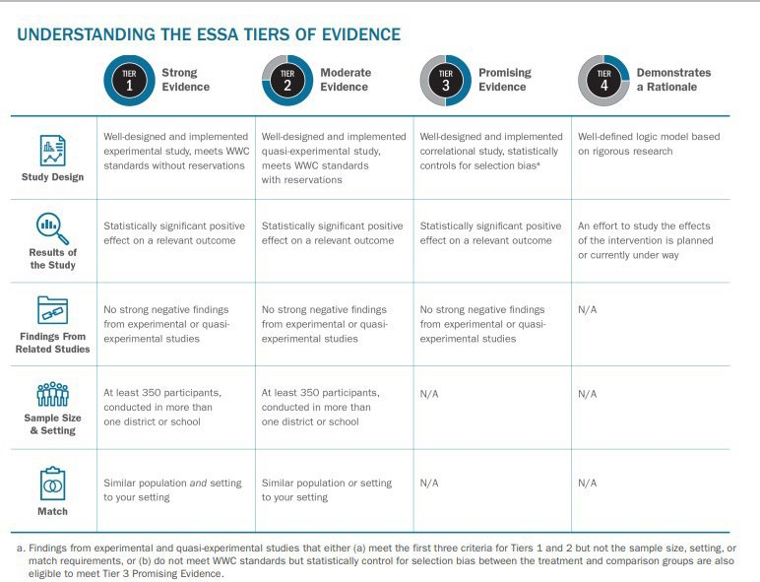

School Improvement Grants fund strategies and action steps using strategies, practices, programs, and interventionsi with strong, moderate, or promising evidence. “Demonstrating a Rationale” is not an allowable evidence base for schools in school improvement.

The table below includes ESSA’s definition for each of the four tiers, along with a practical interpretation of each tier.
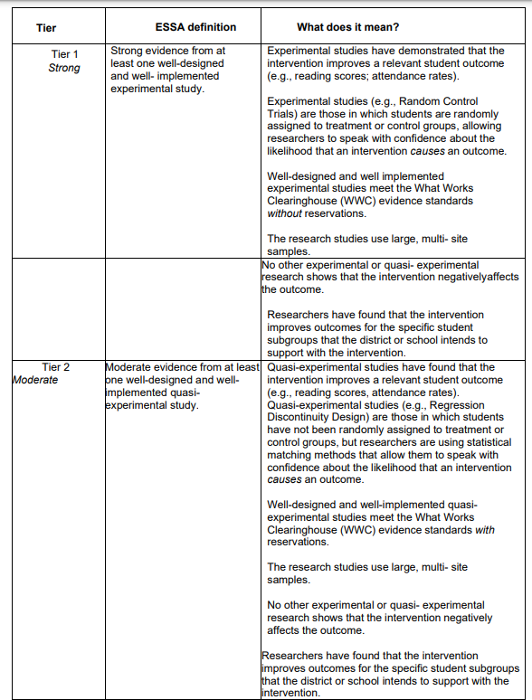

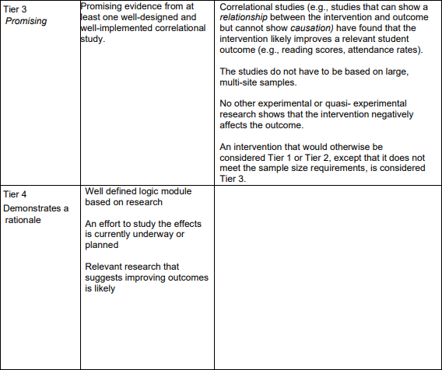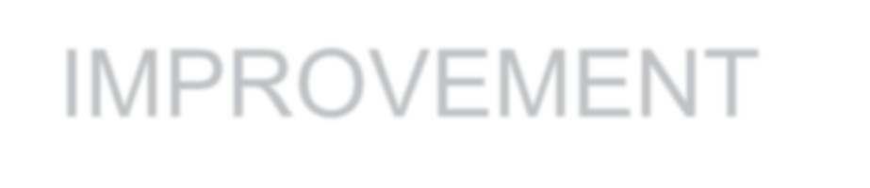
NOT ALLOWED FOR SCHOOL IMPROVEMENT

Evidenced-based improvement allows states and schools flexibility in choosing interventions however, it also brings more local responsibility. It becomes the combined responsibility of the state and the school to ensure that they align improvement efforts, at all tiers of instruction, to solid evidence.
LEA and school leadership teams can utilize multiple resources to determine whether a strategy, practice, program or intervention meets the Strong, Moderate, or Promising ESSA evidence requirements based on rigorous studies from a reputable third-party evaluator.

RESOURCE AVAILABLE HERE: ESSA-Evidence Based Requirements and Resources
Searchable data base of evidence-based programs, practices, and interventions
See Guidance on the ESSA Levels of Evidence for School Improvement Grants Evidence-Based Practices, Strategies, Programs and Intervention Articles and Resources | Arizona Department of Education (azed.gov) and the Evidence-Based Research Requirements (ESSA) Module Support & Improvement: Professional Learning | Arizona Department of Education (azed.gov) for specific information, support and resources.

SSI Grant Guidelines

Below are examples of the level of detail required in the budget narrative. Please refer to the USFR or USFRCS for additional guidance on coding.
This document provides samples but is not an all-inclusive list of approvable formats, costs, etc.

6100 Salaries
Function Code 1000 (direct instructional contact with students)
Board adopted salary or hourly
Detail needed: # of staff x # of hours x hourly rate = total; FTE x salary = total What is the pay for? (example: after school tutoring, substitutes)
Position example: reading interventionist
*Job description required for positions
*Tutoring plan required for tutoring programs
*Stipend amounts are not allowed – must break down hours x hourly rate

Function Code 2100, 2200, 2600, 2700 (staff)
Board adopted hourly rate
Detail needed: # of staff x # of hours x hourly rate = total; FTE x salary = total
What is the pay for? (example: off contract committee work to research math curriculum) Position example: data coach
*Job description required for positions
*Stipend amounts are not allowed – must break down hours x hourly rate

6200 Benefits
All Function Codes
Board adopted rates
Benefits are required for each position in 6100. Exceptions must be noted in your narrative. Provide the percentage used in your cost calculation for related benefits

6300 Purchased Professional Services
Function code 2100, 2200, 2600, 2700 (staff)
TBD based on provider services or conference fees
Educational Service Provider (external provider/consultant) Detail needed: Who? What? When? For whom?
How much? # of days x daily rate =
*Scope of work with deliverables required for external providers/consultants
Professional Learning Activities
Detail needed: Who? What? When? For whom? How much? # of days x daily rate =
Conference registration *Conference brochure or agenda required Detail needed: Conference name, location? length? Who is attending? Registration cost x # of staff =
Function Code 2300, 2400, 2500, 2900 (administrators)
TBD based on provider services or conference fees
Leadership Development
Detail needed: Who? What? When? For whom? How much? # of days x daily rate =
*Scope of work with deliverables required for external providers/consultants

Professional Learning Activities
Detail needed: Who? What? When? For whom? How much? # of days x daily rate =
Conference registration *Conference brochure or agenda required Detail needed: Conference name, location? length? Who is attending? Registration cost x # of staff =

6500 Travel Costs
Function Code 2100, 2200, 2600, 2700 (staff)
TBD based on state per diem or board adopted rates
Travel expenses related to conferences attended by staff. Detail needed: Conference name and date Transportation cost (airfare or mileage) x # of staff = Hotel room cost x nights x # of staff =
Per Diem x # days x # of staff =
*Please check conference details. If breakfast and lunch are provided at the conference, per diem cannot be reimbursed for these meals.

Function Code 2300, 2400, 2500, 2900 (administrators)
TBD based on state per diem or board adopted rates
Travel expenses related to conferences attended by administrators. Detail needed: Conference name and date
Transportation cost (airfare or mileage) x # of administrators = Hotel room cost x nights x # of administrators =
Per Diem x # days x # of administrators =
*Please check conference details. If breakfast and lunch are provided at the conference, per diem cannot be reimbursed for these meals.

6600 Supplies
Function Code 1000 (direct instructional contact with students)
TBD
Curricular materials, instructional kits, site licenses, etc. for student use Detail needed: Who will use? What is the purpose?
Item name x # of items x cost =
*Miscellaneous office supplies and student rewards not allowed.
*Quotes are needed for all items.

Function Code 2100, 2200, 2600, 2700 (staff)
TBD
Supplies for staff, professional learning books, etc. Detail needed: Who will use? What is the purpose? Item name x # of items x cost =
*Miscellaneous office supplies not allowed
*Quotes are needed for all items.

SSI Grant recipients are required to:
- Receive EPS approval for revisions prior to implementing any change in spending or program.
- Submit revisions for any fiscal or programmatic change.
- In accordance with sound accounting practices, LEAs are required to request reimbursements monthly.
- Keep necessary Time and Effort documentation.
- Submit Completion Reports on time.

*Grantees failing to meet any single requirement of compliance are subject to possible funding forfeiture or having funds placed on hold.

Grant Revision Requirements

-A remaining balance of zero is necessary.
*Do not delete any of the original narrative – add to/below the original narrative.
-Note the revision # and date of revision (i.e. Revision #1, Oct. 5, 2021)
-Use a different color font for each new revision or highlight the new revision.

-Be detailed in your narrative to indicate if an expenditure increased, decreased, or was added.

-Double check your math. The total in the narrative must match the line item total.
-Upload any revised quotes, scopes of work, evidence-based summary forms, etc.

-Revise your IAP to match the revision in GME. Add/remove any funding tags if needed.

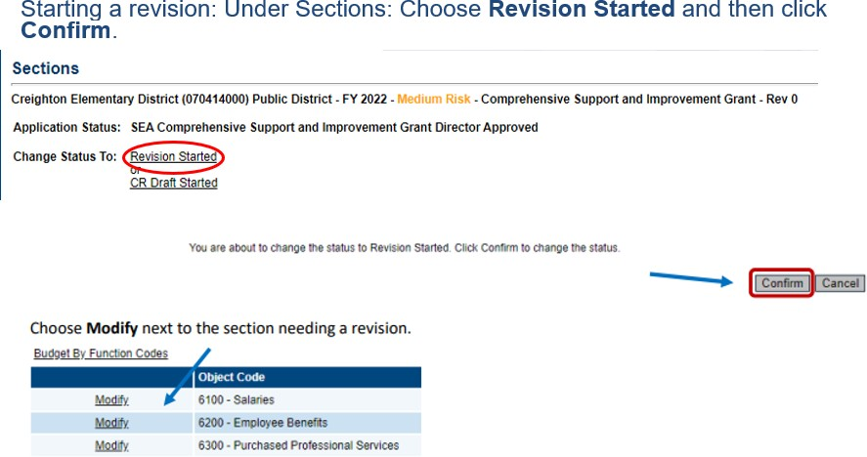

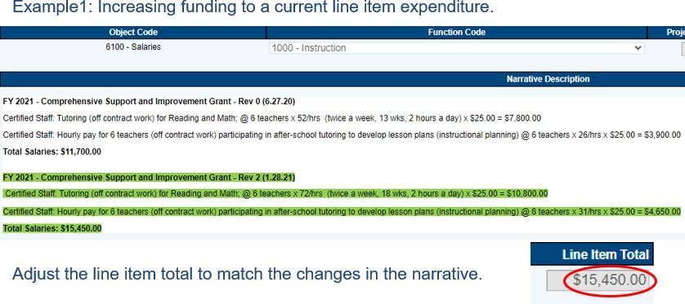

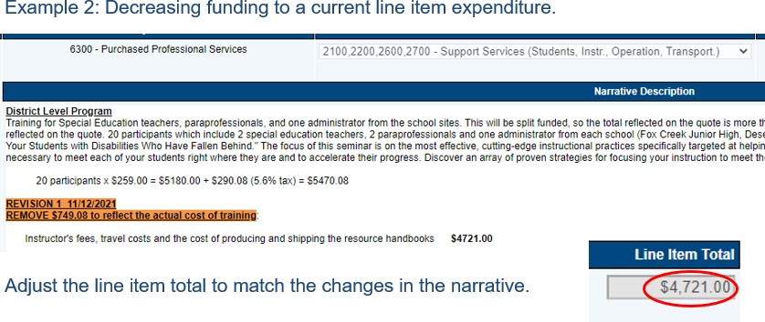

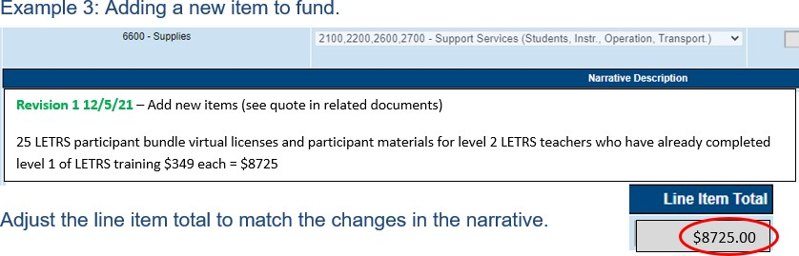

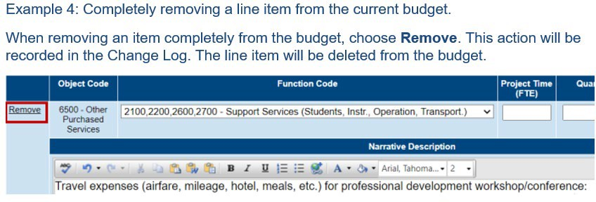

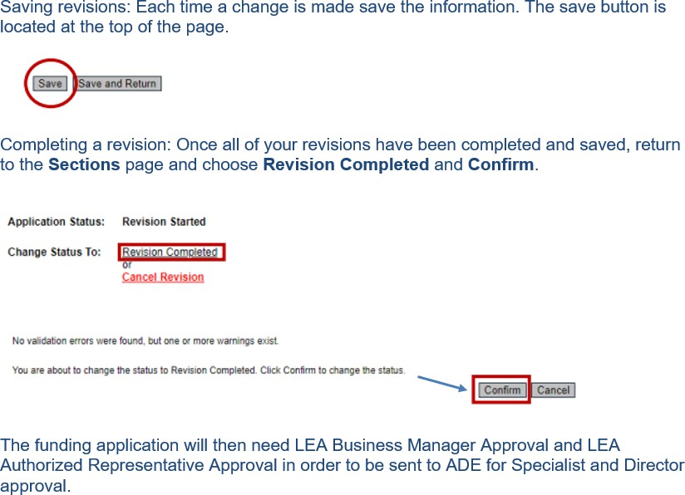

Tutoring Plan
For use of School Improvement Grant Funds (CSI, TSI, SIG)

When using any school improvement funds for a tutoring program, an explicit plan must be provided to ensure that the instruction is targeted, evidence-based and different than instruction provided during the school day. Tutoring time may not be used as a study hall, work completion opportunity or homework room.

LEA:

School:

Circle Grant: CSI TSI SIG

Tutoring Purpose: content area/s and expected outcomes

Targeted Students Populations:

Tutoring Dates:
Tutoring Session Times:

Staffing: Who is teaching the tutoring groups (positions, not names; every effort should be made to assign highly effective teachers; required to be effective teachers)?

Student Identification for Participation: How will students be identified; indicate data to be used, including instruments/assessments?

Program Content: What evidence-based material are being used?

Program and Pedagogy: How is the tutoring different from core instruction?
Student Progress Monitoring: What data will be used to measure progress in the program? (including monitoring instruments/assessments and intervals/timelines)

Program Monitoring: How will the tutoring program be monitored? (including who will oversee the project?)

Program Evaluation: How will the tutoring program be evaluated?
Accessibility: How will equitable accessibility be ensured for all eligible (identified subgroup) students; will transportation be provided?

TSI **If providing tutoring to students with disabilities, the following assurances apply: The school/LEA assures that:
- FAPE services are provided during the school day.
- Tutoring services are above and beyond what is stated in the IEP.
- Tutoring services will be accessible to all eligible students in the target population Initialing the boxes and the signature below assures to the conditions described.

Signature (superintendent or designee)

Print Name and Title

Date

School Support and Improvement Contact List

Devon Isherwood, Deputy Associate Superintendent
Christina Pou Aldrich, Director, School Support and Improvement Jennifer Zorger Education Program Specialist, Phoenix
Peggy Fontenot, Education Program Specialist, South Sarah Barnes, Education Program Specialist, South Becca Moehring, Education Program Specialist, Phoenix Jennifer Spaniak, Education Program Specialist, Phoenix Katy Plencner, Education Program Specialist, Phoenix Amanda Wilber, Education Program Specialist, Phoenix
Kelly Curtin, Education Program Specialist, Phoenix
Ken Rausch, Education Program Specialist, Phoenix Michael Hansen, Education Program Specialist, Phoenix Chelle Kemper, Education Program Specialist, Phoenix Serena Lobo, Education Program Specialist, TSI, Phoenix

Cindy Richards, Project Specialist

