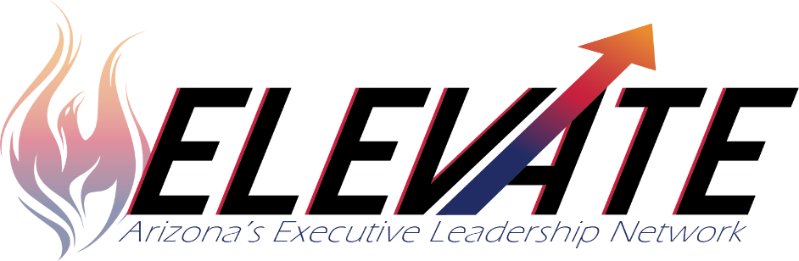

Elevate is a highly successful, evidence-based two-year Systemic Leadership Development Program for LEA and school leadership teams to learn, plan and implement positive, systemic change together. Some convenings are virtual and some are in person.
Elevate offers:
- Equity focused, strength-based leadership
- Improvement levers of Culture; Talent Management; and Instructional Infrastructure, curriculum, instruction, assessment, observation and feedback and data drive instruction and decision making
- Systems change theory coupled with Implementation Science and Improvement Science
- Integration of Social Emotional Learning and Multi-Tiered Systems of Support
- Teaming structures and collective efficacy
- Ongoing mentorship and support for site leaders
- Networking opportunities
Gaining Knowledge
- LEA Team Bootcamp
- Four three-day convenings each year
- Scope and sequence for three improvement levers and their components, change process, equity, and strengths-based leadership
- National and local presenters and Case Studies
- Panorama partnership with staff and student voice surveys
- Team time for learning, discussing, and planning next steps

Taking Action
- Utilize ELEVATE evidence-based, best practices improvement lever continua to build capacity in the three school improvement levers to impact system transformation to improve student outcomes
- Eliminate the Knowing-Doing Gap
- Utilize Panorama surveys to develop teacher and staff well-being, build supports for the whole child and create welcoming, inclusive learning environments where all students belong and thrive
- Develop and implement implementation plans based on Integrated action plan and systemic and systematic change
- Transform and sustain effectives systems in LEA and schools

“Courage is contagious. A critical mass of brave leaders is the foundation of an intentionally courageous culture. Every time we are brave with our lives, we make people around us a little braver and our organizations bolder and stronger." Brene’ Brown

Funding is available for LEAs with CSI and/or TSI schools
Contact: Christina Aldrich⏐christina.aldrich@azed.gov⏐602-364-2202

