FY23 CNA, RCA, IAP Timeline & Checklist
LEA: | School(s): | Classification(s):
FY23 Planning Process & Timeline At-A-Glance
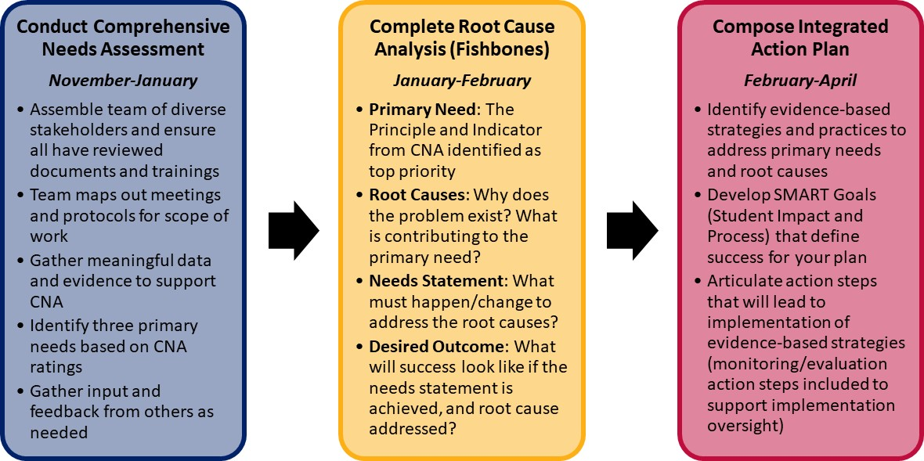

Detailed Checklist of Planning Process

Pre-Planning
- School and LEA contact forms have been completed at www.azed.gov/improvement (for CSI and TSI schools)
- Principal/school leader has access to the GME Planning Tool.
- Assemble planning team with various stakeholders/staff members to do CNA and IAP.
- Training modules, guidance documents, and necessary materials have been distributed to the team.
- A timeline with meeting dates has been developed to guide the completion of the team’s tasks ahead
(option to use the CNA and IAP Team Planning doc).

Comprehensive Needs Assessment (CNA)
- Team reviews CNA in entirety and uses data and evidence to rate each Indicator.
- Team has identified Principles and Indicators with lowest scores in order to prioritize 3-4 Primary Needs. These will be used for the Root Cause Analysis.
- Indicator ratings are entered into GME. [Planning > IAP > CNA Principles 1-6 (REQUIRED)]
- Complete CNA Data Assurances in Data Tab in GME. [Planning > Integrated Action Plan > Data Tab]

Root Cause Analysis (RCA)
- Team completed a Fishbone Diagram (Root Cause Analysis) for each of the identified primary needs from the CNA (must have 3).
- Every fishbone includes:
  - (Head) Primary Need: Principle and Indicator from CNA that has been determined as a top priority and is a low score/undesirable outcome. Should be stated as a problem and phrased in a negative (i.e. “2.4 Our teachers do not implement evidence-based, rigorous instruction…”)
  - (Bones) Root Causes: The most influential contributing factors that are causing the undesired outcome/need. These should be categorized and answer “Why is the problem existing? What is contributing to the problem? Who plays a role in contributing to the problem?”
  - Overall Root Cause: The synthesis of the most powerful root cause(s) that the team will work to correct in the future.
  - (Tail) Need Statement: Summary of what needs to change to fix the overall root cause. At a high level, what does the team believe needs to happen in order to correct the overall root cause and address the undesired primary need?
  - Desired Outcome: Determine what success will look like if the needs statement is achieved and the root causes addressed. What will be true if you accomplish what is articulated in the need statement?
- (TSI Only) - TSI Subgroups must be considered and clearly represented in the root cause analysis by either embedding within the root causes/categories or by creating a separate fishbone just for that subgroup need.
- Fishbone documents are uploaded into GME. [Planning > IAP > Related Documents]
- Final CNA Summary entered in GME. [Planning > IAP> CNA Final Summary (REQUIRED)]

Evidence-Based Strategies and Practices
- Team has determined evidence-based strategies and practices that will support the achievement of the desired outcomes from the root cause analyses. The strategies you have selected must be in classified in one of the top three tiers: Strong, Moderate, Promising.
- The strategies that have been selected are classified in one of the top three tiers: Strong, Moderate, Promising for School improvement; including Tier 4, Provide a Rationale for Title l, ll, lV-A
- (Required for CSI and TSI Grant Applicants) Complete and upload Evidence-Based Summary form(s) for each grant-funded strategy, intervention, program, or practice. [Funding Application > (select grant) > Related Documents]

SMART Goals
- Team has developed all required SMART goals based on your school/district’s classification(s). See
chart below for reference.
- SMART Goals include the necessary components:
  - S- Specific: Focused, tangible outcome, clear/defined
  - M- Measurable: Clearly names how success will be measured, ability to track progress
  - A- Attainable: Ambitious and feasible, motivating, within your control/influence
  - R- Relevant: Aligned to needs/values/vision, meaningful based on objectives
  - T- Time-Based: Target date is named, urgency established, realistic timeframe
- (Go back to Evidence-Based Strategies) Team has revisited the evidence-based strategies and practices to ensure that the strategies that were originally determined will accomplish the goals that have been set. Adjust as needed.

Required SMART Goals by Classification
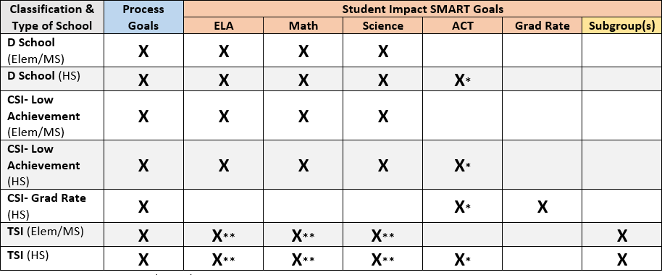
*ACT could fulfill ELA/Math/Science goals because it measures English, mathematics, reading, science, and writing.
**Title I TSI requires ELA, Math, and Science which can include subgroup goals.
Integrated Action Planning
Complete the following steps in GME: [Planning > IAP > Principles, Strategies, Action Steps (REQUIRED)]
- A principle summary box has been completed for each primary need in GME with the following:
  - Primary Need
  - Root Cause
  - Needs Statement
  - Desired outcome
  - SMART Goals
- Evidence-Based Strategies that will support the achievement of the desired outcome and SMART goal(s) are entered in the IAP in GME. Add a strategy by clicking on the “Create Strategy” tab and then fill in the title and description of the strategy.
- Action Steps that will lead to the implementation of evidence-based strategies are entered in the IAP in GME and include the title, description, person responsible, and timeline.
- Monitoring and Evaluation Action Steps are listed under each strategy.
  - Monitoring action steps should answer “How will you monitor implementation of this strategy? What evidence will you collect and when?”
  - Evaluation action steps should answer “How will you know what you have implemented is effective? How will you measure the student impact of this strategy? What evidence will you collect and when?”
- Applicable program tags have been applied to all action steps associated with school improvement classifications and/or grants. See Program / Funding Tags Guidance for more details.
  - School Improvement Program Tags: CSI, SIG, State Improvement (for D or F Schools), TSI
  - School Improvement Funding Tags: Comprehensive Support and Improvement Grant, CSI Graduation Rate Grant, Targeted Support and Improvement Grant

*For non-Title I Schools (SSI ONLY): Disregard notes about GME entry and program tags. Make sure you email your Specialist all documentation that pertains to your planning process (CNA, RCA Fishbones, IAP).

Consolidated Resources
Planning Phase | Resources, Trainings, Guidance, Templates
Pre-Planning | - **FY23 CNA, IAP, and IAP Guidance Document  - Creating Roles Quick Reference Guide (GME)  - CNA and IAP Team Plan
Comprehensive Needs Assessment (CNA) | - CNA Rubric with Full Details  - CNA Module (video)  - CNA Module (slides)
Root Cause Analysis (RCA) | - FY23 Root Cause Analysis Module (video)  - FY23 Root Cause Analysis Module (slides)  - 5 Whys Worksheet  - Root Cause Analysis Target Questions  - Fishbone Template - Word doc (new version)
Evidence-Based Strategies and Practices | - Evidence-Based Strategies Module (video)  - Evidence-Based Strategies Module (slides)  - ESSA Evidence-Based Requirements and Resources Guidance Document  - Using the WWC to Find ESSA Tiers of Evidence  - ***ADE-SSI Evidence-Based Practices webpage  - ESSA Evidence-Based Resource Websites  - Evidence Based Summary Form (Fillable PDF)  - Evidence Based Summary Form (Example)  - Effective Evidence Based Practices  - ESSA-Evidence Based Requirements & Resource Spreadsheet
SMART Goals | - SMART Goal Module (video)  - SMART Goal Module (slides)  - SMART Goal Format Suggestions
Integrated Action Planning | - Building Your School IAP Module (video)  - Building Your School IAP Module (slides)  - LEA IAP Quick Reference Guide (GME)  - School IAP Mini-Handbook (GME)  - LIAP vs. SIAP with Example  - IAP Worksheet (option 1- portrait)  - IAP Worksheet (option 2- landscape)

