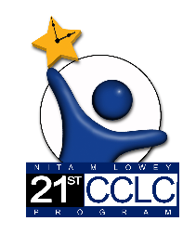
21st CCLC Annual Performance Report Teacher Survey-
Teacher Reported Student Engagement

Student Name: ___________________

Please complete this survey for the student listed above in your school day classroom, reflecting on the entire time the student was in your class this year.
For each question, consider if the student did not need to improve in this engagement area (i.e., already satisfactory level of engagement for this question), showed improved engagement over time, remained at the same level of engagement throughout, or decreased in their engagement over time. This survey is required to maintain federal grant funding for the 21st CCLC grant. Thanks for your efforts.

- While this student was in your regular school day class, assess their change in Class Participation.
- Did not need to improve
- Improved
- Remained the same
- Decreased

- While this student was in your regular school day class, assess their change in Positive Classroom Behavior.
- Did not need to improve
- Improved
- Remained the same
- Decreased

- While this student was in your regular school day class, assess their change in Positive Peer Relationships.
- Did not need to improve
- Improved
- Remained the same
- Decreased

