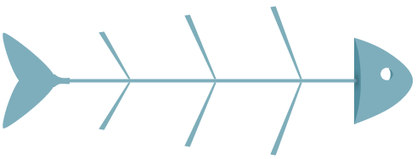
Root Cause Analysis Fishbone Template
School Name – revised dd/mm/yy
Overall Root Cause Statement
The synthesis of the most powerful root cause(s).

Root Causes (label each category/headline and include details)
These are the most influential contributing factors. “Why is the problem existing? What is contributing to the problem? Who plays a role in contributing to the problem?”
Primary Need  The Principle and Indicator from CNA stated as a problem |  |  |  | Need Statement  What must happen/change to address the root cause(s) and the primary need?

Desired Outcome
What will success look like if the needs statement is achieved and root causes addressed?

