State of Arizona
Department of Education

Perkins V
Performance Measures &
Enrollment Reporting Guidelines
(Postsecondary)

Cathie Raymond
Deputy Associate Superintendent/State Director
Career and Technical Education
High Academic Standards for Students
Arizona Department of Education
1535 W. Jefferson St. Phoenix, AZ 85007
(602) 364-2211

The contents of this publication were developed with funds allocated by the U.S. Department of Education under the Carl D. Perkins Career and Technical Education Act of 2006 P.L. 109-270. These contents do not necessarily represent the policy of the agency, nor should endorsement by the Federal government be assumed.
The Arizona Department of Education does not discriminate on the basis of race, religion, color, national origin, sex, disability or age in its programs, activities or in its hiring and employment practices. For questions or concerns regarding this statement, please contact Administrative Services at 602-542-3186. Contact Information:
The Arizona Department of Education does not discriminate on the basis of race, color, national origin, sex, age or disability in access to, treatment, or employment in educational programs or activities which it operates.
Inquiries regarding Title IX / 504 contact:

Billie Belanger
Title IX Coordinator
Human Resources Manager
Arizona Department of Education
1535 W. Jefferson St.
Phoenix, AZ 85007 602-542-3186
billie.belanger@azed.gov

Section 1
Postsecondary Performance Measures

Introduction

The purpose of the postsecondary guidelines is to serve as an overview of the performance measures reporting requirements required Section 113 of the Strengthening Career and Technical Education for the 21st Century (Perkins V). Section 113 of Perkins V requires Arizona to establish a performance accountability system to “assess the effectiveness of the State and the eligible recipients of the State in achieving statewide progress in career and technical education, and to optimize the return of investment of Federal funds in career and technical education activities”.

As required by Section 113, Arizona has established core indicators of performance for CTE concentrators at the postsecondary level that are valid and reliable for assessing the effectiveness of CTE programs.

Calculation of Performance Measures

All CTE performance measures contain a numerator and a denominator and result in a percentage which is then compared to the State Determined Levels of Performance (SDLP). All performance measures are calculated using CTE concentrator data collected from Arizona’s postsecondary institutions (community colleges) through the online CTE Data Portal.

Definition of CTE participant: At the postsecondary level, a CTE participant is a student who completes 1 or more courses (and earns credit) in a career and technical education program or program of study in the reporting year.

Definition of CTE concentrator: At the postsecondary level, a CTE concentrator is a student who has earned 12 credits or more in a single CTE program or program of study (or has completed the program if the program consists of fewer than 12 credits). 3 credits may be from academic courses. Arizona does not define a timeframe in which students must earn credits to be considered a concentrator (i.e. students are not tracked as part of a cohort for purposes of Perkins V accountability).

Meeting Performance Measures

The State Determined Level of Performance (SDLP) is a measurable and quantifiable indicator of performance negotiated between ADE and the U.S. Education Department Office of Career, Technical and Adult Education (OCTAE). The state must attain the SDLP which increases annually.

A subrecipient is required to meet at least 90% of the SDLP for each performance measure to be considered “meeting” the performance measure. Failure to meet SLDP will require the postsecondary institution to submit a Performance Improvement Plan as part of their Perkins funding application. Failure to meet SLDP for three consecutive years will result in the postsecondary institution being placed on a Directed Improvement Plan with quarterly progress reports required as part of the improvement plan. ADE monitors all Perkins sub-recipients (both secondary and postsecondary) for compliance and quality.

Postsecondary Performance Measures

Data for the Career and Technical Education postsecondary performance measures are collected in the Consolidated Annual Report (CAR IV). The measures are listed below. See the “Submitting Performance Measure Data to ADE” section for more detailed instructions.

1P1 Retention and Placement
Numerator: Number of CTE concentrators who, in the second quarter after program completion, remain enrolled in postsecondary education or advanced training, enter military service, volunteer in a national service program that receives assistance through the National and Community Service Ace of 1990 or the Peace Corps, or were employed.
Denominator: Number of CTE concentrators who completed their CTE program in the reporting year.

2P1 Credentials, Certificate, or Degree
Numerator: Number of CTE concentrators who attained a recognized postsecondary certificate, degree, or credential during participation in a CTE program or within one year of program completion.
Denominator: Number of CTE concentrators who left postsecondary education during the reporting year.

3P1 Nontraditional Enrollment†
Numerator: Number of nontraditional students who concentrated in a nontraditional CTE program in the reporting year.
Denominator: Number of students who concentrated in a nontraditional CTE program in the reporting year.

† Nontraditional programs are those in which individuals from a single gender comprise less than 25% of the individuals employed in the related occupation or field of work. CTE program’s nontraditional gender can be found online at www.azed.gov/cte/programs.

State Determined Levels of Performance (SDLP)
Performance Measure | SY2019 - 2020 |  | SY2020 - 2021 |  | SY2021 - 2022 |  | SY2022 - 2023
 | SDLP | 90% of SDLP | SDLP | 90% of SDLP | SDLP | 90% of SDLP | SDLP | 90% of SDLP
1P1 – Retention & Placement | 35.00% | 31.5% | 35.25% | 31.73% | 35.50% | 31.95% | 35.75% | 32.18%
2P1 – Credential, Certificate, or Degree | 45.00% | 40.5% | 45.25% | 40.73% | 45.50% | 40.95% | 45.75% | 41.18%
3P1 – Nontraditional Enrollment | 22.00% | 19.8% | 22.25% | 20.03% | 22.50% | 20.25% | 22.75% | 20.48%

A subrecipient is required to meet at least 90% of the SDLP for each performance measure to be considered “meeting” the performance measure.
Section 2
Submitting Performance Measures Data to ADE

Postsecondary institutions (subrecipients) are required to submit CTE enrollment and performance measure data to ADE on an annual basis. Enrollment and performance measure data is submitted to ADE through the CTE Data Portal. Details for accessing the CTE Data Portal as a postsecondary institution can be found online at www.azed.gov/cte/cte-data-portal-information.

Subrecipients are required to report on all students participating in CTE programs administered by the institution. This includes both Perkins-funded and non-Perkins funded programs.

Performance Data Forms
The performance data forms require subrecipients to report the numerator and denominator values for each of the postsecondary performance measures.

The grand total, gender, and race/ethnicity values should be unduplicated. This means that a student should only be counted once, regardless of the number of programs in which they are concentrators and each student should be counted in only one (1) sub-category (i.e. a student is either Male OR Female). Race/Ethnicity reporting uses the 1997 revised standards. See summary of classification below.

Data for Special Populations and disaggregation by Career Cluster may be duplicated. This means that a student can be counted in more than 1 sub-category, if applicable. However, students that concentrate in multiple programs should still only be counted once for each applicable sub-category (i.e. a student may be considered an “Individual from Economically Disadvantaged Families” AND an “English Learner”, but should be counted only once in each of those sub-categories, even if they concentrate in more than one (1) CTE program; a student may be counted in both “Health Science” and “STEM” career clusters, but should be counted only once in each of those sub-categories, even if they concentrate in more than one (1) CTE program).

The Placement values may be duplicated. This means that a student can be counted in more than one (1) placement category, if applicable. However, students that concentrate in multiple programs should still be counted once for each applicable placement category.

Race/Ethnicity Reporting
Race/Ethnicity reporting uses the categories and definitions based on the Revisions to the Standards for the Classification of Federal Data on Race and Ethnicity that was issued by the Office of Management and Budget in 1997 (62 FR 58782; see: https://www.govinfo.gov/content/pkg/FR-1997-10-30/pdf/97-28653.pdf.

American Indian or Alaskan Native – A person having origins in any of the original peoples of North and South America (including Central America), and who maintains a tribal affiliation or community attachment.
Asian – A person having origins in any of the original peoples of the Far East, East, Southeast Asia, or the Indian subcontinent including, for example, Cambodia, China, India, Japan, Korea, Malaysia, Pakistan, the Philippine Islands, Thailand, and Vietnam.
Black or African American – A person having origins in any of the Black racial groups of Africa.
Hispanic or Latino – A person of Cuban, Mexican, Puerto Rican, South or Central American, or other Spanish culture or origin.
Native Hawaiian or Pacific Islander – A person having origins in any of the original peoples of Hawaii, Guam, Samoa, or other Pacific Islands.
White – A person having origins in any of the original peoples of Europe, the Middle East, or North Africa.
Two or More Races – A person belonging to two or more racial groups.
Race and/or Ethnicity Unknown – A postsecondary student only who does not self-identify a race and/or ethnicity on a local information collection.

Special Populations
Special populations reporting uses the list in Perkins V Section 3(48). At the postsecondary level, the term “Special Populations” means:

- Individuals with disabilities
- Individuals from economically disadvantaged families
- Single Parents (including single pregnant women)
- Out-of-workforce individuals (formerly Displaced Homemaker)¹
- English Learners
- Homeless individuals (as described in section 725 of the McKinney-Vento Homeless Assistance Act (42 U.S.C. 11434a)
- Youth who are in, or have aged out of, the foster care system^{2, 4}
- Youth with a parent who is a member of the armed forces and is on active duty^{3,4}

¹The term “Out of Workforce Individual” means as (a) an individual who is a displaced homemaker as defined in section 3 of WIOA or (b) an individual who has worked primarily without remuneration to care for a home and family, and for that reason has diminished marketable skills, or (c) is a parent whose youngest dependent child will become ineligible to receive assistance under Part A of title IV of the Social Security Act no later than 2 years after the date on which the parent applies for assistance under such title, and (d) is unemployed or underemployed and is experiencing difficulty in obtaining or upgrading employment.

²Since postsecondary institutions primarily work with adults, there may be few students who qualify in this population. However, if a college has a dual enrollment program that allows youth (secondary students) to take college courses while still in high school, any secondary students need to be counted in all applicable categories.

³The “Youth with active military duty parents” population does not include active military duty students. Only students with a parent in the military on active duty should be counted here. Note that if a student is dual enrolled, then the student needs to be counted at both the secondary and postsecondary levels (see note 1).

⁴The term “youth” includes only students between the ages 14-24 in postsecondary Perkins V reporting. This definition of youth aligns with the definition provided in the Workforce Innovation and Opportunity Act (WIOA).

Homeless individuals, youth who are in or have aged out of Foster Care, and youth with an active military parent are Perkins V additions to the special population’s definition.

Performance Measure: 1P1 Retention & Placement

Sample Reporting Form for 1P1 Retention & Placement

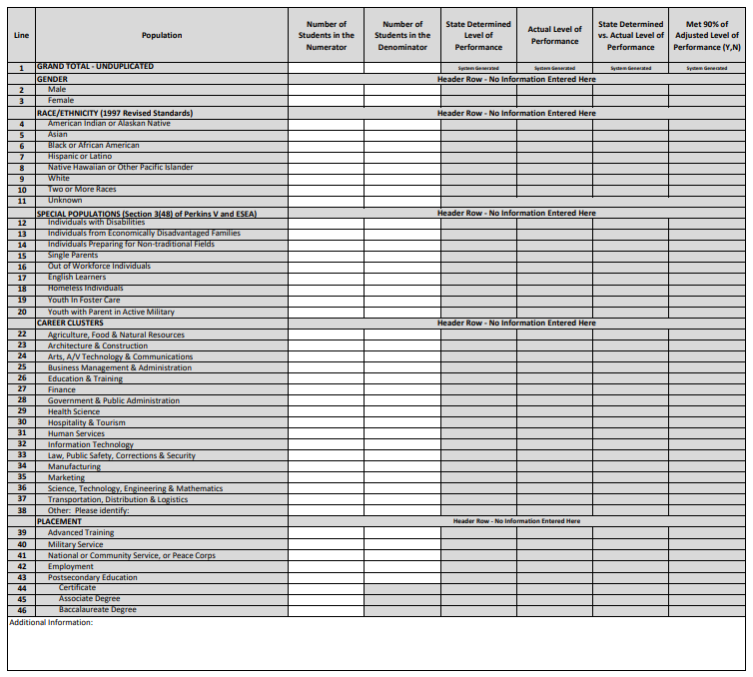

Field Definitions for 1P1 Retention & Placement

Field | Comments
GRAND TOTAL – UNDUPLICATED | Enter the total number of students that should be considered in the numerator and denominator. Students should be unduplicated, meaning that they should be counted only one time, regardless of number of CTE program in which they are a concentrator/completer or the number of placement categories that may apply.
Gender | Total students broken down by gender (Male or Female). The sum of these should equal the grand total for both the numerator and denominator. All students must be counted as either Male or Female. Count should be unduplicated.
Race/Ethnicity | Total students broken down by race/ethnicity. Sum of each race/ethnicity should equal the grand total for both the numerator and denominator. Count should be unduplicated, meaning that students should be counted only in one race or ethnicity category. See ‘Race/Ethnicity Reporting’ section for more details.
Special Populations | Students broken down by special population groups as outlined in Perkins V Section 3(48). Students should be counted in each special population that applies and as such is considered a duplicated count. Students should be counted only once if they concentrate in and complete multiple programs. Sum of special populations may not equal the grand total for the numerator and denominator. See ‘Special Populations Reporting’ section for more details.
Career Clusters | Students broken down by the career cluster that has been assigned to the CTE program that they have completed. Students should be counted in each career cluster that applies, meaning that if a student has completed multiple CTE programs that are in different career clusters, the student should be counted in each career cluster. Students should only be counted one time for each career cluster that applies, meaning that if a student completes multiple CTE programs within the same career cluster, they should only be counted once in that career cluster. Sum of career clusters may not equal the grand total for the numerator and denominator.
Placements | Students broken down by the retention or placement category that applies. Students that remain enrolled in postsecondary education must also be disaggregated by level of education, but disaggregated data does not require a denominator value.  Students who are accepted to postsecondary education but are not yet enrolled are not considered to have Placement for this measure.

Business Rules for 1P1 Retention & Placement

Reporting Timeframe

Due to the requirement that Retention and Placement data be collected in the second quarter after a CTE concentrator completes their CTE program, a 1-year lag exists between the reporting year and the year that data is submitted. The reporting year is the year that the CTE concentrator completes their program and will be one year prior to the year for which data is submitted.

If the CTE Program is completed… | Second Quarter after exit is… | Data is submitted…  in relation to when CTE program is completed
07/01 – 09/30 (FY Q1) | 01/01 – 03/31 (FY Q3) | After the next FY Q4
10/01 – 12/31 (FY Q2) | 04/01 – 06/30 (FY Q4) | After the next FY Q4
01/01 – 03/31 (FY Q3) | 07/01/ - 09/30 (Next FY Q1) | After the next FY Q4
04-01 – 06/30 (FY Q4) | 10/01 – 12/31 (Next FY Q2) | After the next FY Q4

Data submitted in… | For Reporting Year:
Fall 2021 | 2020 (July 1, 2019 – June 30, 2020)
Fall 2022 | 2021 (July 1, 2020 – June 30, 2021)
Fall 2023 | 2023 (July 1, 2021 – June 30, 2022)

Numerator and Denominator Counts

Numerator | Number of CTE concentrators who, during the second quarter after program completion, remain enrolled in postsecondary education or advanced training, enter military service, a service program that receives assistance through the National & Community Service Act of 1990, the Peace Corps, or were employed.  - Count should be unduplicated (meaning that students should be counted only once regardless of the number of CTE programs they’ve completed or number of placement categories that apply.  - Only CTE concentrators that have completed a CTE program in the reporting year should be included in the numerator.  - Count should be the number of concentrators that completed their CTE program in the reporting year and are considered placed in one or more of the eligible retention/placement categories.
Denominator | Number of CTE concentrators who completed their CTE program in the reporting year.  - Count should be unduplicated (meaning that students should be counted only once regardless of the number of CTE programs they’ve completed.  - Count should be the number of concentrators that completed their CTE program in the reporting year.

Frequently Asked Questions about 1P1 Retention & Placement

Question 1: If a student has been accepted to a postsecondary institution, but is not yet enrolled, can they be counted as having continued in postsecondary education?
Response to Question 1: No – a student must be enrolled in a postsecondary institution to be considered as placed in postsecondary education for this performance measure.
Question 2: Is a denominator required for the disaggregated data for postsecondary education by education level?
Response to Question 2: No – a denominator is not required for this disaggregated data.
Question 3: How long should a student be tracked from first enrollment to be considered in this performance measure?
Response to Question 3: The state does not define a set timeframe during which students must gain credits to be considered for performance measures. All CTE concentrators who complete their CTE program in the reporting year, as defined for the performance measure, should be considered in the performance measure.
Question 4: Can I follow-up/contact all CTE concentrators at the same time?
Response to Question 4: To be considered for the performance measure, a CTE concentrator must be considered placed in one or more of the eligible retention/placement categories listed in the performance measure in the second quarter after the concentrator completed their CTE program. It is at the sub-recipient’s discretion how or when data is collected after the second quarter after program completion.

Performance Measure: 2P1 Credential, Certificate, or Degree

Sample Reporting Form for 2P1 Credential, Certificate, or Degree

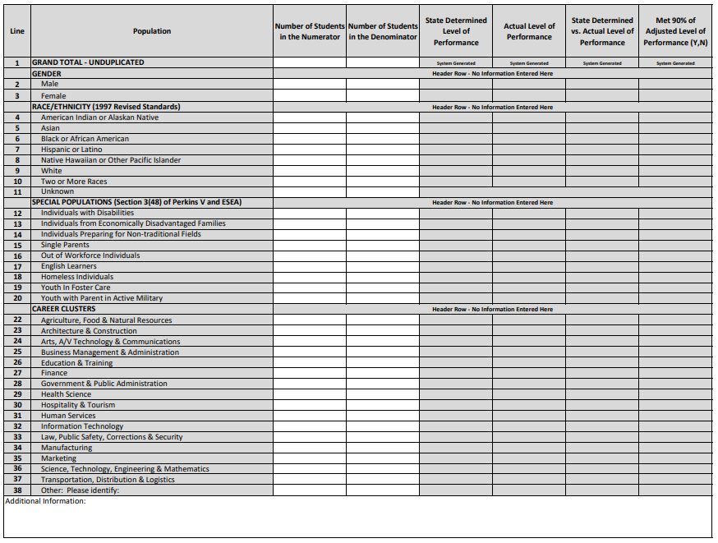

Field Definitions for 2P1 Credential, Certificate, or Degree
Field | Comments
GRAND TOTAL – UNDUPLICATED | Enter the total number of students that should be considered in the numerator and denominator. Students should be unduplicated, meaning that they should be counted only one time, regardless of number of CTE program in which they are a concentrator/completer or the number of credentials they have attained.
Gender | Total students broken down by gender (Male or Female). The sum of these should equal the grand total for both the numerator and denominator. All students must be counted as either Male or Female. Count should be unduplicated.
Race/Ethnicity | Total students broken down by race/ethnicity. Sum of each race/ethnicity should equal the grand total for both the numerator and denominator. Count should be unduplicated, meaning that students should be counted only in one race or ethnicity category. See ‘Race/Ethnicity Reporting’ section for more details.
Special Populations | Students broken down by special population groups as outlined in Perkins V Section 3(48). Students should be counted in each special population that applies and as such is considered a duplicated count. Students should be counted only once if they concentrate in and complete multiple programs. Sum of special populations may not equal the grand total for the numerator and denominator. See ‘Special Populations Reporting’ section for more details.
Career Clusters | Students broken down by the career cluster that has been assigned to the CTE program that they have completed. Students should be counted in each career cluster that applies, meaning that if a student has completed multiple CTE programs that are in different career clusters, the student should be counted in each career cluster. Students should only be counted one time for each career cluster that applies, meaning that if a student completes multiple CTE programs within the same career cluster, they should only be counted once in that career cluster. Sum of career clusters may not equal the grand total for the numerator and denominator.

Business Rules for 2P1 Credential, Certificate, or Degree
Reporting Timeframe

In order to include students that attain a credential, certificate, or degree during participation in their CTE program or within one year after completion of their CTE program, a 1-year lag exists between the reporting year and the year that data is submitted. The reporting year is the year that the CTE concentrator completes their program and will be one year prior to the year for which data is submitted. This allows for a year-long window to pass from program completion to when data is submitted so that any credential attained by a CTE program completer within 1 year (365 days) of program completion can be included in the measure. Even if a CTE concentrator attains a credential, certificate, or degree during program participation/prior to program completion, they must still be counted in the correct performance measure data when submitted to ADE, which will be one year after program completion. Individuals must not be counted in multiple years data unless they complete a distinct CTE program in another year.

Data submitted in… | Reporting Year/Year Program was completed… | Credential must be attained by*:
Fall 2021 | 2020 (July 1, 2019 – June 30, 2020) | Program completion date + 365 days
Fall 2022 | 2021 (July 1, 2020 – June 30, 2021) | Program completion date + 365 days
Fall 2023 | 2022 (July 1, 2021 – June 30, 2022) | Program completion date + 365 days
* If not attained during program completion

Numerator and Denominator Counts

Numerator | Number of CTE concentrators who attain a recognized postsecondary certificate, degree, or credential during participation in a CTE program or within 1 year of program completion.  - Count should be unduplicated (meaning that students should be counted only once regardless of the number of CTE programs they’ve completed or number of credentials, certificates, or degrees they’ve earned.  - Only CTE concentrators who completed their program in the reporting year should be considered in the numerator – the reporting year lags 1 year behind the year that data is submitted. See ‘Reporting Timeframe’ for more information.  - Count should be CTE concentrators that have attained a credential, certificate, or degree during their CTE program (no timeframe restraint) or within 1 year of program completion (credential must be attained by their program completion date + 365 days.
Denominator | Number of CTE concentrators who left secondary education during the reporting year.  - Count should be unduplicated (meaning that students should be counted only once regardless of the number of CTE programs for which they are considered concentrators.  - All CTE concentrators who left postsecondary education during the reporting year must be counted. This includes both concentrators that complete their CTE program and concentrators that do not complete their CTE program.  - Count should be the number of concentrators that do not return to the same postsecondary institution for the following year.

Example 1 for 2P1 Credential, Certificate, or Degree
A CTE concentrator completes their CTE program in May 2020. To be considered in the numerator of this performance measure, the student must attain a credential, certificate, or degree no later than May 2021. To allow for this timeframe, this student will be included in the performance measures for FY 2021 with data submitted to ADE in Fall 2021. The reporting year is considered FY 2020 since that is the year that the student completed their program. The student will also be counted in the denominator for this performance measure for FY 2021.

Example 2 for 2P1 Credential, Certificate, or Degree
A CTE concentrator completes their CTE program in May 2020, but attained a credential, certificate, or degree during participation in the CTE program (prior to completing the program). Since the student has attained a credential, certificate, or degree, the student will be considered in the numerator of this performance measure for FY 2021 with data submitted to ADE in Fall 2021. The reporting year is considered FY 2020 since that is the year that the student completed their program. The student will also be counted in the denominator for this performance measure for FY 2021.

Example 3 for 2P1 Credential, Certificate, or Degree
A CTE concentrator completes their CTE program in December 2019 (FY 2020). To be considered in the numerator of this performance measure, the student must attain a credential, certificate, or degree no later than December 2020. To allow for this timeframe, the student will be included in the Performance Measures for FY 2021 with data submitted to ADE in Fall 2021. In this example, the student does not attain a credential by the deadline and is not included in the numerator for this performance measure for any year. The reporting year is considered FY 2020 since that is the year in which the student completed their CTE program. The student will be counted in the denominator for this performance measure for FY 2021.

Frequently Asked Questions about 2P1 Credential, Certificate, or Degree

Question 1: Are sub-recipients required to disaggregate data by type of credential, certificate, or degree attained?
Response to Question 1: No – sub-recipients are not required to disaggregate data by type.
Question 2: How is “left postsecondary education” defined in the denominator of this performance measure?
Response to Question 2: A student should be considered for the denominator if they are no longer enrolled in any classes at the reporting institution. If a student has transferred to a different postsecondary institution, they are considered to have “left postsecondary education” for purposes of this performance measure denominator.
Question 3: If a student completes the requirements for a credential, certificate, or degree, but does not actually receive the credential, certificate, or degree, can they be counted in this performance measure?
Response to Question 4: No – the student must actually receive the industry-recognized credential, certificate, or degree to be considered in the numerator of this measure.
Question 4: Can a student be counted in the performance measures for the year in which they complete their CTE program if they’ve attained a credential, certificate, or degree during program participation?
Response to Question 4: No – all concentrators must be counted in the performance measures for the appropriate fiscal year, regardless of when they attained their credential, certificate, or degree (within the allowed timeframe). The appropriate fiscal year is the fiscal year following the reporting year and the reporting year is the year in which the completed their CTE program.

Performance Measure 3P1 Nontraditional Enrollment
Sample Reporting Form for 3P1 Nontraditional Enrollment
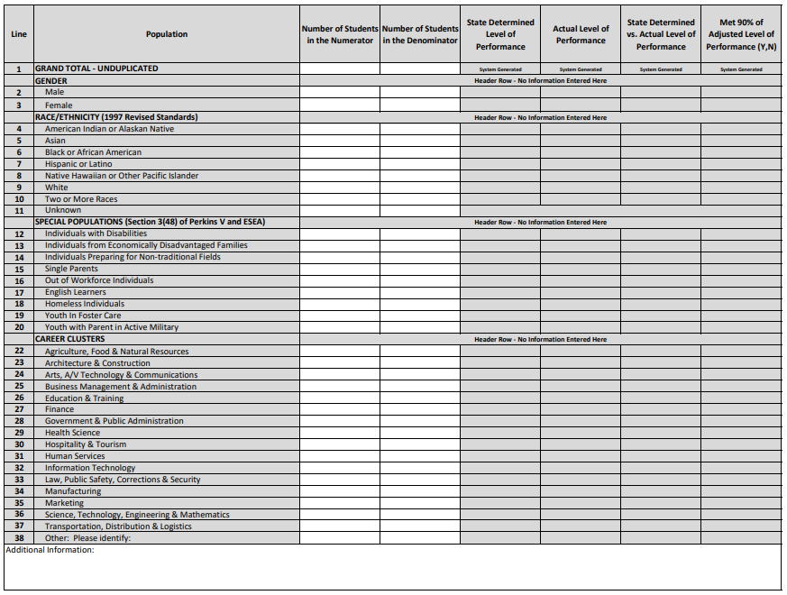

Field Definitions for 3P1 Nontraditional Enrollment
Field | Comments
GRAND TOTAL – UNDUPLICATED | Enter the total number of students that should be considered in the numerator and denominator. Students should be unduplicated, meaning that they should be counted only one time, regardless of number of nontraditional CTE program in which they are a concentrator.
Gender | Total students broken down by gender (Male or Female). The sum of these should equal the grand total for both the numerator and denominator. All students must be counted as either Male or Female. Count should be unduplicated.
Race/Ethnicity | Total students broken down by race/ethnicity. Sum of each race/ethnicity should equal the grand total for both the numerator and denominator. Count should be unduplicated, meaning that students should be counted only in one race or ethnicity category. See ‘Race/Ethnicity Reporting’ section for more details.
Special Populations | Students broken down by special population groups as outlined in Perkins V Section 3(48). Students should be counted in each special population that applies and as such is considered a duplicated count. Students should be counted only once if they concentrate in and complete multiple programs. Sum of special populations may not equal the grand total for the numerator and denominator. See ‘Special Populations Reporting’ section for more details.
Career Clusters | Students broken down by the career cluster that has been assigned to the CTE program that they have completed. Students should be counted in each career cluster that applies, meaning that if a student has concentrated in multiple CTE programs that are in different career clusters, the student should be counted in each career cluster. Students should only be counted one time for each career cluster that applies, meaning that if a student concentrates in multiple CTE programs within the same career cluster, they should only be counted once in that career cluster. Sum of career clusters may not equal the grand total for the numerator and denominator.

Business Rules for 3P1 Nontraditional Enrollment
Reporting Timeframe

This performance measure tracks CTE concentrator enrollment in nontraditional CTE programs and as such, the reporting year is the year for which data is submitted.

Data Submitted in… | Nontraditional Concentrator Enrollment for FY/PY (Reporting Year) …
Fall 2021 | FY 2021 (July 1, 2020 – June 30, 2021)
Fall 2022 | FY 2022 (July 1, 2021 – June 30, 2022)
Fall 2023 | FY 2023 (July 1, 2022 – June 30, 2023)

Nontraditional Programs

Nontraditional programs are those in which individuals from a single gender comprise less than 25% of the individuals employed in the related occupation or field of work. CTE program’s nontraditional gender can be found online at www.azed.gov/cte/programs by viewing the “CTE Program List” for a given year.

Numerator and Denominator Counts

Numerator | Number of nontraditional students who concentrated in a nontraditional CTE program in the reporting year.  - Count should be unduplicated (meaning that students should be counted only once regardless of the number of nontraditional CTE programs in which they are concentrators).  - Student must meet the definition of concentrator at the postsecondary level to be considered in this measure.  - Count should be the number of students that are the nontraditional gender and are concentrators in a nontraditional program as identified on the approved CTE Programs list for the reporting year.
Denominator | Number of students who concentrated in a nontraditional CTE program in the reporting year.  - Count should be unduplicated (meaning that students should be counted only once regardless of the number of nontraditional CTE programs in which they are concentrators).  - Students must meet the definition of concentrator at the postsecondary level to be considered in this measure.  - Count should be the number of students who are concentrators in a nontraditional program as identified on the approved CTE Programs list for the reporting year.

Frequently Asked Questions about 3P1 Nontraditional Enrollment

Question 1: How are students counted where gender is unknown or not provided?
Response to Question 1: Students who do not identify as either male or female cannot be included in counts where sex is a required category but should be included in all counts where sex is not a required category.

Section 3
Postsecondary Perkins Grant

Perkins Eligibility for Postsecondary Institutions

To be eligible to receive Perkins funding at the postsecondary level, subrecipients must:
- Offer career advisement
- Offer programs which support training for in-demand industries
- Ensure postsecondary instructor is qualified for the CTE program they are teaching
- Ensure work-based learning is included in program
- Involve industry in continuous improvement and decision making to ensure relevant content
- Ensure Professional Skills are integrated into the program
- Ensure the program is inclusive for all special populations as evidenced by recruitment efforts, availability of support services, and enrollment
- Provide documentation program is approved by the Higher Learning Commission

Creating and Implementing an Improvement Plan (postsecondary institutions)

If a postsecondary institution fails to meet at least 90% of the State Determined Levels of Performance (SLDP) or show improvement to a previously negotiated local level of performance, the postsecondary institution is required to create and implement an Improvement Plan. Per Section 123(a)(1) of Perkins V, failure to create and implement an Improvement Plan for performance measures not met could result in loss of funds. To determine whether an Improvement Plan for performance measures not met is necessary, compare the Postsecondary institution Level of Performance to 90% of the State Determined Level of Performance (90% SDLP) for each performance measure.
According to Section 123(b)(1-5) of Perkins V, postsecondary institutions that fail to meet 90% of SLDP on any measure must submit an Improvement Plan. The CTE Grant Program Specialist staff (GPS) will provide technical assistance for those postsecondary institutions with a Year 1 Improvement plan on any performance measure to monitor progress. If there is a Year 2 of an Improvement Plan, postsecondary institutions will receive increased GPS technical assistance and monitoring for implementing the Improvement Plan. The Improvement Plan must be submitted to the State by November 30 of the plan year. The Improvement Plan is embedded in the body of the Perkins grant application.

The Improvement Plan must include the following:
- The core indicator(s) of performance for which the postsecondary institution failed to meet the 90% threshold.
- If there are categories of students for which there were quantifiable disparities or gaps in performance comparted to all students or any other category of students, these categories must be addressed to include all geographic, socioeconomic, or ethnic anomalies.
- The action steps which will be implemented, beginning in the current program year, to improve the performance levels for those core indicators not met or any categories of students for which disparities or gaps in performance were identified.
- The staff member(s) responsible for each action step.
- The timeline for completing each action step.
Creating and Implementing a Directed Improvement Plan for Performance Measures Not Met for Three Consecutive Years (postsecondary institutions)

If a Postsecondary institution fails to meet at least 90% of SDLP for one or more performance measure for three consecutive years, the postsecondary institution is required to create and implement a Directed Improvement Plan. According to section 123(b)(4) of the Perkins V:
“The eligible agency may, after notice and opportunity for a hearing, withhold from the eligible recipient all, or a portion, of the eligible recipient’s allotment under this title if the eligible recipient— (i) fails to implement an improvement plan…; or (ii) with respect to any specific core indicator of performance that was identified in a program improvement plan…fails to meet at least 90 percent of the local level of performance for such core indicator for 2 consecutive years after the eligible recipient has been identified for improvement…”

Postsecondary institutions that fail to meet the SDLP for any performance measure for three consecutive years will not be penalized by sanction to diminish funding for CTE programs. A minimum of 10% of Perkins funding should be redirected to provide activities and/or resources to improve postsecondary institution performance on the measure(s) not met. Postsecondary institutions not meeting SDLP for any measure for three or more consecutive years will be required to create and implement a Directed Improvement Plan which will be provided by ADE/CTE staff.

Upon notification of Year 3 noncompliance, a postsecondary institution must:
- Report quarterly to ADE/CTE on progress.
- If the performance measure not met is nontraditional participation (4S1), the postsecondary institution must:
  - Avail themselves of resources to train staff, administration, and student expectations related to nontraditional sex participation in the identified and selected programs.
  - Implement other best practices as they are identified to reduce the perceived sex biased behaviors.

A Directed Improvement Plan must include the following:
- The core indicator(s) of performance for which the postsecondary institution failed to meet the 90% threshold.
- The postsecondary institution’s negotiated level of performance for the current year.
- If there are categories of students for which there were quantifiable disparities or gaps in performance comparted to all students or any other category of students, these categories must be addressed to include all geographic, socioeconomic, or ethnic anomalies.
- The action steps which will be implemented, beginning in the current program year, to improve the performance levels for those core indicators not met or any categories of students for which disparities or gaps in performance were identified.
- Perkins and/or other funds allocated to increase the performance level.
- The staff member(s) responsible for each action step.
- The timeline for completing each action step.

Section 4
Glossary

Consolidated Annual Report – (also known as “CAR”) The annual year-end report of career and technical education participant and concentrator enrollment and performance measure data. Postsecondary sub-recipients submit CAR data to the Arizona Department of Education which aggregates statewide data and submits a state-level report to the U.S. Department of Education – OCTAE. CAR data is typically due from postsecondary sub-recipients in the Fall of each year for the reporting period that ended on June 30 of that year. Please note that each reporting element may utilize a unique timeframe for which data is collected.

CTE concentrator – At the postsecondary level, a CTE concentrator is a student who has earned 12 credits or more in a single CTE program or program of study (or has completed the program if the program consists of fewer than 12 credits). 3 credits may be from academic courses. Arizona does not define a timeframe in which students must earn credits to be considered a concentrator (i.e. students are not tracked as part of a cohort for purposes of Perkins V accountability).

CTE participant – At the postsecondary level, a CTE participant is a student who completes 1 or more courses (and earns credit) in a career and technical education program or program of study in the reporting year.

Reporting Year – The reporting year is the year for which data is collected and may or may not align to the year in which data is submitted. CTE Participant and CTE Concentrator Enrollment forms utilize a reporting year that is the same as the year that data is submitted, and each performance measure may utilize a unique reporting year to ensure that quality data is attained and submitted. Please refer to each performance measure for guidance on when data should be collected and submitted.

Office of Career, Technical, and Adult Education – (also known as “OCTAE”) The U.S. Department of Education office responsible for the state’s adherence to the regulations defined in the Perkins act. OCTAE also provides support for state level education agencies and collects the consolidated annual report from ADE.

Program – A combination of courses and related activities that leads to an industry-recognized credential, certificate, or degree. CTE programs must be listed on the Approved CTE Programs list for the reporting year to be included in annual reporting or for any funding purposes.

Program of Study – The term “program of study” means a coordinator, nonduplicative sequence of academic and technical content at the secondary and postsecondary level that –
- Incorporates challenging state academic standards, including those adopted by a State under section 1111(b)(1) of the Elementary and Secondary Education Act of 1965
- Addresses both academic and technical knowledge and skills, including employability skills
- Is aligned with the needs of industries in the economy of the State, region, Tribal community, or local area
- Progresses in specificity (beginning with all aspects of an industry or career cluster and leading to more occupation-specific instruction)
- Has multiple entry and exit points that incorporate credentialing
- Culminates in the attainment of a recognized postsecondary credential

State Determined Level of Performance – (also known as “SDLP”) The State Determined Level of Performance (SDLP) is a measurable and quantifiable indicator of performance negotiated between ADE and the U.S. Education Department Office of Career, Technical and Adult Education (OCTAE). The state must attain the SDLP which increases annually.

