
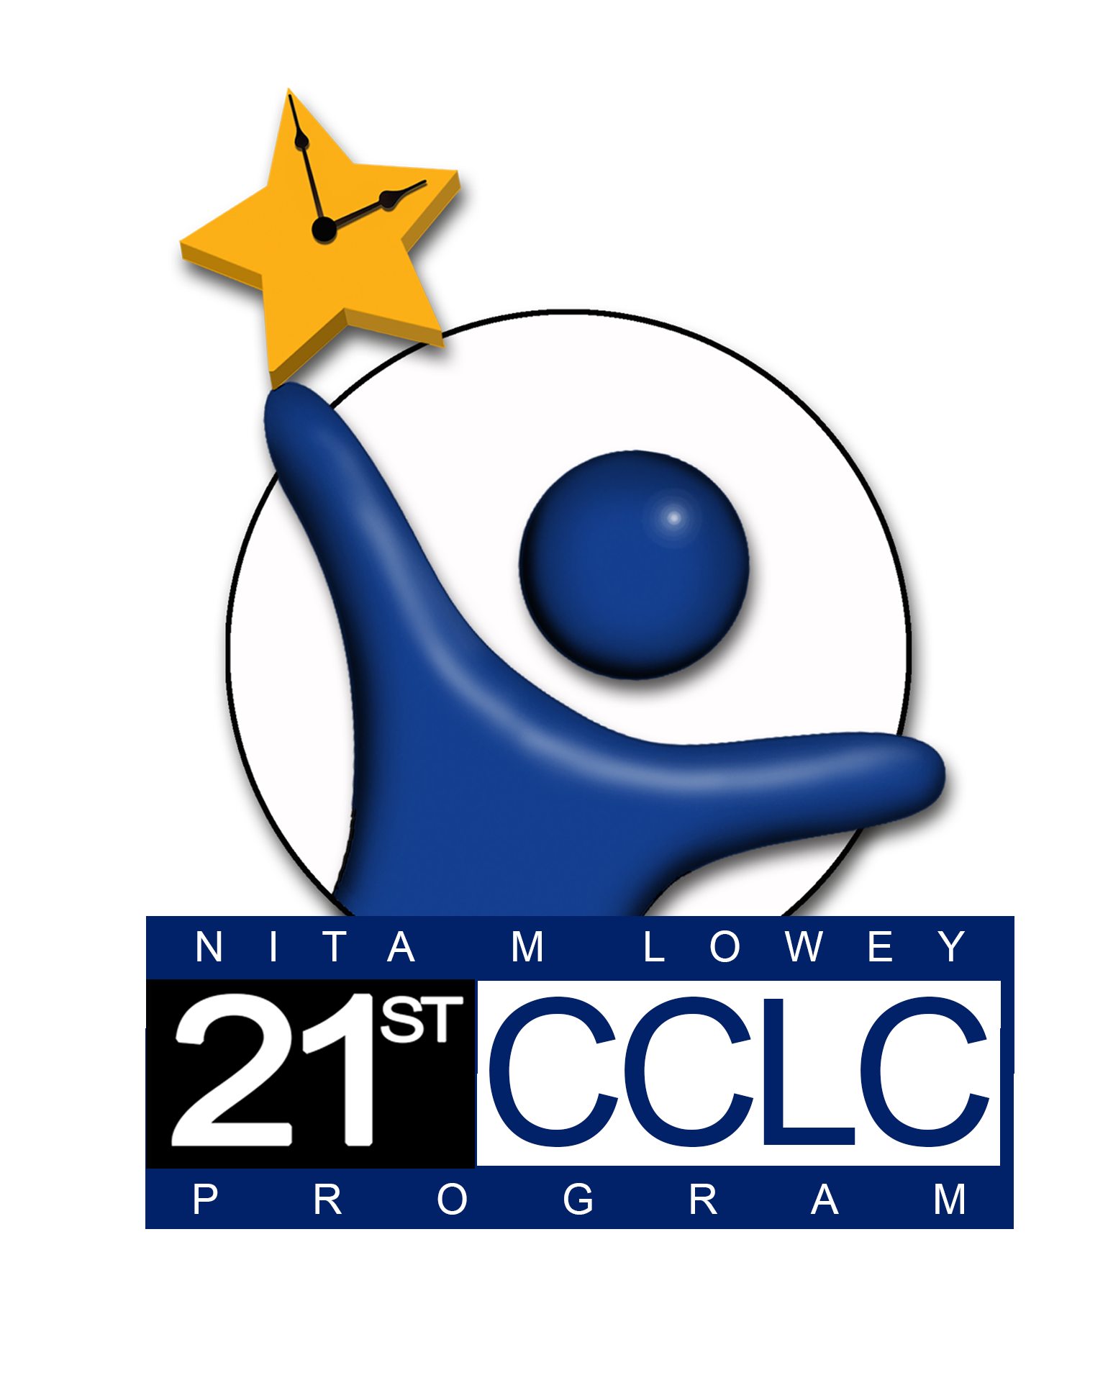
21st Century Community Learning Centers
Annual Site Evaluation Report
See Required Reporting Due Dates
for exact date at this link:
http://www.azed.gov/21stcclc/required-reporting/
Report Sections:
The 21st Century Community Learning Centers afterschool program is funded by a federal grant from the U.S. Department of Education and administered by the Arizona Department of Education. For more information visit: http://www.azed.gov/21stcclc/
Compliance Worksheet
Objectives Worksheet
Continuous Improvement Worksheets


Each section of the Site Evaluation Report must be completed fully to include evidence from the past program year.


Guidance for completing and submitting this report can be found on the 21st CCLC website at http://www.azed.gov/21stcclc/required-reporting/ under the Site Evaluation Blue ribbon drop down.
Please contact your assigned 21st CCLC program specialist if you have other questions or need technical assistance.

Site Information
District/Organization Name:
Site Name:
Cycle: |  |  |  | Year:
Name of Person Responsible for filling out report:
Phone: |  |  |  | Email:

21st CCLC Program
Self-Assessment Compliance Worksheet
Directions: Select “Yes” if the site met the requirement during the program year and “No” if the site did not meet the requirement. If you select “No” on any item of the Compliance Worksheet, please indicate the reason(s) in the comments section.

For requirements with additional narrative requested (in blue), add appropriate answers to the comments section.

1. Direct Student Services
Requirement | Compliant | Comments
a. Program services are provided for the number of hours and days per week proposed in original approved application. | Yes  No
b. Student services are provided for the number of days and to the projected number of regular student attendees as proposed in the application funding formula. | Yes  No
c. Classes/Services provided support academic objectives for students. | Yes  No
d. Classes/Services provided support youth development objectives for students. | Yes  No
e. Services are being provided for the target population identified in the application. | Yes  No

2. Direct Family Services
Requirement | Compliant | Comments
a. Ongoing family engagement services are provided as proposed in the original application. | Yes  No
b. The family engagement activities offered support academic achievement of 21st CCLC students.  Family Engagement services are intended to involve adult family members of 21st CCLC student participants in ongoing activities that will have an impact on their children’s academic success. Provide 1-2 paragraphs describing your site’s family engagement services/activities. | Yes  No | Narrative required:

3. Alignment to the School Day
Requirement | Compliant | Comments
a. Student data is used to make decisions regarding program implementation. | Yes  No
b. Regular communication occurs between 21st CCLC staff, school administrators, and regular school day staff to access and enhance individual student academic progress.  Describe communication between the 21st CCLC program staff and the school day classroom teachers. Include how this communication met the needs of students targeted in your original application during the PROGRAM YEAR. | Yes  No | Narrative required:

4. Safe and Healthy Learning Environment
Requirement | Compliant | Comments
a. A 21st CCLC Safety Plan is developed and implemented. | Yes  No
b. Services are provided in a safe and secure location. | Yes  No
c. If services are provided in a location other than the school, the location will be at least as available and accessible to the students to be served as if the program were located in the school. | Yes/NA  No
d. Procedures for the safe transportation of students between school, 21st CCLC site, and home have been established.  What safety procedures have been established for tracking students during the program and for the safe transportation of students? | Yes  No | Narrative required:
e. Afterschool snacks and summer meals are provided.  What is the site’s procedure for providing afterschool snacks and summer meals for 21st CCLC students? | Yes  No | Narrative required:

5. Equity and Access
Requirement | Compliant | Comments
a. Students with disabilities have been identified and are being served. | Yes  No

6. Evaluation
Requirement | Compliant | Comments
a. Data needed to ensure compliance with all requirements are collected, compiled, and reviewed on a regular basis.  During the PROGRAM YEAR, describe what type of evaluation activities occurred to strengthen the program. Include how staff improved and strengthened the individual student's out-of-school time instruction based on data gathered throughout the year. Identify methods and assessment tools used. | Yes  No | Narrative required:
b. Data needed to measure progress toward reaching grant program objectives are collected, compiled, analyzed, and reviewed on a regular basis.  1) During the PROGRAM YEAR, describe how evaluation results were communicated to all stakeholders and community members. If evaluations results were not communicated to community members and stakeholders, provide an explanation.  2) Identify the lead person(s) for the 21st CCLC evaluation process by name and job title. Include any qualifications and responsibilities this person(s) had to lead the evaluation process. (An external evaluator is not required, however should be listed here if one is used.) | Yes  No | 1) Narrative required:  2) Narrative required:

7. Dissemination
Requirement | Compliant | Comments
a. Methods and strategies to disseminate and share information about the program, outcomes, and accomplishments to parents, staff, students, community members, and other stakeholders are being implemented. | Yes  No

8. Sustainability
Requirement | Compliant | Comments
a. At least one active partnership has been established with an organization that is not the fiscal agent/LEA/school itself.  Identify external partners who supported the 21st CCLC program during the program year and how each partner contributed to meet the program’s needs and objectives. If no external partners were used, provide an explanation as to why and how the site will identify and use external partners in the next program year. | Yes  No | Narrative required:
b. At least one other federal, state, or local program is leveraged to ensure the most effective use of public resources.  Describe how 21st CCLC grant activities collaborated with other federal, state or local community programs in the PROGRAM YEAR. | Yes  No | Narrative required:
c. The site is actively building additional resources in support of its 21st CCLC program through showcasing the program, enlisting new partners, and/or partnering  with alternatively funded programs.  Outline what steps the site took this current year to determine which elements of the program would be the most critical to continue AND to ensure that these components will continue to benefit the students of the school once the grant funding decreases and/or ends. | Yes  No | Narrative required:

9. Fiscal Record Keeping
Requirement | Compliant | Comments
a. Expenditure reports that follow cost principals and ADE Guidelines are kept, organized, and available on request. | Yes  No
b. Pre-approved purchase orders and receipts that coincide with approved budgets are tracked, organized, and available on request. | Yes  No
c. Payroll records showing positions approved in approved budget are kept, organized, and available on request. | Yes  No
d. Time and effort reports are completed, kept, organized, and available upon request. | Yes  No
e. Capital expenditures are in accordance with approved budgets and fixed assets are tracked appropriately. | Yes  No

10. Required Training
Requirement | Compliant | Comments
a. (NEW)21st CCLC district director, the principal, and site coordinators new to grant leadership participated in the Grant Leadership Orientation (GLO) training to understand grant requirements and regulations. | Yes/NA  No
b. (NEW and CONTINUING) Principal and site coordinator(s) attended 21st CCLC annual conference to support the success and best practices of the 21st CCLC program. Any exceptions to this requirement must be approved in writing by ADE 21st CCLC program specialist assigned to the grantee.  Explain in 1-2 paragraphs how your school’s 21st CCLC program was impacted/enhanced by the professional development attended. | Yes  No | Principal attended (name of PD) on (date):  Coordinator attended (name of PD) on (date):  Co-Coordinator attended (name of PD) on (date):  Narrative required:

Program Management (Adequacy of Resources) Questions
Requirement | Comments
During the PROGRAM YEAR, describe the fiscal management of this grant at BOTH the district and site level. | Narrative required:
During the PROGRAM YEAR, describe the involvement of school administration (principal) in managing the grant at this site. | Narrative required:
During the PROGRAM YEAR, describe how staff was recruited and retained in the 21st CCLC program. | Narrative required:

21st CCLC Program
SMART Outcome Objectives Worksheet
The Objectives Worksheet is designed to collect information regarding progress made toward meeting SMART outcome objectives. From your own approved 21st CCLC grant application, please report on all academic, youth development and family engagement SMART outcome objectives from your approved application or Specialist approved revisions. Report all information requested on the Objectives Worksheet for each objective.
Area | SMART Outcome Objective | Data Source | Data Findings | Objective Met
Academics | 1.1 |  |  | Yes  No
Academics | 1.2 |  |  | Yes  No
Academics | 1.3 (if applicable) |  |  | Yes  No
Youth Development | 2.1 |  |  | Yes No
Youth Development | 2.2 (if applicable) |  |  | Yes No
Family Engagement | 3.1 |  |  | Yes No

21st CCLC Program
Continuous Improvement Worksheet
A Continuous Improvement Worksheet must be completed for each SMART outcome objective listed in the Objectives Worksheet (see page 7).
Academic Achievement Outcome Objective 1:
Findings:
Strengths  What helped our successes with the Objective? | Weaknesses  What hurt our success with the Objective? | Opportunities  What might help accomplish the Objective in the future? | Threats  What might hinder our efforts to accomplish the Objective in the future?
Strategies for Improvement. What do we plan to do differently in the future?

21st CCLC Program
Continuous Improvement Worksheet
A Continuous Improvement Worksheet must be completed for each SMART outcome objective listed in the Objectives Worksheet (see page 7).
Academic Achievement Outcome Objective 2:
Findings:
Strengths  What helped our successes with the Objective? | Weaknesses  What hurt our success with the Objective? | Opportunities  What might help accomplish the Objective in the future? | Threats  What might hinder our efforts to accomplish the Objective in the future?
Strategies for Improvement. What do we plan to do differently in the future?

21st CCLC Program
Continuous Improvement Worksheet
A Continuous Improvement Worksheet must be completed for each SMART outcome objective listed in the Objectives Worksheet (see page 7).
Academic Achievement Outcome Objective 3 (if applicable):
Findings:
Strengths  What helped our successes with the Objective? | Weaknesses  What hurt our success with the Objective? | Opportunities  What might help accomplish the Objective in the future? | Threats  What might hinder our efforts to accomplish the Objective in the future?
Strategies for Improvement. What do we plan to do differently in the future?

21st CCLC Program
Continuous Improvement Worksheet
A Continuous Improvement Worksheet must be completed for each SMART outcome objective listed in the Objectives Worksheet (see page 7).
Youth Development Outcome Objective 1:
Findings:
Strengths  What helped our successes with the Objective? | Weaknesses  What hurt our success with the Objective? | Opportunities  What might help accomplish the Objective in the future? | Threats  What might hinder our efforts to accomplish the Objective in the future?
Strategies for Improvement. What do we plan to do differently in the future?

21st CCLC Program
Continuous Improvement Worksheet
A Continuous Improvement Worksheet must be completed for each SMART outcome objective listed in the Objectives Worksheet (see page 7).
Youth Development Outcome Objective 2 (if applicable):
Findings:
Strengths  What helped our successes with the Objective? | Weaknesses  What hurt our success with the Objective? | Opportunities  What might help accomplish the Objective in the future? | Threats  What might hinder our efforts to accomplish the Objective in the future?
Strategies for Improvement. What do we plan to do differently in the future?

21st CCLC Program
Continuous Improvement Worksheet
A Continuous Improvement Worksheet must be completed for each SMART outcome objective listed in the Objectives Worksheet (see page 7).
Family Engagement Objective:
Findings:
Strengths  What helped our successes with the Objective? | Weaknesses  What hurt our success with the Objective? | Opportunities  What might help accomplish the Objective in the future? | Threats  What might hinder our efforts to accomplish the Objective in the future?
Strategies for Improvement. What do we plan to do differently in the future?

Findings: Was the Objective met? Summary or conclusion reached after completion and examination of the compliance and objectives Worksheets or any other relevant resources that have been identified.
Findings: Was the Objective met? Summary or conclusion reached after completion and examination of the compliance and objectives Worksheets or any other relevant resources that have been identified.
Findings: Was the Objective met? Summary or conclusion reached after completion and examination of the compliance and objectives Worksheets or any other relevant resources that have been identified.
Findings: Was the Objective met? Summary or conclusion reached after completion and examination of the compliance and objectives Worksheets or any other relevant resources that have been identified.
Findings: Was the Objective met? Summary or conclusion reached after completion and examination of the compliance and objectives Worksheets or any other relevant resources that have been identified.
Findings: Was the Objective met? Summary or conclusion reached after completion and examination of the compliance and objectives Worksheets or any other relevant resources that have been identified.

