December 2020
This Photo by Unknown Author is licensed under CC BY-NC

Children and youth experiencing homelessness face unique barriers to accessing and succeeding in school. Subtitle VII-B of the McKinney Vento Homeless Assistance Act (42 U.S.C. § 11431 et seq.; hereafter the McKinney-Vento Act) guarantees educational rights and support for students experiencing homelessness, including specific support for unaccompanied youth. Every LEA/Charter must designate a liaison for students experiencing homelessness and provide support, services and immediate education to those children, youth and families. The McKinney Vento Act is a federal law that supersedes conflicting state laws or local policies. Read the Act in its entirety.
ANNOUNCEMENTS

Community + Education = Communication

We had a great AZ State Conference last week! I was so happy to meet you all through the virtual conference. We had great discussions on community housing resources, how to utilize your Continuum of Care and who you can reach out to make those connections. I really enjoyed reviewing the programs from LEAs and Charter school that participated in our liaison round table and finally, sharing questions that have been sent to ADE Homeless inbox. Don’t forget that we need to attend ADE trainings as mandated in the federal law as cited: The McKinney-Vento Act requires State Coordinators to provide professional development opportunities for LEA personnel and the LEA liaison to assist them in identifying and meeting the needs of homeless children and youths, and to provide training on the definitions of terms related to homelessness. [42 U.S.C. § 11432(f)(6)].
If anyone has suggestions or recommendations for future trainings, please send them to me: silvia.chavez@azed.gov .

Trainings
Gentle reminder that several liaisons have not completed their McKinney-Vento.org online training. This is manditory for liaisons. Your user name is your work email and password is: MVLearning2020. The website is: https://arizona.mckinney- vento.org

If you are not listed on the ADE Homeless Liaison Contact list, you will not have access until you update your information with me. Please check your contact information here.
If the information provided is

Early Childhood Education

For very young children (pre-birth to five years old), the impact of homelessness and its associated stressors can negatively impact their brain development, social- emotional learning, and later academic outcomes. Home visiting programs can provide much-needed parenting support to help improve outcomes for these children. You can find some of these programs through this
link: https://strongfamiliesaz.com/programs/
For more resources to support pregnant mothers and very young children experiencing homelessness, please contact: patsy.rethore-larson@azed.gov

This Photo by Unknown Author is licensed under CC BY-NC

Highlights & News

incorrect or missing, please fill
out the updated contact

information form found here.

NCHE Webinars

Register to vote via the NCHE calendar

12pm MST/2pm EST

12/3 - Understanding Doubled up

12/8 - Unaccompanied Homeless Youth

12/16 - Determining Eligibility
OELAS is now Unique Populations! Please note that future department correspondence will be from Unique Populations @ ADE.

Arizona Youth Partnerships has host homes available.
These are for pregnant/parenting young women. An application is necessary and they are statewide Please check out their website or reach out to: Alexandra Harris, Health Education and Case manager: alex@azyp.org or (520) 999-7425.

Health Insurance in Arizona.
Free help is provided through Cover Arizona Application Assistance program. To schedule an appointment to meet with an assistor, call 1-800-377-3536 or visit their website to sign up. OR Apply through your state Medicaid office.

NAEH statement response to USICH’s “Expanding the Toolbox” report.
The response from the National Alliance to End Homelessness can be found here. Read the report here.

Eviction Forum held Nov. 9th and 10th by AZ Housing Coalition.
The eviction mortarium will be lifted soon. We continue to encourage Coalition members to educate clients and renters on the CDC moratorium process and to apply for rental assistance if they are unable to make rent payment. Our CDC Eviction Moratorium Summary explains the steps a renter needs to take to use the CDC moratorium and our List of Known Rental Assistance Resources and Eviction Prevention Programs can be used to identify available rental assistance funds statewide. This list is being updated every two weeks in partnership with the Crisis Response Network.

ADE School Safety Task Force Report available now.
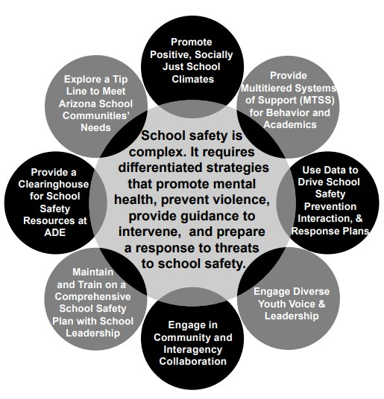
A multi-disciplinary group was gathered to reframe school safety as a multi-directional approach to safety, health and violence. Please read the report and share with your social workers, counselors and anyone else in the LEA/Charter that would benefit from reading. You can find the report here.

QUESTION FROM THE FIELD
Q. We are going back to online learning and providing on-site support services at each individual school. Higher ups and transportation is not providing transportation for homeless students to the on-site option. What do we do?
A. Transportation to on-site learning centers or opportunity centers must be provided to homeless students and families requesting transportation to those sites per McKinney-Vento Act. SchoolHouse Connection has the best response and here is their information:
“It is our understanding that these “On-Site Learning Opportunities” are being provided by the LEA, although in partnership with community organizations. Depending on the circumstance, the LEA may be providing the on-site learning itself, or paying another agency to do it. It may be offered on school grounds or at a community agency. Since the LEA is funding and/or administering the program, it is an LEA activity— in other words, it is a school activity. Practically, it seems like a cross between

core learning (classes) and extra-curricular activities.

The McKinney-Vento Act defines enrollment as “attending classes and participating fully in school activities.” LEAs have to provide immediate enrollment for McKinney-Vento students. LEAs also have to remove barriers to enrollment for McKinney-Vento students. The US Department of Education cited this requirement in finding:

“Therefore, to the extent that lack of access to transportation is a barrier to extracurricular activities for a particular student, an LEA would be required to provide this student with transportation to or from extracurricular activities.” (ED’s EHCY Guidance, August 2018, J-11).

Based on this guidance, and the requirement to remove barriers to enrollment in the Act, transportation to On-Site Learning Opportunities for McKinney-Vento students is required if the students wish to participate, and the lack of transportation is a barrier to their participation.

In addition, in the context of coronavirus, there is a second legal argument, related to identification, enrollment, and retention. The McKinney-Vento Act requires LEAs to remove barriers to identification, enrollment, and retention. We know that with full distance learning in place, it is very difficult to identify students experiencing homelessness. We also know many McKinney-Vento students do not have adequate (or any) internet access, may not have devices, may not have a safe/adequate space to connect to school, and are much less likely to have an adult available to help them connect and engage with their schoolwork. Distance learning places McKinney-Vento students at a very high risk of not participating and of dropping out of school completely— in and of itself, full distance learning is a barrier to enrollment and retention. Where the opportunity to engage McKinney-Vento students in on- site learning exists, and can be done safely, and students/families wish to participate in it, it is imperative that those students have full access to that on-site option. Given the known transportation barriers faced by students and families experiencing homelessness, they will not have full access if transportation is not provided.

At this time, with coronavirus making transportation more logistically complex than usual, schools are facing great challenges in providing transportation. Transportation to On-Site Learning Opportunities does not necessarily have to be via a school bus. It could involve providing gas vouchers for families and students with vehicles; collaborating with community agencies to make use of (safe) transportation options they have available; working with taxi and ride share companies to implement protocols for safely transporting students; etc.”

Cites from SchoolHouse Connections FAQ’s on COVID-19 and Homelessness;

ADE- Homeless Education office will be closed for the holidays:

November 25th – 27th, 2020 December 23rd – 29th, 2020 January 1st, 2021

Please check out the ADE Homeless Education website for resources!

