The Nita M. Lowey 21st Century Community Learning Centers (21st CCLC) Grant
Fiscal Year 2021 (FY21) Continuing Grant Application Guidance

Year 1 of the 21st CCLC Grant is competitive and Years 2-5 are Continuing based on maintaining program eligibility requirements outlined in the Continuing Application.

In the event that anticipated federal funding is decreased or eliminated, a proportional decrease will be made to all awardees. All funding is contingent upon ADE’s receipt of federal funds

The link to log in via the ADEConnect portal is found on the ADE Grants Management web page http://www.azed.gov/grants-management/. This page also offers system guidance and contact information for Grants Management.

You will need an ADEConnect user name and password to submit your Continuing Application.

The Nita M. Lowey 21st Century Community Learning Centers - Continuing Grant Application is available in the Grants Management System (GME) which is accessible in the ADEConnect portal found on the ADE Home Page. It will be posted on March 1, 2020. The Continuing Application will be due June 5, 2020.

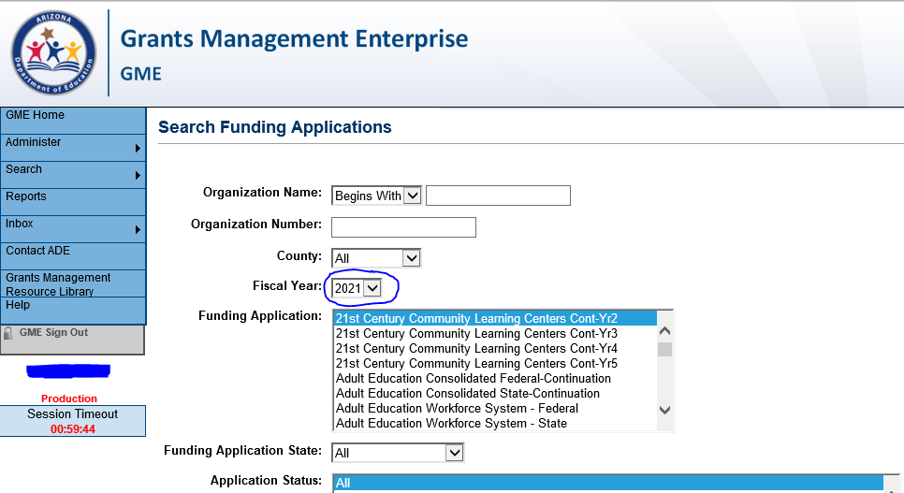

If necessary, you may make minor revisions to your 21st CCLC grant in the Continuing Grant Application. However, it is important that the integrity of the initially awarded application is not compromised. Any changes must receive pre-approval from your assigned program specialist.

Significant changes or insufficient information in the budgets of each site and narrative information explaining the budget expenditures being requested may delay approval.

Any fiscal/programmatic holds will need to be resolved before your 21st CCLC Continuing Application will be approved.

Remember that in order to submit an application, it must be approved all the way up to the “LEA Authorized Representative Approved” level.
Once the application is LEA Authorized Representative Approved, ADE can then
review and approve applications.

How to build your 21st CCLC grant budget
http://www.azed.gov/21stcclc/application-information/ See the 21st CCLC website’s “Application Information” page for the “21st CCLC Tools - Budget Planning Tool” under the “21st CCLC Grant Application Guidance and Resources” Tab.

Before submitting the 21st CCLC application ALWAYS contact your Business Manager and Internal Auditors for guidance on the most current budget coding information.

Be specific when completing the budget narrative descriptions.

Budget Alignment
- Budget will be checked for alignment with entire grant proposal
- Budget items should conform to the USFR Chart of Accounts
- The requested dollar amounts are reasonable and necessary
- Appropriate staffing requirements are reflected in the budget (One Site Coordinator must be on Site during center hours)
- Budget should include costs for MANDATORY Fall Leadership Training for the Principal and Site Coordinator(s).

Recommended Budgetary Guidelines
- Administrative costs do not exceed 25% of total budget
- External evaluator/consultant costs do not exceed 5% of total budget
- Capital costs do not exceed 10% of the total budget and are necessary to proposed programs/services
- Transportation costs do not exceed 4% of total budget.
- Indirect Costs charged to the grant may not exceed the negotiated restricted indirect cost rate. Indirect Costs may not be charged on capital expenditures. If Indirect Cost Rates have not been loaded into the Grants Management System, and the applicant plans to charge the grant, then applicant will write a narrative to this effect in the budget narrative description in the support services supply line (as a placeholder). The narrative should clearly indicate that this is a temporary placement of an allocation for anticipated Indirect Costs, and once the Indirect Cost Rate is approved, the applicant will revise the budget to include the final negotiated indirect costs in the Indirect Costs line of the budget.
- Field trips are allowable under certain conditions as described in the 21st CCLC Guidance Handbook.
- A Capital Outlay Worksheet (COW) is required when an LEA budgets in the capital codes within the Funding Application. For Districts, the codes are 6731-6739. For Charters, the code is 0190. Contact the Grants Management for technical assistance.

Provide the following information in your budget application:

- Staffing Requirement - Must employ at least one site coordinator per site to be on site during center hours. Note: School Administrators with contracts requiring them to be available to work 24/7 may not perform paid work in the 21st CCLC program, as that would be considered supplanting.

- Supplies – You may show items and dollar amount per type. Example: Curriculum Software (identify) = $500, Classroom Supplies – pencils, paper and
consumables at $200 per class x 15 classes = $3,000; Copier Supplies – Toner
– 8 cartridges at $50 each = $400

- Salaries - Show the formula indicating the number of staff/title x dollar amount per hour x number of hours per day x number of days per week x number of weeks = total.

List staff for both the academic year and for summer school.

Examples:
-ACADEMIC YEAR - 5 Academic Instruction Teacher @ $25 hr. x 1 hr. per day x 4 days per week x 30 weeks = $15,000.00
-ACADEMIC YEAR - 2 Academic Enrichment Teachers @ $25 hr. x 1 hr. per day x 4 days per week x 30 weeks = $6,000.00
-SUMMER TERM - 2 Teachers @ $25 hr. x 1 hr. per day x 4 days per week x 30 weeks = $6,000.00
-ACADEMIC YEAR - 1 Paraprofessional (working directly with students) @ $12 hr. x 1 hr. per day x 4 days per week x 30 weeks = $1,440.00
-ACADEMIC YEAR - 1 Paraprofessional (working as clerical support) @ $12 hr. x 1 hr. per day x 4 days per week x 30 weeks = $1,440.00
-Substitute Teachers to enable teachers to attend professional development @ $100 x 3 substitute days = $300.00

- External Evaluators/Consultants – Show the formula indicating the evaluator’s/consultant’s name, description of service x dollar amount per hour x number of hours per day x number of days per week x number of weeks for academic year and summer school = total. An external evaluator/consultant is not required.

XYZ Education Inc., provide evaluation services @ $50.00/hr. x 4 hrs. per day x 1 day per month x 10 months = $2,000

- Capital Expenses – Consult with your Business Office and/or Internal Auditors to decide if furniture and equipment should be put in Capital or Instructional Supplies. A Capital Outlay Worksheet is required when an LEA budgets in the capital codes within the Funding Application. For Districts, the codes are 6731-6739. For Charters, the code is 0190. Contact the Grants Management Department for technical assistance. Also, indicate in the budget narrative description if the capital items will be used exclusively for the 21st CCLC program or if there is a cost-share with the regular school day which will allow the regular school day to use the capital items for an appropriately proportioned amount of time.

- Vendors – While you may have been solicited by a vendor or contractor, be advised that the Arizona Department of Education does not endorse vendors. We do however, encourage you to seek quality services at a reasonable cost that help you meet the objectives stated in your grant. If you choose to contract professional services, make sure the budget narrative includes:

    - vendor name & type of service
    - number of students/families who will benefit from the service
    - number of hours provided
    - cost per hour of service
    - duration of service

Example: ACADEMIC YEAR - XYZ Contractor (identify contractor) to provide physical education services to approximately 15-20 students @ $75.00 per session x 20 1-hour sessions = $1500.00

- Generation of program income - Generation of program income* is NOT allowed by ADE. This includes any program income, including fees for student participation. ADE does NOT allow program income to be generated by charging fees for students to participate in 21st CCLC programs.
Reason: Participant fees can result in exclusion. Even if scholarships are offered, or the fees seem nominal to program staff or leaders, some students or their families may not even apply to participate if they see or become aware of a fee for the program. As there is no way to prove that this type of exclusion is not happening, and it is the intent of the law to ensure that exclusion does not occur, ADE does not allow 21st CCLC participant fees.
* Program income is income generated using 21st CCLC resources.

- Private School Consultation – The site submitted an affirmation of consultation form when applying for the 21st CCLC grant. Since the school/site was awarded, the LEA/fiscal agent should include the 21st CCLC Title IV-B program along with its other federal programs when completing subsequent annual private school consultation for the duration of the 21st CCLC grant award.

- LEA Tribal Affirmation Consultation – Go to the Office of Indian Education website: http://www.azed.gov/oie/tribal-consultation/ and the Arizona Tribal Consultation Guide to see if your Local Educational Agency must submit an LEA Tribal Affirmation of Consultation form to receive federal funds. If your LEA is on the list then the LEA Tribal Affirmation of Consultation must be uploaded with your continuing application.

The Nita M. Lowey 21st Century Community Learning Centers afterschool program is funded by a federal grant from the U.S. Department of Education and administered by the Arizona Department of Education. For more information visit: http://www.azed.gov/21stcclc/

The 21st Century community Learning Centers - Continuing Grant Application was formerly called the RENEWAL application.

