Help Desk Requester
Overview: 2
How to Access Help Desk: 2
How to submit new request: 3
View submitted Requests: 5
Updating an existing request: 5

Overview:
This document provides information on how to submit a new request in the Help Desk System and how to track existing requests.

How to Access Help Desk:
- Access the URL https://helpdesk.azed.gov/
- If you are an ADE employee, then you will be logged in automatically using your system credentials.
- If you are an external user, then you will be redirected to the ADEConnect login page where you will need to enter your email address and password.
- After successful login, you will see the below landing page.
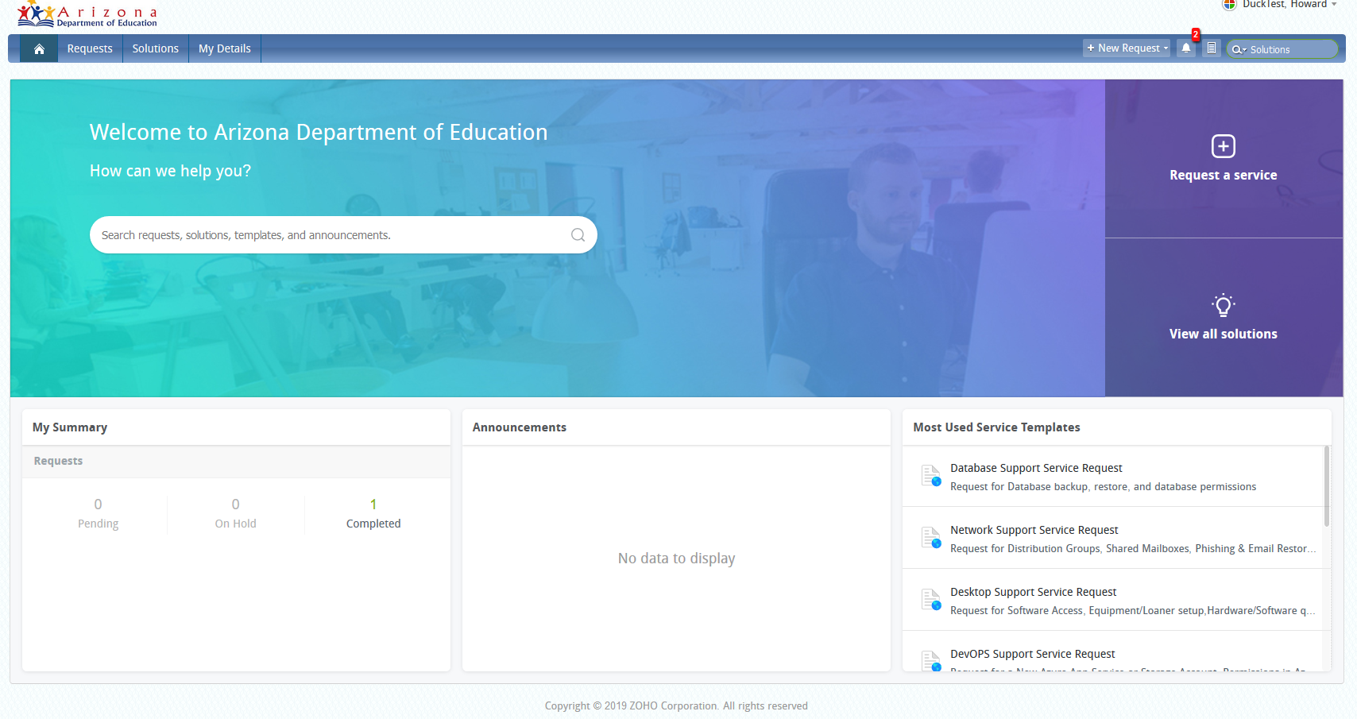
- You will be able to see the summary of all the requests you have submitted in the “My Summary” section.
- If there are any known issues or planned outages for any of the applications, you will be to view them under the Announcements section.
- You will be able to see all of the open requests by clicking the “Requests” menu.

How to submit new request:
- If you want to submit new request, click on “Request a Service” link as shown below.
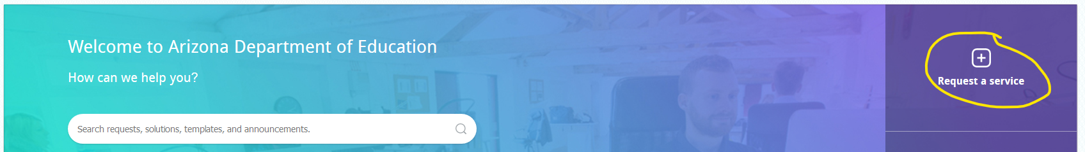
- You will see multiple program areas or departments to which you can submit the request at this time.
- If you want to go back to the previous screen (landing page), click on the “X” icon at the top of the window. Please DO NOT click the browser back button.
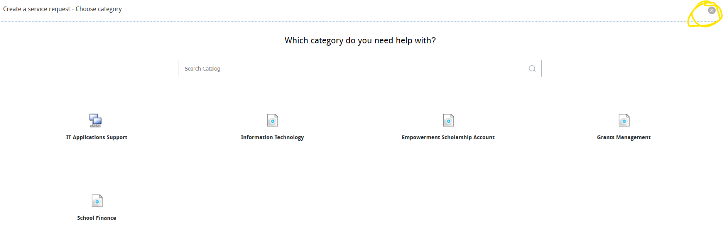
- Click on the appropriate department name to see the available request templates. Identify the corresponding template based on your request and click on the template name.
- You will be prompted to enter the information required for an ADE employee to work on the request similar to the screen below.
- If the selected template does not meet your request, you can click on the “Change Template” link at the top the window to choose a different template.
- You must fill all of the required fields which include an asterisk “*” next to the field name.
- You must select the appropriate “Sub Category” value which will give you multiple options in the Item drop down. Please note that you may see different item lists for different sub category selections. You can repeat this step until you find the appropriate value for your request.

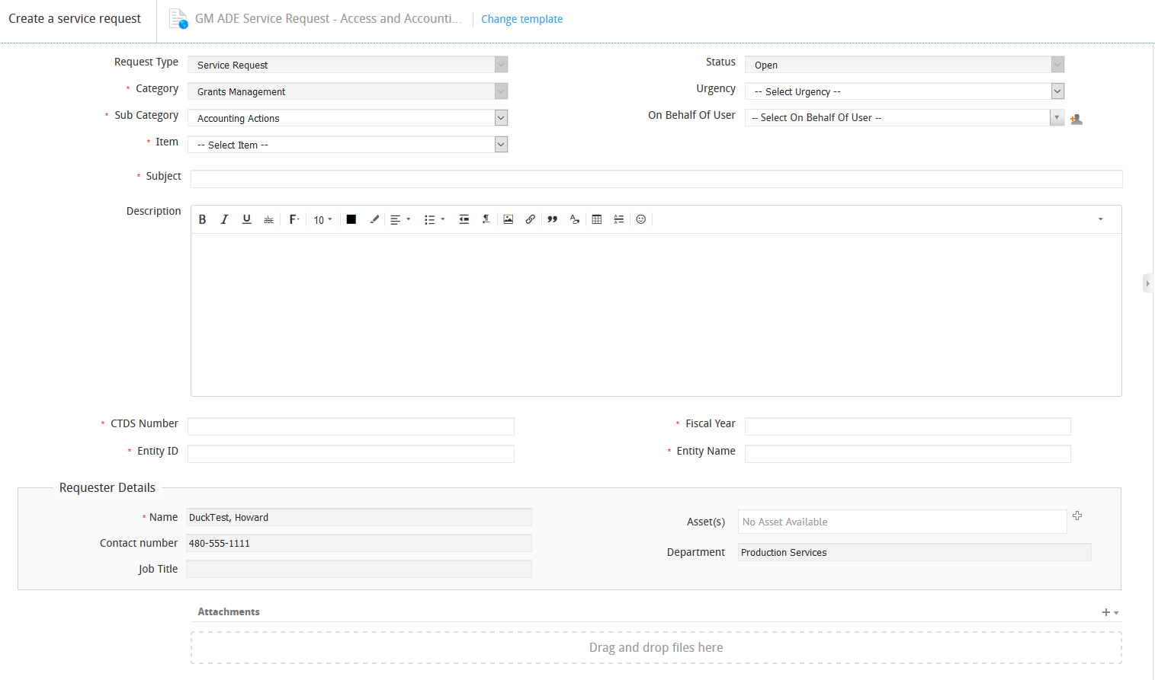
- If a specific request requires additional information, you will be prompted to enter the details at the bottom of the request as shown below. Information requested may vary based on the template or item which you have selected.

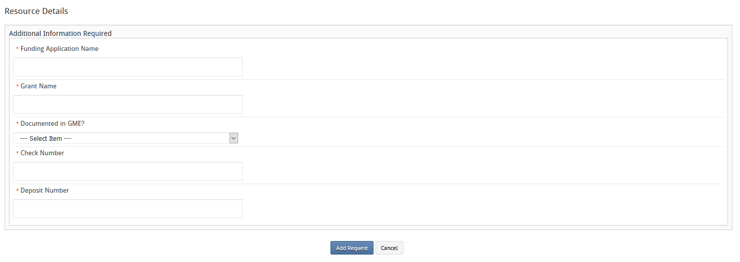

View submitted Requests:
- Once you have logged into the system, click on the “Requests” menu to view all of your summitted requests.
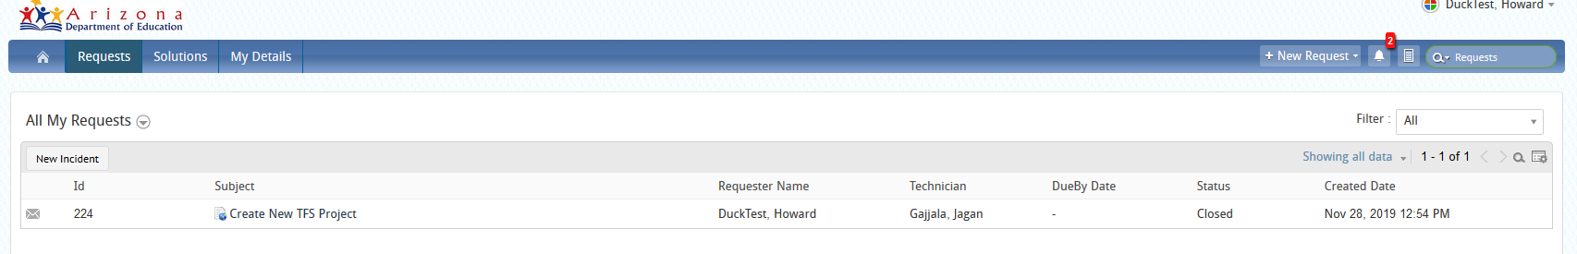
- Click on the Subject title to view the corresponding request as shown below.
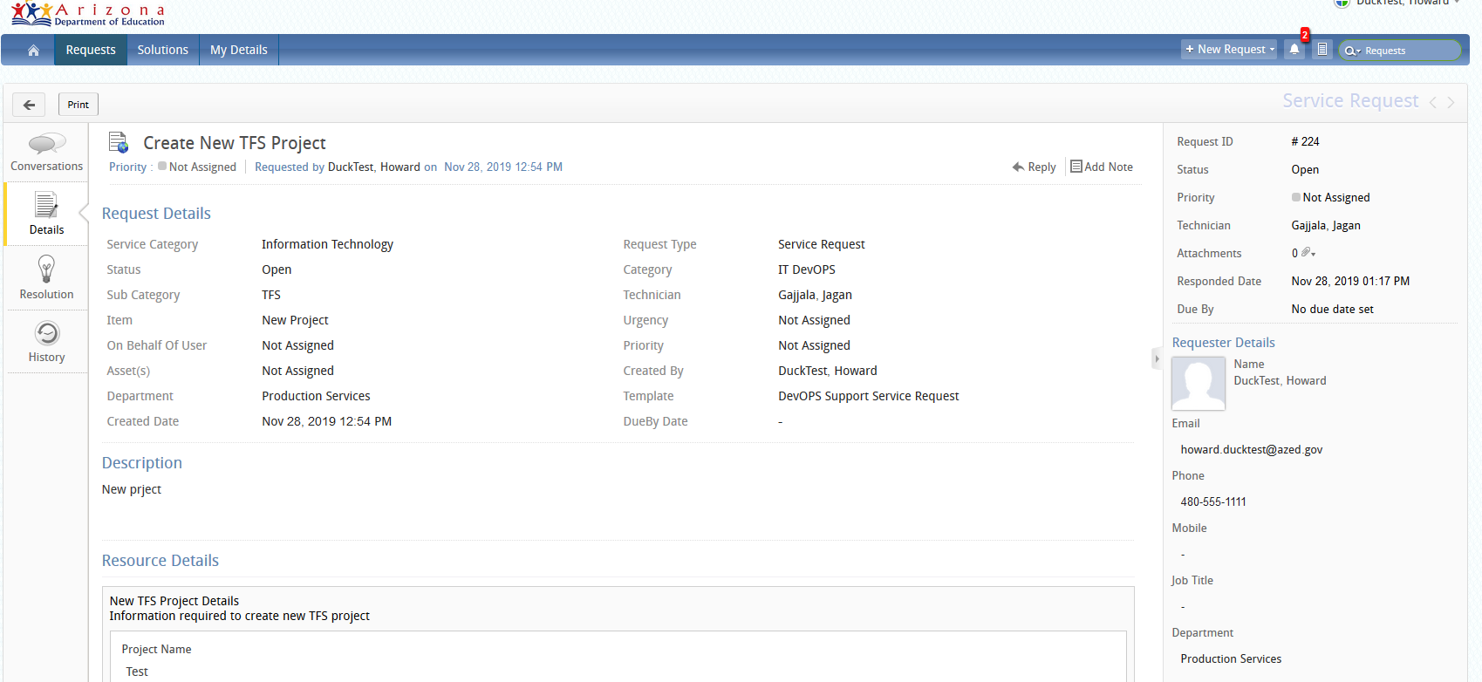

Updating an existing request:
- Click on the Conversations tab to view all of the email conversations or notes for the given ticket. You can add the comments or notes by clicking the “Reply” button.
- You will not be able to Edit the request once it has been submitted but you will be able to add the conversation any time.
