Using the Formative Assessment Rubrics, Reflection and Observation Tools to Support Professional Reflection on Practice

Facilitator Guide

Commissioned by the Formative Assessment for Students and Teachers (FAST)
State Collaborative on Assessment and Student Standards (SCASS) of the
Council of Chief State School Officers (CCSSO)

Member States: Alaska, Arizona, Arkansas, Connecticut, Hawaii, Idaho, Illinois, Iowa, Kansas,
Kentucky, Maryland, Michigan, North Carolina, Ohio, Oregon, Utah, Washington, and Wyoming

By Caroline Wylie, Christine Lyon, and Amanda Roth, Educational Testing Service
January 2016

Contents
Preface 6
Chapter 1: The FARROP 7
What is the FARROP? 7
Purpose of Using the FARROP 8
History of Development 9
Using the FARROP to Support Deliberate Practice 10
Selecting targeted dimensions of formative assessment for improvement and feedback 10
The role of feedback 11
Theory of Action for the FARROP 11
Tools in the FARROP 13
Teacher reflection and self-evaluation 13
Teacher peer observation and reflection 13
Chapter 2: The FARROP Training Courses 13
Accessing the FARROP Training Courses 15
Step 1: Register 15
Step 2: Complete registration 16
Step 3: Launch training 17
Step 4: Launch courses 19
Facilitated Group Trainings 19
3-day facilitated group training 21
1-day facilitated kick-off training 23
Using the courses during common professional development time 24
Facilitating the Training 25
General strategies for group facilitation 25
Courses without video content 26
Courses with video content 26
Chapter 3: Transitioning from Training to Implementation 30
Immediately after Training 30
Teacher self-reflection 30
Scheduling classroom observations 31
Prior to the First Observation 32
Guidance/examples on collecting evidence 33
Sorting evidence 33
Assigning a level 33
Writing a summary statement 34
Longer-term Support for Teachers 34
Revisiting training courses 35
Reviewing new examples of practice with the rubrics 35
Digging deeper into content with formative assessment 36
Integrating practice across dimensions or other aspects of teaching practice 37
Chapter 4: Concluding Thoughts 38
Appendices 40
Appendix 1: Teacher Peer Observation and Self-Reflection Tools 42
from the FARROP 42
Observed Teacher’s Description of Teaching Episodes (p. 79 of the FARROP) 43
Peer Observation Note-Taking form (p. 80 of the FARROP) 44
Peer Observation Summary Form (p. 82 of the FARROP) 45
Post-Observation Discussion Prompts (p. 81 of the FARROP) 46
Teacher Self-Reflection Form (p. 75 of the FARROP) 47
Reflection after Completing Multiple Teacher Self-Reflection Forms 48
(p. 76 of the FARROP) 48
Teacher’s Use of Evidence to Inform Instruction (p. 77 of the FARROP) 49
Students’ Opportunity to Self-Assess/Asses Peers’ Work (p. 78) 50
Appendix 2: Tools for Accessing and Completing the Online Courses 51
Course Numbers, Titles, and Estimated Time 52
Registration and Enrollment Directions 53
Training Courses for Using the FARROP: Quick Reference Handout 54
Appendix 3: Tools for Facilitating Group Training 56
Level Cards 57
ABCD Cards 59
Learning Log 61
FARROP Course Training: Evaluation Form 62
Appendix 4: Tools for Transitioning from Training to Implementation 63
Traffic Lighting Self-evaluation 64
Initial Action Planning 65
Action Planning Log (p. 83 of the FARROP) 66
Swivl Video-Recording and Uploading Directions 67
FARROP TLC Sample Meeting Agenda 70
Sample Ground Rules for Teacher Learning Communities 71
References 72

Preface
Peer observation of and reflection on teaching practice supports professional learning and continuous improvement.
The Formative Assessment Rubrics, Reflection and Observation Tools to Support Professional Reflection on Practice (FARROP) was originally commissioned by the Formative Assessment for Students and Teachers (FAST) State Collaborative on Assessment and Student Standards (SCASS) of the Council of Chief State School Officers (CCSSO). The FARROP was designed as a set of guidelines and resources for use in teacher peer observations and self reflection on formative assessment practices.
The purpose of this Facilitator Guide is to provide guidance for school principals, teachers, coaches or professional developers as they explore using the FARROP. The goal is that this document provides help to structure initial learning opportunities and to support continued school-level learning throughout the year. You should read through the entire FARROP document before you begin to read this document. You will likely also need to complete the FARROP training courses yourself before facilitating them with a group, but you want to review this Facilitator Guide before you complete the training courses.

Chapter 1: The FARROP

What is the FARROP?
The Formative Assessment Rubrics, Reflection and Observation Protocols (FARROP) is a set of rubrics and tools to support teacher self-reflection and peer observation. There are a set of 10 dimensions with associated rubrics that describe how each aspect of formative assessment practice can vary from a novice to sophisticated level of implementation. For more information on the development of the FARROP please see (Wylie & Lyon, in press). The full FARROP document also contains several different tools that support teacher self-reflection on their practice, along with a set of resources to support peer observation and feedback. The rubrics and tools can be used within the context of school-based professional development, with formal or informal groups of teachers, or by individuals who are interested in improving formative assessment practice.
The complete set of training courses described in Chapter 2 focus on providing teachers with knowledge and skills needed to engage in peer observation and feedback. However, for teachers who are interested primarily in the self-reflection tools Courses 2 through 5 would be most useful.
Below we define some of the key terms you will see throughout this facilitator guide, the FARROP, and the training courses.
Dimensions: There are ten dimensions of formative assessment practice that identify important aspects of practice from the definition of formative assessment and the attributes of effective formative assessment. Chapter 1 of the FARROP defines formative assessment and provides several visual illustrations. For a description of the original FAST SCASS definition of formative assessment and a description of each of the attributes please refer to CCSSO (2008). The ten dimensions of formative assessment practice covered by the FARROP include:
- Learning Goals
- Criteria for Success
- Tasks and Activities that Elicit Evidence of Student Learning
- Questioning Strategies that Elicit Evidence of Student Learning
- Extending Thinking During Discussion
- Descriptive Feedback
- Peer Feedback
- Self-Assessment
- Collaborative Culture of Learning
- Using Evidence to Inform Instruction
Rubrics: Each dimension has a rubric that describes four levels of practice. There is a category for Not Observed and then four levels of practice that range from Beginning through Extending. The description of each indicator within the dimension changes by rubric level. Chapter 3 of the FARROP describes the format and content of the dimensions and provides suggestions for becoming familiar with the rubrics.
Indicators: Each rubric details multiple aspects of practice that are called indicators. The indicators identify distinct aspects of practice within a dimension. For example, two of the four indicators within the rubric for Descriptive Feedback describe not only how feedback is provided to students but also whether students have an opportunity to apply the feedback to their own work.
Observation Notes: After each rubric there is a page of observation notes that elaborate on terms used in the rubric and that describe how to handle specific cases during an observation.
If you haven’t already reviewed the full FARROP document and the ten dimension rubrics, please take some time to do that prior to reviewing the rest of this facilitator guide.

Purpose of Using the FARROP
The FARROP rubrics and tools were created to be used within the context of school-based professional development, with formal or informal groups of teachers, or by individuals who are interested in improving formative assessment practice.
The rubrics along with the reflection and observation tools have not been developed for summative evaluations. Therefore, these tools should not be used for summative purposes without first studying their validity and reliability, creating a training and certification system for observers, and developing a process to monitor observer accuracy on an ongoing basis.
Even when used purely for the purpose of professional development, we recommend that teachers complete basic training in order to become acquainted with the dimensions and rubrics. The FARROP training modules do not provide sufficient practice opportunities for observers for high stakes judgments. Specifically note that there is no certification test before peer observations begins.
By way of contrast, the Teachscape Focus system provides 26 hours of training and multiple proficiency checks (e.g., calibration sets, certification tests, etc.) for observers using Danielson Framework for Teaching for high-stakes, evaluation purposes. These strict requirements are important because of the potential consequences of high-stakes assessments. However, when scores and feedback are used to support teacher professional development, the potential consequences of score accuracy and reliability are less severe, and therefore, lower levels of reliability may be acceptable. In addition, research on observer reliability has indicated that observers continue to learn to score in the early days of large scale scoring, despite robust training, certification, and calibration processes (Casabianca, Lockwood, & McCaffrey, 2014). Given the lower stakes of this use case, it may be reasonable to assume that as teachers begin observing peers and receive feedback on their own practice, they will deepen their understanding of how to apply the rubrics and reliability will improve.
We are deeply committed to creating structures and supports that allow teachers to learn together in a safe environment. The theory of action for the FARROP suggests that the process of selecting a dimension for focused practice, getting feedback, and reflecting on the feedback in light of a self-assessment will promote reflection and growth even if observers’ ratings are not always fully accurate.

History of Development
The Formative Assessment for Students and Teachers (FAST) State Collaborative on Assessment and Student Standards (SCASS) commissioned the development of the FARROP in 2012, recognizing that an observation protocol focused on formative assessment practices would be a valuable tool for teachers to use to support their growth in this area.
The FAST SCASS members worked with researchers from ETS to define a set of ten dimensions that covered important aspects of formative assessment practice in the classroom. They then created a rubric for each dimension to describe how teaching practice evolves from beginning to expert practice.
Additional guidelines for conducting peer observation and self-assessment were created to form the document known as the FARROP: Formative Assessment Rubrics, Reflection and Observation Protocols.
The figure below (Figure 1) highlights the multiple rounds of review and revision that the FARROP went through.
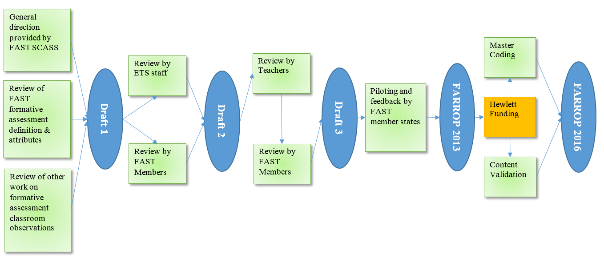
Figure 1. The iterative design process for the FARROP
As a result of the Hewlett Foundation funding in 2015-16, a series of training modules were created to support teachers’ initial exploration of the dimensions and rubrics. For each dimension, exemplar videos were selected through a master-coding process to provide examples of practice for each level of each of the 10 rubrics.
The videos were selected from the ETS Video Library which includes classroom videos from the Measures of Effective Teaching Extension (METX) collection. Because the METX collection holds multiple videos per teacher, the same teacher with a different lesson may be observed across the modules. It is also possible that the same teacher/lesson is used across more than one dimension.

Using the FARROP to Support Deliberate Practice
The FARROP was developed in order to promote reflection and growth through a process of “Deliberate Practice”. Deliberate Practice is a highly structured activity that is undertaken with a specific goal of improving performance. This type of practice is different from simply repeating a task over and over again in the same way. Rather the goal of deliberate practice is to make changes to specific aspects of how you approach or complete the task in order to improve performance. In a teaching context, deliberate practice requires that a teacher reflects on his or her practice to evaluate what may benefit from improvement, selects one or two small aspects of teaching practice to improve, and develops a process through which the teacher can repeatedly implement the practice while receiving feedback on the results of his or her practice.

Selecting targeted dimensions of formative assessment for improvement and feedback
The dimensions of the FARROP divide the construct of formative assessment practice into ten discrete parts that can be separately defined and described. However, these distinctions are in part artificial, since a number of the dimensions are related, or naturally co-occur in accomplished formative assessment practice. For example a teacher might introduce success criteria at the start of the lesson, and then later ask students to apply those criteria during a peer assessment exercise. However, by separating them out, we can highlight critical aspects of each dimension, to support practice and growth within independent parts of the full construct. Ultimately the goal is for teachers to combine these discrete parts in order to enact integrated formative assessment practices in their classroom.
We know from the theory around deliberate practice that doing something repeatedly doesn’t make us an expert, especially if we keep doing it in exactly the same way. For example, many people continue to type on a keyboard with the hunt-and-peck method in spite of having used computers for years, without ever trying to master touch typing. Improving a skill takes something more―deliberate practice with feedback.
When engaging in deliberate practice, the goal is to break down a skill into components in order to focus on specific aspects and then bring the separate individual components back together to form the whole. For example, in practice, sprinters don’t just repeatedly run 100-meter dashes. Instead, they practice the individual components, such as their starts and finishes, in order to put it all together in competition.
The FARROP is serving a similar process by taking a complex skill (formative assessment) and breaking it into discrete components for focused or deliberate practice. Once a teacher has had an opportunity to reflect on his or her practice and complete a self-assessment, they can select one or two discrete parts of formative assessment as defined by the ten dimensions of formative assessment practice within the FARROP. This does not mean they will not still implement the other parts, but it does mean that they will be repeatedly and purposefully practicing a single dimension and getting feedback from a peer through peer observation. The “Observed Teacher’s Description of Teaching Episodes” form (see Appendix 1 or p. 79 of the FARROP) includes a place for an observed teacher to identify the targeted dimensions for feedback to ensure that the observer provides actionable feedback in the area of focus. This will be described in more detail in other sections of this guide (e.g., the role of feedback, collecting evidence, etc.)

The role of feedback
Another aspect of deliberate practice is receiving feedback. It’s not enough for sprinters to keep trying to perfect their start over and over on their own. A peer watching a sprinter can notice his or her hand position relative to the start line, use of the foot pedals, and the angle of the sprinter’s head and make suggestions for improvement accordingly. Knowing this additional information helps the sprinter practice more deliberately and pay attention to that specific aspect of his or her run. And the observer can identify when the sprinter is improving and then provide additional feedback on the next aspect of the skill to be worked on.
We see the use of deliberate practice with students within classrooms. For example, for early readers, an elementary teacher may ensure that students are reading “just my level” books to provide deliberate, targeted practice. In addition, the teacher may also serve as a coach during individual sessions or with leveled reading groups to provide strategies to help students overcome specific difficulties.
For teachers, it is not quite as easy to isolate and repeatedly practice a single aspect; however by identifying a specific area to work on and soliciting targeted feedback in that area, he or she can bring focused attention to that aspect of formative assessment, receive feedback that targets it, and improve over time. The FARROP includes guidance and a “Peer Observation Summary Form” (See Appendix 1 or p. 82 of the FARROP) to guide the provision of feedback. In a targeted observation the observer would select the targeted dimensions, provide a rubric level based on the observation, and quote specific evidence from the notes and the rubric to explain the rubric level. During the post-observation conference, the observer and observed teacher should have a dialogue about what was observed and what might not have been observed. The “Post-Observation Discussion Prompts” (see Appendix 1 or page 81) of the FARROP provide some guidance for the types of questions that might be discussed and how to use the discussion to move practice further.
Whether a teacher uses the self-reflection or peer observation tools from the FARROP, the overall purpose is to engage in deliberate practice in order to improve one’s formative assessment practices. The theory of action below describes this process more fully.

Theory of Action for the FARROP
The theory of action describes the chain of inferences that connect the components of an observation system to the desired outcomes – in this case, improved student learning. The diagram below shows the intermediate changes or outcomes that occur before the final result of improved student learning.
The FARROP theory of action proposes a set initial requirements that state that teachers need to:
- Have access to consistent and accurate measurement of and feedback on their formative assessment practices,
- Have opportunities to receive feedback on their practice,
- Have opportunities to reflect and provide feedback on the practices of others,
- Have access to examples of quality formative assessment practices, and
- Be committed to improving practice and trying out new ideas.
From this combination of resources, processes and attitudes, we identify two intermediate steps in the theory of action: (1) increased awareness of what quality formative assessment practice can look like and increased awareness of strengths and weaknesses; and, (2) improvements in teaching and learning practices.
From these changes we then identify two final outcomes: (1) an increased student role in the learning process and (2) improvements in student learning. Figure two below, provides a graphical illustration of the connection between the FARROP components, the inferences, and the final outcomes.
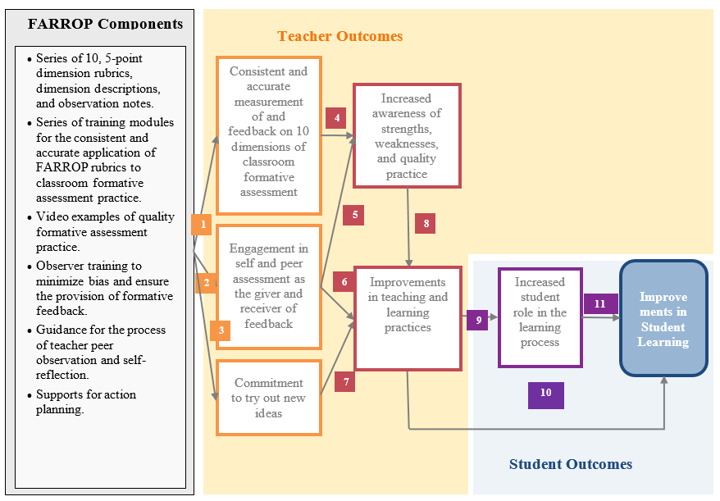
Figure 2. The theory of action for the FARROP

Tools in the FARROP
The full FARROP document includes resources and processes to help teachers undertake the process of reflection and deliberate practice within the context of formative assessment practice. The various tools and resources that are available are included in the appendices and described in the following sections.

Teacher reflection and self-evaluation
To support individual teacher reflection the FARROP contains three sets of tools:
- Tools to support teacher self-reflection on one or more of the dimensions of formative assessment practice (i.e., The “Teacher Self-Reflection Form”, p. 75 and the “Reflection after Completing Multiple Teacher Self-Reflection Forms”, p. 76) are included in the FARROP. Copies are also provided in Appendix 1.
- The second tool is the “Teacher’s Use of Evidence to Inform Instruction” form (See Appendix 1 or p. 77 of the FARROP). This is one of two tools described in Chapter 5 of the FARROP (i.e., Using Frequency Indices to Support Self-Reflection).
- The third tool is the “Students’ Opportunity to Self-assess/Assess Peers’ Work” form (see Appendix 1 or p. 78 of the FARROP) and use of this tool is also described on page 34 in Chapter 5 of the FARROP.

Teacher peer observation and reflection
The FARROP also contains a set of tools to support peer observation and feedback. The FARROP courses are designed to support teachers to learn about the dimensions and the observation process, and the remainder of this document is focused on providing guidelines for facilitators (coaches, lead teachers, district or school level coordinators etc.) who are supporting teachers who are engaged in this process.

Chapter 2: The FARROP Training Courses
To accompany the FARROP and to respond to stakeholders' and pilot participants' requests for additional training in the use of the rubrics and tools, a series of eight, on-line training courses were developed. The courses are hosted by Frontline Technologies and available through a creative commons license that recognizes the FAST SCASS as the original developers of the content.
The online training is approximately 12.5 hours in length with seven required courses that are self-directed and can be completed over a number of sessions. An additional 2.0 hours of optional training is also available as course 8 and provides additional videos and opportunities to score across 10 dimensions. A printable handout with course numbers, titles, and the estimated time to complete is available in Appendix 2. The eight available courses include
- Introduction and Bias
- Learning about the Dimensions: Learning Goals and Criteria for Success
- Learning about the Dimensions: Tasks and Activities and Questioning Strategies
- Learning about the Dimensions: Peer Feedback, Self-Assessment, and Collaboration
- Learning about the Dimensions: Feedback Loops, Descriptive Feedback and Use of Evidence
- Giving and Receiving Feedback
- Learning about the Dimensions: Scoring Lessons Across 10 Dimensions
- Learning about the Dimensions: Reflecting on More Lessons
The first course, “Introduction and Bias” provides an introduction to the FARROP and engages participants in activities related to minimizing bias. Even highly trained, well-intentioned observers can have known biases as well as personal preferences regarding teaching practice. The goal is to help teachers identify and manage these biases, emphasizing the importance of fairness in assigning rubric levels. Given the introductory nature of this course and the importance of minimizing bias, the recommendation is for all teachers to complete this course first and prior to observing a peer. As such, the platform requires completion of this course before allowing a teacher to access later courses.
The next four courses (i.e., Courses 2 through 5) all follow the same structure, and each course focuses on two or three FARROP dimensions. Within each course, teachers are first introduced to one dimension and its associated rubric. Next, teachers view two to six benchmark video clips that illustrate rubric levels and key distinctions between levels. For each benchmark video the lesson context, postclip information, final score, and rationale are presented. During this process, teachers are also able to practice writing evidence statements to support a given clip's score for the specific rubric. This process is repeated for each dimension covered by the course. Finally, each of these courses ends with two longer practice opportunities where teachers consider the implementation of multiple dimensions covered by the courses within the context of one video. These courses can be completed in sequence or used as “just in time” professional learning. An example of “just in time” professional learning would be if a teacher learning community decided to focus on starts and ends of lessons by integrating more learning goals and criteria for success into all of their lessons. If these teachers were using the FARROP to observe one another and provide feedback, they may only need to complete courses 1, 2, and 6.
The sixth course, “Giving and Receiving Feedback” presents research-based elements of appropriate feedback, and how to use evidence and feedback to improve practice through the development and refinement of action plans. Finally, the last two courses, provide opportunities for teachers to practice scoring across all 10 dimensions on lesson-length videos.
Teachers’ understanding of the rubrics, the exemplars, and the process will deepen not only as they work their way through the courses, but also as they start observing peers, collecting evidence, and using the rubrics. Additionally, the process of receiving feedback and reflecting on their own practice will also support and deepen understanding of the rubrics and formative assessment practice.
The sections that follow describe how to access the FARROP training courses and provide several sample agendas for planning facilitated group trainings that utilize the online courses.

Accessing the FARROP Training Courses
The FARROP Training courses are on-line, self-paced courses and will be hosted by Frontline Technologies as an open educational resource for the duration of the FAST-ER grant and an additional five years. To facilitate open access, teachers in any school or district can create an account, register for the courses, and enroll into training. Directions for the process are provided as a handout that can be printed or distributed to teachers is provided in Appendix 8. The section below integrates these directions with screen shots from the platform form to help facilitators assist teachers with the registering and enrolling processes. Finally, Frontline Technologies provides e-mail and chat support to help solve any technological problems that are encountered during registration or while completing the courses.

Step 1: Register
To begin the registration process, go to http://www.edtrainingcenter.com and you will see the following page.
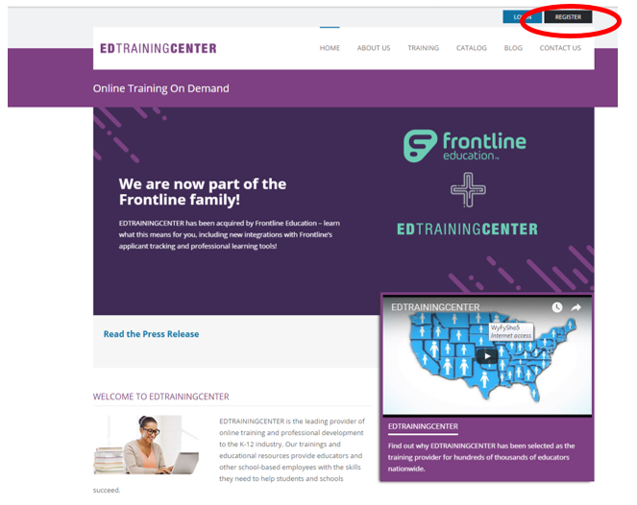
Click on the black Register button at the top right hand side of the screen, circled in red in the screen shot above.

Step 2: Complete registration
Provide the required information including your “Division,” which is “Training Courses for Using the FARROP” as shown below. The fastest way to locate it in the Division selection window is to type “FARROP” into the Title field and click Search. Then click on the actual group when it appears. This will select it and the selection pop up window will close.
Create your password and then click Login.
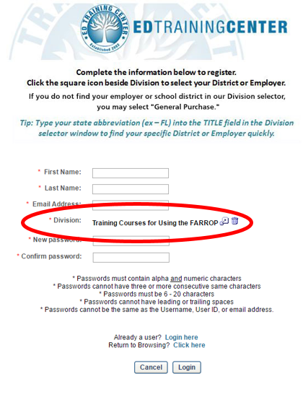

Step 3: Launch training
Once enrollment into all course parts is complete, you may access the training program by clicking Learning.
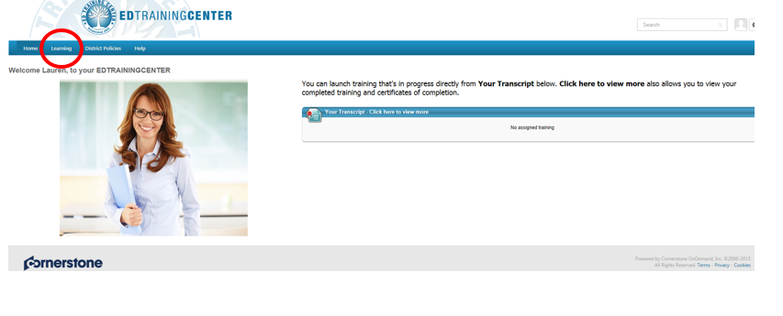
Next, select “Training Courses for Using the FARROP”.
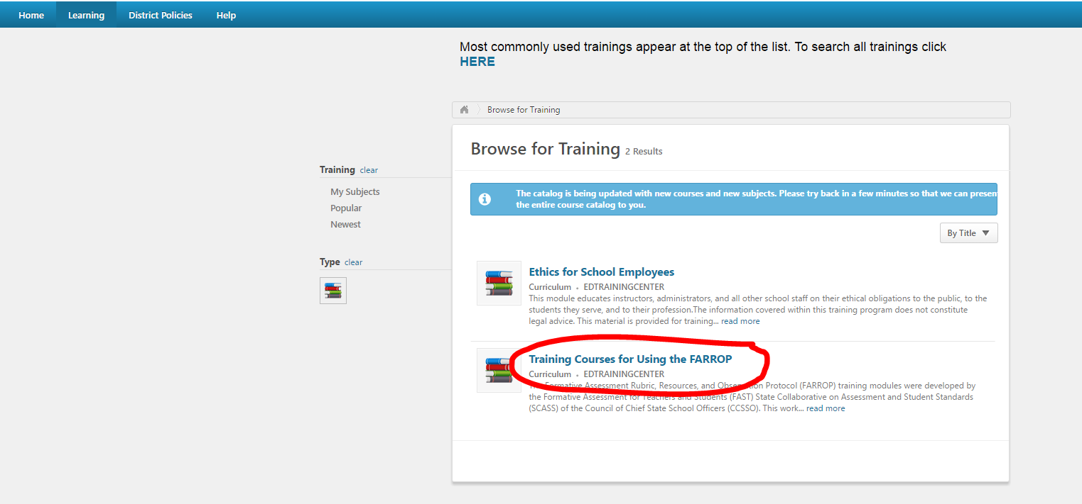

Then select ‘Request’ to add the course to your transcript.
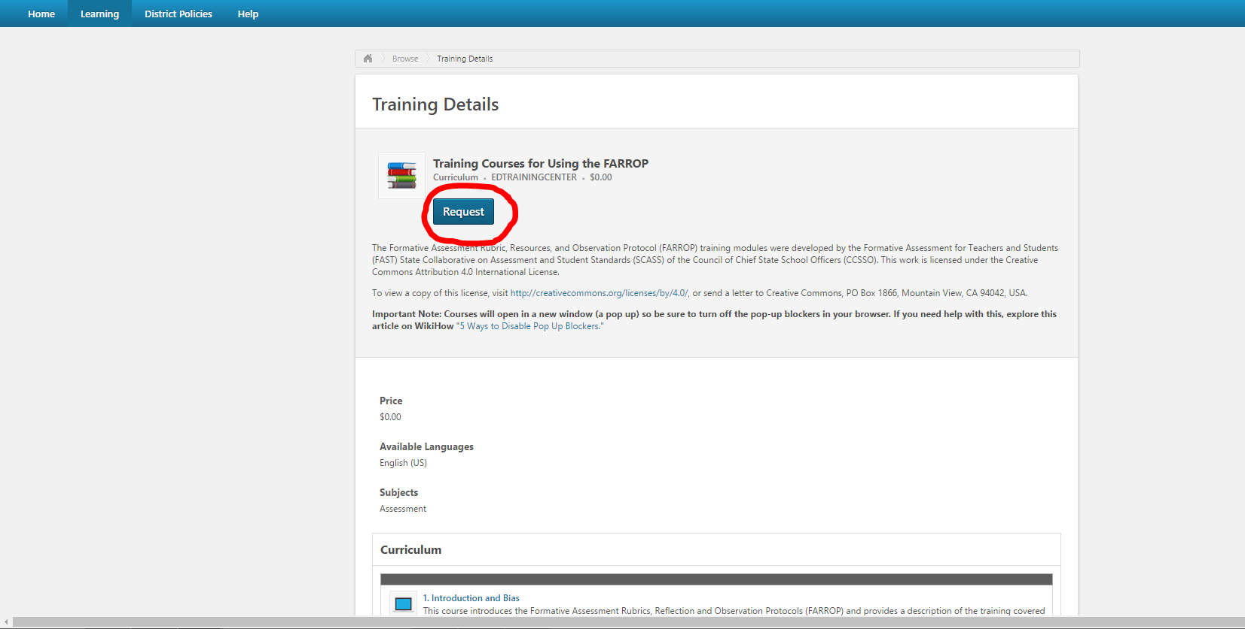
The next screen will appear, and you can now open the curriculum.
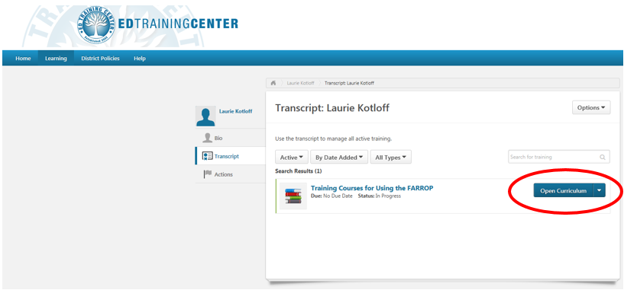
To view a full list of the courses and to see progress within the courses, select “open curriculum” (circled above).

Step 4: Launch courses
This screen will be available anytime you log into the platform. You can begin a course by clicking Launch. Please note, Course 1 must be completed first in order to open courses 2-8. The remainder of the courses can be completed in any order, but all teachers should complete Course 1 before conducting any peer observations.
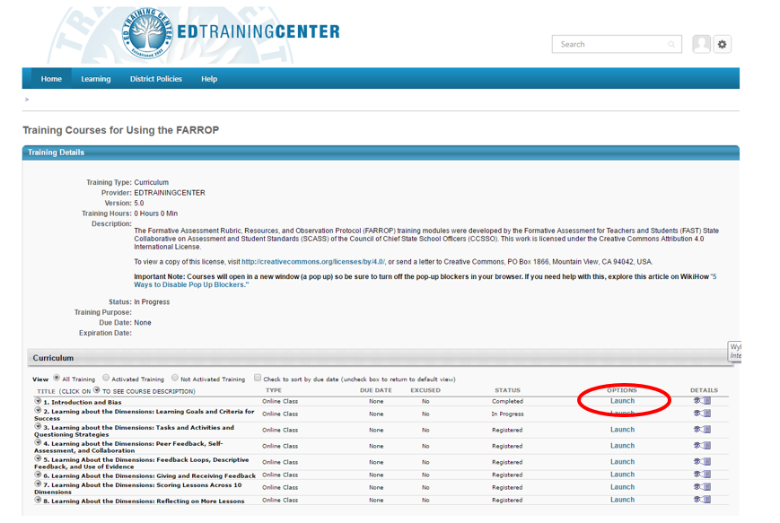
In addition, individual courses do not need to be completed in one sitting; a teacher may begin a course and close out part of the way through. The system will save their work and the course will resume where they left off. Certificates of completion are available at the end of each course.

Facilitated Group Trainings
While the FARROP courses are designed to allow for self-directed and individual learning formats, it is also possible to facilitate group trainings using these materials. The following section provides exemplar agendas for this use. Implementation of these models will depend on the time you have available with teachers, when you start training, and the unique context of the school. The chart below reviews three such possibilities for group or individual training.

Duration | Training Format | Best use Case
3-day training | Group Training | If a group of teachers is able to devote 3 days of time during the summer, the training courses could be completed before the start of the school year.
1-day kick-off training | Individual | If a group of teachers is able to devote 1-2 days of time during the summer with some additional time spent individually reviewing the remaining courses, we suggest the following breakdown of courses as a way for teachers to use a combination of summer PD and individual time to complete the modules. With a combination of summer PD days and individual time this work could be completed by late September/early October.
Series of 2-4 hour meetings | Combination | If your school offers regularly-scheduled PD sessions during the school year (e.g., PLC meetings, grade/subject team meetings, all-staff weekly meetings), consider allocating a series of these meetings to studying the FARROP courses and then observing each other (live or through video) and providing feedback. Focusing on the content of one course at a time will help deepen teachers' understanding of the dimensions. If possible, teachers could read the FARROP and/or watch the course content before the meeting session so that time together can be devoted to conversation, questions, and logistics for observations. With a combination of summer PD days and 1-2 PLC meetings per month, this work could be completed by December.

For each suggested training format above, an exemplar agenda is provided below and can be modified for variations in starting time and school context. The corresponding sample agendas assume that teachers are starting training over the summer or at the start of the school year, cover the described formats, and make the described assumptions about the training format and participant expectations.

3-day facilitated group training
Prior to attending the training, this agenda assumes that participants will review the first three sections of the FARROP document to familiarize themselves with the observation instrument, its purposes, and the included tools. Participants do not need to closely review the rubrics prior to the training.
Day 1
8:30 – 8:45 | Introduction: Goals and Agenda Overview
8:45-10:15 | Review of Course 1 – Introduction and Bias  - Participants will reflect on the introduction to the FARROP and the peer observation process. Facilitators will answer questions as needed.  - Participants will discuss how bias could impact the peer observation process.
10:15-10:30 | BREAK
10:30-12:30 | Participants will explore the FARROP, including the use of the rubrics, by collaboratively completing Course 2 – Learning about the Dimensions: Learning Targets and Criteria for Success
12:30 – 1:15 | LUNCH
1:15 – 3:15 | Participants collaboratively complete Course 3 – Learning about the Dimensions: Tasks and Activities and Questioning Strategies
3:15 – 3:30 | Exit Ticket Questions: What have I learned today? What more do I wish to know? What do I find confusing?

Day 2
8:30 – 8:45 | Introduction: Goals and Agenda Overview
8:45-9:00 | Review exit ticket questions from previous day
9:00-10:00 | Review of Course 6 – Giving and Receiving Feedback
10:00-10:15 | BREAK
10:15-12:15 | Participants collaboratively complete Course 4 – Learning about the Dimensions: Peer Feedback, Self-Assessment, and Collaboration
12:15 – 1:00 | LUNCH
1:00 – 3:00 | Participants collaboratively complete Course 5 – Learning about the Dimensions: Feedback Loops, Descriptive Feedback, and Use of Evidence
3:00 – 3:15 | Exit Ticket Questions: What have I learned today? What more do I wish to know? What do I find confusing?

Day 3
8:30 – 8:45 | Introduction: Goals and Agenda Overview
8:45-9:00 | Review exit ticket questions from previous day
9:00-10:00 | Independent viewing and scoring of Video 1 from Course 7
10:00-10:15 | BREAK
10:15-12:15 | Complete scoring of Video 1, group discussion of evidence and ratings for each dimension
12:15 – 1:00 | LUNCH
1:00 – 3:00 | Independent viewing and scoring of Video 2 from Course 7. Group discussion of evidence and ratings for each dimension.
3:00 – 3:15 | Exit Ticket Question: What reflections do you have on this training? What feedback do you have?

1-day facilitated kick-off training
Prior to attending the training, this agenda assumes that participants will review the first three sections of the FARROP document to familiarize themselves with the observation instrument, its purposes, and the included tools. Participants do not need to closely review the rubrics prior to the training.
Kick off Day
8:30 – 8:45 | Introduction: Goals and Agenda Overview  - Review the introductory course  - Review one of the four courses that explores the dimensions, associated rubrics and benchmark videos  - Review the course on giving and receiving feedback
8:45-10:15 | Review of Course 1 – Introduction and Bias  - Participants will reflect on the introduction to the FARROP and the peer observation process. Facilitators will answer questions as needed.  - Participants will discuss how bias could impact the peer observation process.
10:15-10:30 | BREAK
10:30-12:30 | Participants will explore the FARROP, including the use of the rubrics, by collaboratively completing Course 2 – Learning about the Dimensions: Learning Targets and Criteria for Success
12:30 – 1:15 | LUNCH
1:15 – 3:15 | Review of Course 6 – Giving and Receiving Feedback
3:15 – 3:30 | Exit Ticket Questions: What have I learned today? What more do I wish to know? What do I find confusing?

Following the kick-off training, the expectation is that participants will complete courses 2-4 (or those that are applicable) and 7 individually.

Using the courses during common professional development time
This agenda assumes that participants will meet a minimum of 6 times during common professional development time (e.g., TLC meetings, department meetings, common planning time, etc.) over the course of four months to complete the training. It is a combination of group and individual training. In this format, the assumption is that participants will review the first three sections of the FARROP individually after the first meeting.
Common Planning Time
Meeting | Course | Month
TLC 1 | Review Course 1 – Introduction together | September
Individually | Review sections 1-3 of the FARROP
TLC 2 | Review Course 2 – Learning Goals and Criteria for Success together
Individually | Review the rubrics for Course 3 individually | October
TLC 3 | Review Course 3 – Tasks and Activities and Questioning Strategies focusing on the benchmark examples
Individually | Review the rubrics for Course 4 individually
TLC 4 | Review Course 4 – Peer Feedback, Self-Assessment and Collaboration focusing on the benchmark examples
Individually | Review the rubrics for Course 5 individually | November
TLC 5 | Review Course 5 – Feedback Loops, Descriptive Feedback and Use of Evidence” focusing on the benchmark examples
Individually | Review Course 6 – Giving and Receiving Feedback individually
Individually | Complete Course 7 – Scoring Lessons Across 10 Dimensions individually | December
TLC 6 | Discuss experiences with courses 5-7, complete the self-assessment tool to identify an area of focus, and develop an action plan/ schedule a peer-observation

For agendas 2 and 3 presented above, participants will complete a subset of the training courses independently. As such, it may be useful to review the “Training Courses for Using the FARROP Quick Reference Handout” in Appendix 2 as a group.

Facilitating the Training
Each of the agendas in the previous section assumes some facilitated group training. This section provides some guidance on how to use the online courses in a group setting. Depending on the size of the group, facilitators may want to use a variety of strategies to support full group participation. In many ways, the strategies below also model good classroom teaching practice.
One benefit to participating in a group learning session for these online courses is the added opportunity to discuss emergent understanding of the rubrics and to examine the nuances of practice at varying rubric levels by closely examining practices associated with each dimension in turn. Depending on the size of the group, a facilitator will need to make decisions about how to structure discussion time, how much time to give, and how to best share out ideas to the larger group for the benefit of everyone’s learning.

General strategies for group facilitation
A strategy for reporting out after group discussions is to label table groups and randomly select one or two for reporting out, rather than having every group report out for each group discussion session. Groups that had very different ideas can then be invited to add to the initial discussion. The facilitator will want to ensure than every group participates across several discussions, but also that groups do not assume they will not be called on after they have participated the first time.
Another strategy, especially if there is more than one facilitator, is for the facilitator(s) to move around the groups to listen in on group discussions and then to highlight the most salient ideas for the whole group. Groups can then be invited to add on to those initial ideas, but this strategy can reduce time spent on less relevant discussions.
Level Cards (Appendix 3) have the letters B, D, P, E and NO to represent the rubric levels Beginning, Developing, Progressing, Extending and Not Observed. These level cards can be printed out and cut up ahead of time so that each participant has a set. After watching and scoring a video, a quick way to get a sense of participants’ judgments is to have them hold up the card for the level they awarded. Two versions are included, black and white and colored. If available, the colored version will help the facilitator complete a quick scan of the room, by color, to get a sense of the range of levels awarded. This is also a good way to start group discussion time, so that each group member has a chance to share their initial thinking on a video before the group discussion starts.
ABCD Cards (Appendix 3) have the letters A, C, E, G and B, D, F, T on two separate sheets of paper to make duplication and collating quicker. These cards can be used for multiple choice or True and False questions throughout the courses.
A Parking Lot for interesting ideas or questions that are not central to the training can be used so that those ideas can be recorded for addressing at the end of the session or at some other time rather than during the training itself, particularly if time is somewhat limited. This might be a large piece of chart paper located on the wall where people can place post-it notes during the session. It is best practice to take a few minutes toward the end of the session (i.e.: before a break or before the end of the day’s session) to validate and address each question left in the parking lot that day.
When the training is extended over several days, it is often useful to have the participants reflect on their own learning throughout the sessions. Appendix 3 contains both a Learning Log and a Module Training Feedback Form which can be used either separately or together to provide a reflection and feedback opportunity. Other similar strategies include having participants write a “lingering question” that they have at the end of the day on a post-it note and leave it on a chart as they leave the training. These questions can be reviewed and can be reviewed/addressed at later trainings.

Courses without video content
Course 1: Introduction and Course 6: Giving and Receiving Feedback do not contain video content and do not review any of the FARROP dimensions or rubrics within them. There are two ways to play these courses for group facilitation. One way is to use the edtrainingcenter.com launcher to display the courses as the teachers might do on their own laptops and walk through the courses together, pausing for teachers to complete the activities individually or collaboratively through discussion. Another method for displaying these courses is through Microsoft PowerPoint Presentations (PPT), which are available to you through the FAST SCASS SPACES site. The PPT slides are an exact replication of the courses available in the Launcher.
One advantage to using the PPT slides for these two courses is that you can customize the slide shows to match your agenda, presentation style, or to insert additional directions for group activities. In addition, courses 1 and 6 are reflective courses on personal bias and giving and receiving feedback, so they are a natural opportunity for teachers to close their laptops (i.e.: eliminate potential distractions) and focus only on the projected PPT, any handouts you give them, and the group discussions and personal reflection time you foster as the facilitator.
However, please note that in order for courses 2-8 to “unlock” in the training site for any user, they will have to walk through Course 1 first. After Course 1 is complete, then all of the other courses may be completed in any order.

Courses with video content
Courses 2-5 all contain video content and therefore must be facilitated within the edtrainingcenter.com website. Each of these courses covers one to two dimensions and follows a similar seven-step sequence. Within each dimension, participants will complete the following activities:
- Course Overview
- Looking Back
- Introduction to the Dimension and Rubrics
- Review of the Observer Notes
- Applying the Rubric
- Looking Forward
- Check for Understanding
The activities were designed to ensure that participants have an opportunity not only to be introduced to content but also to engage with the content in a variety of ways and answer questions to self-assess their understanding of the dimension.
Since the courses all follow a similar sequence, it is possible to develop a common facilitation structure of a group training for all four of these courses. The section below provides suggestions for facilitation for one dimension, within one course – Course 2: Learning about the Dimensions: Learning Goals and Criteria for Success. This course is the first course in the series that works through some of the FARROP dimensions and rubrics, using videos of classroom practice to illustrate nuanced teaching at various levels of the rubrics. The following section focuses on the first half of the course, which is training on Dimension 1: Learning Goals.
Slides | Content | Possible Facilitation Strategies
1-4 | Introduction, Learning Goals and Criteria for Success, and definition of Learning Goals Dimension | Be sure to spend at least a brief amount time on these slides to model strong teaching practice and so that teachers know what to expect from the course.
5 | Learning Goals: Looking Back | This slide provides a good opportunity for teachers to spend some time self-reflecting and then sharing their responses with a small group. Facilitators may want to walk around the room and ask follow up questions to group members as they discuss.
6-8.4 | Learning Goals Rubric and Indicators | Have single-page handouts of the rubric for each teacher. Allow 5-10 minutes for teachers to read over the rubric and encourage them to take notes and write questions in the margins as well. Assign groups a rubric level and ask them to consider what classroom practice at this level would look like based on the definitions provided in the rubric rows, then have groups share out and discuss their descriptions. Then, as the slides progress and the indicator descriptions are provided across rubric levels, have an open discussion with groups to consider how they might add to or change their descriptions of practice at their given level.
9 | Observation Notes | Have handouts of the Dimension 1 Observation Notes or have teachers take out their copies of the FARROP. Ask teachers to spend 5 silent minutes reviewing them, then ask for any questions anyone has.
10 | Observation Notes Multiple Choice Questions | To answer the multiple choice questions, consider using group polling either through a website (e.g., Poll Everywhere) or without technology (e.g., ABCD cards, thumbs up, thumbs down) to help determine the group’s understanding before selecting one response to click through. If there is a large misconception among group members, be sure to lead a discussion and find consensus before moving to the next slide.
11-12 | Applying the rubric to video clips | Review these slides briefly so that teachers know what to expect for the video portions. Also note that the rest of the courses follow a similar format, so they will know what to expect throughout the training.
13-17 | Benchmark Video Clips | The video will automatically start playing when you get to a slide with a video clip, so it’s recommended to quickly click the pause button in the lower left-hand corner. Then, point out to teachers that we already know the level of the video clip, as stated in the heading of the slide. Have someone read the lesson context aloud for the group, and ask teachers to record their observation notes at their seats, having the rubric handy. It is important to remind teachers at this point that since only a short clip is included, the context information may contain useful information that will help when assigning a rubric level and writing an evidence statement.  Next play the video clip. Once the clip is complete, have a participant read aloud the Postclip context information before moving on. Give teachers a few minutes to consider their observation notes, either individually or in small groups. Then create a list of their evidence statements in the text box under the video. Once this is done, click submit. Now, a rating justification box will pop up on the left-hand side of the screen. Compare these notes with the evidence the teachers recorded. What is the same? What was missing from the teachers’ collective notes? How do these notes compare to the rubric and the indicator rows?  When you are ready to proceed onto the next video clip, click the continue button at the bottom of the Rating Justification. Be ready to click the pause button on the lower left-hand side of the next video clip screen and repeat the process:  - Rubric level and lesson context read aloud  - Play video while teachers take observation notes  - Read aloud Postclip context  - Facilitate gathering evidence statements, click submit  - Compare collective evidence statements to ratings justification on the left. Lead a discussion to respond to questions and clarify understanding for participants.
18-19 | Evidence Statements | This portion of the online training provides short descriptions of teaching practice that provides teachers an opportunity to see a model of what an evidence statement might look like for a given dimension while also considering where it falls on the rubric for that dimension. This portion of the training could be completed with a group polling website or with Level Cards. It is worth taking the time to discuss why people might respond with the wrong rubric level for a given evidence statement to head off any misconceptions or questions.
20 | Learning Goals: Looking Forward | This activity is a chance for teachers to consider all they have come to learn about the dimension and connect it to their own teaching practice. Give teachers the time and space to respond to this prompt and then share out with a small group of colleagues.

Within courses 2-5, the activities above will repeat two times for some courses and three times for others, depending on the number of dimensions covered. The activities above can be repeated for each dimension, or a facilitator may choose to integrate other activities in order to maintain teacher engagement. The final activity in each course is an opportunity for teachers to view a longer (approximately 15-20 minutes) video, take notes, assign rubric levels, and write evidence statements for given dimensions. This would be a good opportunity to have teachers view video independently (teachers would need individual laptops and headphones), to share evidence statements, and to collect evidence of understanding of the rubric levels through the use of level cards (see Appendix 3). This activity can make good use of the level cards since rubric levels are not provided for these clips at the start of the clip. By polling the room to see the level assigned to the clip for each dimension, the facilitator can keep track of those dimensions where follow up activities and discussions may be warranted.
The final course, Course 7, provides an opportunity for teachers to practice observing a full length lesson. This course could be completed as a group facilitated viewing or individual viewing. In facilitated group viewing formats it is important to ensure that everyone can see the screen, everyone reviews the clip context, and the audio is sufficient for all participants to hear. In addition, during a group viewing session, the facilitator will need to pause the video every 3-5 minutes to allow teachers to take notes or catch up. In individual viewing settings, teachers will need access to a laptop or tablet in order to view the video and will need headphones. However, this format allows teachers to proceed at their own pace, pausing when needed. The group should come together to discuss their notes, evidence statements, and rubric levels once viewing is complete.
Finally, as mentioned at the beginning of this section, the table above provides some suggestions for facilitating a group training using courses 2-5. These do not represent the only way to facilitate the group training and should be adapted to meet the needs of different facilitators and groups.

Chapter 3: Transitioning from Training to Implementation
Chapter 2 focused on the use of the FARROP training courses to prepare teachers to begin to use the peer observation process. This chapter focuses on what happens next and how to support teachers making that transition from training to peer observations. We divide this chapter into three sections: (1) what to consider immediately after training, (2) supporting peer observation, and (3) considerations for longer term support for teachers.

Immediately after Training
After the training has been completed, teachers are ready to start using the FARROP for both self-assessment and peer observation, however, facilitators may want to encourage teachers to do some self-reflection prior to scheduling an observation and may want to work with teachers and administrators to discuss the format and scheduling of observations. These topics are discussed below.

Teacher self-reflection
It is important for teachers to leave training having had some time to plan where they want to begin their own learning process. One place to start is for the teachers to complete a self-reflection at the end of the training to give them a place to think about on which dimensions to ask for feedback during observations. This is not intended to be a full-blown action plan, but to help them get started.
For an example of a self-reflection plan see the “Traffic Lighting Self Evaluation” form, the “Initial Action Planning” form, and the “Action Planning” log in Appendix 4.
Some things for teachers to consider when planning how to start peer observations:
- A group of teachers may want to have discussion around their areas of strength. This may provide a way for one teacher to ask another to observe for the purpose of strengthening their own practice.
- A teacher may want to start with an aspect of practice in which they are already beginning to use some formative assessment practices but where there is some room for growth, rather than starting with an aspect of practice that they are not currently using at all.
- A teacher could ask to observe a peer on something that is of interest but not part of the observer’s regular practice.
- A teacher may want to ask a peer for an observation and feedback that is focused on a single dimension to confirm or challenge the teacher’s initial self assessment.
The most important thing is just to get started. The first observation will likely feel a little awkward as both the observer and the observed teacher get used to deprivatizing practice, implementing new observation processes, and providing constructive feedback.

Scheduling classroom observations
Depending on how the initial training was organized, and by whom, it may be important to have some discussions at the school level about classroom observations and how to organize them with buy-in from the school leadership.
Observations can be conducted in two ways: (1) the observer is live in the classroom or (2) the observer watches a video of the lesson. There are pros and cons for each approach as shown in the table below.
Observation Format | Pro | Con
Live Observation | - Observer is able to see everything that happens in the classroom  - Observer is able to move around and reposition their location during the lesson to listen to small group work | - Logistically more challenging than video observation, since observer has to have someone cover his/her class during the observation or complete the observation during a free period
Video Observation | - The observer does not need to be present in the classroom during the observation  - The students may be less distracted by the video camera than by the presence of another person  - The teacher requesting the observation can record the lesson that she/he wants feedback on without having to work around the observer’s schedule | - The observer’s view of the lesson is restricted to what is caught on camera  - Setting up the camera and audio equipment becomes an added layer of prep work for the observed teacher at the start of their lesson.

One suggestion for recording classroom interactions using a remote camera is the SWIVL system which works with an iPhone, iPad, or other tablet to record a lesson. Appendix 4 provides information on this system and directions for recording and saving videos. Schools may also have their own video cameras that teachers can use.
Regardless of the hardware selected, the use of video observations will require a process for saving and sharing the video with the peer observer. The simplest way to do this is through a pre-observation meeting where the observed teacher shares a copy of the video and brings a copy of the “Observed Teacher’s Description of the Teaching Episodes” form (see Appendix 1). The peer observer would then view the video and take notes in a similar manner as with a live observation.
Conversely, schools or districts may have software or platforms that can facilitate this process electronically. For example, Frontline Technologies, the company hosting the training courses, also has a platform that can facilitate this process. The platform, called Elevate, facilitates the video upload, sharing, and viewing process. In addition, this platform allows for the observer to share rubric levels and feedback with the observed teacher via the system. Frontline Technologies has created a customized version of the platform for use with the FARROP that includes the FARROP dimensions and some of the tools for teacher peer observation. More information on the Elevate platform can be obtained by contacting Frontline Technologies directly.

Prior to the First Observation
Once teachers have completed the training, decided on an observation format, and scheduled their first observation, they may need a reminder or some reassurance on how to use the FARROP to collect evidence and provide feedback to a colleague. All of the information below regarding evidence and feedback is presented in Course 6. Even if teachers have completed Course 6, they can log in and re-review the full course, the PowerPoint slides referenced in the previous section on facilitated group trainings can be shared with teachers to review at their own pace, or a group meeting to discuss the process could be beneficial. This section highlights some of the most important aspects of the process of collecting evidence and provides some notes on each step of the process that might also be helpful to review.

Guidance/examples on collecting evidence
Before observing a peer, the observer should review the peer’s “Observed Teacher’s Description of Teaching Episodes” form (see Appendix 1 or p. 79 of the FARROP) to get a sense of how the class about to be observed is going to play out. Remember, the plan could change on the fly, but the episodes identified in advance will give the observer a sense of the likely flow of the lesson and the dimensions on which the teacher wants feedback. The observer does not need to take detailed notes for all parts of the lesson, depending on the request for feedback. For example, if the teacher wants feedback on learning goals and criteria for success, the observer may not describe in detail how the students engage in group work, but the observer should describe how the teacher begins and ends the lesson in terms of setting up the learning for the students.
When the observer is observing a teacher in a classroom or watching a video, the observer should take specific notes about how the students are grouped in the classroom, what students are doing and saying, and what the teacher is doing and saying. The FARROP includes a “Peer Observation Note-Taking Form” that can be used to guide this process (see Appendix 1 or p. 80 of the FARROP). While taking notes, the observer should avoid interpreting the evidence. The observer should also avoid trying to map evidence to the rubric or to the levels of the rubric until after the observation.
Observers can use shorthand to help with note-taking. For example, an observer may write “T” for teacher, “S” for student, “Ss” for students, “LG” for learning goal, “FB” for feedback, “HW” for homework, “GW” for group work, or any other shorthand that is consistent and that the observer will understand after the observation.

Sorting evidence
Once the observer has completed the observation, he or she should go back through the detailed notes and highlight evidence for a the targeted dimension(s) identified on the “Observed Teacher’s Description of Teaching Episodes” form or copy and paste it into the “Peer Observation Summary Form” (see Appendix 1 or p. 82 of the FARROP) so that the observer can see all the evidence for a particular dimension in one place. Note that not all the evidence written will be relevant to a dimension.

Assigning a level
Once the observer has compiled the evidence for a dimension, he or she should review the rubric and the observation notes for that dimension. The first step is to determine if the dimension was observed. Many of the rubrics include a “not observed” level. The practice in many of the dimensions will not be observed in every lesson, therefore, assigning “not observed” does not indicate that improvement is needed, rather this rubric level just indicates that in this particular lesson, this practice did not occur.
If a dimension was observed, next, read all four levels of the dimension – and each indicator. For each indicator, think about what level (or levels if the wording is the same across multiple levels) is most appropriate. To select the appropriate level, think about the dimension as a whole and where the preponderance of evidence lies. Keep in mind that just as the purpose of formative assessment is to promote thinking and move learning forward, the purpose of formative peer observation is to promote thinking and move practice forward. Therefore, while it may be uncomfortable to assign a lower rubric level, if it is supported by evidence from the lesson and language in the rubric, it can be a powerful leverage to improve practice.
Finally, it is important to review the “Observed Teachers’ Description of Teaching Episodes” and to assign rubric levels only for those dimensions that the teacher has identified as a targeted dimension for feedback. An observer should not provide feedback on any dimension or practices not identified by the observed teacher for feedback.

Writing a summary statement
The observer should use the language of the rubric to help him or her craft the final rating justification for each dimension. Using the rubric language ensures that both the observer and observed teacher are using similar language and making similar assumptions about formative assessment. In addition, the use of the rubric language will allow the observed teacher to see where the evidence that was collected aligns with different statements in the rubric and will allow for easier interpretation of the suggested rubric level. It may be helpful to discuss the example below with teachers before their first observation.
This video is scored at the Progressing level because T uses criteria for success that are appropriate to the learning goal (the attributes of a fluent reader ) and are accessible (students are able to use the language of the attributes to describe both the T's and groups of students' reading). The T provides a way for the Ss to internalize them (T models fluent and not fluent reading, models both strong and weak feedback that they might give to each other in their groups) and there is evidence that some students engage with them in meaningful ways (to talk about mood of the poem).
The text in black is taken from each of the indicators that describe the Progressing level of the rubric. The text in green is a summary of the evidence that was collected from the observation that supports the justification for each component.

Longer-term Support for Teachers
After the initial training is completed and observations are underway, teachers may need additional support to deepen their understanding of the rubrics or of formative assessment. To accomplish this, we recommend the use of school-based teacher learning communities (TLCs).
Teacher learning communities provide teachers with time, structures, information, and collegial support that research has shown can help them develop their practice in deep and lasting ways. They also provide a mechanism to build capacity for continuous improvement. TLCs typically consist of a group of five to eight teachers focused on improving practice in a specific area. In this case, a teacher learning community would be focused on improving formative assessment practice through the use of the FARROP, self-reflection, and peer observations.
Appendix 4 provides a sample agenda for a TLC meeting. Since TLC meetings are teacher learning communities, the focus and format of the meeting should be adjusted to meet the needs of the teachers in the group and to focus on areas of practice identified by teachers in the group. The sample agenda includes five parts:
- How is your formative assessment practice is going?
- How are observations going?
- What are you learning from the observation process?
- Customized learning
- Wrap up and planning
This section focuses on topics that could be selected for part 4 of the TLC meeting – customized learning. This part of the agenda will vary according to the time of year and the needs of the group. While these decisions should be made collaboratively with the group, the actual “leadership” of the group may be singular or distributed. In a singular format, a single leader (or pair of leaders) will prepare topics and materials for each of the group meetings. In a distributed leadership format, pairs of teachers could each select a month and a topic, prepare the materials, and facilitate the discussion.
There are a variety of resources available to help teacher leaders prepare materials and facilitate discussions. The topic of “customized learning” will dictate the materials that are used. Some example topics are discussed below.

Revisiting training courses
Some teacher learning communities may decide to identify one or two specific dimensions of the FARROP on which they want to refresh their understanding or deepen their practice. Returning to some of the benchmark examples to discuss the rubric and indicators along with the video may support that learning. In addition, when deepening practice the group may decide to use one of the additional videos in courses 7 and 8 as a resource to score and discuss for a specific, identified dimension.

Reviewing new examples of practice with the rubrics
Another way to deepen understanding and practice of specific dimensions is to review new examples of practice with the rubrics. Videos of classroom practice can be identified either from the teachers in the group themselves or from web-based resources. In the first scenario, teachers within the group would volunteer to share video from a recent observation. The observed teacher should lead the discussion with support from the observing teacher. In this scenario, all teachers in the group would view the same video, collect evidence, and think about a level rating. The discussion would focus on the strengths of the video, any indicators where there is room for improvement, and any strategies or techniques used in the video that another teacher may want to implement in their own classroom.
If teachers in the group are not yet comfortable sharing videos of their own practice with the entire group, videos can be located from other web-based resources. For example, the Teaching Channel (https://www.teachingchannel.org/) is a free, nonprofit online resource that includes video showcases of teaching practices in American schools. The website includes videos across five subject areas and grades preK-12. Similarly, YouTube includes a large variety of lesson videos that can be located using their search function. For example, this link (https://www.youtube.com/results?search_query=mathematics+lessons+for+high+school) will take you to the results of a search for high school mathematics lessons.
Using videos from teachers outside of your group may desensitize the conversation and allow teachers to really dig into the dimension of focus and provide constructive, but critical feedback without the risks associated with providing feedback to a peer. However, locating a video will take the leader time in order to ensure that the content area and grade level are appropriate and to find a video that illustrates the dimensions of interest. It is not atypical for some strategies to not appear in a full-length video (e.g., descriptive feedback, metacognition, peer assessment) and therefore it may take time to locate videos focused on these dimensions.

Digging deeper into content with formative assessment
While the FARROP was designed to focus on the formative assessment process and to be used by teachers in any grade level or content area, experts in the field agree that quality formative assessment does not occur in isolation from the content being taught to students. Content within a formative assessment process can take many forms and will require teachers to consider the following:
- What should students should know or understand by the end of unit or a lesson?
- What misconceptions or underdeveloped understandings do students bring to a topic or unit?
- How does student understanding progress within a topic?
- What tasks and activities are used to help students construct understanding of a topic?
- What is the alignment between the intellectual rigor of the questions, tasks, and activities and the demands of the standards?
As such, TLCs, may decide to focus their collaborative time on integrating formative assessment practices with the actual content being covered in their classes. Some examples of topics for the group to explore include:
- Writing learning intentions for a unit of study
- Developing questions to further probe student understanding
- Developing targeted questions to quickly uncover student misconceptions
- Developing differentiated tasks and activities for students that push student thinking on the same content but at different levels of proficiency
- Reviewing small samples of student work to practice providing formative feedback to students on specific tasks
- Developing supports to introduce criteria for success that students can use for the provision of peer feedback on a specific performance assessment
Focusing meetings on any of these topics will require the group to identify an upcoming unit of study, review curricular materials, and possibly discuss sample student work. The leader for the TLC meeting should make expectations clear prior to the meeting and ensure that all necessary materials and exemplars are ready for the meeting.

Integrating practice across dimensions or other aspects of teaching practice
There are any number of topics that potentially impact formative assessment practices in a classroom that a teacher learning community could select to work on to continue their collaborative work. Below we suggest a few topics to get started, but this is by no means a complete list.
Time for professional development. One challenge for teacher learning communities is finding and protecting time to meet. If this issue surfaces, the group may benefit by spending some time to brainstorm potential solutions that would allow the group to continue to meet.
School Culture and Climate. Central to a well-rounded formative assessment practice is the support for student autonomy and efficacy. This can be communicated by the way in which the teacher supports meaningful self and peer assessment, provides choices for students in terms of learning opportunities, engages students in establishing learning goals, etc. Some of these practices may be quite unfamiliar to some teachers – and to some students. The learning community could spend time working through ways to introduce self and peer assessment practices or strategies to support students develop success criteria and other mechanisms that support a smooth-running classroom with clear norms and expectations.
Supporting student autonomy and metacognition through individual student goal setting. As an extension of the topic above, the learning community could also investigate ways to support student goal setting based on teacher or peer feedback, or the student’s own self-reflection. It will manifest in different ways across content areas, which may result in teachers suggesting ideas that other teachers had never considered. Also, sharing ideas across content areas within a school is a way to provide for more uniform experiences for students.
Grading policies. Some schools have policies about grading that may not embody good assessment practices (e.g., requiring teachers to “grade” every piece of work which reduces opportunity for formative feedback). There are numerous resources available on this topic that can provide good discussion material as the group reviews school practices in order to identify areas for potential change.
Pacing Guides. A central tenant of formative assessment is that assessment information should be used to inform next instructional steps. In some schools, pacing guides and the expectation that teachers should adhere to them closely make it challenging for teachers to make instructional adjustments. A TLC group could decide to focus on this topic, reviewing pacing guides to prioritize key learning topics within each unit in order to identify time that could be used for instructional adjustments.

Chapter 4: Concluding Thoughts
The purpose of this Facilitator Guide was to provide information to help coaches, lead teachers, or others who are working with teachers to use the FARROP to support peer observation and reflection on formative assessment practices.
Peer observation along with teacher self-reflection grounded in clear ideas about what rich and productive formative assessment practices look like can lead to purposeful changes in teaching and, ultimately, in student learning.
We recognize that changing practice and breaking habits can be challenging and takes time. For that reason, quite a number of the suggestions in this document focused on the role of school-based teacher learning communities as a mechanism that can provide ongoing support for teachers by reducing isolation and by providing encouragement and accountability and the opportunity for teachers to learn from the experiences of others.
Establishing teacher learning communities requires trusting relationships among participants so that honest feedback can be provided and heard without individuals feeling threatened. To facilitate this process, it may be helpful to collaboratively set ground rules for the teacher learning community. Appendix 4 provides a sample list of ground rules that can be used for discussion or to develop new ground rules.
In addition, part of the process of peer observation, compared to principal observation, is that both individuals are givers and receivers of feedback. We expect that teachers will deepen their understanding of formative assessment and the FARROP rubrics over time as they use them, and so the quality of feedback will also improve over time. It is important for the learning community to establish levels of trust. Some groups may need more time than others to develop this.
As the learning community evolves, new members will be added as other teachers develop interest or new teachers join the department or school. You may need to break the group into smaller groups so that everyone has an opportunity to participate, or so that the new teachers have an opportunity to work through the FARROP training modules on their own.
As a group matures, new learning may shift from focusing on one or two dimensions of the FARROP to the larger collection of the dimensions to considering how to integrate them together seamlessly. Alternatively, the group may take up other challenges that impact formative assessment such as the school or district grading policies or other policies that challenge robust formative assessment practice. This is no right or wrong answer for what the learning community can focus on, so long as members continue to have opportunity to learn and refine their own practices. Just as we want to develop our students as life-long learners, we recognize that teachers are also life-long learners.

This brings us to some final questions for you to consider as we end this chapter:
Where do you want your teachers to be in two more years?
What will their classrooms look like?
What will student learning look like?
“Anyone who stops learning is old, whether at twenty or eighty. Anyone who keeps learning stays young.” ― Henry Ford

Appendices
The appendices that follow include a series of printable forms that can be photocopied for use in professional learning meetings or other contexts. Below is a listing of each appendix and a note about its purpose.
Appendix 1: Teacher Peer Observation and Self-Reflection Tools from the FARROP
This appendix includes eight tools that can be used to guide the peer observation and self-reflection process. All of these tools are available and further described in the FARROP document. Tools include:
- Observed Teacher’s Description of Teaching Episodes
- Peer Observation Note-Taking Form
- Peer Observation Summary Form
- Post-Observation Discussion Prompts
- Teacher Self-Reflection Form
- Reflection after Completing Multiple Teacher Self-Reflection Forms
- Teacher’s Use of Evidence to Inform Instruction
- Students’ Opportunity to Self-assess/Assess Peers’ Work
Appendix 2: Tools for Accessing and Completing the Online Courses
This appendix includes three handouts that can facilitate access to and completion of the online courses.
- The first handout provides a summary of the courses and the estimated time to complete the courses. This handout may be useful to share with a learning community in advance to help orient them to the breadth of what will be covered and to set priorities. For example, a group might decide to focus initially on a particular subset of the FARROP dimensions and select among the courses to prioritize.
- The second handout provides brief direction and enrollment instructions for teachers.
- The third handout provides a quick reference handout that describes the format and key features of the courses. This may be helpful to give teachers if they will be completing the courses independently.
Appendix 3: Tools for Facilitating Group Training
This appendix provides tools and handouts for facilitating group training. The appendix includes several options for low-tech polling strategies and handouts to gather feedback on the training.
Appendix 4: Tools for Transitioning from Training to Implementation
This section provides tools and handouts to facilitate long-term support for teachers using the FARROP for the process of peer observation which include:
- Self-Reflection tools: The traffic lighting self evaluation, traffic lighting next steps, and action planning log provide potential self-reflection activities for participants to complete at the end of the training to guide next steps.
- Swivl Video-Recording and Uploading Directions: This document provides instructions for the use of Swivl, which is just one type of hardware that facilitates the collection, distribution, and scoring of video during a peer-observation process.
- Sample TLC meeting agenda: This handout provides a possible outline for activities that could be completed as part of teacher learning community meetings.
- Sample Ground Rules: If a group of teachers have not collaborated in a learning community previously, these ground rules can form the basis for a discussion around how the group should function, expectations, and norms. The group might decide to write their own norms that everyone agrees to follow.

Appendix 1: Teacher Peer Observation and Self-Reflection Tools

from the FARROP

Observed Teacher’s Description of Teaching Episodes (p. 79 of the FARROP)

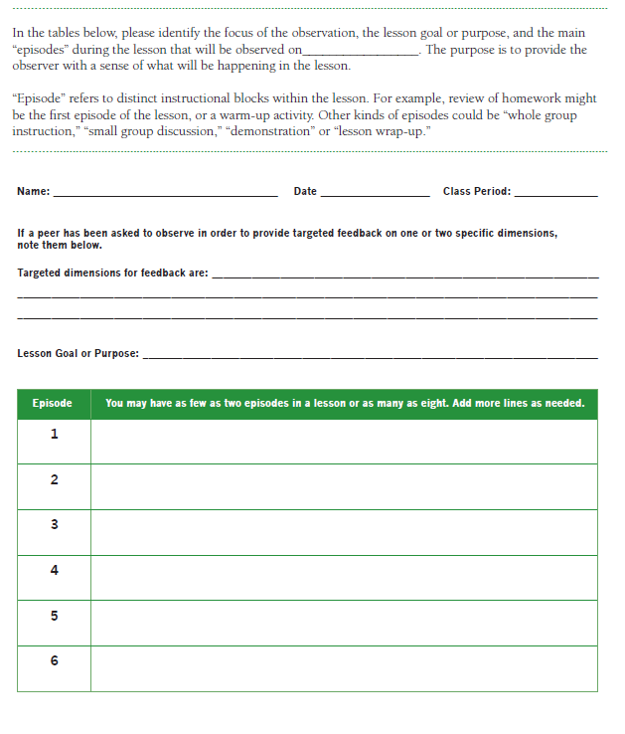

Peer Observation Note-Taking form (p. 80 of the FARROP)

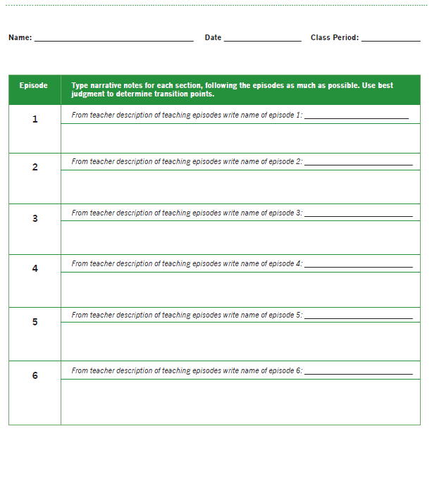

Peer Observation Summary Form (p. 82 of the FARROP)

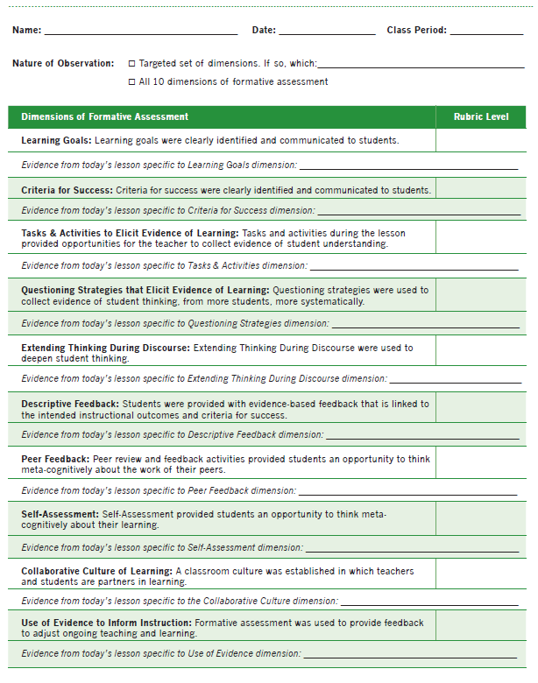

Post-Observation Discussion Prompts (p. 81 of the FARROP)

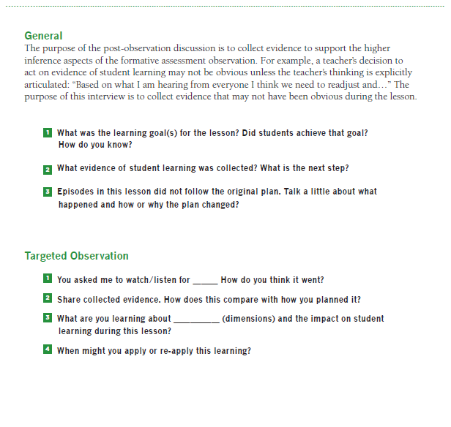

Teacher Self-Reflection Form (p. 75 of the FARROP)

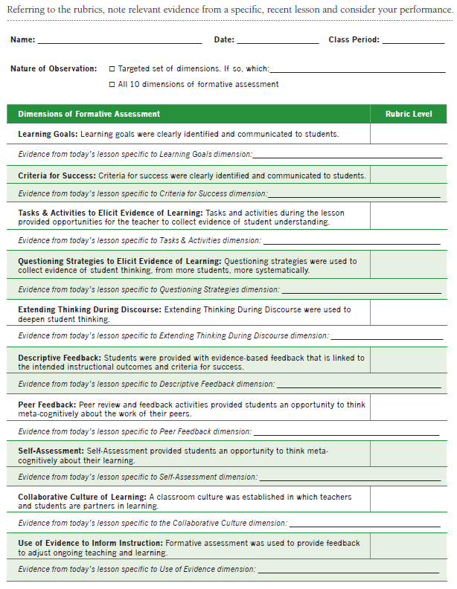

Reflection after Completing Multiple Teacher Self-Reflection Forms

(p. 76 of the FARROP)

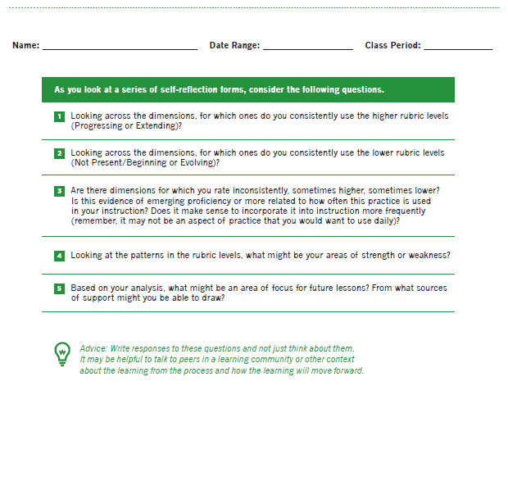

Teacher’s Use of Evidence to Inform Instruction (p. 77 of the FARROP)

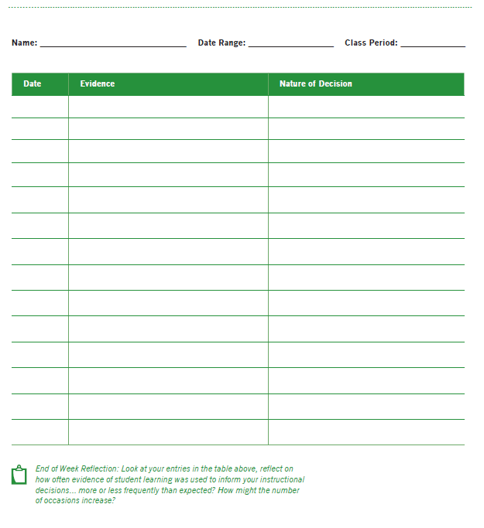

Students’ Opportunity to Self-Assess/Asses Peers’ Work (p. 78)
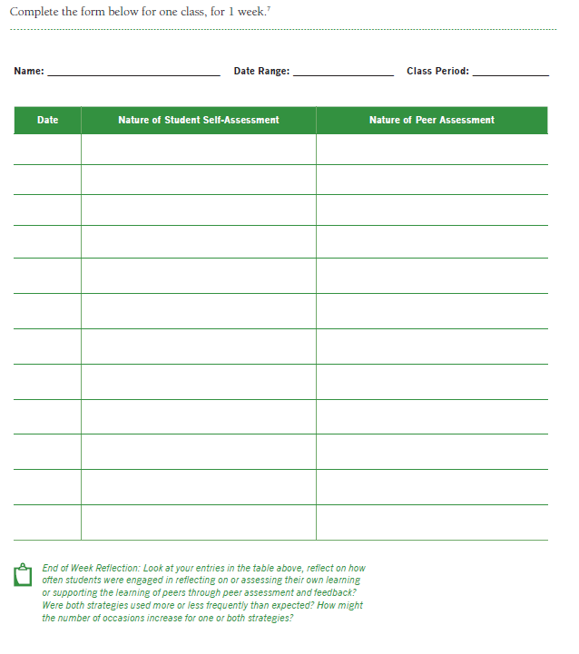

Appendix 2: Tools for Accessing and Completing the Online Courses

Course Numbers, Titles, and Estimated Time

Course Number | Course Title | Estimated Time | Optional/ Required
1 | Introduction | 60 min | Required
2 | Learning Goals and Criteria for Success | 120 min | Required
3 | Tasks and Activities and Questioning Strategies | 120 min | Required
4 | Peer Feedback, Self-Assessment and Collaboration | 120 min | Required
5 | Feedback Loops, Descriptive Feedback and Use of Evidence | 120 min | Required
6 | Giving and Receiving Feedback | 60 min | Required
7 | Scoring Lessons Across 10 Dimensions | 150 min | Required
8 | Reflecting on More Lessons | 150 min | Optional

The total required training time (courses 1-7) is 12.5 hours with an additional 2.5 hours of optional training (course 8).

Registration and Enrollment Directions

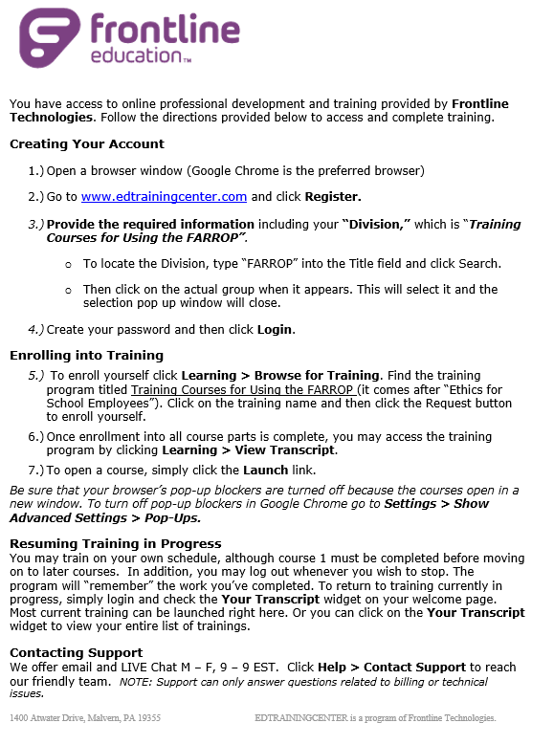

Training Courses for Using the FARROP: Quick Reference Handout
- Once enrolled in training, you will be able to launch Course 1. All other courses will indicate “pending prior training” until Course 1 is completed. You must complete Course 1 before launching later courses. All other courses can be completed in any order, although we suggest completing courses for the dimensions you plan to use prior to completing Course 6 (Giving and Receiving Feedback) and Course 7 (Scoring across Dimensions).
- When you launch a course, it will open in a separate window (see registration/enrollment directions for instructions to turn off pop-up blockers). A course overview is provided at the start of each course. The final section of the overview lists the resources that will be needed and provides a link to download the resource. These resources will open in the original window, not as a separate tab. We suggest you either print the resources or keep them open so you can toggle between the course and the resource as needed.
- The course content appears on the left hand side of the screen. The course title is at the top of the screen and the yellow bar includes a page title at the top. On the right hand side of the screen there is an “outline” that lists each of the slides in the course. The outline allows you to see how many slides are in a course and allows you to move within the course. You can move backwards to re-review content; however, you cannot use the outline to move forward without completing course activities first. Slides in the outline may have a triangle next to them. This indicates that there are a group of related slides. Titles of related slides can be viewed by clicking on the triangle to expand the list of slides.
- There are constructed response questions and multiple choice questions throughout each course. You must enter a response before you can move on to the next screen. In addition, once you open a slide with a “quiz” you cannot go backwards until you answer the question.
- In most cases, after answering a question a sample response will be provided. For multiple choice questions this is the “correct” response. For constructed response questions there may be more than one correct response. The sample response provides one sample. In each case, compare your answer to the sample response and justification. If you still have questions, consider discussing the content with a colleague.
- Courses 2-5 each provide learning opportunities for 2-3 dimensions. The learning opportunities for each dimension follow a similar sequence:
- Course Overview
- Looking Back
- Introduction to the Dimension and Rubrics
- Review of the observer notes
- Applying the Rubric
- Looking Forward
- Check for Understanding

- The Looking Back and Looking Forward Activities are parallel activities and include parallel questions. When looking back, we are asking you to reflect on your current practice, and when looking forward, we are asking you to think about how your implementation of the dimension might change after considering the training. These slides look similar, so please carefully read the questions before answering.
- Screen shots of the rubrics are provided to help orient you to the dimension and the rubrics. However, the screenshots are used only to point you to specific pieces of information. You should print a full copy of the FARROP or keep the resource open as a separate tab so you can read the full text of each dimension rubric.
- In this version of the FARROP, the numerical scores have been replaced with qualitative labels that indicate not observed, beginning, developing, progressing, and extending and letter icons. A new PDF version of the FARROP will be provided on the SPACES site once all necessary edits are completed.
- For each dimension and rubric, a series of benchmark videos is provided in the “Applying the Rubric” section of the courses. The top of the slide indicates the dimension and the rubric level assigned to the video. The left hand side provides the lesson context and postclip information. This information is critical to the benchmark score, so please review it carefully. The right hand side provides the video and a text box to enter evidence. The progress bar at the bottom allows you to pause the video and indicates how much time is left in the current video.
NOTE: The video will automatically start when you move to a benchmark video slide. When completing the course, pause the video so that you have time to read the lesson context and postclip information.
- After reviewing the lesson context and postclip information and typing your evidence, hit the submit button (you cannot hit submit until you have entered evidence for the video). On the right hand side of the next screen you will see a thumb nail of the video along with your recorded evidence. On the left hand side you will see the rating justification provided by the master coders for this clip. Make sure to carefully review the rating justification and compare the noted evidence to your evidence. Once you hit continue (bottom left hand side) you will not be able to go back until you have completed all of the benchmark videos for the dimension. Once you complete the full set of benchmark videos, you can go back and re-review a video by selecting the slide in the outline section of the navigation bar.
NOTE: If you go back to re-review a benchmark video, you will be able to review the lesson context and post clip context and watch the video clip again; however, you will not be able to edit your evidence or review the rating justification again.
- After completing dimension training for each dimension covered by a course, you will have the opportunity to view a longer video and write rating justifications for all covered dimensions.
- At the end of each course, you will have the option to print a certificate of completion. At the bottom of this slide you will see a “next” and “back” button. Clicking on the “next” button will not end the course; rather, you must select “exit” on the top right hand side. This will save your progress and allow access to later courses (if you are in Course 1).
- After you complete a course, it will no longer appear in the top level “Your Transcript” section. To review a completed course, click on “Your Transcript” and in the first drop down menu select “Completed”. This will bring up a list of all courses that have been previously completed. If you launch a completed course, you will have the option to resume from where you left off which will allow you to move between screens without entering new answers or to start fresh. Starting fresh will take you back to the beginning of the course and will require you to answer all of the questions again.

Appendix 3: Tools for Facilitating Group Training

Level Cards
Beginning | Developing
Progressing | Extending
NO not observed
Beginning | Developing
Progressing | Extending
NO not observed

ABCD Cards
A |  | C
E |  | G
 | B |  | D
 | F |  | T

Learning Log

- What was one formative assessment approach that you learned more about today that could be implemented in your classroom tomorrow?

- Please complete at least two of the following sentence starters to share your thoughts on today’s sessions.
    - Today I learned…
    - I was surprised by…
    - The most useful thing I will take from these sessions is…
    - I was interested in…
    - What I liked most about today was…
    - One thing I’m not sure about is…
    - The main thing I want to find out more about is…
    - After these sessions, I feel…
    - I might have gotten more from today if…

- Please feel free to add any additional comments that you think we should know about.

FARROP Course Training: Evaluation Form

District: _______________ School: _____________ Position/ Title: ________________

Please indicate your level of satisfaction with the FARROP Course Training by responding to the questions that follow.
The FARROP Course Training Workshop
How successful was the FARROP Course Training in introducing you to the FARROP dimensions and rubrics? | Not at all Very  Successful 1 2 3 4 5 Successful
What was the most successful aspect of the FARROP Course Training?
What was the least successful aspect of the FARROP Course Training?
What specific suggestions do you have for improving the FARROP Course Training?
Additional Comments

Appendix 4: Tools for Transitioning from Training to Implementation

Traffic Lighting Self-evaluation
Directions: Each of the 10 FARROP dimensions is listed in the table below. Review the list individually. Then traffic-light each technique by putting a check in the appropriate box: green (I understand what this dimension is and could implement this dimension in my classroom right now), yellow (I need additional information, support, or materials to implement this dimension in my classroom), or red (I have no idea how to implement it in my classroom).

FARROP Dimension |  | Green | Yellow | Red
Learning Goals
Criteria for Success
Tasks and Activities that Elicit Evidence of Student Learning
Questioning Strategies that Elicit Evidence of Student Learning
Extending Thinking During Discourse
Descriptive Feedback
Peer Feedback
Self-Assessment
Collaborative Culture of Learning
Using Evidence to Inform Instruction

Initial Action Planning

- Choose one FARROP dimension that you “green-lighted” during the traffic lighting activity and explain how you will continue to implement it in your classroom. Do you want a peer to observe you implement this dimension to support your self-assessment?

- Choose a FARROP dimension that you “yellow-lighted” that you would like to use more, but need to know more about. List any resources you might use to help you to learn more about this technique in order to implement it in the future. Is this a place to try to observe a peer implement this dimension to deepen your understanding of it?

Action Planning Log (p. 83 of the FARROP)

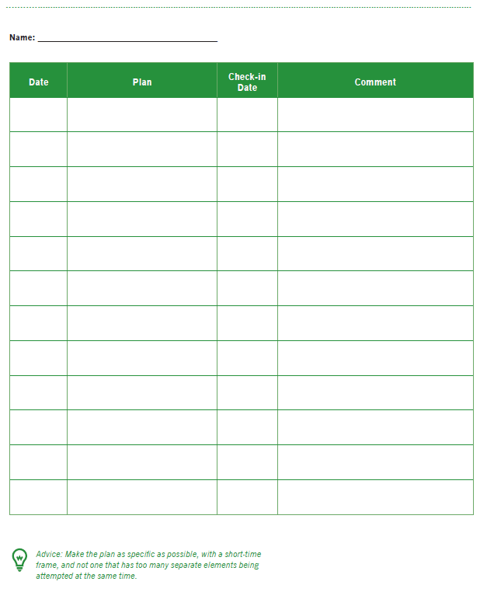

Swivl Video-Recording and Uploading Directions
Equipment and Purpose
The equipment used for video recording includes an iPad and full Swivl system. Specifically,
- iPad mini (although other smart devices are compatible) with charging cord, directions, and storage box.
- Swivl system:
  - Swivl Carrying Case: holds all Swivl equipment, including the charging cord
  - Swivl Base: This is white and black, will hold the iPad mini (landscape), and will follow the Teacher Marker in order to record the teacher anywhere in the room
Note: There is a storage/charging compartment at the back of the base which can hold/charge 1 marker; this location stores one of the two markers when not in use.
  - Audio Cable: This black cable is in a small plastic bag and connects the iPad mini to the Swivl and allows for audio to be recorded
  - Teacher Marker: This marker should be worn around your neck with the provided lanyard. The marker communicates with the base so that the iPad can follow you throughout the room and will capture your audio
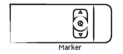
  - Student Marker: This second (optional) marker captures student dialogue but will not move the iPad. A lanyard is provided and can be used if individual students wear the marker.
Note: The markers are not labeled Teacher or Student. Rather, the first marker that is turned On will move the Swivl base. The second marker, if used, will automatically become part of the recorded file. That is, both marker’s captured audio is included.
--------------------------------------------------------------------------------------------------------------------
The day before/morning of video recording
- Ensure all needed equipment (iPad, Swivl Base, and both markers) is charged (the night before, previous class period). The iPad can be plugged in and used by Swivl at the same time. Audio markers are charged within the Swivl base when the base is plugged in (the charging compartment is located at the back of the base). There is only space in the base for one marker to be charged at a time. Therefore, once the Teacher Marker is charged, insert the Student Marker to allow that audio marker to charge too.
--------------------------------------------------------------------------------------------------------------------
Before the lesson to be video recorded
- Turn on iPad
- Check Settings app on iPad to confirm that the iPad is connected to a Wi-Fi network and that the Bluetooth is On
- Place iPad in Swivl base, with the tablet screen forward facing, in slot in front of base’s Power button. To turn on the Swivl base, hold the Power Button until the lights come on (the base should begin moving)
- Select “Allow” when prompt appears on iPad saying ‘Swivl Capture wants to communicate’ (this opens the Swivl app)
- Plug in audio cable: one end goes into the white base (into the microphone port) and the other into the left-hand side of the iPad
Note: You will see a warning/reminder that your audio cable is not plugged in if you forget.
- Place base roughly 6 to 15 feet from yourself
Note: You need to be in the base’s line of sight (or infrared light located in front of base).
- Locate two charged markers (one will be in the charging dock on the back of the Swivl)
- Turn on the Teacher marker by pressing and holding the Power button on its side; Swivl will begin to move/tilt
Note: 3 lights turn green—base Power, Sync button , and marker—indicating a connection; you will see a reminder if a marker is not turned on, which is needed for a full connection. Affix the Teacher Marker to the lanyard clip, and hang it around your neck. For a seamless connection experience, an unobstructed line of sight of the marker is required.
- Turn on the Student Marker and place it where it will capture the most student dialogue
--------------------------------------------------------------------------------------------------------------------
Troubleshooting
- For the Swivl to connect, Bluetooth must be On in the iPad Settings; if not, Swivl will not work. Go to the iPad Settings and ensure Bluetooth is turned On. In this same view, if the Swivl is not connected, find it in the list of devices and click on it to Connect. Once connected, the icon will be colored white on the iPad when in Camera view.
- When you load the free Swivl app onto the iPad, there is a short Swivl demo of its use. The Swivl website has User Guides (https://www.swivl.com/wp-content/uploads/2015/05/User-Guide.pdf) and other Support.
--------------------------------------------------------------------------------------------------------------------
Recording the Lesson
- Before beginning instruction, hit the white circle Record button with your finger on the iPad touch screen
Note: The white circle will continuously blink red, and timer will start to count the time, indicating that the iPad is recording.
- At the end of the lesson, hit the flashing Record button again to Stop recording; the red flashing circle on the iPad camera will return to a solid white circle
- Once the recording is stopped, the video will automatically upload from the Swivl Library App to a secure Cloud
Note: Do NOT turn the iPad off while the recording is uploading. Depending on the length of the video recording, this process could take 5-10 minutes.
- To confirm video upload, click the following icon located in the upper left of iPad. The screen below should display. Locate your video (it should be sorted by recently recorded) at the top of the screen. The cloud icon to the far right will be green if the video has been successfully uploaded. If the cloud is still black, the upload is in process.
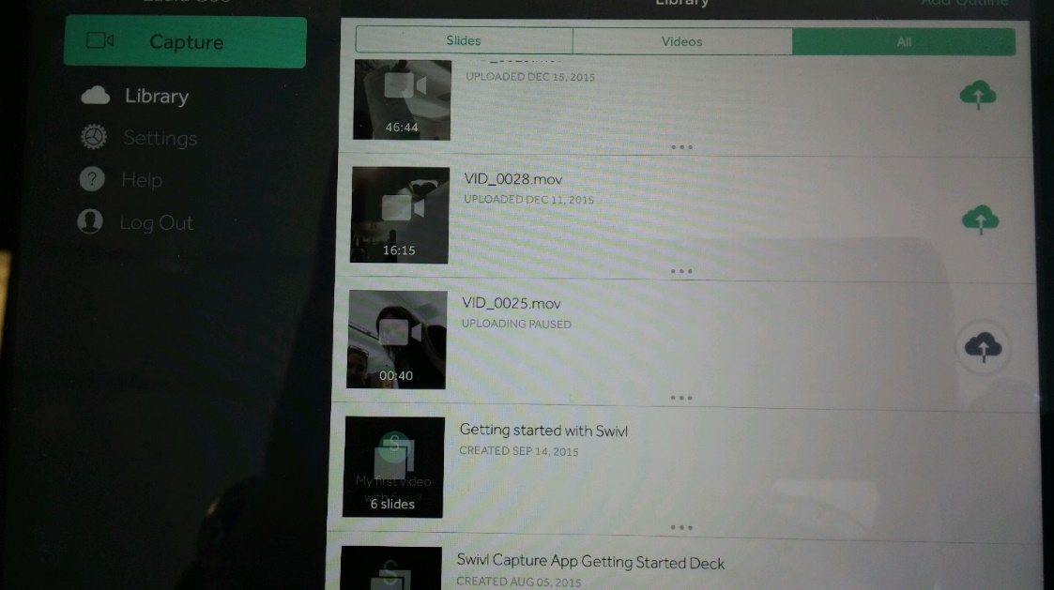
- While on this screen, you can preview any videos by touching the video. Videos can be paused or played. You can exit the video preview by hitting the “x” in the top left hand corner of the video which will bring you back to the Library screen. To return to the recording screen, press the green “Capture” button (as shown above) in the top left.
- If the Cloud is configured to your email address, you will receive an email when your video is successfully uploaded. The cloud service is a secure account, with all videos automatically set to Private.
---------------------------------------------------------------------------------------------------------------------
After Uploading complete
- Turn off all equipment and store one marker inside the Swivl base. Store the Swivl base, the second marker, both lanyards, and the audio cable in the provided carrying bag.
- Turn off the iPad, box it, and securely store away with Swivl bag.

FARROP TLC Sample Meeting Agenda
Introduction and Agenda Review
- Review agenda
- Remind participants about the importance of sticking to the one-minute discussion time-frames so that everyone has a chance to participate
Part 1: Review How Your Formative Assessment Practice is Going
Each participant has one minute to share out using the questions below as guidelines. The group has one minute to ask clarifying questions. Repeat the process until everyone has shared.
- How have you been changing your formative assessment practice? What FARROP dimension does it primarily connect to?
- What changes are you noticing with your students?
- What are you still working on/modifying to make it work for you and your students?
Part 2: Review How Observations are Going
Each participant has one minute to share out using the questions below as guidelines. The group has one minute to provide specific suggestions (or offer to meet outside of the meeting if the suggestion will take more than one minute). Repeat the process until everyone has shared.
- What is working well in terms of logistics for observing peers and providing feedback?
- What are you struggling with?
- What can the group help with?
Part 3: What are you learning from the observations
Without getting into the details of what was observed in a lesson specifically, each participant has one minute to share out using the questions below as guidelines.
- Thinking about the observations you have completed, what has pushed your own thinking about formative assessment?
- What are you going to try new or differently as a result?
Part 4: Customized Learning
This part of the agenda will vary according to the time of the year and the needs of the group. See Chapter 3 of the facilitator guide for suggested content.
Part 4: Wrap-up and Planning
Each participant should take a few minutes to review the most recent version of their personal action plan and update it to reflect what they are currently focused on.

Sample Ground Rules for Teacher Learning Communities
Use of Time and the Focus of Meetings
- Make attending TLC meetings a priority.
- Do your best to be on time and stay for the full meeting.
- Identify a time keeper so that everyone has an opportunity to share and all activities can be completed.
- Make sure everyone who wants to speak is heard and everyone who would like to provide feedback gets a chance.
- The ultimate purpose of using the FARROP for peer observation and self reflection is to improve formative assessment practice and to improve student learning. Focus discussions on the discussion of formative assessment practice and experiences with the FARROP.
- Avoid side-conversations or off task topics.

How We Speak about the Work of Teaching and Learning
- Give credit where credit is due. You—and all teachers—have always done the best you could with the information and resources you had at the time, and so have students. Acknowledge this, especially when giving feedback.
- Use descriptive language to discuss practice and student work. This will help you to avoid making judgmental statements.
- Be honest about your own strengths and weaknesses.
- Show respect for the work of your colleagues and for the work of all students, even when there are disagreements.
- Acknowledge that you can learn from teachers at all levels of familiarity with formative assessment, those that are both new and experienced.
- Be respectful of students and families at all times, even when describing challenging issues and behaviors.
- Do not use sarcasm.

How We Listen and Provide Support
- Keep and open mind about new ideas and use active listening strategies.
- Make honest AND supportive suggestions to your colleagues.
- Base your suggestions in real experience and in the rubric descriptions.
- Acknowledge that at times different approaches will be needed for both different teachers and different students.

Productive Attitudes
- Determine a leadership structure and decide how to share the workload and offering to help when needed.
- Strive to be realistic and positive.
- Remember that in order to make changes to habits and practices, you need to be open to learning new things, to giving up existing habits and practices, and to continuously reflect on the effectiveness of both old and new habits and practices.

References

Casabianca, J. M., Lockwood, J. R., & McCaffrey, D. F. (2014). Trends in classroom observation scores. Educational and Psychological Measurement, 1-27. doi: 10.1177/0013164414539163
CCSSO. (2008). Attributes of effective formative assessment. A work product coordinated by Sarah McManus, NC Department of Public Instruction, for the Formative Assessment for Students and Teachers (FAST) collaborative. Council of Chief State School Officers: Washington, DC.
Wylie, E. C., & Lyon, C. J. (in press). Developing a formative assessment protocol to support professional growth. Educational Assessment.

