Foster Care & Education Recent History

Studies demonstrate that students in foster care experience more challenges throughout their education compared to their peers, such as the following: frequent school changes, delayed enrollment when school changes occur, higher rates of school suspensions and expulsions, lower achievement in reading and math, higher levels of being held back and dropping out, far lower high school and college graduation rates (Taken from ‘Roadmap for Foster Care and K–12 Data Linkages Key Focus Areas to Ensure Quality Implementation’ by Data Quality Campaign & Legal Center for Foster Care & Education). Recognizing the unique needs of children in foster care, States and the Federal government have launched efforts in recent years to increase the educational stability of and to improve educational outcomes for these youth.¹
History
The Fostering Connections to Success and Increasing Adoptions Act of 2008 (Fostering Connections Act). The legislation requires child welfare agencies (CWA) to collaborate with educational agencies to keep children in foster care in the same school when living placements change, if remaining in that school is in their best interest. The legislation requires CWAs to ensure that children in foster care who do change schools are promptly enrolled in a new school, with the relevant school records. ¹
In January 2013, Congress passed the Uninterrupted Scholars Act (USA), which amended the Family Educational Rights and Privacy Act (FERPA) to permit educational agencies and institutions to disclose, without parental consent or the consent of an eligible student, education records of students in foster care to State and tribal CWAs. The statute also amended the requirement that educational agencies and institutions notify parents before complying with judicial orders and subpoenas in certain situations. This legislation helps to ensure privacy protections for children and families and to facilitate more efficient data-sharing pertaining to children in foster care between child welfare and educational agencies, a critical component to ensuring school stability for these youth.¹
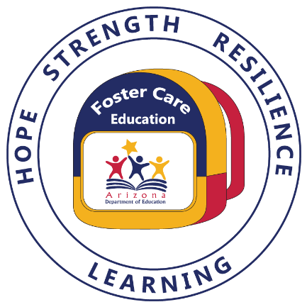
In December 2015, Congress passed the Every Student Succeeds Act (ESSA), which reauthorized the Elementary and Secondary Education Act of 1965 (ESEA), and built on the legislative successes outlined above by instituting new protections for children in foster care. These provisions, which take effect on December 10, 2016, complement those in the Fostering Connections Act and require SEAs and LEAs to work with CWAs to ensure the educational stability of children in foster care. The foster care provisions of Title I, Part A (Title I) of the ESEA emphasize the importance of collaboration and joint decision-making between CWAs and educational agencies. While these provisions do not create new requirements for CWAs, they mirror and enhance similar provisions in the Fostering Connections Act. Considered together, these laws make clear that the educational stability of children in foster care is a joint responsibility of educational and CWAs, and to successfully implement these provisions, these entities will need to collaborate continuously. ¹

