Troops To Educators
The Troops to Educators program (TTE) is Arizona's version of the national Troops to Teachers program (TTT) and is a free service to help active-duty, their spouse, veterans, and reservists navigate the certification process to begin a new career in education for grades K-12. Eligible participants can receive educational counseling, certification recommendation, and employment referral assistance throughout Arizona.
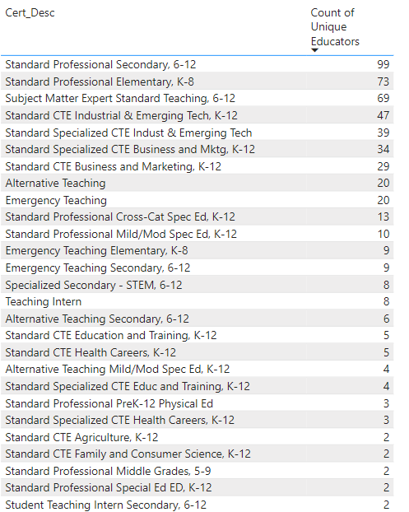
Certified
The table to the left shows that from fiscal year 2018 through 2022, 381 unique educators were certified to teach through the Troops to Educators program. The most common certification received was a Standard Profession Secondary (grades 6-12) with 99 individuals earning this certification, followed by 73 educators earning a certification in Elementary Education (grades K-8).

Below you can see the number of unique educators certified during each fiscal year as well as a breakdown of ethnicity for the 381 individuals certified from 2018-2022.

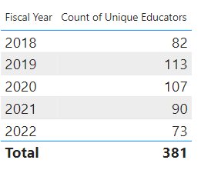
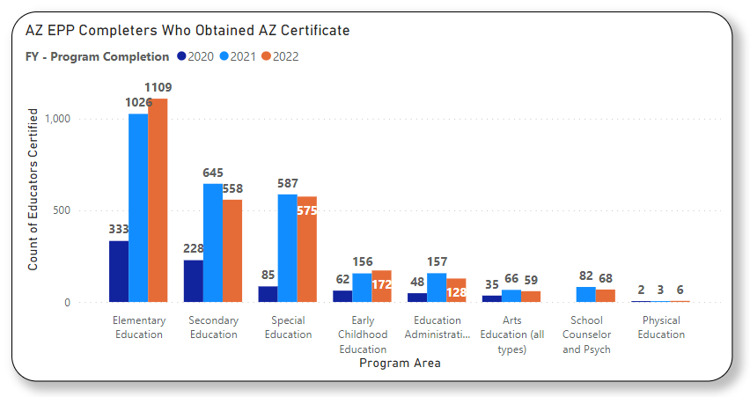

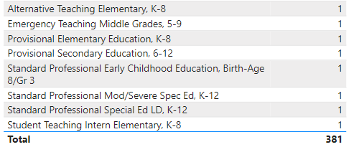

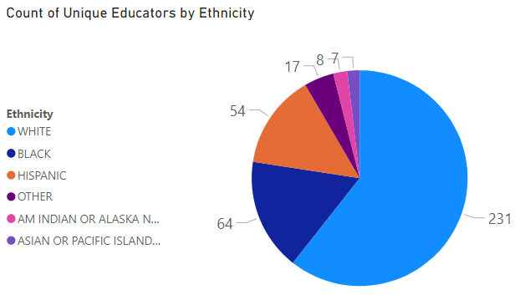

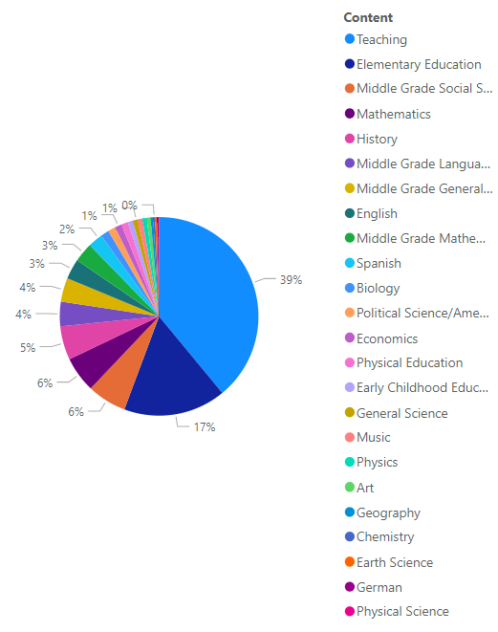
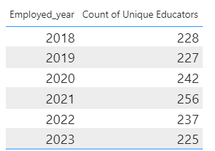
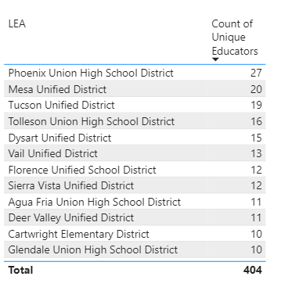
In Th e Classroom
Of the 381 individuals that were certified to teach between fiscal years 2018 and 2022, 377 were reported by a Local Education Agency (LEA) as teaching in the Teacher Input Application (TIA). The pie graph to the right represents the content areas that TTE teachers were reported as teaching.

Below you will see the districts that have employed 10 or more unique educators through TTE, with Phoenix Union High School District leading with 27 educators over the past 6 years.

Finally, the table in the bottom right displays the number of unique educators reported in TIA as employed each year in an Arizona LEA.

