2021 Minority & Diversity Scholarship Award
Rosalina Anaya, MEd

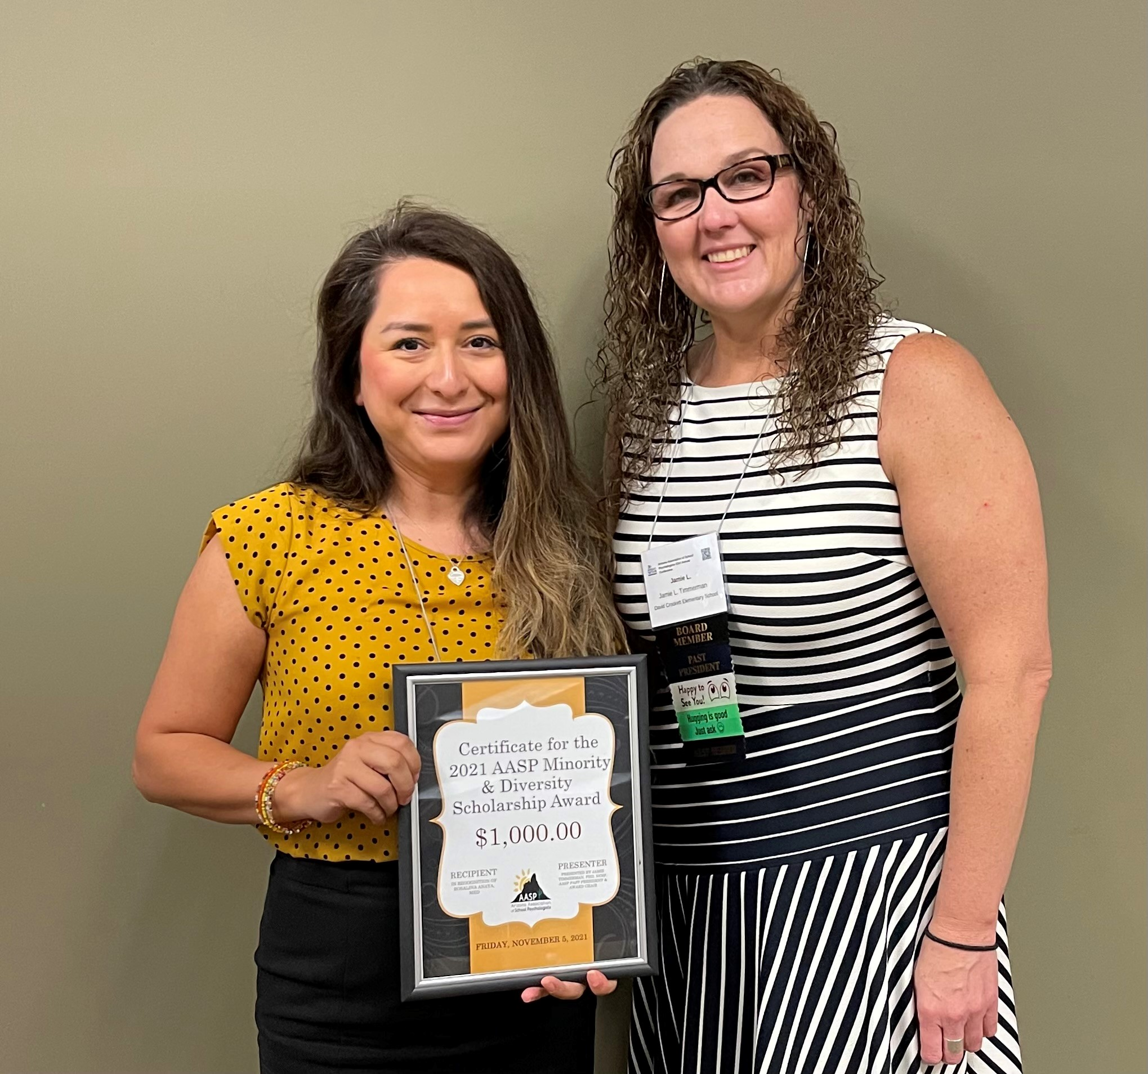
Rosalina received her Bachelor of Arts in Psychology at the University of Arizona in Tucson. She received her Master of Education in School Counseling at Northern Arizona University in Tucson. Rosalina is currently in the Educational Specialist in School Psychology graduate training program at the University of Arizona Chandler. Rosalina is bilingual (English and Spanish). She has a passion for kids and Rosalina wants to use her prior experience and Spanish-speaking skills to improve cultural and linguistic diversity in the field of school psychology.

