2021 AASP Keith Perkins Lifetime Achievement Award
David L. Wodrich, PhD
University of Arizona

Over the past 45 years, Dr. Wodrich has changed countless lives and made impactful contributions to the field of school psychology through various roles, including practicing school psychologist, clinical director at Phoenix Children’s hospital, researcher, journal editor, author, and professor. His research and publications on the academic impact of childhood chronic illness have resulted in improved school outcomes for students with epilepsy, diabetes, cancer, and other chronic illnesses. He and a research team created the EdMedKids website, which provides teachers with research-based information and tools for educating students with chronic illness.
Dr. Wodrich has a particular interest in how health conditions impact children in schools and has conducted research in this area in many different ways. He has regularly included both classroom teachers and special education teachers in research studies demonstrating an understanding that teachers play an indispensable role in helping children with health conditions achieve in school.
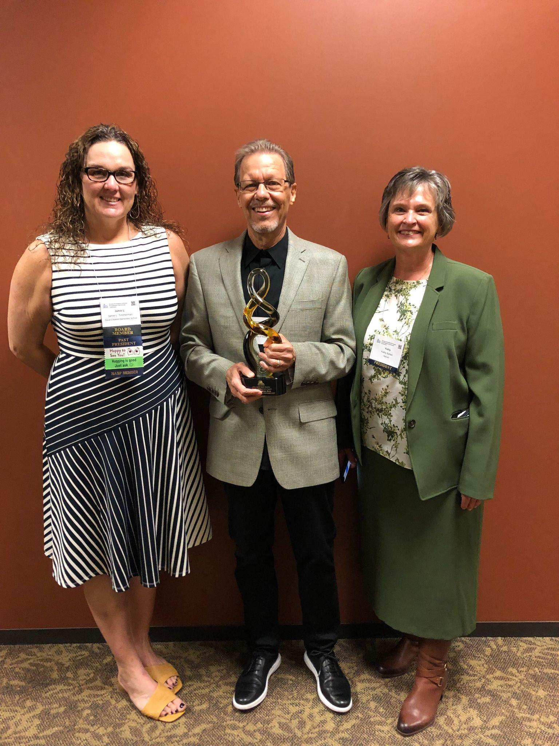
Dr. Wodrich has trained innumerable graduate students who went on to directly serve students in the schools and through their research. It is not a given that graduate students will have the opportunity to receive training from a practicing psychologist. Dr. Wodrich has drawn on his clinical experiences to train effective practitioners for many years. Additionally, Dr. Wodrich has continued to work directly with children and adolescents in private practice; this provides children unique access to one of the most highly qualified evaluators, in any area of psychology, in the state of Arizona.
Dr. Wodrich is dedicated to improving the practice of school psychology for the children we serve and for school psychologists themselves. Dr. Wodrich has been training graduate students for a few decades now, however he is still working to be a better trainer and teacher. He embodies the notion of a lifelong learner, Dr. Wodrich is never one to sit passively back and assume he knows all there is to know. To this end he challenges his graduate students to continually improve and revise their practice throughout their careers. Dr. Wodrich sees the value that school psychologists provide to children, families, and schools and encourages his graduates to see themselves as highly qualified professionals that should advocate for themselves to be able to use their skills to directly support students, teachers, and families, more so than swimming through paperwork.
Dr. Wodrich has been an instructor, a mentor, a colleague, and a friend over the past 13 years. As an instructor, Dr. Wodrich was incredibly knowledgeable and fair. He taught with passion and with a desire to help you to understand and learn the importance of the material and not just the material. He frequently encouraged us to challenge the traditional thoughts about things and to “think” about problems rather than simply accept a situation. He has also been a mentor and friend to me throughout the years as I completed my schooling and began a career. He is always ready to support other school psychologists and remains close with many of his previous students.
As a professor, Dr. Wodrich teaches the needed instruction for his students to become successful school psychologists, but also instills in his students the importance of remaining curious and searching for answers by thinking outside of the box. He educates those new to the profession with expertise from his years of experience. He inspires his students to become fellow leaders who advocate for the diverse needs of students and their families and promote mental health and positive school climates.
As a professor he has made a profound impact on the lives of countless graduate students that he has taught and mentored through the years. His support and guidance for his graduate students is commendable. Graduate students would jokingly suggest that they would make a bracelet that read “W.W.W.D.,” which is an acronym for “What would Wodrich do?” Dr. Wodrich has undoubtedly inspired his graduate students to become great school psychologists so that we can provide children with the highest level of service.
Dr. Wodrich understands the importance of meeting parents’ needs to have well-informed meaningful answers about why their children are struggling. When teaching graduate students, he emphasizes the need to understand how parent concerns relate to the referral question and challenges psychologists to provide parents with meaningful answers that go above and beyond a statement of special education eligibility. Dr. Wodrich has written a book specifically for parents to better understand the psychoeducational evaluation process and the information that comes out of those evaluations.
Dr. Wodrich has served the profession of School Psychology in many ways throughout his career. In regard to a search for knowledge, he has conducted original research with multiple universities, many graduate students and multiple hospitals. He is motivated and enthusiastic about the research process and never tires of trying to move the research base forward. His particular passion is the impact of different health conditions on children’s well-being. Dr. Wodrich consistently conducts this research in a manner that addresses how children are impacted in the areas of learning and in the school setting working to make results relevant to practitioners in the field. Most recently, Dr. Wodrich published a free to the public e-book, entitled Fingertip Facts for School Psychologists: Definitions, Explanations, Links (2021). This is an incredibly useful resource for all practicing school psychologists and full of helpful information and links.
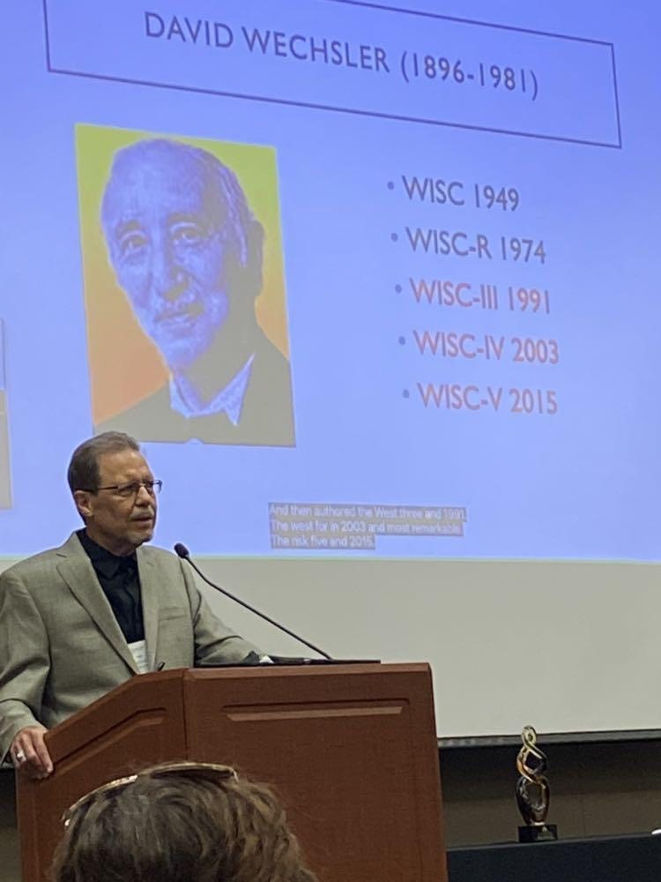
Regarding ethical and professional conduct, Dr. Wodrich is keenly aware of NASP and APA codes of ethics in addition to Federal and State Laws. He models careful and reflective decision making when dealing with complicated situations. In his different roles in university settings, Dr. Wodrich has also challenged his students and colleagues to think through decisions in a deliberate way that considers ethical codes, laws, and the best-interest of the child.
There are few individuals in the state who have had as much of a profound impact on the field and the practice of school psychology than Dr. Wodrich. Dr. David Wodrich encompasses all of the characteristics of an outstanding leader and lifelong learner. Dr. Wodrich has impacted the field on every possible level for longer than many of us have been practicing. Dr. Wodrich is an experienced school psychologist practitioner, and a trainer for most school psychology leaders and practitioners in our state. In his time teaching at the university level, he sought after for his vast knowledge and experience to provide invaluable and ongoing professional development for practicing school psychologists. Dr. Wodrich’s work has empowered countless school psychologists to embrace their training and expand their role as school psychologists. Through his continued work in the private sector, he continues to demonstrate the value of school psychologists to the community at large. His entire professional career has been devoted to supporting students, teachers, administrators, parents, community agencies and the profession at large. Dr. Wodrich embodies what the Keith Perkins Lifetime Achievement Award is all about. Dr. Wodrich has impacted the lives of many children through his direct work as a practitioner and more than can be counted through his work training graduate students. Dr. Wodrich has spent his career supporting and advocating for students and their families and has significantly impacted and advanced the profession of school psychology.

